

September 2024

Dear Mapping Coordinator:

The National Center for Education Statistics (NCES) sponsors the School District Review Program (SDRP), enabling the U.S. Census Bureau to create poverty and population estimates by school district geography. The poverty and population estimates produced by the Census Bureau are of vital importance for each state’s allocation of federal funding under Title I, Part A of the Elementary and Secondary Education Act (ESEA) as amended (Public Law 114-95).

The 2025 SDRP annotation materials are posted on the [SDRP website](http://www.census.gov/programs-surveys/sdrp.html). The materials include the quick start and respondent guides, the Geographic Update Partnership Software, school district inventory listing files, a submission log file, and school district boundary shapefiles. Please review the posted materials and update the following information, if necessary:

* Census Bureau school district boundaries;
* School district names;
* School district levels;
* School District Local Education Agency (SDLEA) codes;
* Grade ranges for allocating children if two school districts occupy the same area;
* Counties in which school districts are located; and
* Relationships where school districts are coextensive with other legal areas such as counties, cities, towns, and townships.

The Census Bureau requests that the state’s SDRP submission reflect the school districts, as they will exist on   
January 1, 2025. The deadline for submitting updates to the Census Bureau is December 31, 2024. For questions about the SDRP, please contact the Census Bureau at <[geo.school@census.gov](mailto:geo.school@census.gov)> or 301-763-1099.

Sincerely,

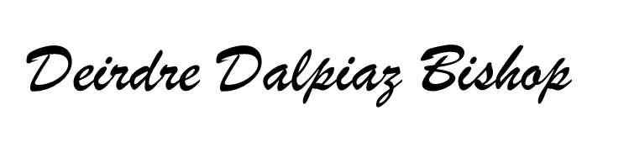

Deirdre Dalpiaz Bishop

Chief, Geography Division

cc: State Title I Coordinator

*We estimate that participating in the School District Review Program will take 41 hours on average. Send comments regarding this burden estimate or any other aspect of this collection of information, including suggestions for reducing this burden to <*[*geo.school@census.gov*](mailto:geo.school@census.gov)*>. This collection has been approved by the Office of Management and Budget (OMB). The eight-digit OMB approval number that appears at the upper left of this document confirms this approval. If this number were not displayed, we could not conduct this program. The Census Bureau’s legal authority for conducting activities in this document comes from Title 13 U.S. Code, Sections 16, 141, and 193. The NCES’ legal authority for conducting activities in this document comes from Title I, Part A of the ESEA as amended by the Every Student Succeeds Act of 2015, Public Law 114-95.*