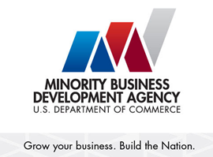

**MBDA Shared Outcome Agreement**

**Between**

**(Insert Partner MBDA Business Center/Project #1)**

**And**

**(Insert Partner MBDA Business Center/Project #2)**

The MBDA mission is to promote the growth of minority-owned business through the mobilization and advancement of public and private sector programs, policy and research. The MBDA Business Centers and Projects support this mission by helping minority business enterprises (MBEs) to build scale and capacity; increase revenues; create and retain jobs; and expand regionally, nationally and internationally.

In support of this mission the (Insert Business Center/Project #1) and the (Insert Business Center/Project #2) agree to enter into a MBDA Shared Outcome Agreement for the purpose of working together and sharing (Insert MBE name here) to assist them with access to mutually beneficial relationships for the growth expansion of minority owned businesses and facilitation of access to (*capital, contracts and/or market opportunities – insert specifically which applies here*). Resulting Transactions will be shared on a 50/50 split. (Special Mention: The 50/50 split can be negotiated.)

___________________________________________

(Insert Project Director #1 & name of Business Center/Project MBDA BC Date

Print and sign

Date: ___________________________

____________________________________________

(Insert Project Director #1 & name of Business Center/Project MBDA BC

Print and sign

Date: ____________________________