Offshore Wind Energy Development and the Gulf of Mexico Region

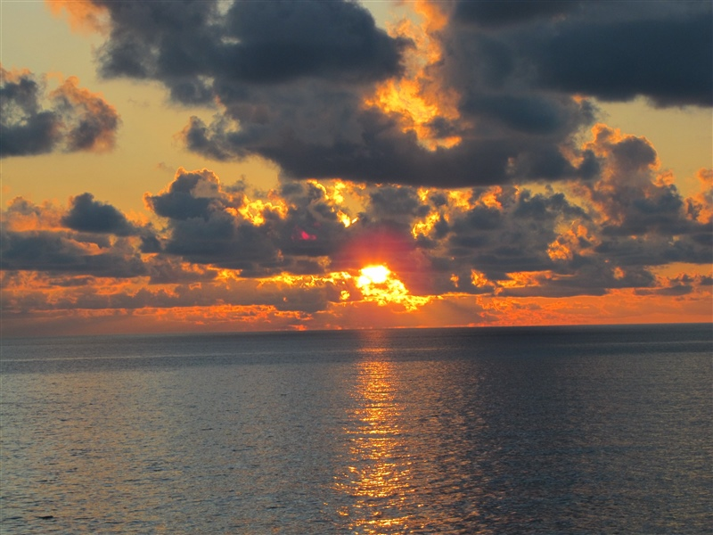

Credit: Officers and Crew of NOAA Ship PISCES; Collection of Commander Jeremy Adams, NOAA Corps Location: Gulf of Mexico

Offshore wind energy development is proposed in the Gulf of Mexico (see map below) by the Bureau of Ocean Energy Management (BOEM). This survey is one of several studies to collect information to inform decision-making processes. We are interested in learning about your opinions. Your responses will help NOAA and BOEM understand the potential human and social impacts from offshore wind energy development in the Gulf of Mexico.
By completing the survey, you are consenting to participate in this research. Although we hope that you will answer every question, you are free to skip any questions. Your participation is voluntary, and you may withdraw your consent and discontinue participation at any time. The survey will take approximately 10-15 minutes to complete. You will not be individually identified, and your responses will be used for statistical purposes only.
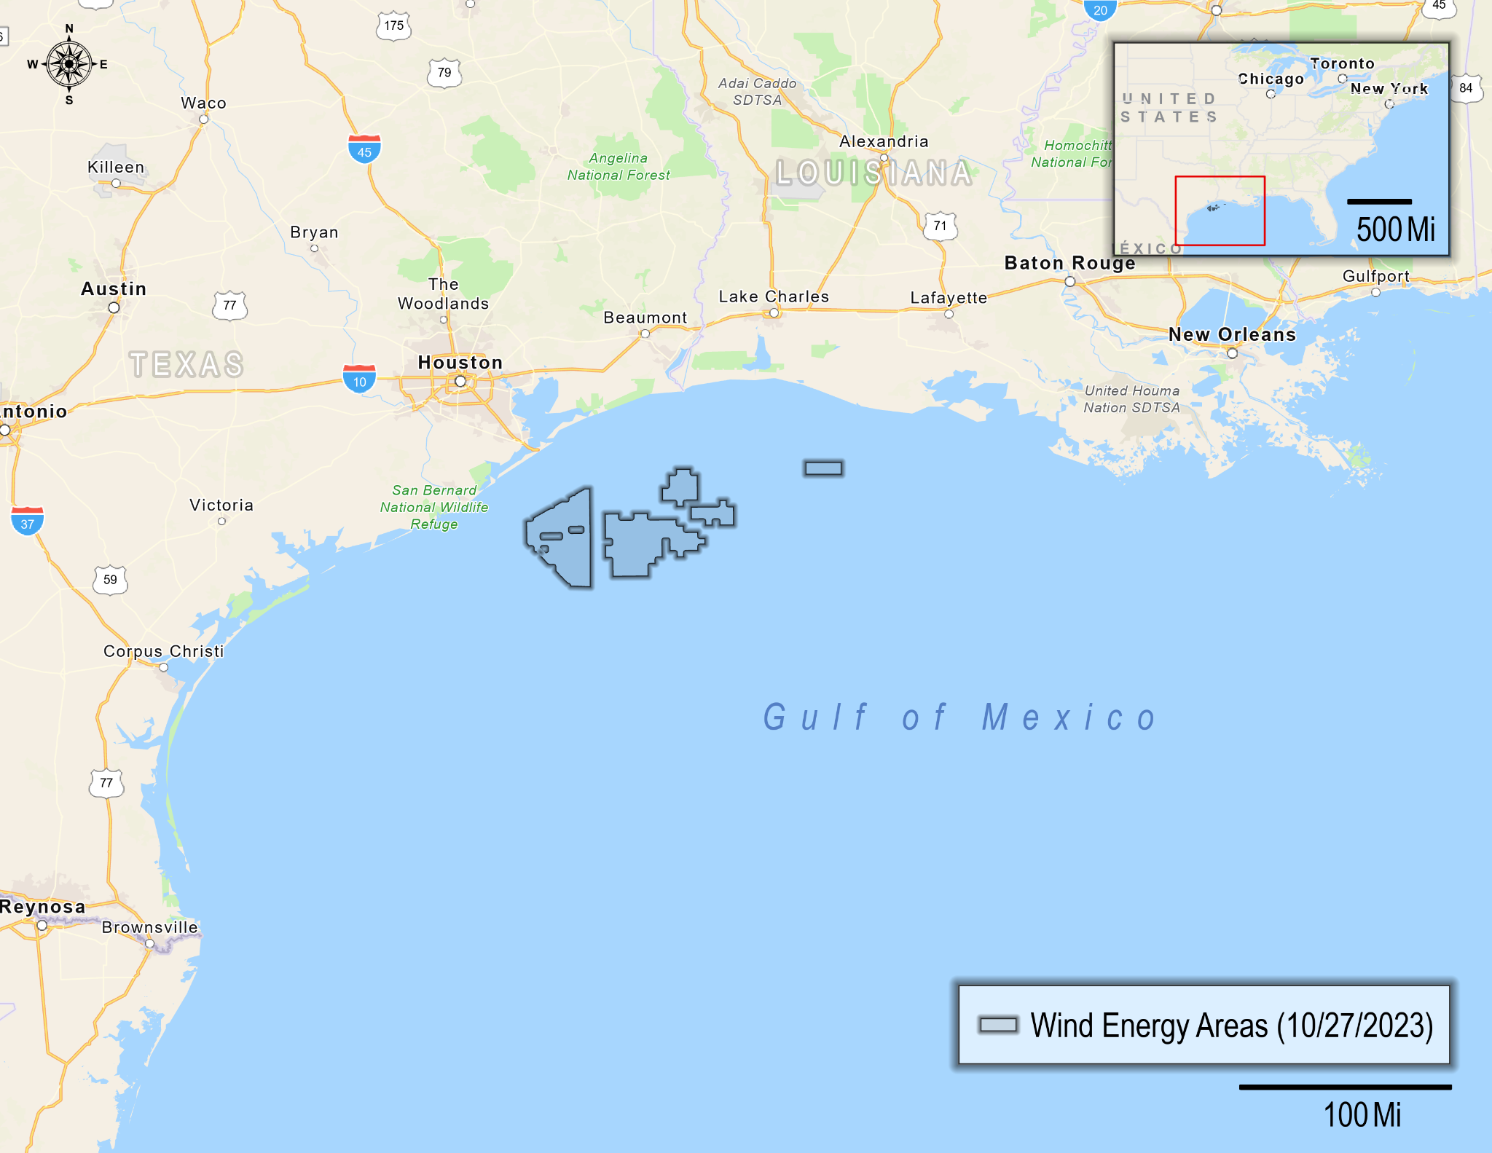

- Before today, had you heard about the potential for offshore wind energy development in the Gulf of Mexico?
- Yes
- No, but I had heard about offshore wind energy, in general
- No, and I hadn’t heard about offshore wind energy before today
- How knowledgeable do you feel about offshore wind energy?
- Not at all knowledgeable
- Somewhat knowledgeable
- Very knowledgeable
- Extremely knowledgeable
- Given what you currently know about offshore wind energy, have you formed an opinion about its potential development in the Gulf of Mexico?
- I support offshore wind energy in the Gulf of Mexico 🡪 SKIP to Q5
- I oppose offshore wind energy in the Gulf of Mexico 🡪 SKIP to Q5
- I have not yet made up my mind 🡪 CONTINUE to Q4
- [IF Q3=3] Even though you have not yet made up your mind about offshore wind energy development in the Gulf of Mexico, which way are you leaning?
- To support development
- To oppose development
- I don’t know
The Gulf of Mexico produces oil and gas. We are interested in understanding your perceptions of the impacts from offshore oil and gas in the Gulf of Mexico.
- What potential impact do you think oil and gas production in the Gulf of Mexico has on these items? (select one response for each item)
 | Very negative impact | Negative  impact | No  impact | Positive  impact | Very positive impact | Not  Sure
Affordability of residential electricity
Reliability of residential electricity
Commercial fishing - excluding shrimping
Commercial shrimping
Commercial aquaculture
Coastal community livelihoods
Recreational saltwater fishing
Views of the ocean
Coastal habitats
Whales, dolphins, and sea turtles
Migratory birds and seabirds
Tribal/Traditional way of life
Marine navigation

In addition to oil and gas, the Gulf of Mexico may also produce energy from offshore wind in the future. We are interested in understanding your perceptions of potential impacts from offshore wind energy in the Gulf of Mexico.

- Given what you currently know about offshore wind energy, what potential impact do you think offshore wind energy production in the Gulf of Mexico will have on these same items? (select one response for each item)
 | Very negative impact | Negative  impact | No  impact | Positive  impact | Very positive impact | Not  Sure
Affordability of residential electricity
Reliability of residential electricity
Commercial fishing - excluding shrimping
Commercial shrimping
Commercial aquaculture
Coastal community livelihoods
Recreational saltwater fishing
Views of the ocean
Coastal habitats
Whales, dolphins, and sea turtles
Migratory birds and seabirds
Tribal/Traditional way of life
Marine navigation
- Next, please tell us how important these same items are to you in terms of your quality of life in the Gulf of Mexico region. (select one response for each item)
 | Not at all  important | Somewhat  important | Very  important | Extremely  important
Affordability of residential electricity
Reliability of residential electricity
Commercial fishing - excluding shrimping
Commercial shrimping
Commercial aquaculture
Coastal community livelihoods
Recreational saltwater fishing
Views of the ocean
Coastal habitats
Whales, dolphins, and sea turtles
Migratory birds and seabirds
Tribal/Traditional way of life
Marine navigation

- How important do you think it is to pursue offshore wind energy development in the Gulf of Mexico?
- Not at all important
- Somewhat important
- Very important
- Extremely important
- How important is it for electricity produced by offshore wind energy development in the Gulf of Mexico to… (select one response for each item)
 | Not at all important | Somewhat important | Very important | Extremely important
Be used in your state?
Provide electricity for residential use?
Provide electricity for industrial use?
Provide electricity for commercial use?
Replace electricity produced by non-renewable sources?
- Which of the following sources would you prefer to produce energy for your state? (select one response for each item)

 | Yes | No
Hydropower (dams)
Coal
Oil (petroleum-based fuels)
Natural gas
Offshore wind
Land-based wind
Nuclear
Solar
Biomass (wood, plant or animal materials)
Marine hydropower (wave, tidal, current)
Geothermal

- Do you believe that climate change is happening?
- Yes 🡪 CONTINUE to Q12
- No 🡪 SKIP to Q14
- I don’t know 🡪 SKIP to Q13

- Do you believe climate change is mainly caused by human activities or natural forces?
- Human activities
- Natural forces
- I don't know
- Do you believe offshore wind energy could be an effective way to reduce climate change?
- Yes
- No
- I don’t know
The next several questions will ask about your past experiences, intentions, and preferences related to public participation in local issues in the Gulf of Mexico region.
- In the last 12 months, have you done any of the following in response to either any environmental issue or offshore wind energy development in the Gulf of Mexico? (select one response for each item)
 | Any environmental issue in the Gulf of Mexico region | Offshore wind energy in the Gulf of Mexico | Neither
Signed a petition
Written a letter to the editor
Contacted a public official
Joined or renewed membership to an advocacy group
Attended a public meeting sponsored by a government agency
Attended a public meeting sponsored by an advocacy group
Attended a demonstration
Contributed money to an organization
Voted in a federal, state, or local election
Displayed your position, such as with a bumper sticker, clothing, or yard sign
Tried to change a friend’s or relative’s mind
Tried to influence others using social media
- In the next 12 months, how likely are you to do any of the following in response to offshore wind energy development in the Gulf of Mexico? (select one response for each item)
 | Not at all likely | Somewhat likely | Very likely | Extremely likely
Sign a petition
Write a letter to the editor
Contact a public official
Join or renew membership to an advocacy group
Attend a public meeting sponsored by a government agency
Attend a public meeting sponsored by an advocacy group
Attend a demonstration
Contribute money to an organization
Vote in a federal, state, or local election
Display your position, such as with a bumper sticker, clothing, or yard sign
Try to change a friend’s or relative’s mind
Try to influence others using social media

- How important is it for members of the public to provide input on offshore wind energy development in the Gulf of Mexico?
- Not at all important
- Somewhat important
- Very important
- Extremely important
- How influential do you think public input is on offshore wind energy development in the Gulf of Mexico?
- Not at all influential
- Somewhat influential
- Very influential
- Extremely influential
- I don’t know
- How important to you are the following goals of public participation? (select one response for each item)
 | Not at all important | Somewhat important | Very important | Extremely important
Identify what is most important to the public
Incorporate public preferences into decisions
Create opportunities for fair discussion
Allow all interested individuals to have a say
Enlighten decision makers to public needs
Identify public preferences for potential solutions
Incorporate local knowledge into decisions
Incorporate Indigenous knowledge into decisions
Provide information to the public

- How influential do you think the results of this survey will be on offshore wind energy development in the Gulf of Mexico?
- Not at all influential
- Somewhat influential
- Very influential
- Extremely influential
- Are you aware that the Bureau of Ocean Energy Management (BOEM) has hosted public meetings or asked for public comments related to offshore wind energy development in the Gulf of Mexico?
- Yes
- No

This is the final section of the survey. The following questions ensure that all groups are fairly represented. All answers are confidential.
- What is your sex?
- Female
- Male
- Transgender, non-binary, or another gender
- Prefer not to answer
- What is your race and/or ethnicity?
Select all that apply and enter additional details in the spaces below.

◻ American Indian or Alaska Native – Enter, for example, Navajo Nation, Blackfeet Tribe of the Blackfeet Indian Reservation of Montana, Native Village of Barrow Inupiat Traditional Government, Nome Eskimo Community, Aztec, Maya, etc.

◻ Asian – Provide details below.
◻ Chinese ◻ Asian Indian ◻ Filipino
◻ Vietnamese ◻ Korean ◻ Japanese
Enter, for example, Pakistani, Hmong, Afghan, etc.

◻ Black or African American – Provide details below.
◻ African American ◻ Jamaican ◻ Haitian
◻ Nigerian ◻ Ethiopian ◻ Somali
Enter, for example, Trinidadian and Tobagonian, Ghanaian, Congolese, etc.

◻ Hispanic or Latino – Provide details below.
◻ Mexican ◻ Puerto Rican ◻ Salvadoran
◻ Cuban ◻ Dominican ◻ Guatemalan
Enter, for example, Colombian, Honduran, Spaniard, etc.

◻ Middle Eastern or North African – Provide details below.
◻ Lebanese ◻ Iranian ◻ Egyptian
◻ Syrian ◻ Iraqi ◻ Israeli
Enter, for example, Moroccan, Yemeni, Kurdish, etc.

◻ Native Hawaiian or Pacific Islander – Provide details below.
◻ Native Hawaiian ◻ Samoan ◻ Chamorro
◻ Tongan ◻ Fijian ◻ Marshallese
Enter, for example, Chuukese, Palauan, Tahitian, etc.

◻ White – Provide details below.
◻ English ◻ German ◻ Irish
◻ Italian ◻ Polish ◻ Scottish
Enter, for example, French, Swedish, Norwegian, etc.

- In what year were you born? __________
- Is English your primary language?
- Yes
- No
- What is the highest level of education you have completed? (select only one)
- Less than 9th grade
- 9th to 12th grade, no diploma
- High school graduate (includes equivalency)
- Some college, no degree
- Occupational, technical, or vocational program
- Associate's degree
- Bachelor's degree
- Graduate or professional degree
- Are you a seasonal or year-round resident of the Gulf of Mexico region?
- Seasonal resident (I live in the Gulf of Mexico region only part of the year)
- Year-round resident (I live in the Gulf of Mexico region all year)
- How many years have you been a resident of the Gulf of Mexico region? __________
- Do you own or rent this residence (where this survey was mailed to)?
- Own
- Rent
- Other
- How many people, including yourself, live in your household? __________
- How many of these people are at least 18 years old? __________
- Do you or does anyone in your household currently hold a saltwater fishing license?
- Yes
- No
- Which best describes your current employment status? (select all that apply)
- Unemployed
- Employed full-time
- Employed part-time
- Retired
- Student
- Homemaker
- Are you or anyone in your household currently employed in one of the following industries? (please select Yes or No for each item)

 | Yes | No
Fishing or fishing related (such as aquaculture, seafood preparation, or wholesalers)
Generation or distribution of renewable energy
Extraction or distribution of oil or natural gas
Marine construction
Port management or operations
Utility systems construction
Real estate, rental, or leasing

- What was your annual household income in 202X, before taxes? (select only one)
- Less than $25,000
- $25,000 to $44,999
- $45,000 to $74,999
- $75,000 to $124,999
- $125,000 or more
Thank you very much for taking the time to complete our survey. If you have any additional comments, please feel free to include them in the space provided below.

Thank you! That’s our last question. Please place this completed questionnaire in the postage-paid envelope provided and drop it off in the mail.

