National Oceanic and Atmospheric Administration and National Weather Service
Focus Group Guide for Fire Weather Decision Makers
April 10, 2024

Public Burden Statement

A Federal agency may not conduct or sponsor, and a person is not required to respond to, nor shall a person be subject to a penalty for failure to comply with an information collection subject to the requirements of the Paperwork Reduction Act of 1995 unless the information collection has a currently valid OMB Control Number. The approved OMB Control Number for this information collection is 0648–XXXX, which expires on XX/XX/20XX. Without this approval, we could not conduct this survey. Public reporting for this information collection is estimated to be approximately 2 hours per response, including the time for reviewing instructions, searching existing data sources, gathering and maintaining the data needed, and completing and reviewing the information collection. All responses to this information collection are voluntary. Send comments regarding this burden estimate or any other aspect of this information collection, including suggestions for reducing this burden to NOAA/NWS Analyze, Forecast, and Support Office: 1325 East-West Hwy, Silver Spring, MD 20910, Attn: Dr. Danielle Nagele, danielle.nagele@noaa.gov.
- Introduction, Rules, and Participant Introductions
Thank you so much for your time today. Our discussion is part of a study on the use of probabilistic information in fire weather forecasting.
We are conducting this research on behalf of the National Oceanic and Atmospheric Administration and the National Weather Service to find out more about fire weather managers and decision makers.
We are recording the discussion, but nothing you say will ever be associated with your name; we simply use the recording to transcribe comments and analyze the data for research purposes.
Please be candid and honest—the discussion is for research, so there are no right or wrong answers.
To begin, please share your first name; where you work, a brief description of your role in wildland fire mitigation, management, and response; and how long you’ve been in your position.
- Decision-Making Process

  - Today, we are going to be discussing a few different things, including your decision-making process, the information you use in your decision making and risk assessment, how probabilistic information and factors are currently used in your decision making, timing and thresholds related to your decision making, and then finally we are going to look at some deterministic and probabilistic products to try to better understand what role probabilistic information and products could play in your future decision making. For the purposes of this focus group, we will be focusing on all of these topics as they relate specifically to fire weather.

First, we would like to understand the steps involved in your decision-making process related to wildland fires.
  - What types of weather-related decisions do you need to make regarding the mitigation of wildland fires? Probe: Think about decisions related to day-to-day preparedness, such as public needs, sharing of information, staffing needs, etc.
    - Who do you communicate with about mitigation needs and decisions?
    - What resources or information do you use or share with your audience to communicate mitigation needs and decisions?
    - What weather factors guide your decisions related to mitigation? Probe: Why do they guide your decisions? How do they guide your decisions?
  - How about weather-related decisions about the management of wildland fire? Probe: Think about decisions related to implementation strategies, decisions related to prescribed burns, etc. What role does weather play in the decisions you make regarding the management of wildland fires?
    - Who do you communicate with about management needs and decisions?
    - What resources or information do you use or share with your audience to communicate management needs and decisions?
    - What weather factors guide your decisions related to management? Probe: Why and how do they guide your decisions?
  - How about weather-related decisions about response to wildland fire? Probe: Think about decisions related to allocation of resources (staffing, resources, materials), communication with partners and audience, etc.
    - Who do you communicate with about response needs and decisions?
    - What resources or information do you use or share with your audience to communicate response needs and decisions?
    - Do you have access to all of the resources you need? Probe: What are you missing?
      - How do you think where you work (state/region) plays a part in your access to these resources?
    - What weather factors guide your decisions related to response? Probe: Why and how do they guide your decisions?
  - What are the major differences between your approaches to mitigation, management, and response? Or are they largely the same?
  - What are the sources of uncertainty for you in your decision making?

- Information Related to Risk Assessment and Decision Making

  - What types of fire environment information do you use to assess risk?
    - Specifically, what fire environment information do you use related to fuels to assess risk?
    - How about fire environment information related to fire danger—what information do you use to assess risk?
      - Where do you find this information?
      - Can you find all of the information you need? In other words, is there any information you do not have that could help you better assess risk? Probe: If so, what information about fuels could help you better assess risk?
    - Outside of fuels and fire danger information, is there any other fire environment information you use to assess risk?
    - Is there any fire weather or other fire environment information that you need to inform decisions or situational awareness that you are not currently getting? Probe: If so, what?
      - How would this information help you better assess risk?
  - How do you currently recognize anomalous fire weather events? In other words, how do you compare events to evaluate? Probe: Thinking about the pocket card, for example, do you use the pocket card or similar resources to compare events and shape your decision-making?
    - What role do resources like the pocket card play in your decision making?

- Probabilistic Factors

  - Do you use probabilistic fuels and fire danger information, such as percentile rankings, in your current operational assessments? If yes, specifically, what do you use? How do you use this information?
    - What value does this information add to your operational assessments? Your overall decision-making?
  - Do you feel that probabilistic information adds value above and beyond the traditional deterministic information you typically see? Why or why not? If yes, what value specifically?
    - Do you feel that probabilistic information helps with your decision-making in a way that deterministic information does not? Why or why not? If yes, how does it help?
  - Other than probability of participation (PoP) and Lightning Activity Level (LAL), do you use any other type of probabilistic weather information in your current operational assessments? If yes, what other probabilistic weather information do you use? How do you use it?
    - What value does this information add to your operational assessments?
  - Do you think probabilistic weather outlooks might better inform your decisions?
    - How would they better inform your decisions? Probe: What aspects of your decision-making would be improved?

- Decision-Making Timing and Thresholds

We would like to understand more about when and how you are accessing information for fire-related decision making and whether or not that process best suits your needs.
  - Do you feel that you access fire information and products more often for situational awareness or for big picture decision-making? Why?
    - Is the information you need for situational awareness and larger decision-making available when and where you need it? Probe: In other words, can you access the information you need from anywhere at any time?
  - What are the temporal times scales of the decisions you make? Are you looking into information often and early in order to preposition resources based on early indicators (as in this fire season in California could be very active)? Or would you say you are taking more of a reactive approach to information—when you get information about an emergency, you decide how to react with resources?
    - How do these time scales guide your decisions?
      - Are you getting information as often as you need to make good decisions? Is there any information or are there any products you would like to see updated more often? Probe: How would changes to this frequency help with your decision-making?
    - Do you have all of the information you need to make temporal time scales-based decisions? If not, what information are you missing? What would aid in your decision-making?

- Deterministic vs. Probabilistic Examples

Next, we would like to discuss some specific products you are likely very familiar with: Red Flag Warnings, Spot Forecasts, and a probabilistic fire weather forecast. We will start with a Red Flag Warning. In this example, from 2023, you can see the deterministic information you would normally see, but the text in the red box has been added to give you an idea of what probabilistic information might look like in a Red Flag Warning.

  - Based on the information you see here, what is your first impression of the added information?
    - How useful do you think the probabilistic information is about the severity of fire weather and fuel conditions based on percentiles?
      - Do you think a particular part is more useful than others—fuels information or weather information, for example? Probe: Why are some parts more useful than others?
    - What value, if any, does this probabilistic information provide above and beyond the standard deterministic product? Probe: Would it help in your decision-making related to fire weather? How?
      - How would it help in your decision-making?
      - How does it help you mitigate risk, if at all? What information, specifically, aids in risk mitigation decisions?
    - Do you think there should be more probabilistic information added to this Red Flag Warning—something else that might help in your decision making? Is yes, what else could or should be added?

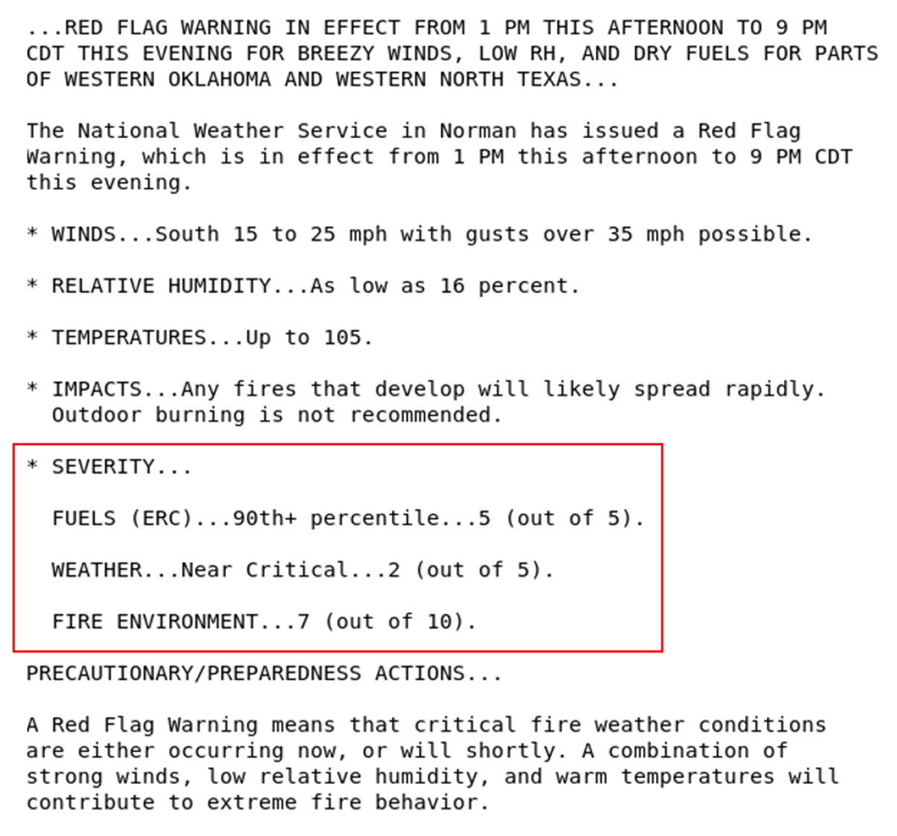
Next, we would like to discuss a spot forecast. As with the other example, you can see the deterministic information you would normally see, but the text in red font gives you an idea of what probabilistic information might look like in a spot forecast.

  - Based on the information you see here, what is your first impression of the added information?
    - How useful do you think probabilistic exceedance information on different weather parameters and thresholds is in a spot forecast?
      - Do you think a particular part or parts is more useful than others? Probe: Which parts? Why are some parts more useful than others?
    - What value, if any, does this probabilistic information provide above and beyond the standard deterministic product?
    - Do you think you would utilize this information to make operational decisions?
      - How would you use it to make operational decisions?
    - Do you think there should be more probabilistic information added to this spot forecast—something else that might help in your decision making? Is yes, what else could or should be added?
    - If so, how would you utilize this information to make operational decisions?

Spot Forecast

549
FNUS74 KOUN 131152
FWSOUN

Spot Forecast for Shaw Fire...USFS
National Weather Service Norman OK
652 AM CDT Fri Apr 13 2018

Forecast is based on request time of 0700 CDT on April 13.
If conditions become unrepresentative...contact the National Weather
Service.

Please contact our office at (405) 325-3816 if you have questions
or concerns with this forecast.

...RED FLAG WARNING IN EFFECT FROM 10 AM THIS MORNING TO 10 PM
CDT THIS EVENING...
...WIND ADVISORY IN EFFECT FROM 10 AM THIS MORNING TO 7 PM CDT
THIS EVENING...
...WIND ADVISORY IN EFFECT FROM 3 AM TO 8 PM CDT SATURDAY...

.DISCUSSION...
Cloud cover this morning is expected to decrease by mid to late morning. Very dry air will move into northwestern Oklahoma through the mid morning with a 42% chance of relative humidity dropping below 10%. A northwesterly wind shift is expected this afternoon across northwestern Oklahoma. The most likely arrival of the wind shift at the Shaw Fire will be at 4 PM with the earliest arrival at 1 PM. Gusty northwest winds are expected behind the front (probability of gusts > 35 mph is 46%) along with cooler temperatures and somewhat higher humidity. A strong northwest wind will continue tonight into Saturday.

.TODAY...

Sky/weather..................Sunny (20-30 percent).
Prob of any lightning........0%.
Max temperature..............Around 72.
Prob max temp >85F...........5%.
Prob max temp anom >+10F.....23%.
Min humidity.................13%.
Prob min humid <10%..........42%.
Wind (20 ft)........Breezy. Southwest winds 16 to 24 mph with gusts
to around 31 mph, becoming northwest 24 to 26
mph with gusts to around 33 mph in the afternoon.
Prob wind (20 ft) >20 mph....85%.
Prob gust (20 ft) >35 mph....46%.
Prob gust (20 ft) >50 mph....3%.
Prob of wind shift >30 deg...96%.
Mixing height.......300-1400 ft AGL, increasing to 4800-5900 ft
AGL.
Prob mix height >5000 ft.....87%.
Transport winds.....Southwest 16 to 24 mph, becoming northwest 24
to 26 mph in the late morning and afternoon.
Smoke dispersal.....Poor to good (4200-49300 knot-ft), increasing
to excellent (92400 knot-ft) early in the
morning, then increasing to excellent (164700
knot-ft) in the late morning and early
afternoon, decreasing to excellent (134300
knot-ft) late.

TIME (CDT) 7 AM 9 AM 11 AM 1 PM 3 PM 5 PM
Sky (%).........4 4 8 31 31 42
Weather cov.....
Weather type....NONE NONE NONE NONE NONE NONE
Tstm cov........
Temp............63 68 70 71 69 63
RH..............38 20 15 13 20 27
Prob RH <10%....0 18 38 42 18 10
20 ft wind......SW 17 SW 24 SW 26 W 24 W 25 NW 26
Prob 20 ft wind
> 20 mph........44 77 81 77 78 81
20 ft wind gust.22 31 33 33 33 33
Prob 20 ft wind
Gust > 35 mph...15 36 43 44 43 45
Prob 20 ft wind
Gust > 50 mph...0 0 0 2 2 3
Mix hgt (ft)....1400 3500 5100 5900 5400 4800
Prob mix hgt (ft)
> 5000 ft.......0 15 62 87 79 45
Transport wind..SW 12 SW 36 SW 40 SW 40 W 35 W 24
VRate ktft/1000.49 132 190 204 175 134

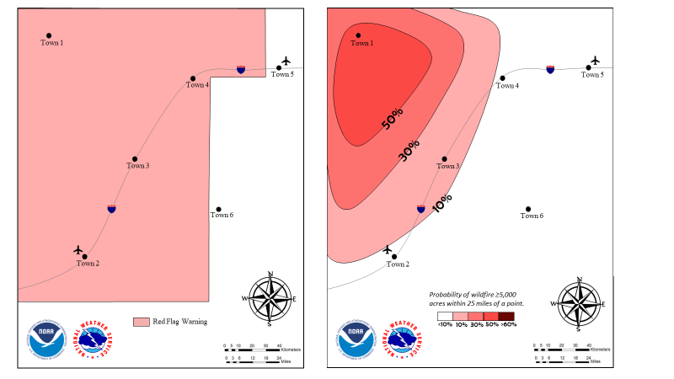
Next, we have a probabilistic fire weather forecast. In this example, we show a typical red flag warning first. The image on the right shows more probabilistic detail. Below the images is a table with some information about the region.

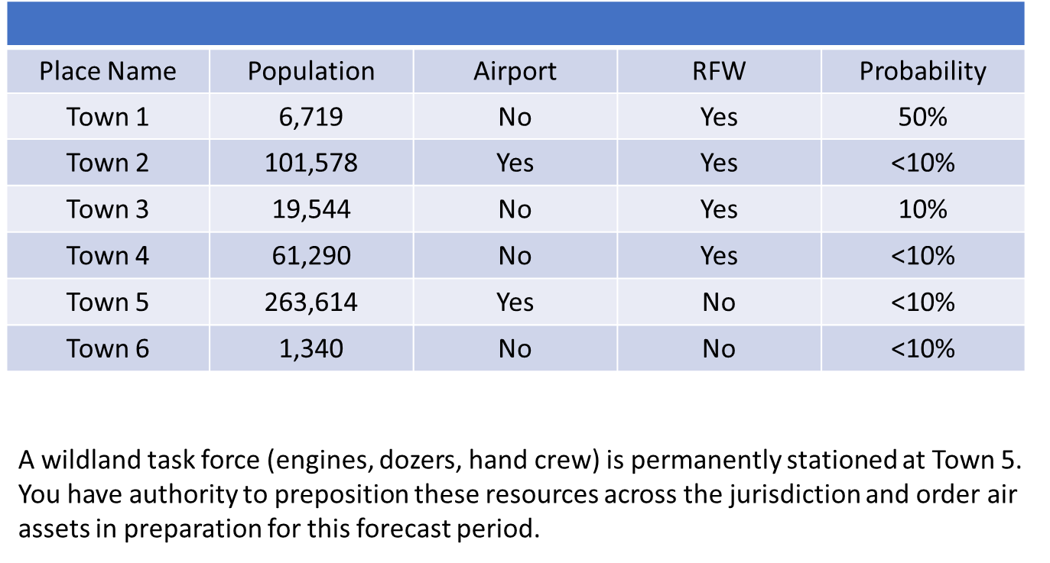
  - Based on the information you see here, what is your first impression of the added information?
    - How useful do you think probabilistic information on different fire weather parameters and thresholds is in the image on the right?
      - Do you think a particular part or parts is more useful than others? Probe: Which parts? Why are some parts more useful than others?
    - What value, if any, does this probabilistic information provide above and beyond the standard deterministic product?
    - Do you think you would utilize this information to make operational decisions?
      - How would you use it to make operational decisions?
    - Do you think there should be more probabilistic information added to the second image—something else that might help in your decision making? Is yes, what else could or should be added?
    - If so, how would you utilize this information to make operational decisions?
    - Let’s focus on Town 1, I would like to know a little more about how and where you would preposition resources based on the information in the image and the table.
      - How about Town 5, how would your planning and decision-making change if Town 5 had a greater probability of wildfire?
    - What else do you think is important to understand about your decision-making based on the information presented here?

- Future of Probabilistic Information

  - We have discussed a few ways to integrate probabilistic information into fire weather forecasting. Can you think of any other tools, products, or services that could benefit from or be enhanced by this type of information? Probe: What tools, products, or services? How would this benefit or enhance them?
  - What kind of changes do you anticipate will occur in the coming years that will impact your decision-making process, your workflow, and the information or resources you need to make decisions?
    - In general, is there anything that you think you will need in the future for wildland fire mitigation, management, or response that you do not have now? Probe: What do you think you will need? Why do you think you will need it?
  - Do you foresee there being an increased need for probabilistic information moving forward? Why or why not? How do you foresee probabilistic information being used other than the ways we have discussed today?

- Final Thoughts
Thank you all for participating in this discussion. As you all know, the purpose of this group was to find out more about your roles and decision-making processes and how probabilistic information might be useful to you. Does anyone have any final thoughts or comments about anything we have discussed today?

Original

549
FNUS74 KOUN 131152
FWSOUN

Spot Forecast for Shaw Fire...USFS
National Weather Service Norman OK
652 AM CDT Fri Apr 13 2018

Forecast is based on request time of 0700 CDT on April 13.
If conditions become unrepresentative...contact the National Weather
Service.

Please contact our office at (405) 325-3816 if you have questions
or concerns with this forecast.

...RED FLAG WARNING IN EFFECT FROM 10 AM THIS MORNING TO 10 PM
CDT THIS EVENING...
...WIND ADVISORY IN EFFECT FROM 10 AM THIS MORNING TO 7 PM CDT
THIS EVENING...
...WIND ADVISORY IN EFFECT FROM 3 AM TO 8 PM CDT SATURDAY...

.DISCUSSION...
Cloud cover this morning is expected to decrease by mid to late morning. Very dry air across the Texas Panhandle will move into northwestern Oklahoma through the mid morning. By early to mid afternoon, a cold front will move across northwestern Oklahoma. Gusty northwest winds are expected behind the front along with cooler temperatures and somewhat higher humidity. A strong northwest wind will continue tonight into Saturday.

.TODAY...

Sky/weather.........Sunny (20-30 percent).
Max temperature.....Around 72.
Min humidity........13 percent.
Wind (20 ft)........Breezy. Southwest winds 16 to 24 mph with gusts
to around 31 mph, becoming northwest 24 to 26
mph with gusts to around 33 mph in the late
morning and afternoon.
Mixing height.......300-1400 ft AGL, increasing to 4800-5900 ft
AGL.
Transport winds.....Southwest 16 to 24 mph, becoming northwest 24
to 26 mph in the late morning and afternoon.
Smoke dispersal.....Poor to good (4200-49300 knot-ft), increasing
to excellent (92400 knot-ft) early in the
morning, then increasing to excellent (164700
knot-ft) in the late morning and early
afternoon, decreasing to excellent (134300
knot-ft) late.

TIME (CDT) 7 AM 9 AM 11 AM 1 PM 3 PM 5 PM
Sky (%).........4 4 8 31 31 42
Weather cov.....
Weather type....NONE NONE NONE NONE NONE NONE
Tstm cov........
Temp............63 68 70 71 69 63
RH..............38 20 15 13 20 27
20 ft wind......SW 17 SW 24 SW 26 W 24 W 25 NW 26
20 ft wind gust.22 31 33 33 33 33
Mix hgt (ft)....1400 3500 5100 5900 5400 4800
Transport wind..SW 12 SW 36 SW 40 SW 40 W 35 W 24
VRate ktft/1000.49 132 190 204 175 134

