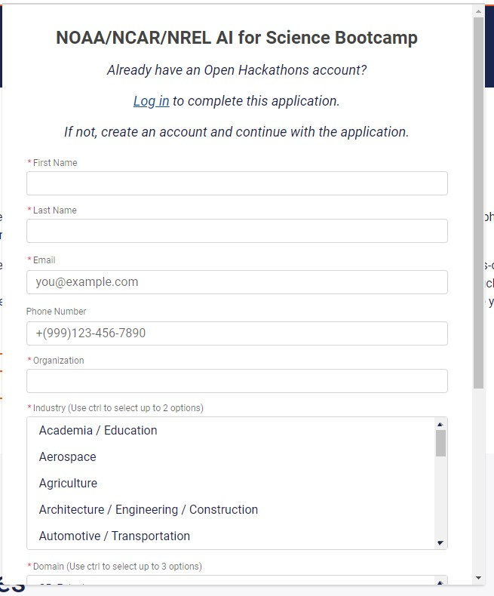

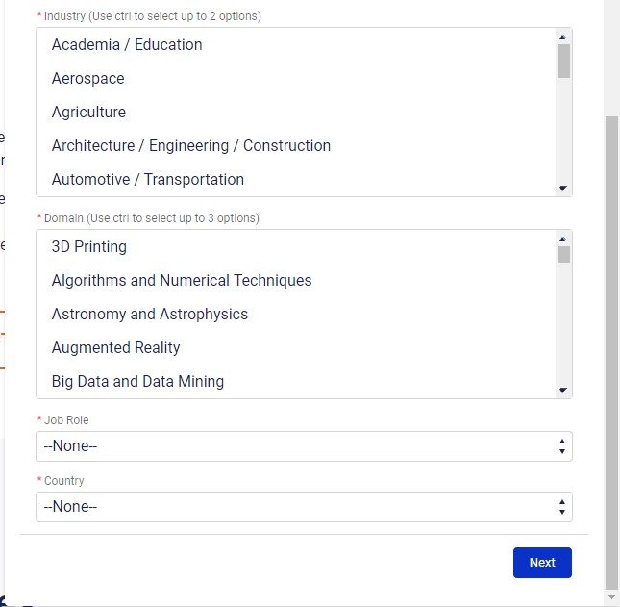

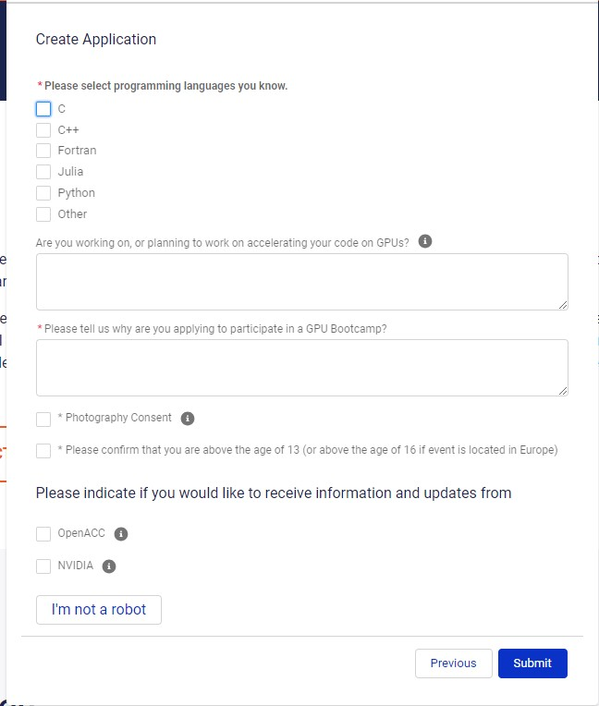

**Privacy Act Statement**

**Authority:** The collection of this information is authorized under 5 U.S.C. § 301, Departmental regulations which authorizes the operations of an executive agency, including the creation, custodianship, maintenance and distribution of records, and 15 U.S.C. 1512, Powers and duties of Department.

**Purpose:** NOAA collects limited information, such as name, address, phone number, or email address for a variety of purposes. This information will be used to respond to user inquiries or provide services requested by the user or for registration to a NOAA program or event.

**Routine Uses:**  Disclosure of this information is permitted under the Privacy Act of 1974 (5 U.S.C. Section 552a**)** to be shared among Department staff for work-related purposes. Disclosure of this information is also subject to all of the published routine uses as identified in the Privacy Act System of Records Notice COMMERCE/NOAA-11, Contact Information for Members of the Public Requesting or Providing Information Related to NOAA’s Mission, and [COMMERCE/DEPT-23](https://www.osec.doc.gov/opog/PrivacyAct/SORNs/dept-23.html), Information Collected Electronically in Connection with Department of Commerce Activities, Events, and Programs.

**Disclosure:**  Furnishing this information is voluntary. Failure to provide this information may prevent you from being registered for a NOAA program or event. By providing this information, you are consenting to the use of that information only for the purpose for which it is submitted.

**PRA Burden Statement**

A Federal agency may not conduct or sponsor, and a person is not required to respond to, nor shall a person be subject to a penalty for failure to comply with an information collection subject to the requirements of the Paperwork Reduction Act of 1995 unless the information collection has a currently valid OMB Control Number. The approved OMB Control Number for this information collection is 0690-0038. Without this approval, we could not conduct this collection of information. Public reporting for this information collection is estimated to be approximately 10 minutes per response, including the time for reviewing instructions, searching existing data sources, gathering and maintaining the data needed, and completing and reviewing the information collection. All responses to this information collection are voluntary. Send comments regarding this burden estimate or any other aspect of this information collection, including suggestions for reducing this burden to the Dymon Davis, dymon.davis@noaa.gov.