Draft of email to NIST WiSTEM community for survey

Email Title: NIST WiSTEM Survey

Hi WiSTEM Community,

The NIST WiSTEM Board has put together a survey to learn about the interests of the NIST WiSTEM members. The survey results will also assist us in the planning and scheduling of future WiSTEM sponsored events. If you have any questions or comments about the survey, please reach out to the WiSTEM president Greta Babakhanova at greta.babakhanova@nist.gov

Please click to go to the Google form to complete the survey. Survey submissions will close on date (Month/Day). Your participation in the survey is optional, anonymous, will only take a short amount of time, and is greatly appreciated by the NIST WiSTEM Board.
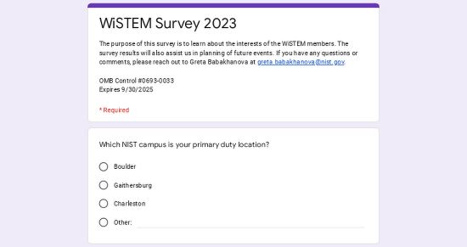 | WiSTEM Survey 2023  The purpose of this survey is to learn about the interests of the WiSTEM members. The survey results will also assist us in planning of future events. If you have any questions or comments, please reach out to Greta Babakhanova at greta.babakhanova@nist.gov. OMB Control #0693-0033 Expires 9/30/2025  docs.google.com

Thank you,
NIST WiSTEM Board

Draft of email to NIST WiSTEM community as survey reminder
Email Title: NIST WiSTEM Survey Reminder

Hi WiSTEM Community,

The NIST WiSTEM survey will close for submission on date (Month/Day). Please consider taking a short amount of time to complete this survey by clicking to go to the Google form.
WiSTEM Survey 2023
The purpose of this survey is to learn about the interests of the WiSTEM members. The survey results will also assist us in planning of future events. If you have any questions or comments, please reach out to Greta Babakhanova at greta.babakhanova@nist.gov. OMB Control #0693-0033 Expires 9/30/2025
docs.google.com

Thank you,
NIST WiSTEM Board

