Title: Questionnaire Exploring Perceptions of Artificial Intelligence
Version: 1. Jian, Control

OMB Control #0693-0043
Expiration Date: 06/30/2025
NIST Generic Clearance for Usability Data Collections

A Federal agency may not conduct or sponsor, and a person is not required to respond to, nor shall a person be subject to a penalty for failure to comply with an information collection subject to the requirements of the Paperwork Reduction Act of 1995 unless the information collection has a currently valid OMB Control Number. The approved OMB Control Number for this information collection is 0693-0043. Without this approval, we could not conduct this survey/information collection. Public reporting for this information collection is estimated to be approximately 30 minutes per response, including the time for reviewing instructions, searching existing data sources, gathering and maintaining the data needed, and completing and reviewing the information collection. All responses to this information collection are voluntary. Send comments regarding this burden estimate or any other aspect of this information collection, including suggestions for reducing this burden to the National Institute of Standards and Technology at: 100 Bureau Drive, Gaithersburg, MD 20899, Attn: Theodore Jensen, theodore.jensen@nist.gov.

Screen 1 - Landing Page:

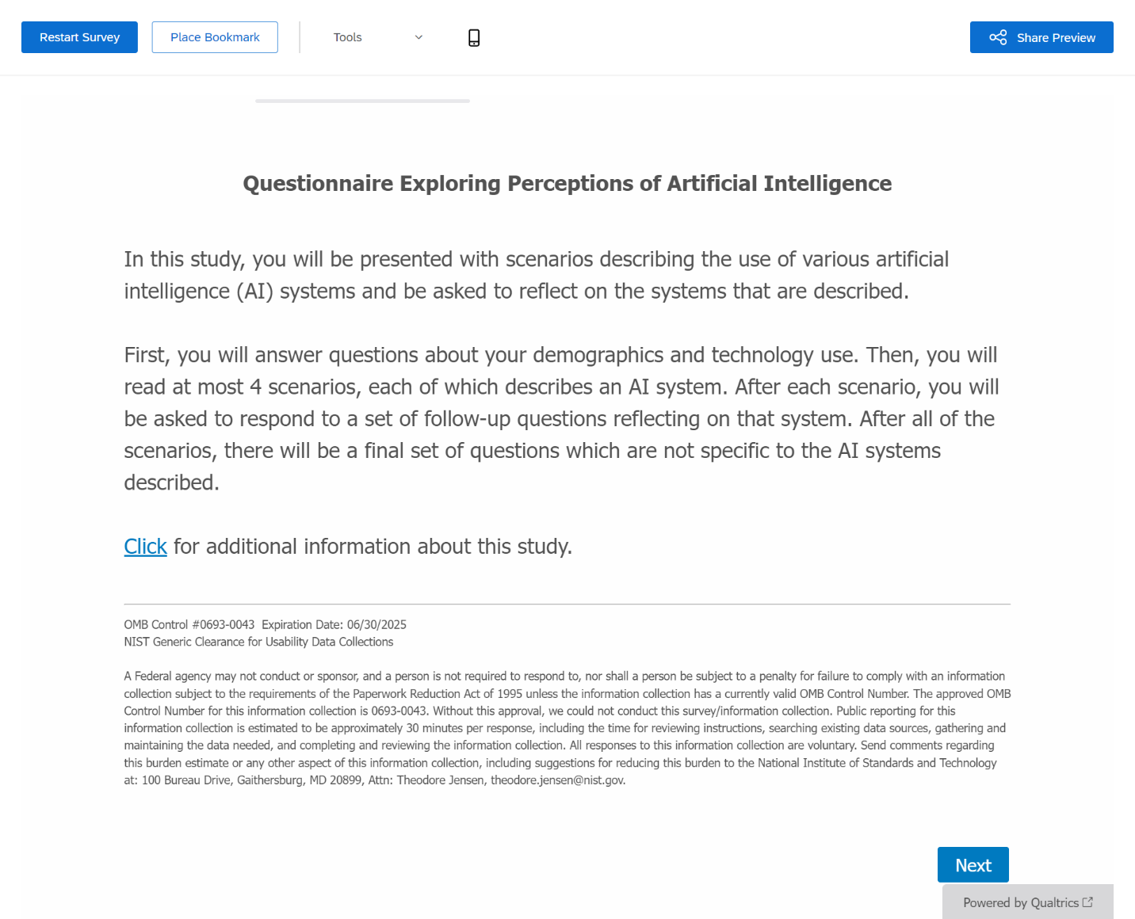
Screen 2 – Demographics & Tech Use:
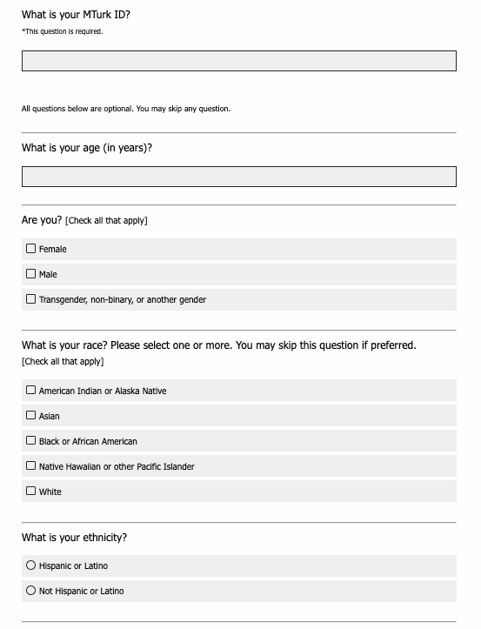

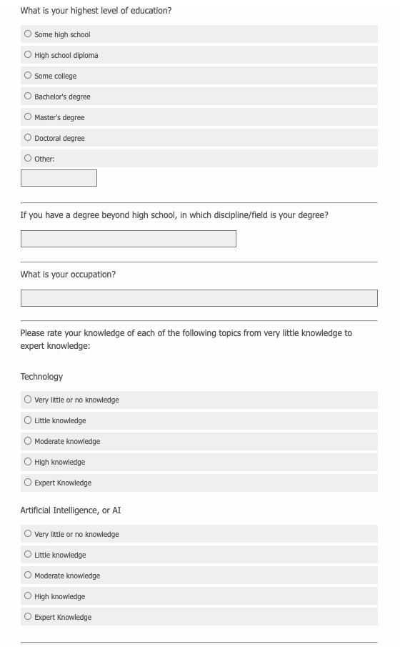
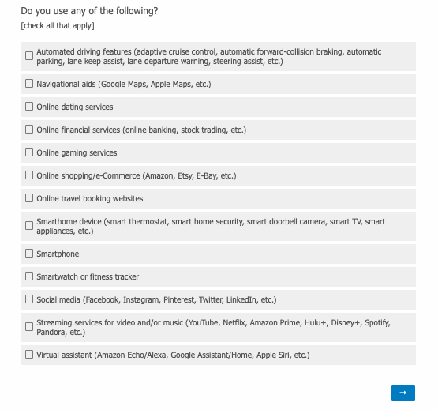

Respondents will be randomly assigned to one of 6 versions of the questionnaire (this version highlighted below):

- Jian, Control
- Jian, Low
- Jian, High
- Malle, Control
- Malle, Low
- Malle, High

Versions differ in terms of the first scale shown for each scenario (Screens 4, 5, 7, 8) as well as the accuracy information given in Hypothetical Use scenarios (Screens 4, 5).
Screen 3 – Hypothetical Use Intro:

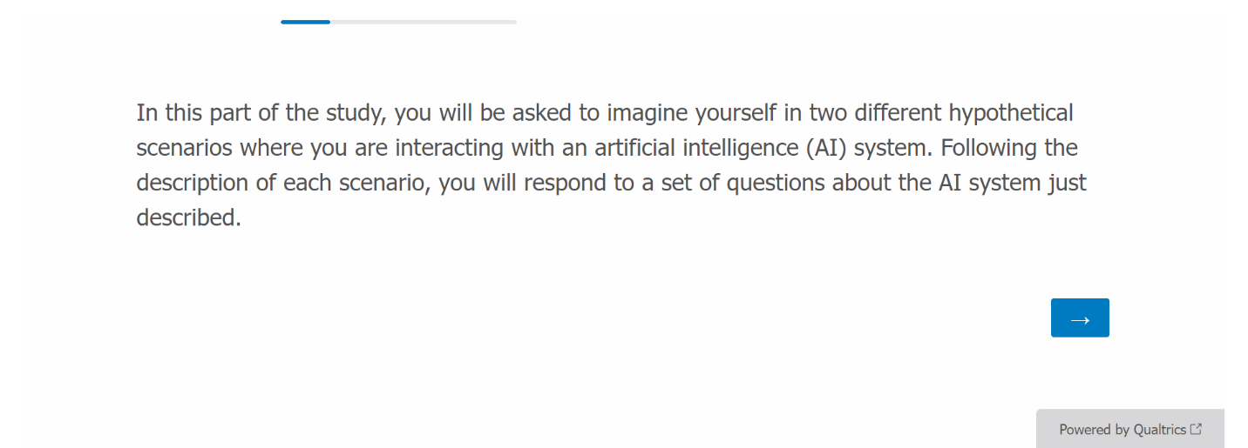

Screen 4 – Hypothetical Use Scenario #1 - Loan:

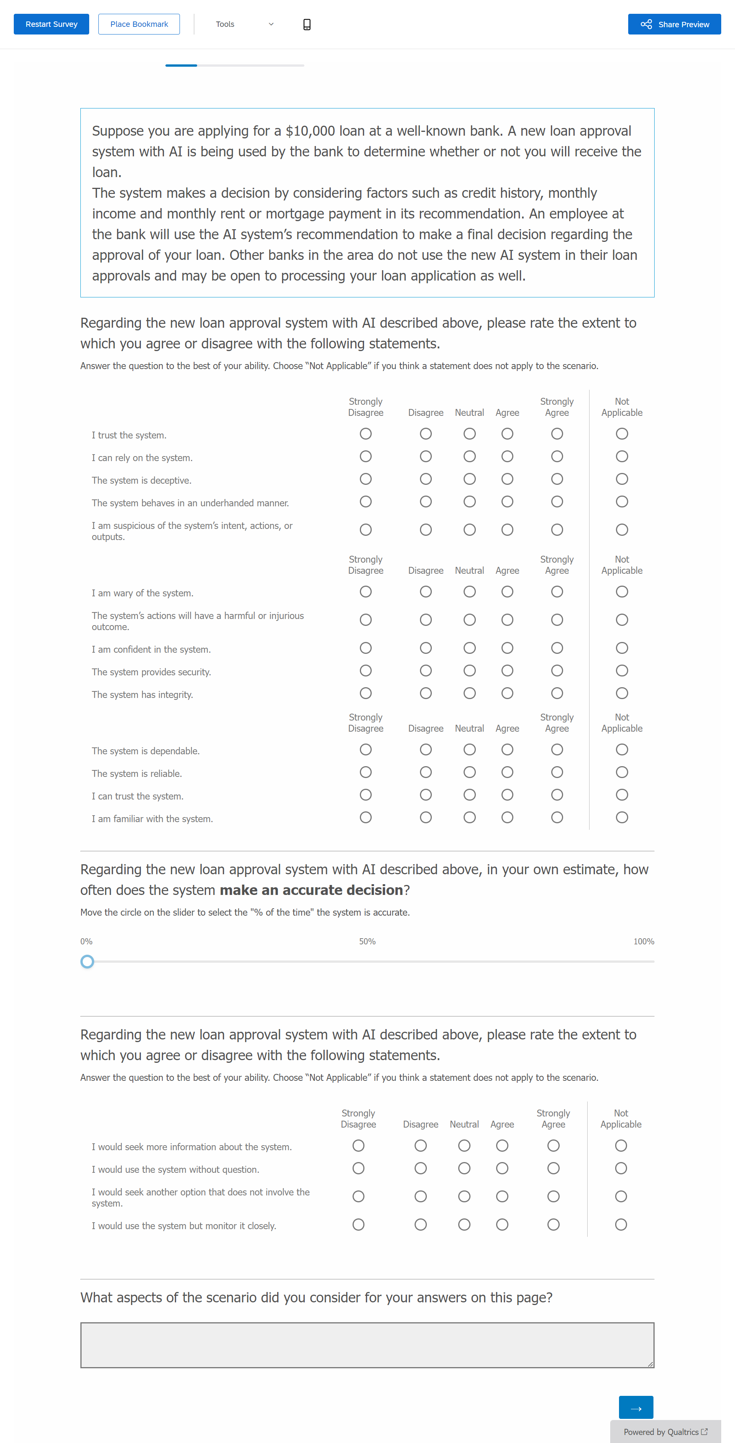
Screen 5 – Hypothetical Use Scenario #2 – Self-Driving Car:

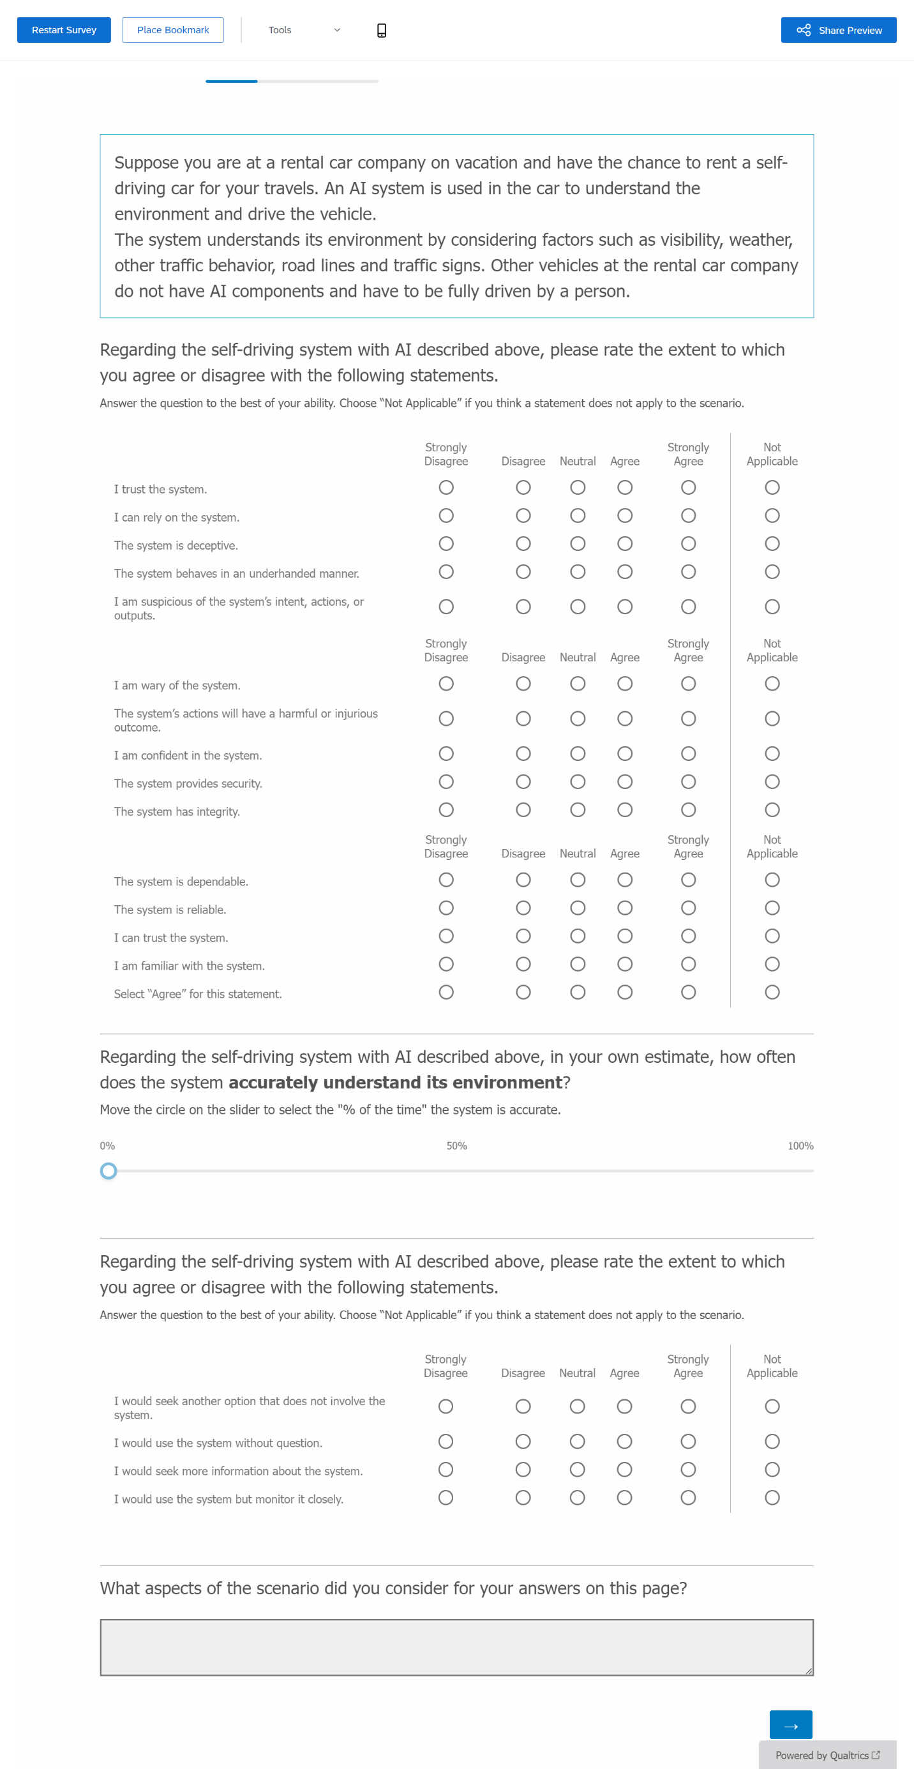
Screen 6 – Personal Use Intro:
[only show this screen if “Navigational aids” and/or “Social media” is checked in Screen 2; worded differently if one (“an artificial intelligence (AI) system”) or two (“two artificial intelligence (AI) systems”) of the options were selected on Screen 2, with the latter shown below]

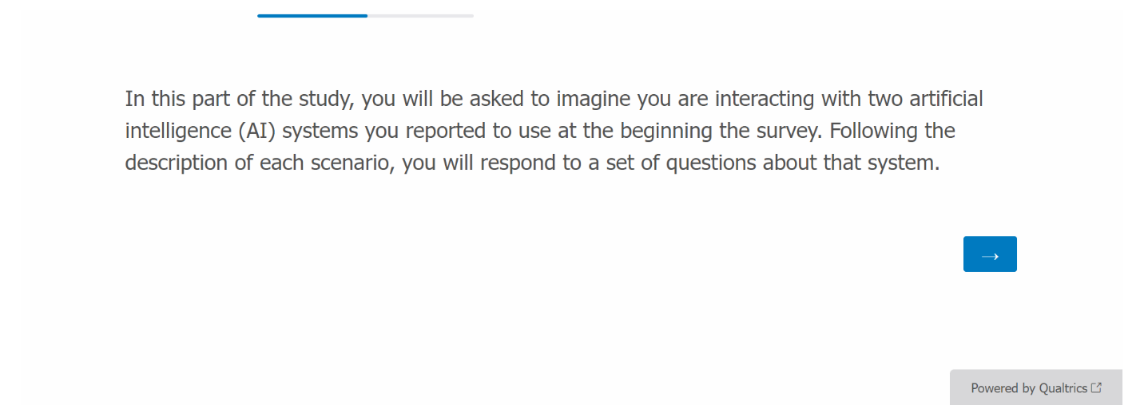
Screen 7 – Personal Use Scenario #1 – Navigational Aid:
[only show this screen if “Navigational aids” is checked in Screen 2]

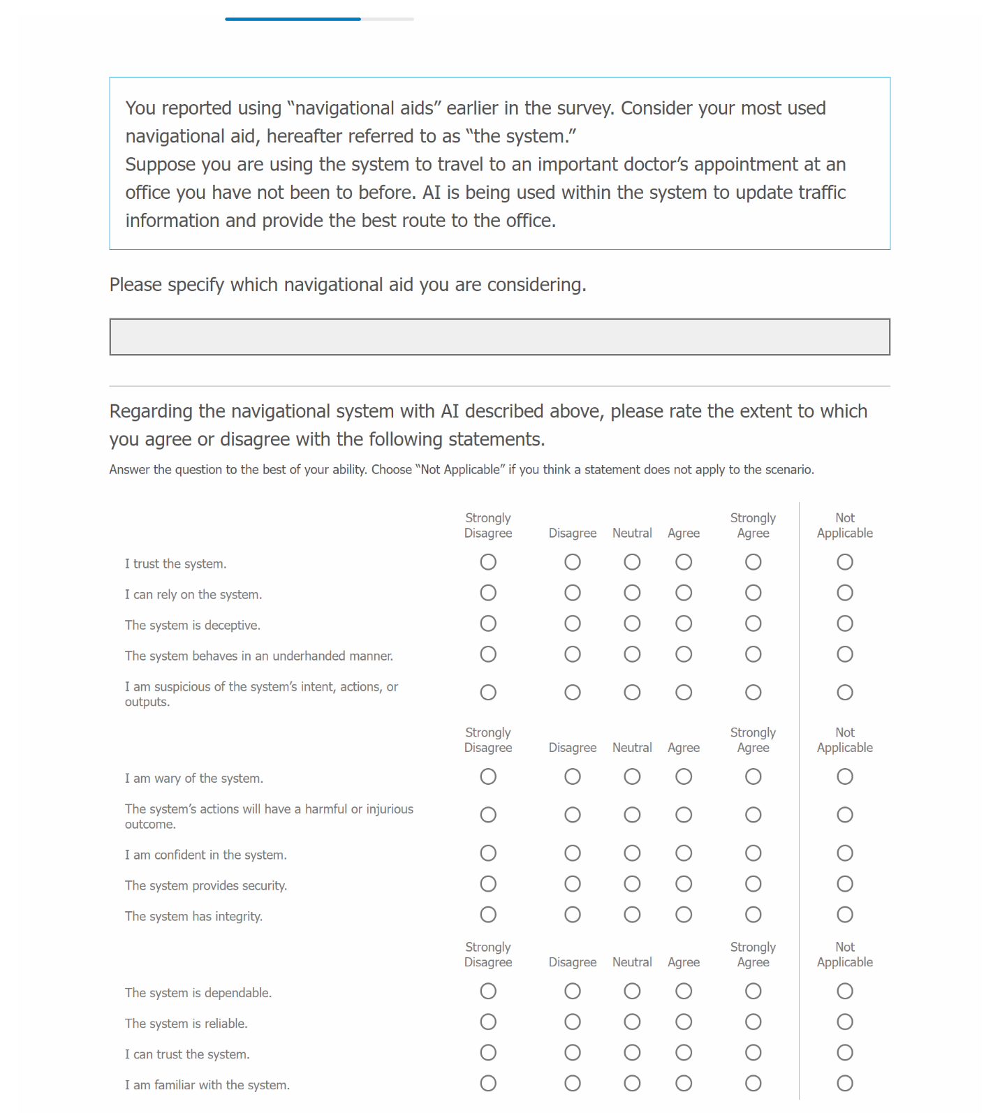
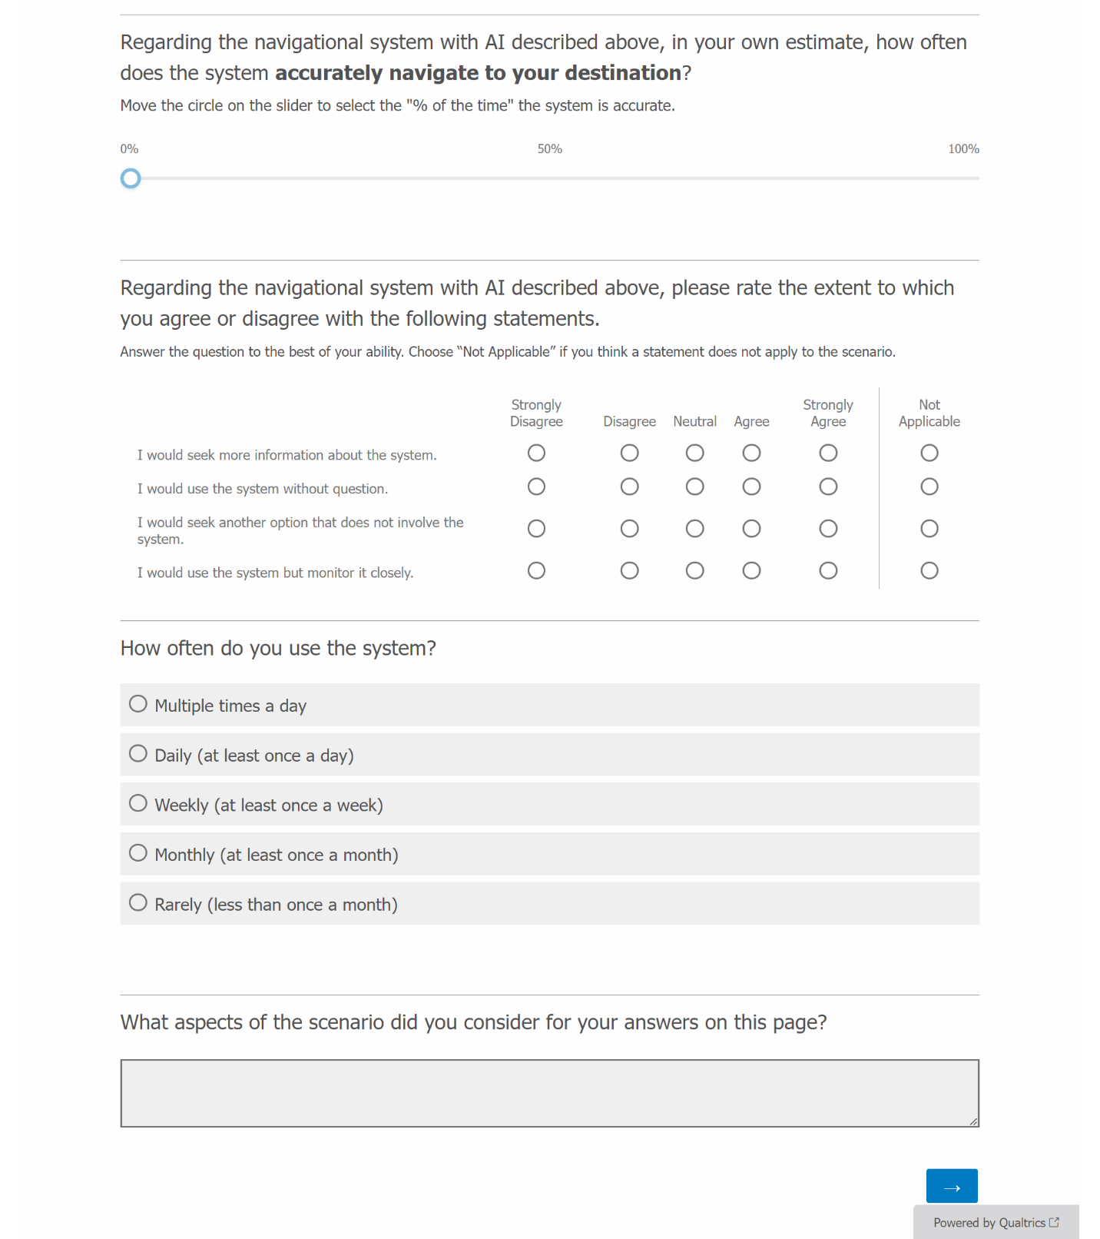

Screen 8 – Personal Use Scenario #2 – Social Media:
[only show this screen if “Social media” is checked in Screen 2]

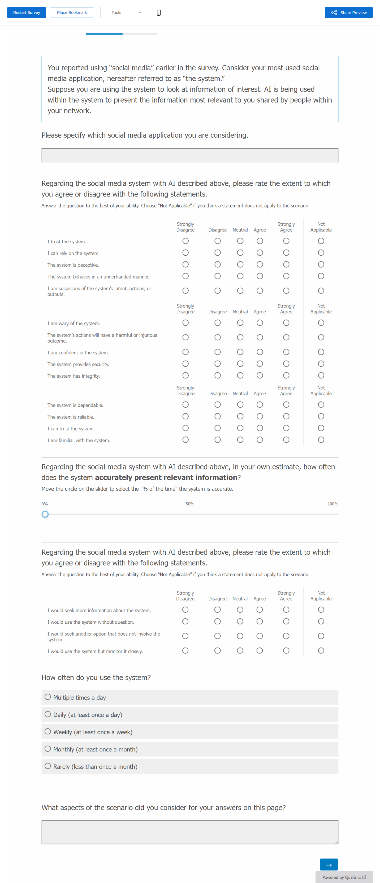
Screen 9 – Perceived Risk:
[“Loan application” and “Self-driving car” appear for all respondents; only show “Navigational aid” and/or “Social media” if checked in Screen 2]

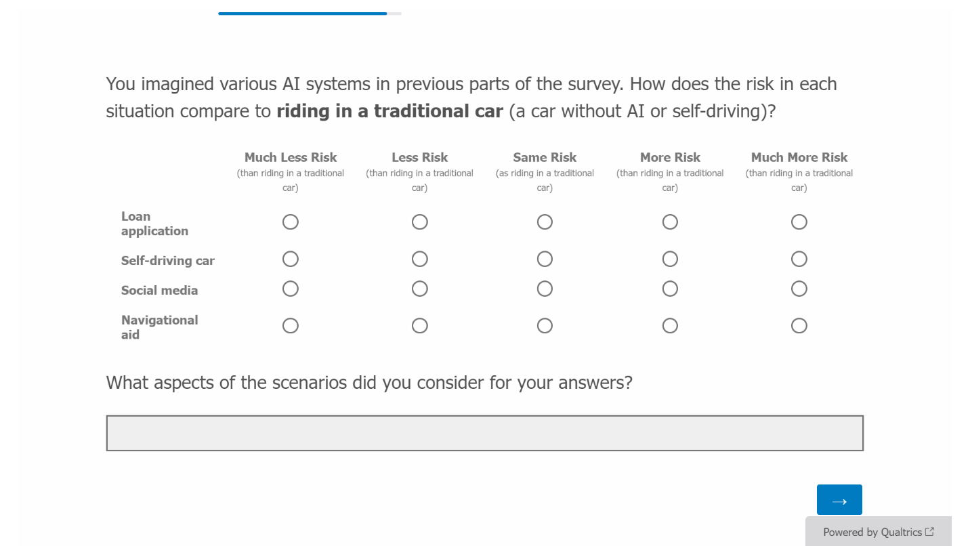

Screen 10 – AICP-R:

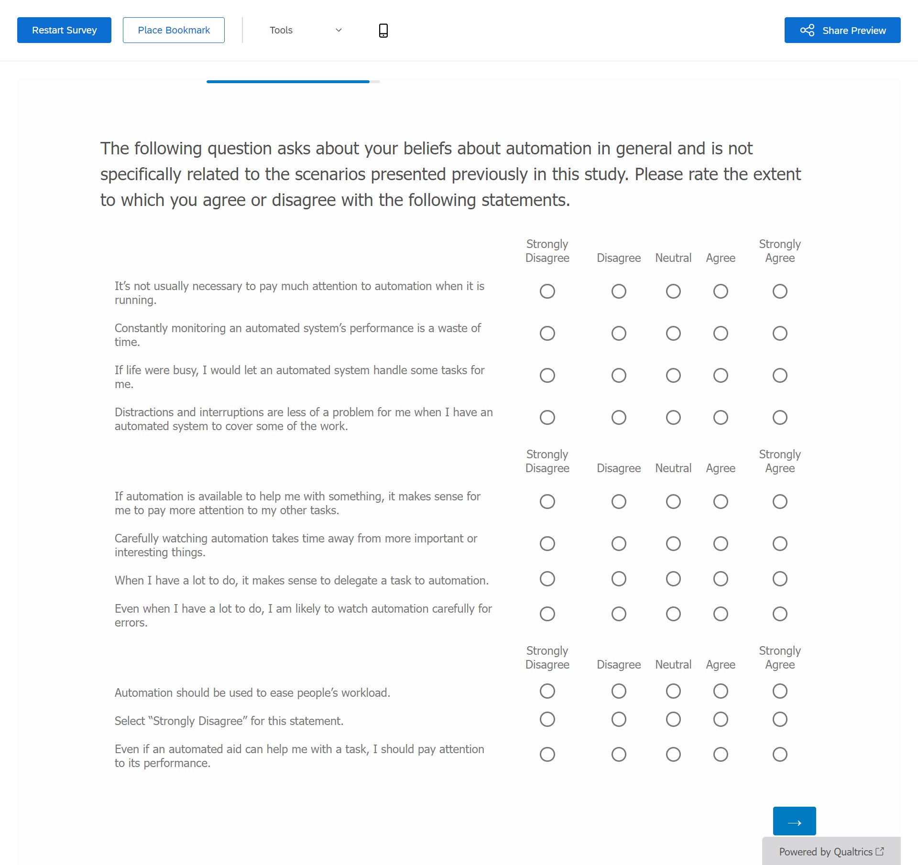

Screen 11 – Final Comments:

[Randomly-generated 10-digit code will be used by Contractor to verify survey completion before compensating; example shown below]
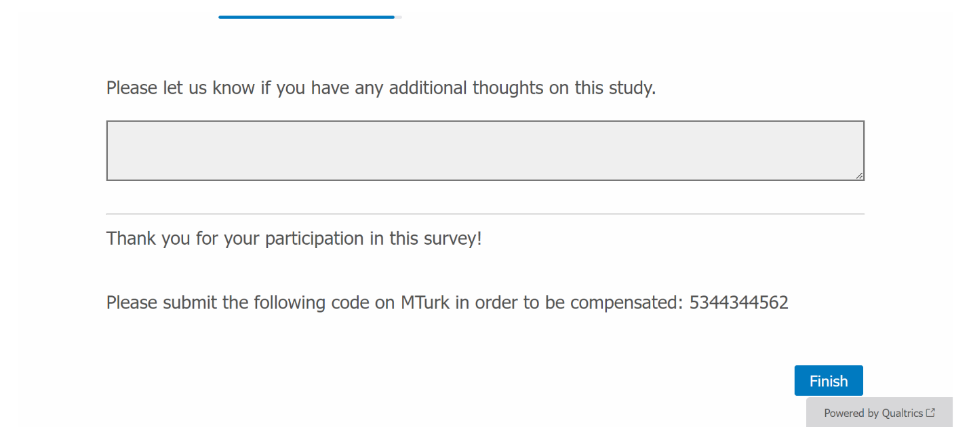
Screen 12 – Thank You Message:

