**AFROTC Application Flow**

Application data is collected from potential ROTC cadets (high school level, enlisted airmen, and college students) using an online application accessed on a web capable device.  The applicant completes an email verification process, enters contact information, and answers questions to confirm eligibility for the program.  If the applicant is not eligible, a notification of ineligibility appears, and the application is closed.  If the applicant is eligible, the entirety of the application is then available for completion. There are two paths to this application. The applicant can apply for AFROTC (with no scholarship) or apply for AFROTC through the High School Scholarship Program (HSSP). Both paths are applying for the AFROTC Program. Each path has their own checklists to work throughout the application process, as the HSSP applicant must complete additional Sections/Questions.  The applicant is notified via email regarding the receipt of a started application and given reminders of any required information that has not been submitted.  Once the applicant submits all required information and the application is reviewed by ROTC Headquarters personnel, a notification is sent to the applicant via email regarding eligibility for the ROTC Program and the High School Scholarship Program, if applicable.

APPLY FOR AFROTC

From the WINGS home page, click on “Apply for AFROTC”. The applicant is directed to the application either be a recruiter, detachment personnel, or through a search engine.

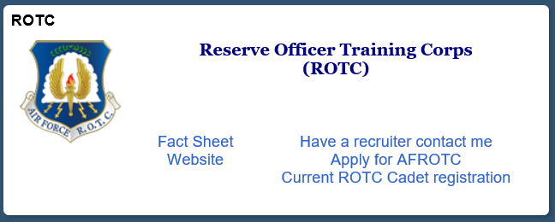

STATEMENTS AND DISCLOSURES

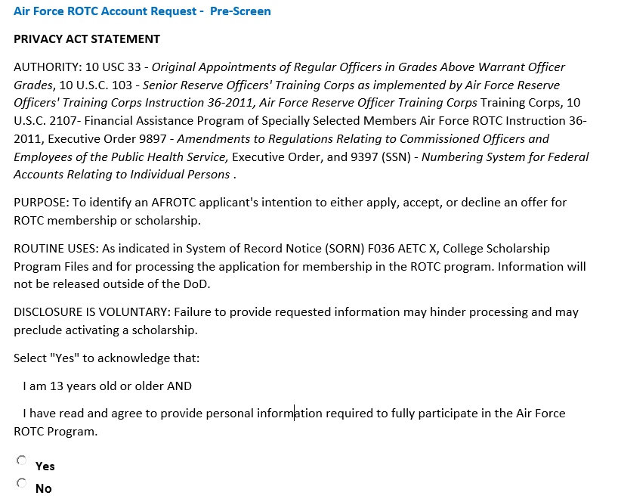

OMB CONTROL NUMBER: 0701-0105

OMB EXPIRATION DATE: XX-XX-XXXX

AGENCY DISCLOSURE NOTICE

The public reporting burden for this collection of information, 0701-0105, is estimated to average 180 minutes per

response, including the time for reviewing instructions, searching existing data sources, gathering and maintaining

the data needed, and completing and reviewing the collection of information. Send comments regarding the burden

estimate or burden reduction suggestion to the Department of Defense, Washington Headquarters Services, at

whs.mc-alex.esd.mbx.dd-dod-information-collections@mail.mil. Respondents should be aware that notwithstanding

any other provision of law, no person shall be subject to any penalty for failing to comply with a collection of

information if it does not display a currently valid OMB control number.





If the Applicant Selected “No” and clicked SUBMIT, the following message would appear on the screen:

Prescreen Failed: You have not agreed to provide personal information required to become an Air Force ROTC Cadet

If the Applicant Selected "Yes” and clicked SUBMIT, then the applicant would be allowed to proceed to create an account.

Enter information to create an account for data collection:

Email verification

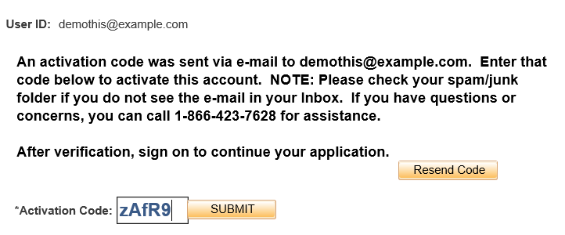

Account activated (and roles granted to begin ROTC Application)



PROFILE

The Applicant will start entering data which will build their Profile in WINGS.

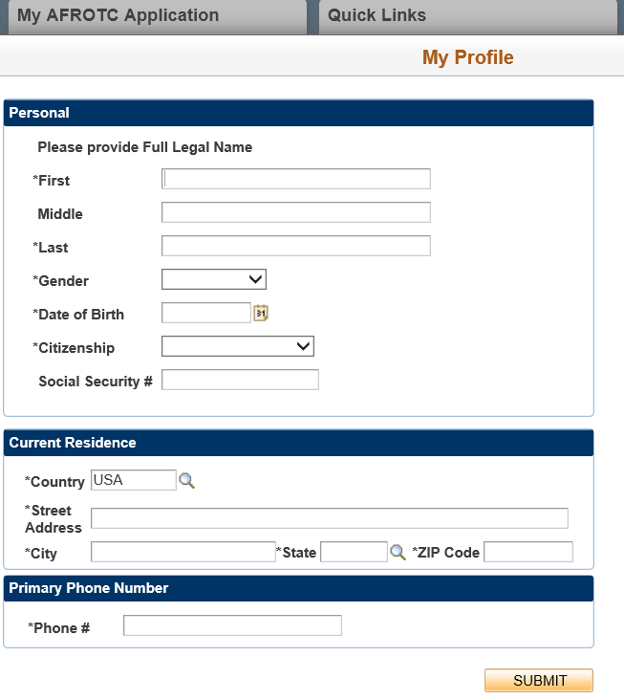

CITIZENSHIP

If applicant selects Non-US, the following will appear for them to complete

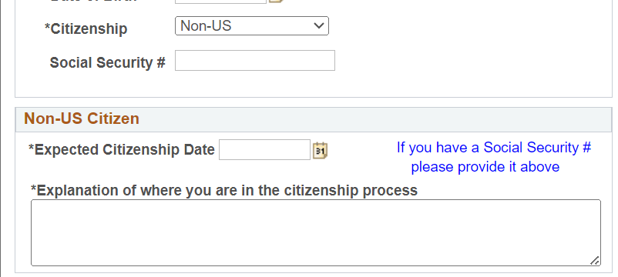

VERIFICATION

The Applicant needs to re-enter key information to verify it matches the previous screen:

LOG IN

On next login, the applicant sees this:

DISCLOSURES

Applicant would click on the My AFROTC Application Tile to begin their application.

CHECKLIST (INITIAL)

Initial checklist before they select Apply for ROTC (same as “No” don’t join AFROTC for students just taking a class)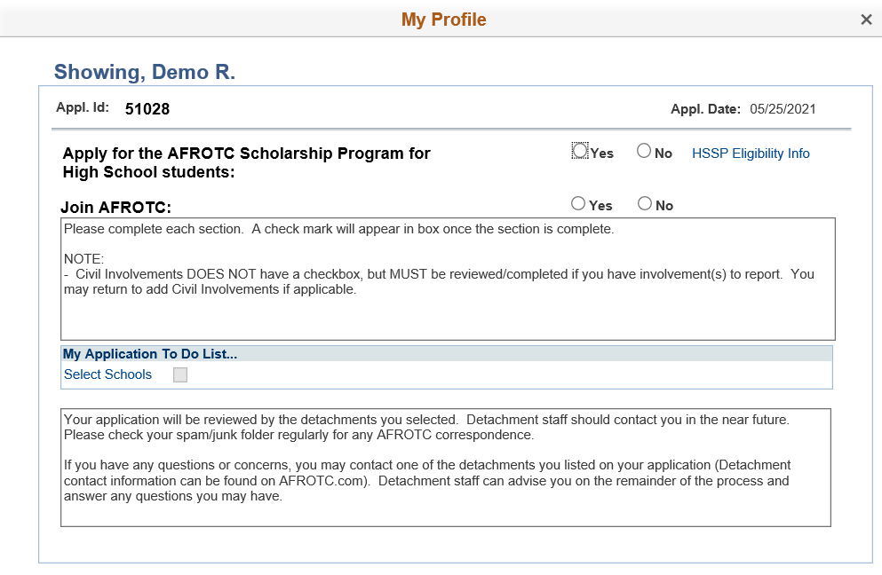

**CHECKLIST (APPLY FOR AFROTC ONLY)**

Selecting High School Scholarship “No” and Join AFROTC “Yes”, the checklist would appear for them to start the application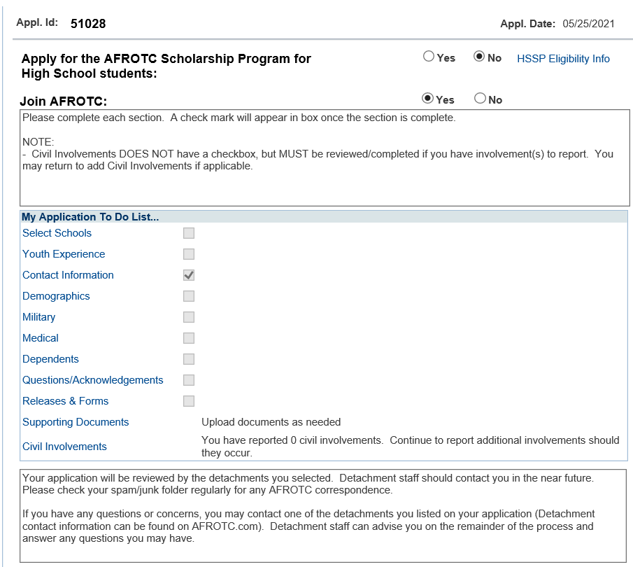

**All AFROTC Applicants (including HSSP applicants) will complete the following Sections/Questions**

**NOTE:**

For presentation purposes the HSSP applicant checklist and the remaining Sections/Questions will be presented after this portion. In real-time, the appropriate Checklist will appear for the applicant based on how they answer the questions in the Initial Checklist.

Select Schools

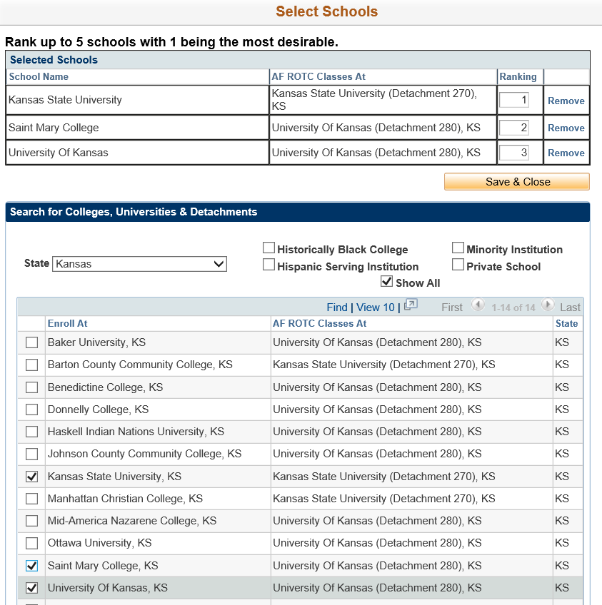

Youth Experience

Contact Information

Emergency Contact Information

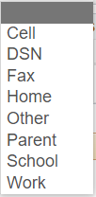

Demographics

Military

Medical

Dependents



DependentS

Questions & Acknowledgements (Acceptance)

Questions & Acknowledgements (prior service)

Questions & Acknowledgements (drug and alcohol)

Questions & Acknowledgements (RELEASES)

Questions & Acknowledgements (disciplinary / criminal history)

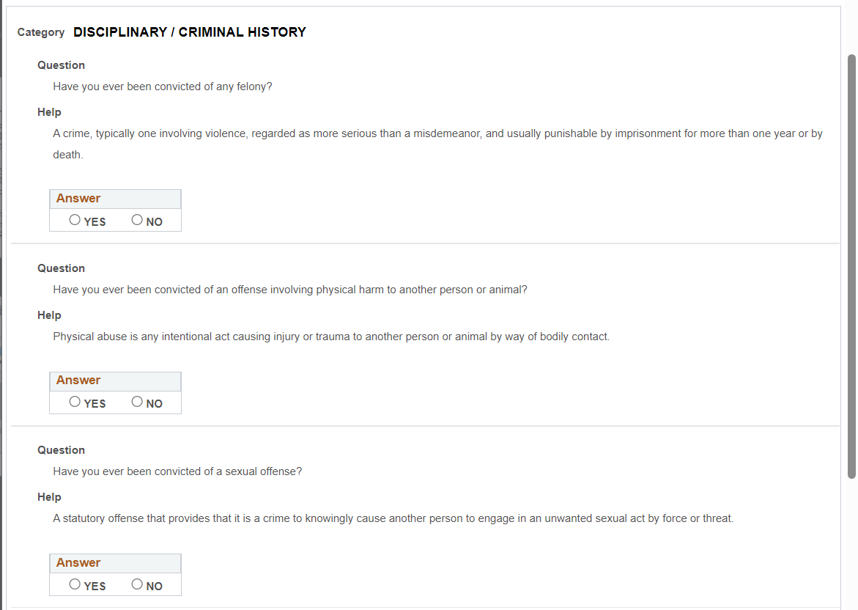

Releases & Forms

Supporting Documents

Civil Involvements

**End of Questions for AFROTC Applicants**

**Note:**

HSSP Applicants will need to complete additional Sections/Questions.

**All HSSP Applicants will complete the following Sections/Questions**

**NOTE:**

1. For presentation purposes the HSSP applicant checklist is being presented now. In real-time, the HSSP applicant would be presented after their Initial Checklist and it would include all the previous Sections/Questions, but in the order presented on the HSSP Checklist which is presented in this portion.
2. Some questions will be duplicative of questions that All AFROTC applicants answered in the previous Sections/Questions. The HSSP Applicants will be asked these questions as part of the HSSP Basic Eligibility at the beginning of their checklist. If the applicant is not disqualified for the Scholarship due to the answers, the duplicative questions will appear later in the Questions/Acknowledgements Section, but their answers will be pre-populated as they are already answered.

**CHECKLIST (APPLY FOR HIGH SCHOOL SCHOLARSHIP)**

Select Apply for ROTC High School Scholarship (HSSP), the checklist would appear for them to begin the

application

**HSSP Basic Eligibility (To be completed by HSSP Applicants Only)**

**HSSP Basic Eligibility (To be completed by HSSP Applicants Only)**

**HSSP Basic Eligibility (To be completed by HSSP Applicants Only)**

**HSSP Basic Eligibility (To be completed by HSSP Applicants Only)**

**HSSP Basic Eligibility (To be completed by HSSP Applicants Only)**

**HSSP Basic Eligibility (To be completed by HSSP Applicants Only)**

DISCLOSURE (Seen by HSSP Applicants Only)

MAJOR PREFERENCES (To be completed by HSSP Applicants Only)

Counselor Form/Transcript (To be completed by HSSP Applicants Only)

Counselor Form/Transcript (To be completed by HSSP Applicants Only)

Test Scores (To be completed by HSSP Applicants Only)

Test Scores (To be completed by HSSP Applicants Only)

Physical Fitness Assessment (To be completed by HSSP Applicants Only)

Activity Sheet (To be completed by HSSP Applicants Only)

Activity Sheet (To be completed by HSSP Applicants Only)

List of Countries presented when search icon is selected



Activity Sheet (To be completed by HSSP Applicants Only)

Fill in the blank

Activity Sheet (To be completed by HSSP Applicants Only)

Activity Sheet (To be completed by HSSP Applicants Only)



Scholarship Additional Info (To be completed by HSSP Applicants Only)

MESSAGE UPON COMPLETION OF APPLICATION

