Tab D: Marine Corps Safety Assessment Recruitment
IRB Approved at the Study Level
Dec 18, 2023
#39085059.0
Email text:
The Marine and Family Programs (MF) Division is conducting a survey on Marines’ awareness of current lethal means safety programs, preferences for safety devices and locations, and thoughts about the place of safety in Marine Corps culture. This survey is sponsored by the Defense Suicide Prevention Office (DSPO) and is being administered by CNA. DSPO and MF are interested in how lethal means safety outreach efforts are being implemented and whether or not these efforts are reaching Marines.
The survey will close on [DATE]. Participation is voluntary. If you are interested and available to participate, please click below to take the survey. The survey should take no more than 15 minutes. No names, contact information, or any other personally identifiable information will be collected in the survey.
[link]
Thank you for your time and consideration.
Social media posts: Date and link to be updated upon arrival
The Marine and Family Programs Division is conducting a survey on Marines’ awareness of current lethal means safety programs, preferences for safety devices and locations, and thoughts about the place of safety in Marine Corps culture.
If you are interested and available to participate, follow the link to take the survey.
[link]
The survey will close on [DATE]. Participation should take no more than 15 minutes. No names, contact information, or any other personally identifiable information will be collected in the survey.
Thank you for your time and consideration.
[One of the following images will accompany the social media post]
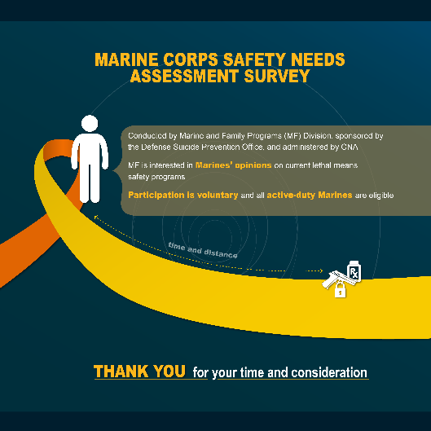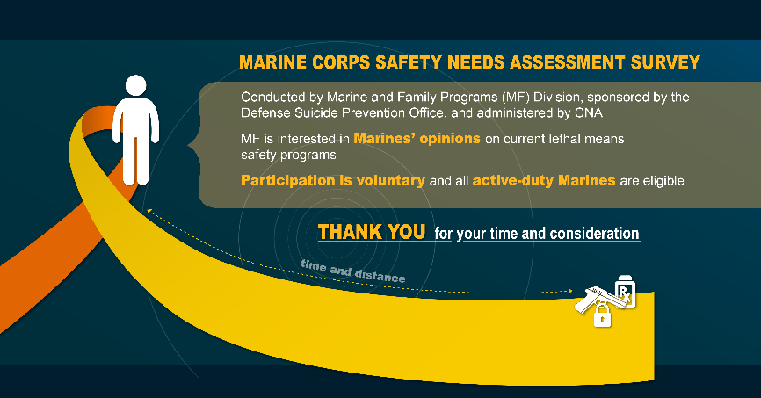

Poster recruitment: Date and QR code to be updated upon approval.