FIC, NCI D43 CareerTrac Screenshots

# Login Page / Landing Page

# Trainees Page

## Trainee Page, Create Trainee

# Personal Info Page

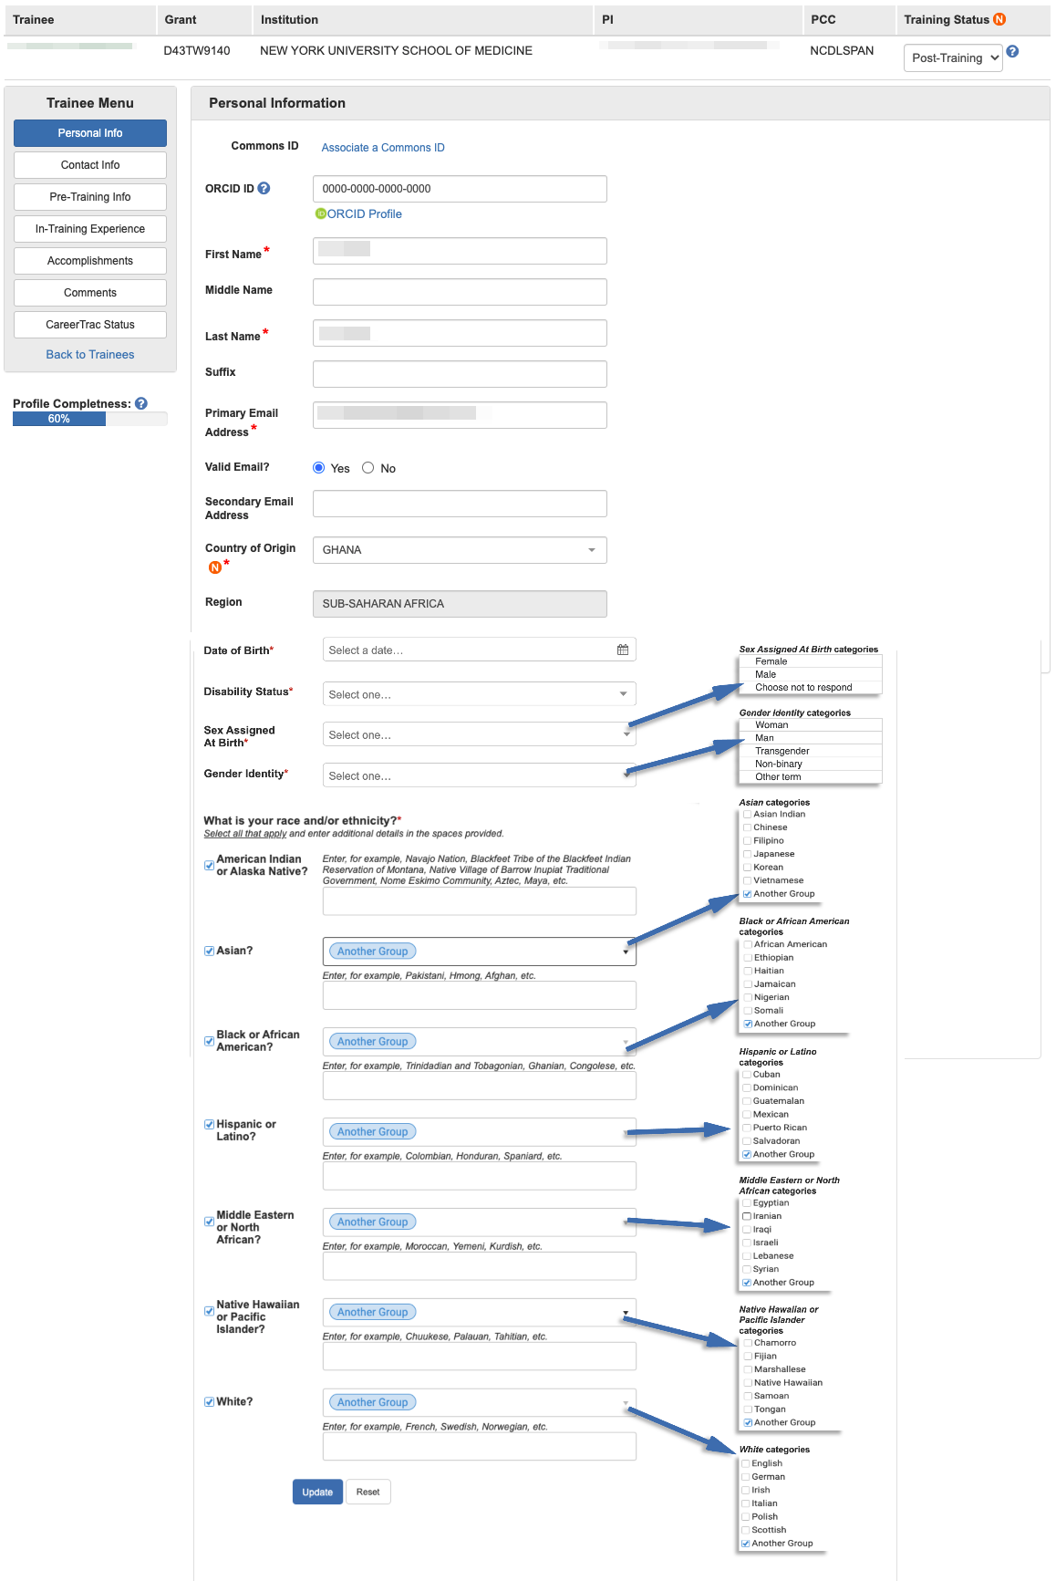

## Personal Info Page – Associate a Commons ID (Search)

## Personal Info Page – Associate a Commons ID (Review)

## Personal Info Page – Commons Trainee

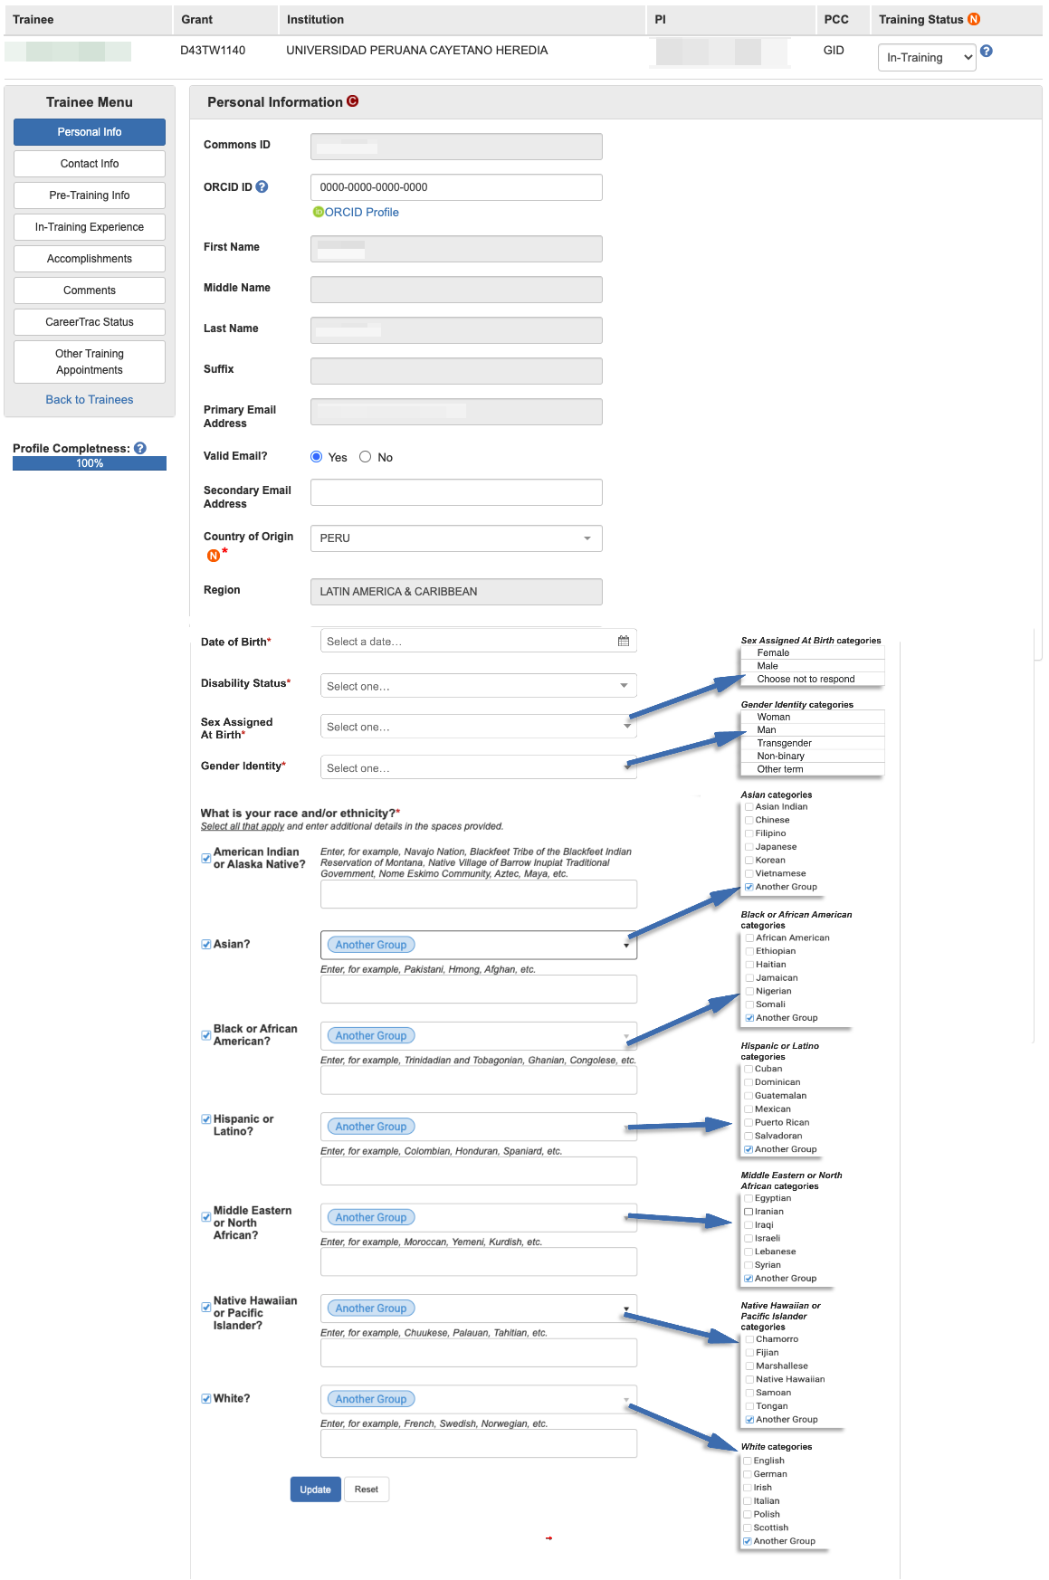

# Contact Info Page

## Contact Info Page – Commons Trainee

# Pre-Training Info

## Pre-Training Info – Create Prior Academic Degree, Search Results (Commons Trainee)

## Pre-Training Info – Create Prior Academic Degree, Import (Commons Trainee)

# In-Training Info Page

## In-Training Info Page – New Mentor (Search)

## In-Training Info Page – New Mentor (Manual Entry)

## In-Training Info Page – New Education, Search (Commons Trainee)

## In-Training Info Page – New Education, Search Results (Commons Trainee)

## In-Training Info Page – New Education, Import (Commons Trainee)

## In-Training Info Page – New Education (Manual Entry)

# Accomplishments Page

## Accomplishments – Career Highlights/Leadership

## Accomplishments – Employment, Search (Commons Trainee)

## Accomplishments – Employment, Search Results (Commons Trainee)

## Accomplishments – Employment, Import (Commons Trainee)

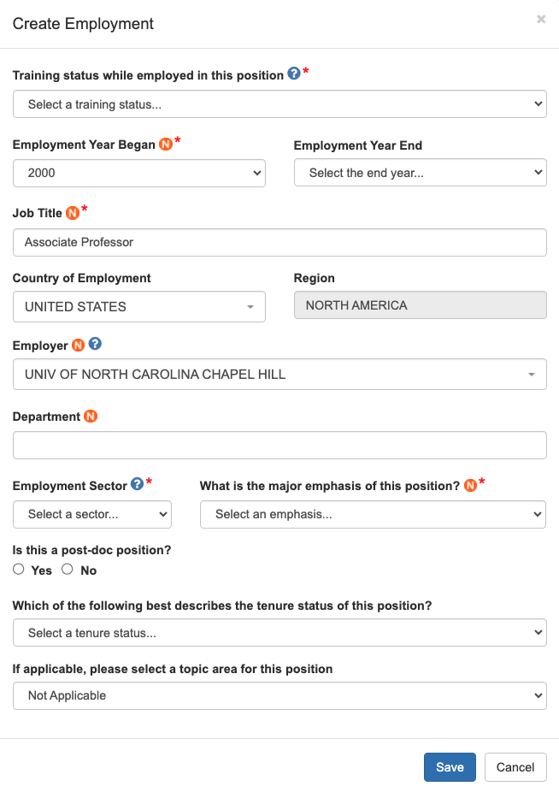

## Accomplishments – Employment (Manual Entry)

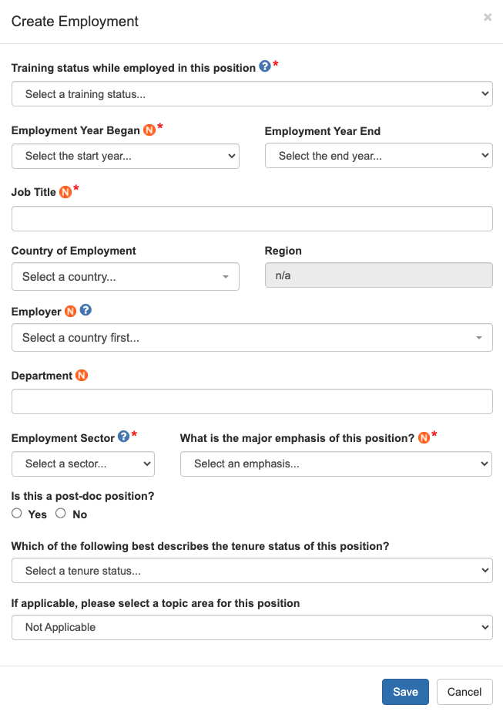

## Accomplishments – Fellowship

## Accomplishments – Honors/Awards

## Accomplishments – New Competitive Funding, Search (Commons Trainee)

## Accomplishments – New Competitive Funding, Search Results (Commons Trainee)

## Accomplishments – New Competitive Funding, Import (Commons Trainee)

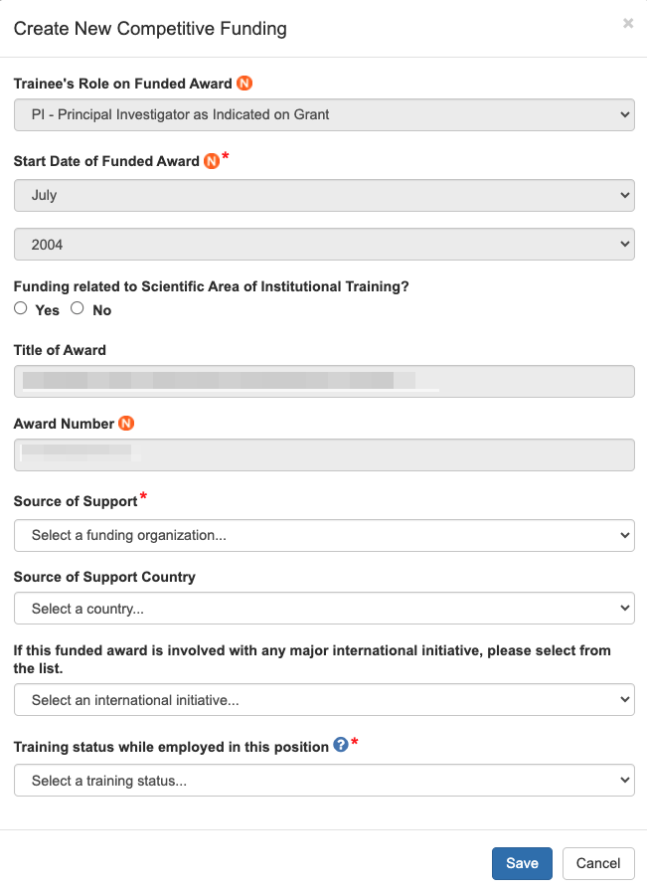

## Accomplishments – New Competitive Funding (Manual Entry)

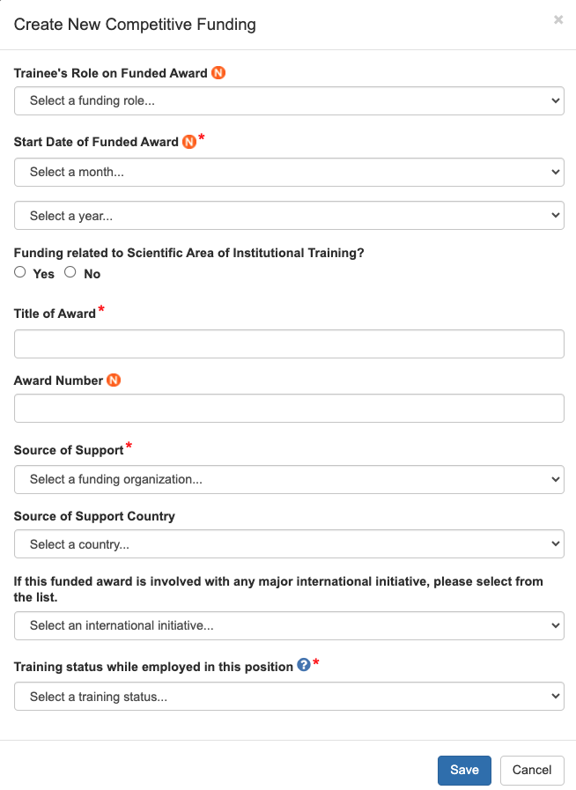

## Accomplishments – Post-Training Education, Search (Commons Trainee)

## Accomplishments – Post-Training Education, Search Results (Commons Trainee)

## Accomplishments – Post-Training Education, Import (Commons Trainee)

## Accomplishments – Post-Training Education (Manual Entry)

## Accomplishments – Posters at Scientific Meetings

## Accomplishments – Product or Policy Development

## Accomplishments – Publications, Search (PubMed Search)

## Accomplishments – Publications, Search Results (PubMed Search)

## Accomplishments – Publications, Import (PubMed Search)

## Accomplishments – Publications (Manual Entry)

## Accomplishments – Students

# Comments Page

## Comments Page – Add Comment

# CareerTrac Status Page

## CareerTrac Status Page – Change Status

# Program Information Page

## Program Information, Program Training Activities

## Program Information, Holistic Approach

## Program Information, Trainee Tracking

## Program Information, Teacher Activities

## Program Information, Teacher Activities (Create Teacher Activities)

## Program Information, Education Products

## Graphical user interface, application Description automatically generatedProgram Information, Education Products (Create Education Product)

## Program Information, Education Products (Create Education Product; conditional Items shown)

## Program Information, Outreach (conditional items shown)

## Program Information, Outreach (Create Outreach Activity, Program A)

## Program Information, Outreach (Create Outreach Activity, Program A; conditional items shown)

## Program Information, Outreach (Create Outreach Activity, Program B)

## Program Information, Outreach (Create Outreach Activity, Program B; conditional items shown)

## Program Information, Collaboration Efforts

## Program Information, Collaboration Efforts (Create Collaboration Effort)

## Program Information, Program Publications

## Program Information, Program Publications (Create Publication; Search/Import)

## Program Information, Program Publications (Create Publication, manual)

