CareerTrac Trainee Portal Screenshots

Trainee Portal form fields presented to trainees will display any data previously entered by the PI or their staff; and any data provided by the trainee will also populate into the “PI view” form fields.

Login Page / Landing Page
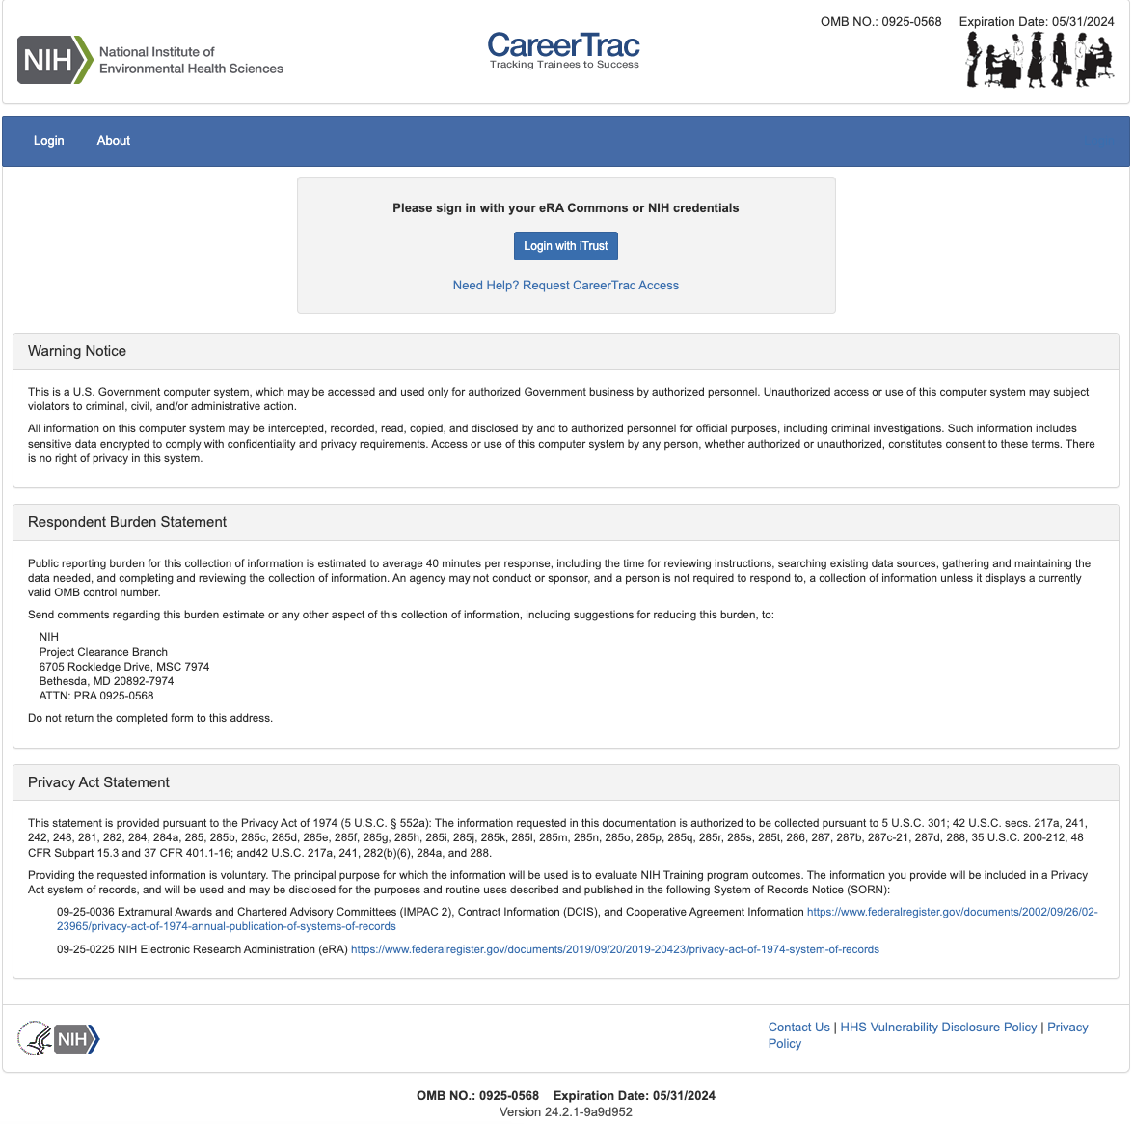

Landing Page
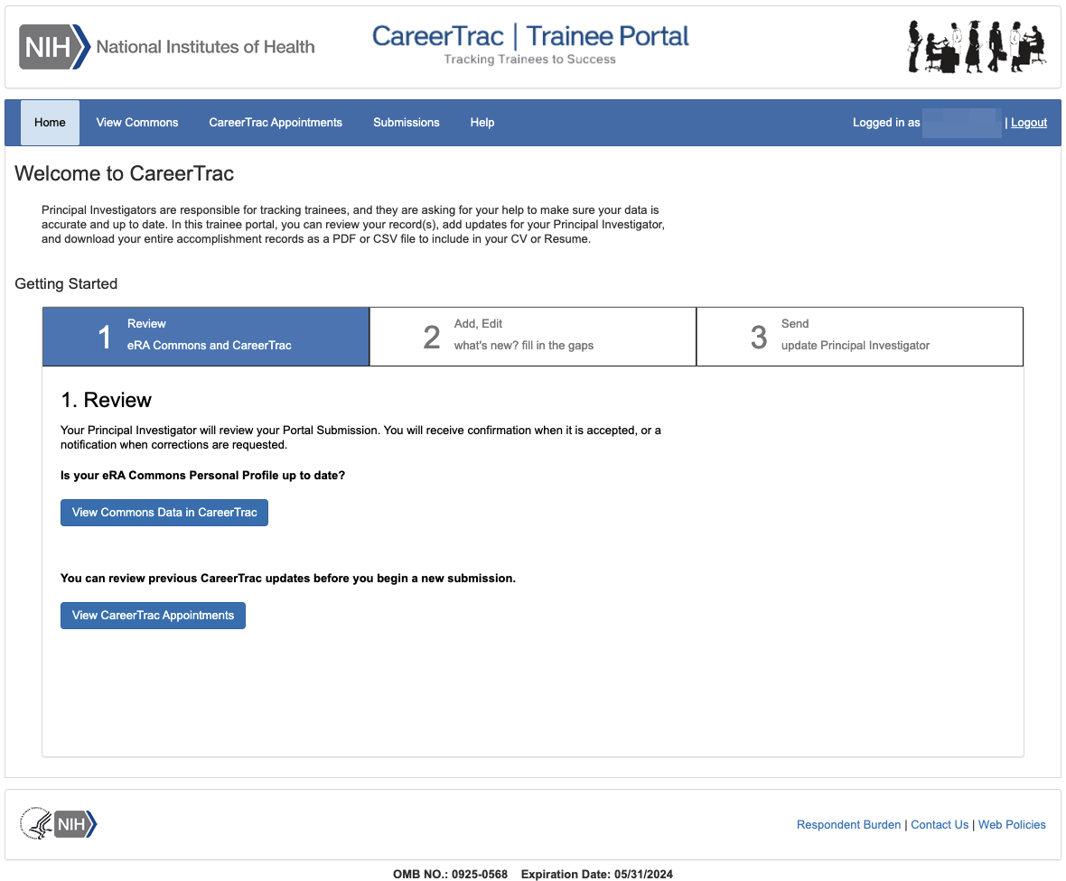

View Commons Page (read-only)
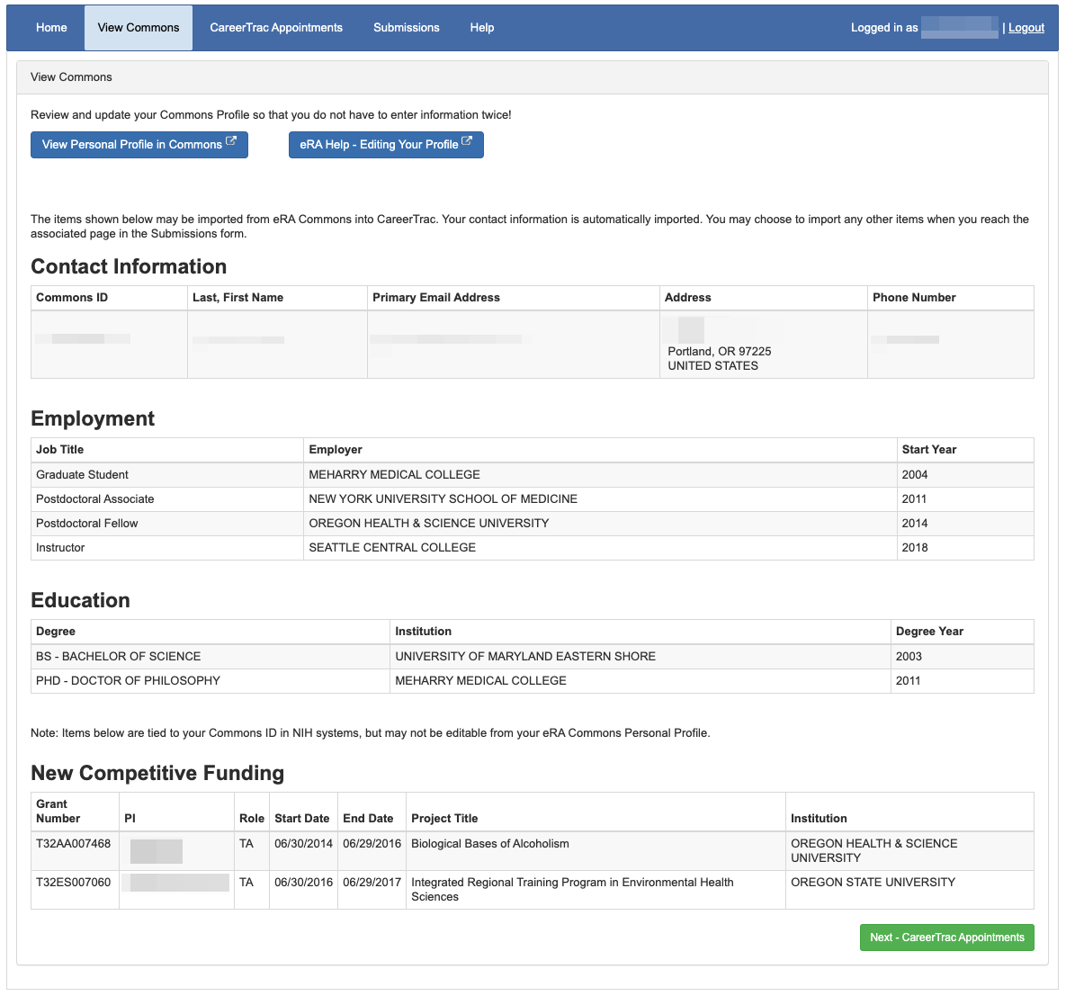

CareerTrac Appointments Page (read-only)
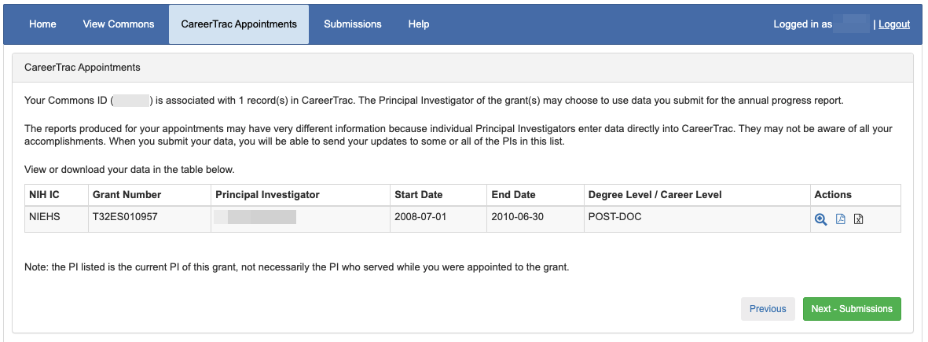

Submissions Page
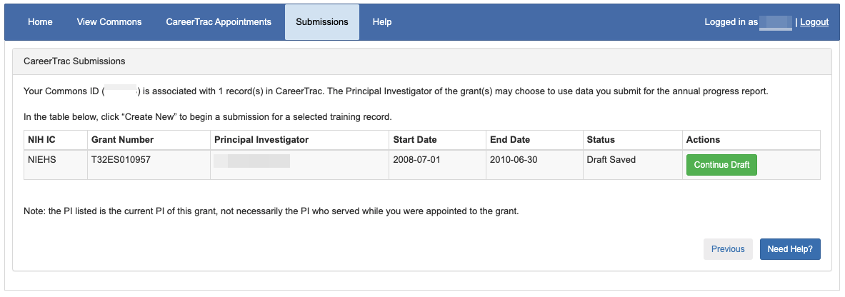

Contact Info Page

Contact Info Page, xTrain trainee
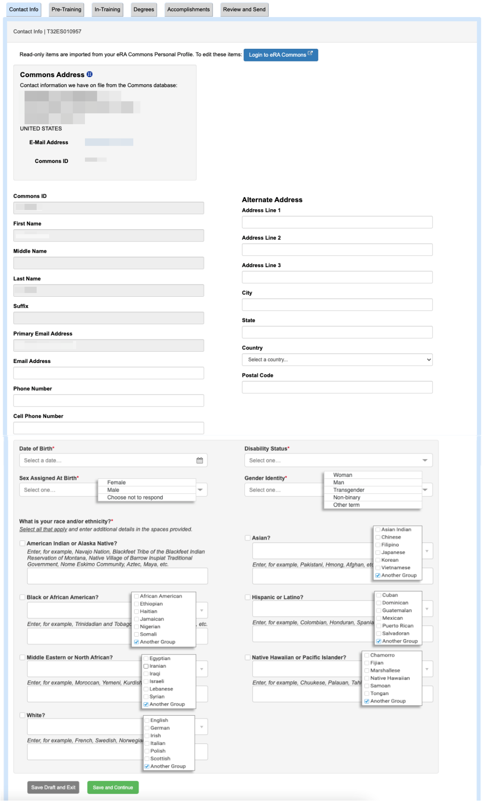

Contact Info Page, Commons Trainee
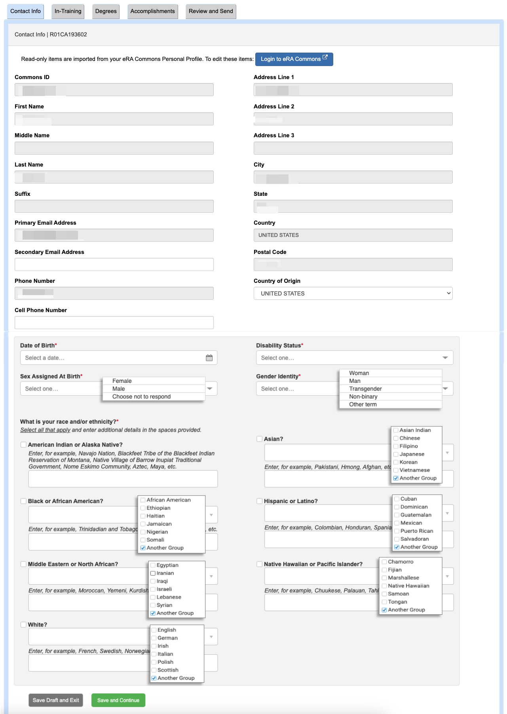

Pre-Training Info
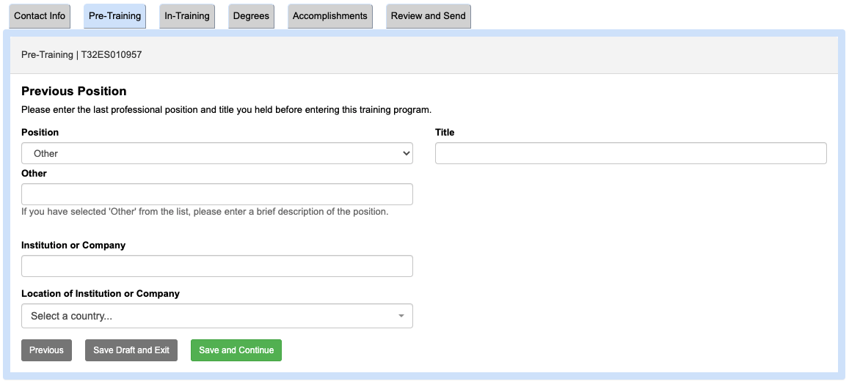

In-Training Info Page

In-Training Info Page (FIC, NCI D43s)
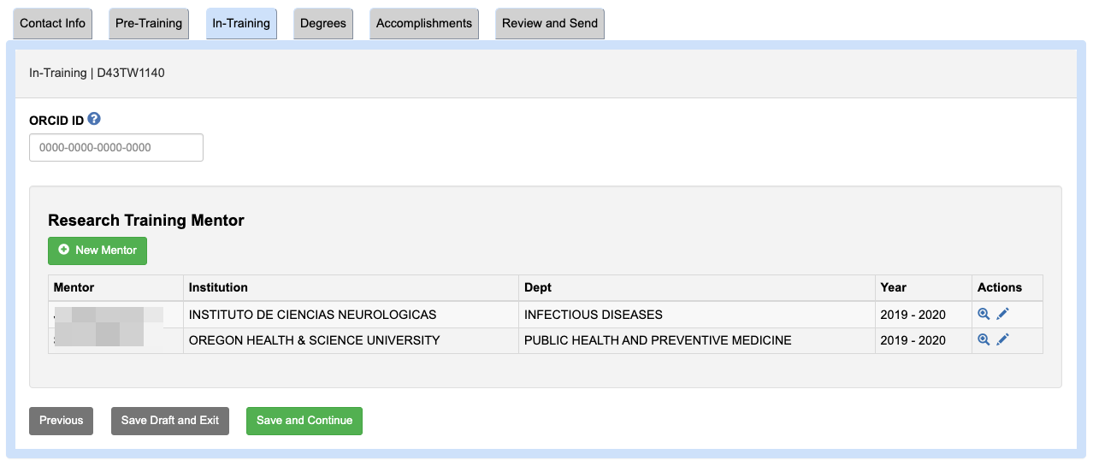

In-Training Info Page (NIEHS, NIDDK)
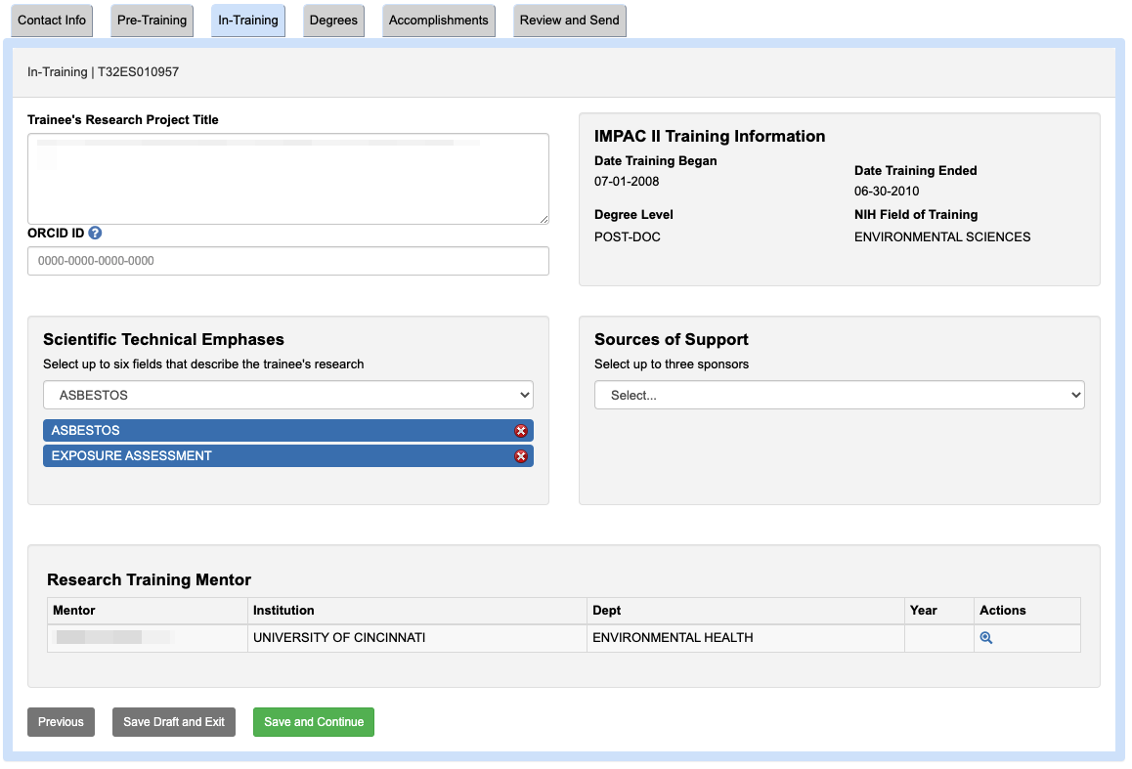

In-Training Info Page (NCI-CRCHD)
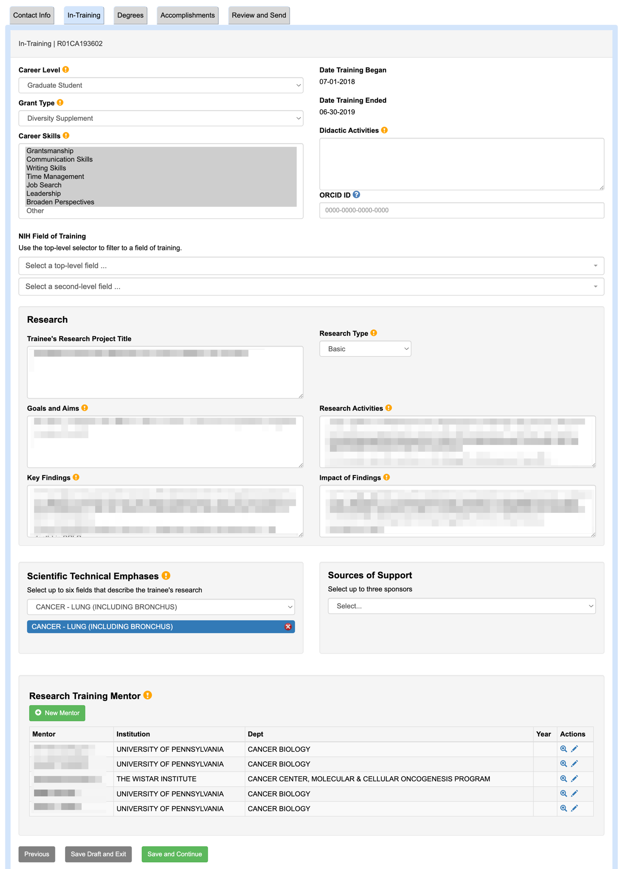

In-Training Info Page (NIEHS Superfund)
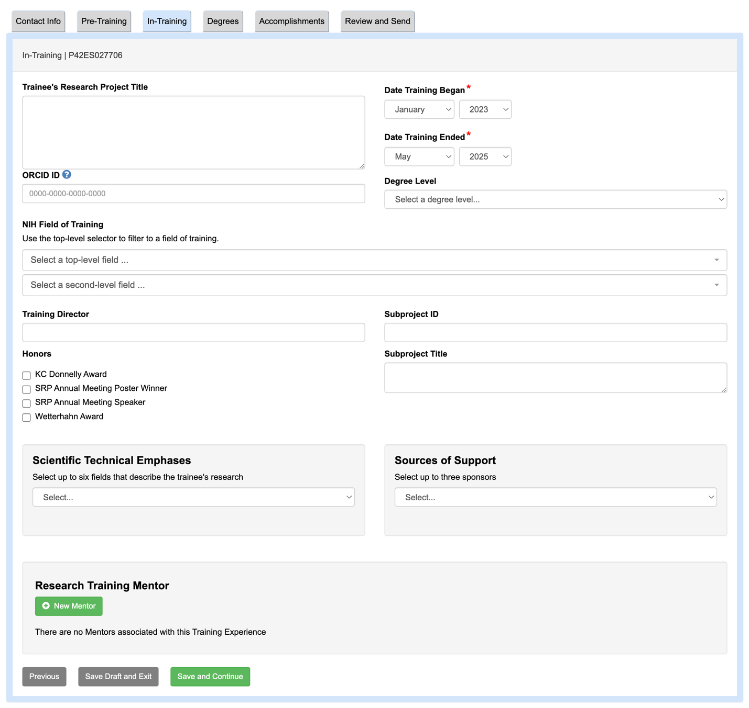

In-Training Info Page – New Mentor (Search)
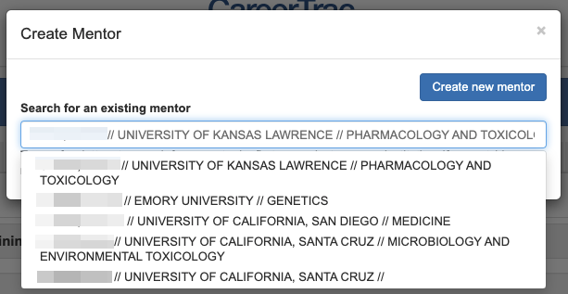

In-Training Info Page – New Mentor (Manual Entry)
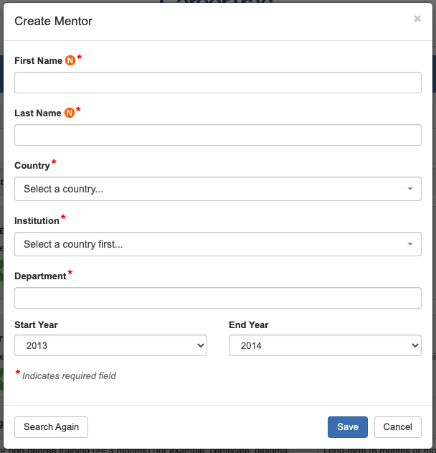

Degrees Page
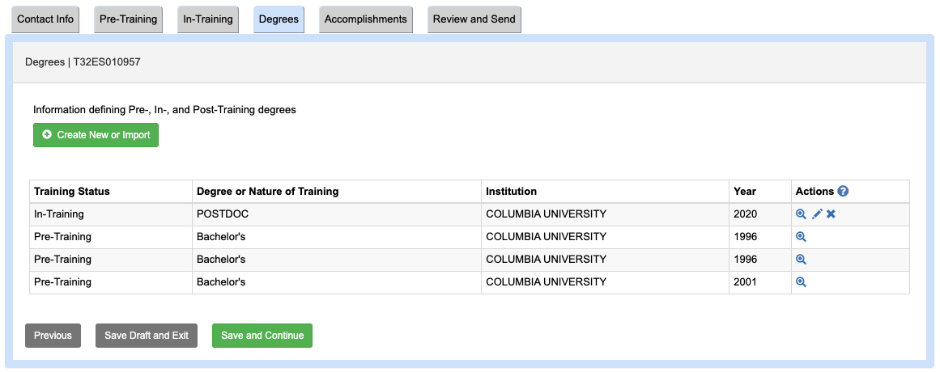

Degrees Page – New Education, Search (Commons Trainee)
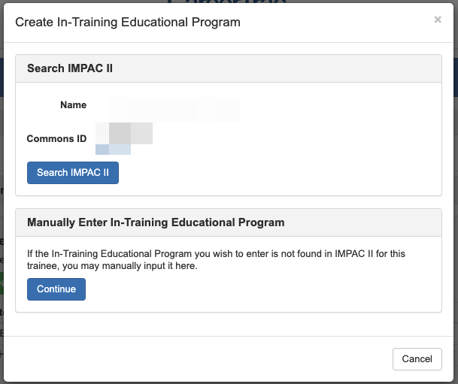

In-Training Info Page – New Education, Search Results (Commons Trainee)
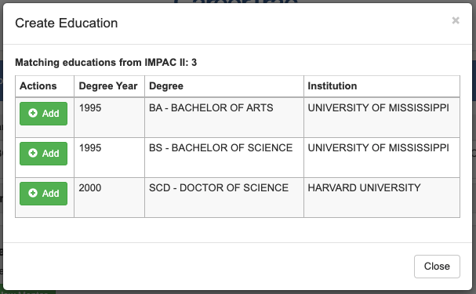

In-Training Info Page – New Education, Import (Commons Trainee)
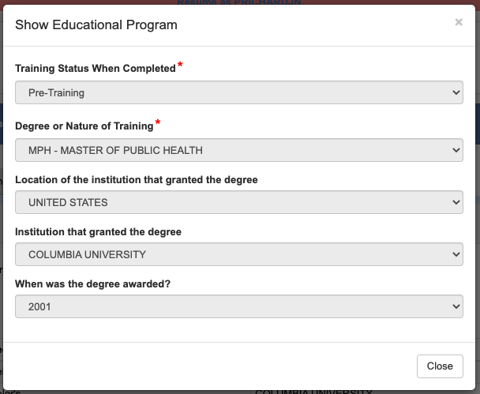

In-Training Info Page – New Education (Manual Entry)
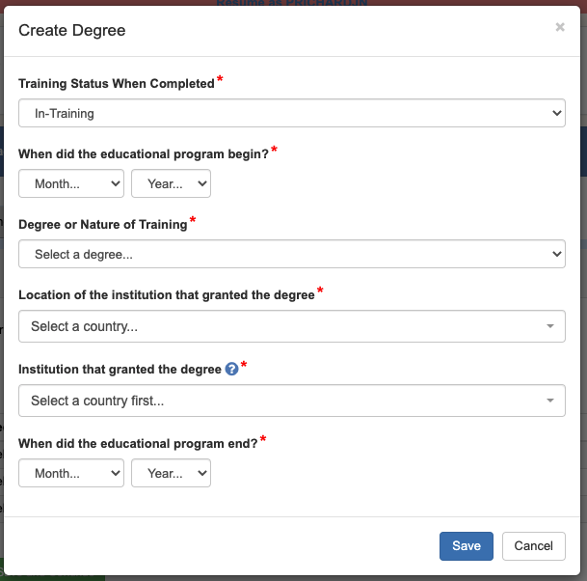

Accomplishments Page
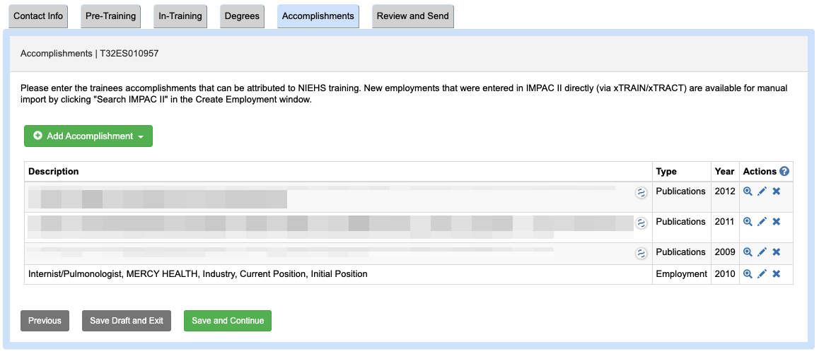

Accomplishments – Career Highlights/Leadership
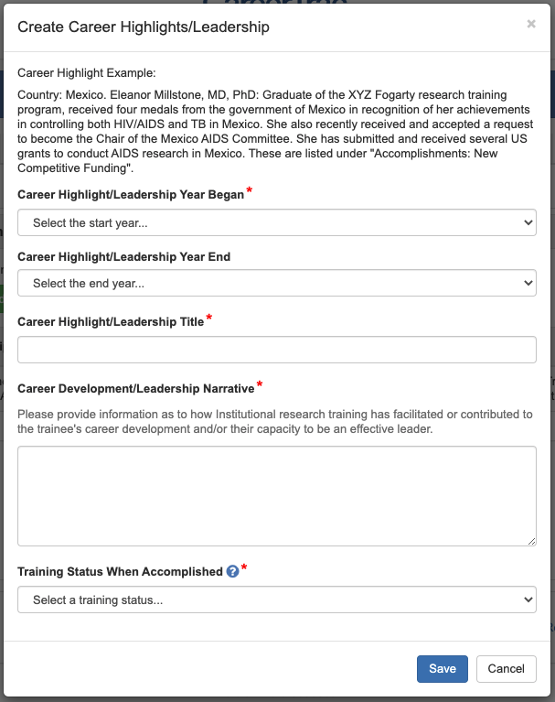

Accomplishments – Employment, Search (Commons Trainee)
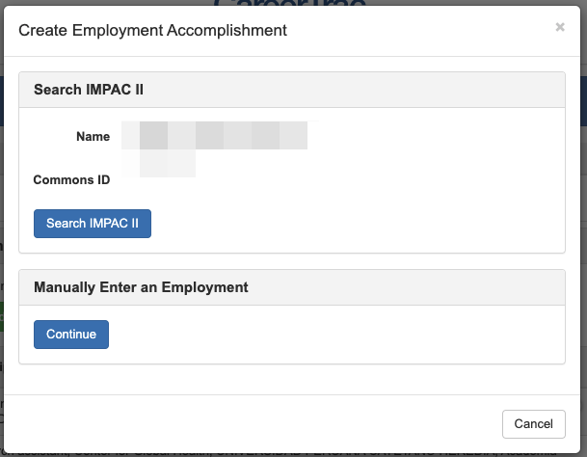

Accomplishments – Employment, Search Results (Commons Trainee)
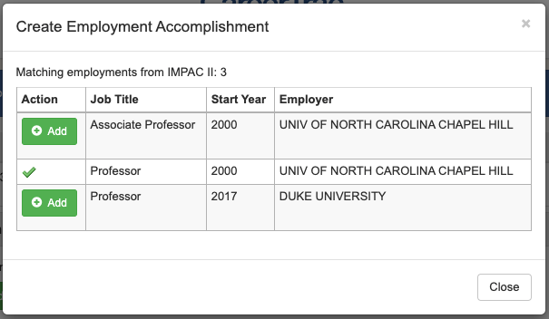

Accomplishments – Employment, Import (Commons Trainee)
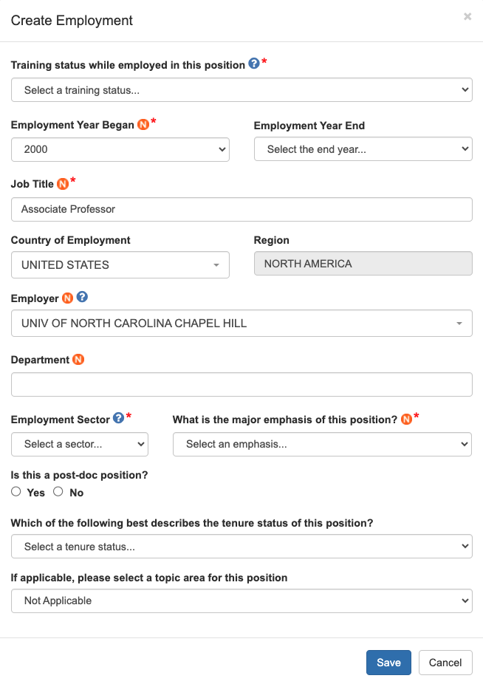

Accomplishments – Employment (Manual Entry)
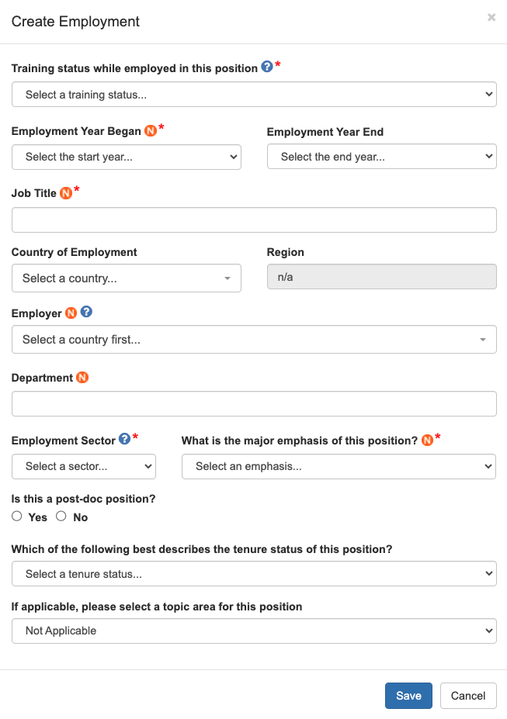

Accomplishments – Fellowship
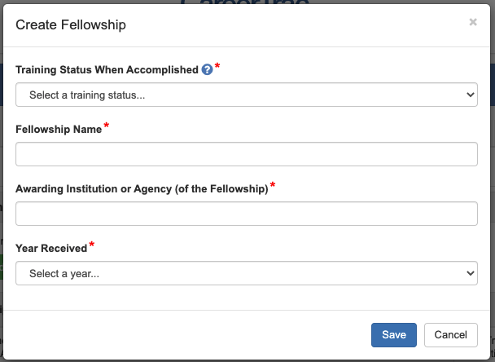

Accomplishments – Honors/Awards
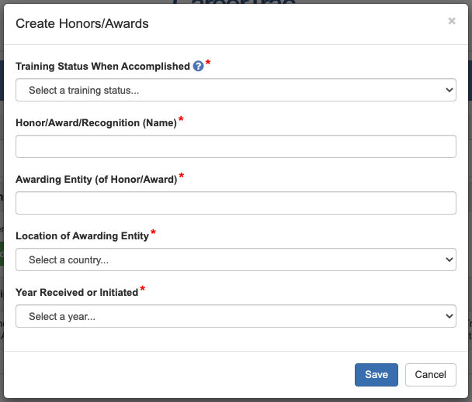

Accomplishments – New Competitive Funding, Search (Commons Trainee)
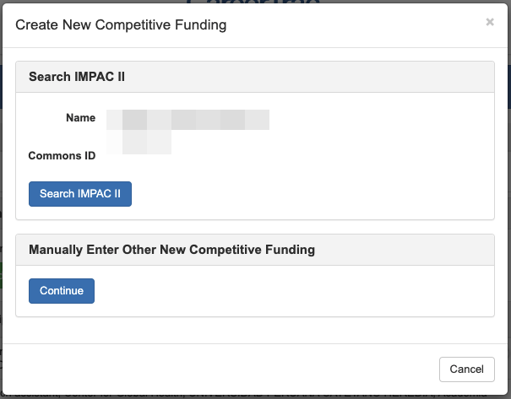

Accomplishments – New Competitive Funding, Search Results (Commons Trainee)
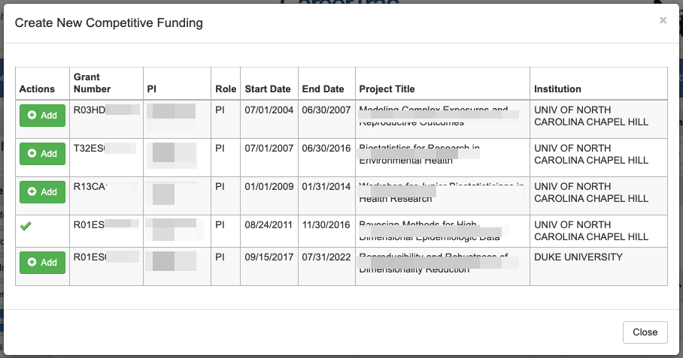

Accomplishments – New Competitive Funding, Import (Commons Trainee)
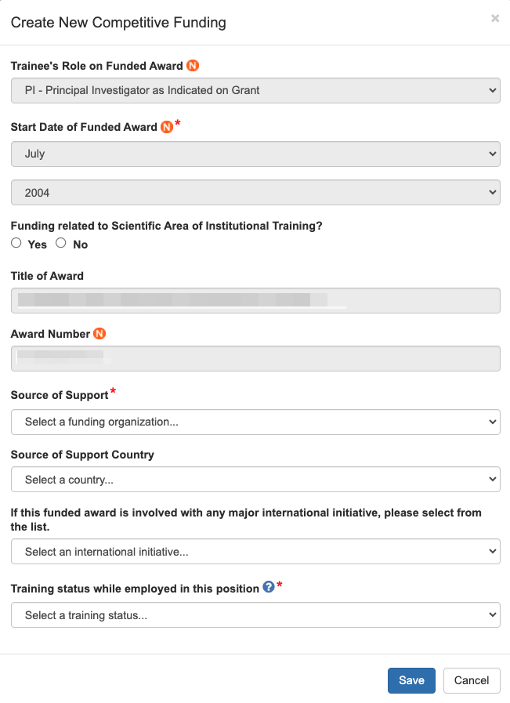

Accomplishments – New Competitive Funding (Manual Entry)
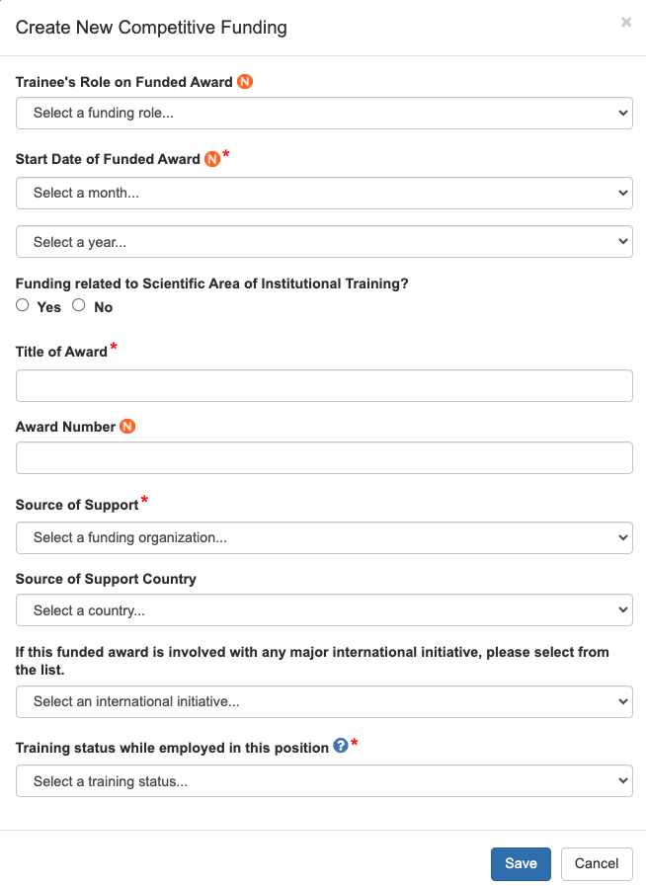

Accomplishments – Post-Training Education, Search (Commons Trainee)
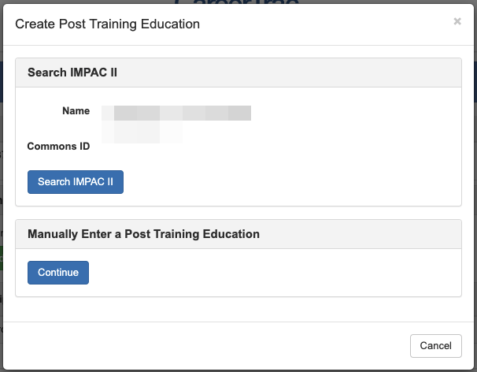

Accomplishments – Post-Training Education, Search Results (Commons Trainee)
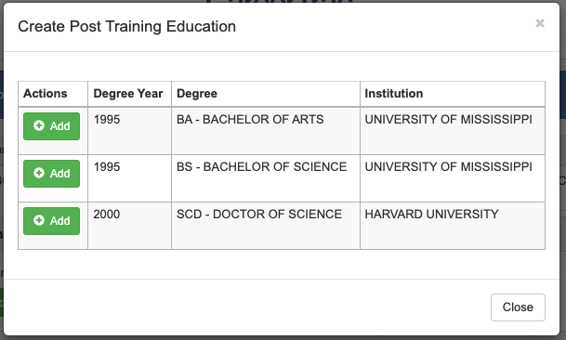

Accomplishments – Post-Training Education, Import (Commons Trainee)
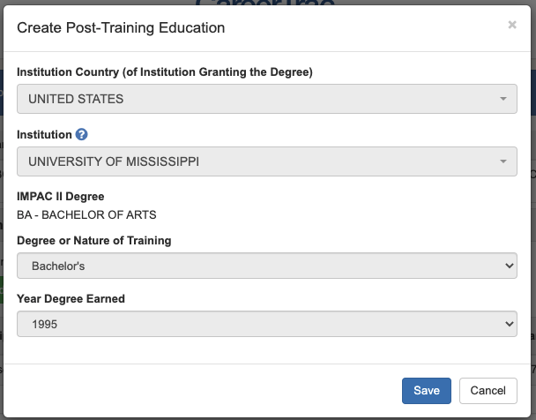

Accomplishments – Post-Training Education (Manual Entry)
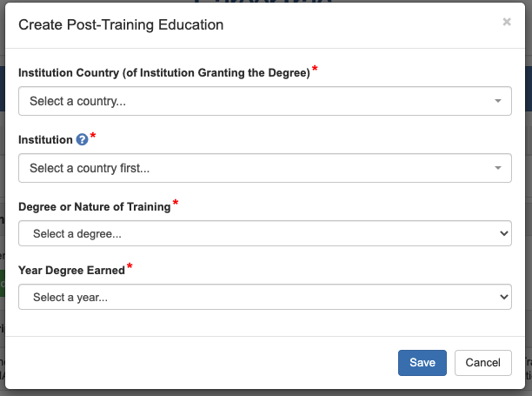

Accomplishments – Posters at Scientific Meetings
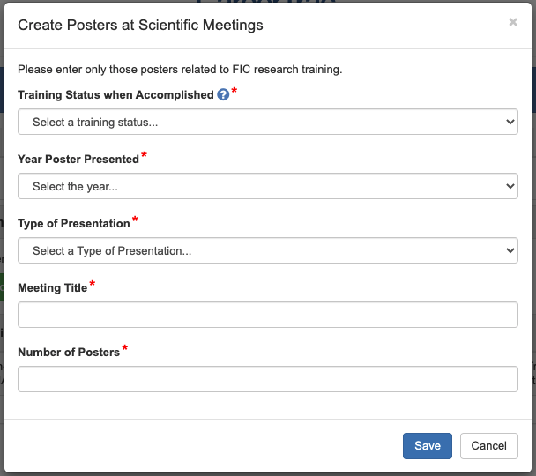

Accomplishments – Product or Policy Development
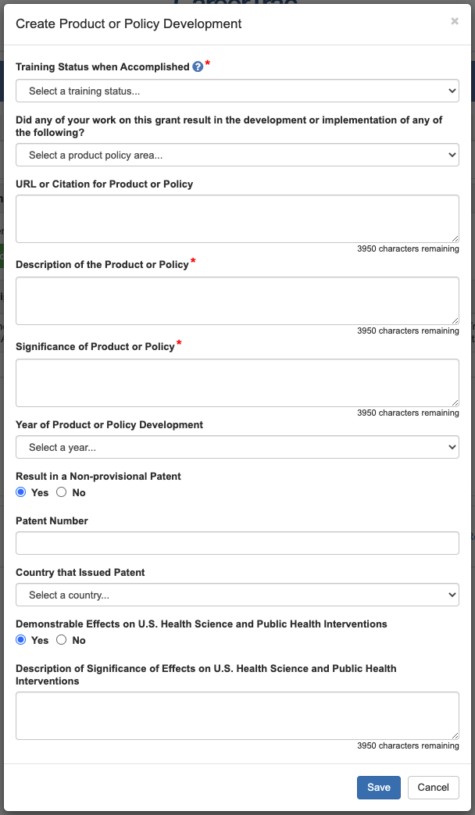

Accomplishments – Publications, Search (PubMed Search)
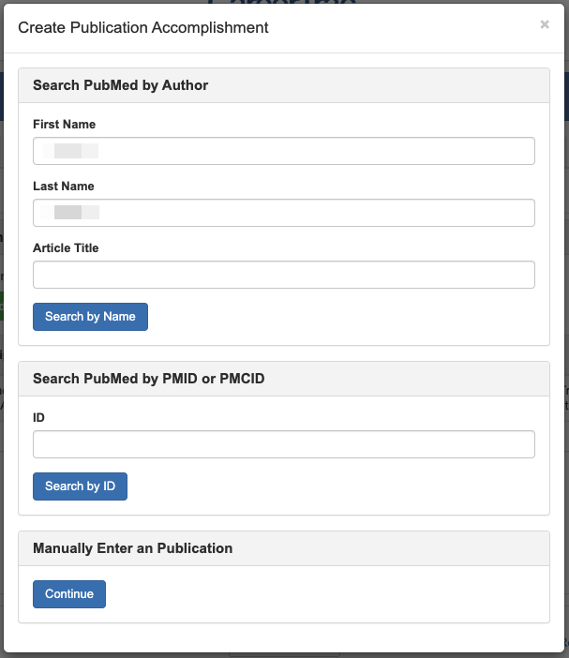

Accomplishments – Publications, Search Results (PubMed Search)
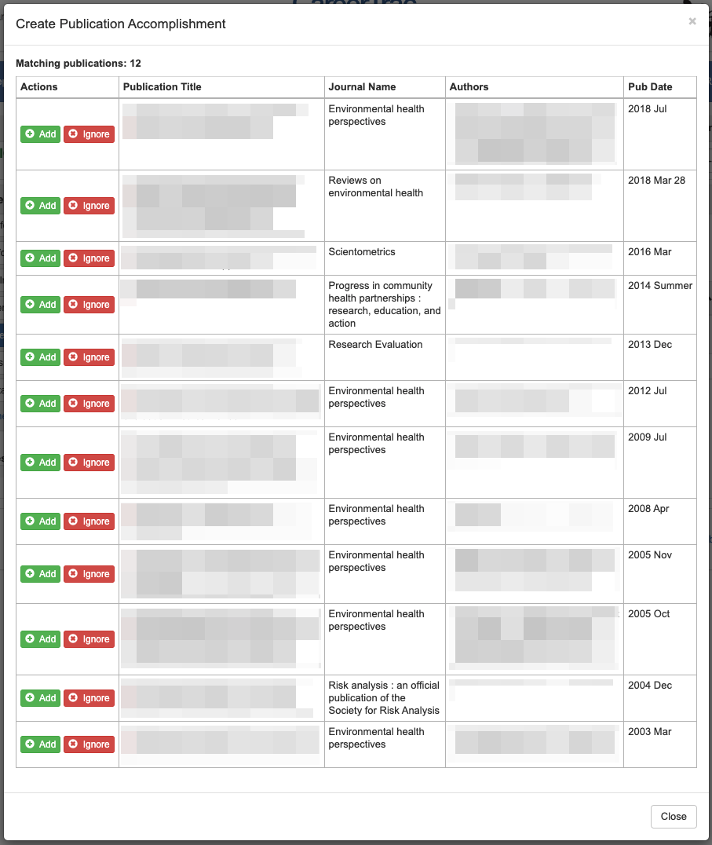

Accomplishments – Publications, Import (PubMed Search)
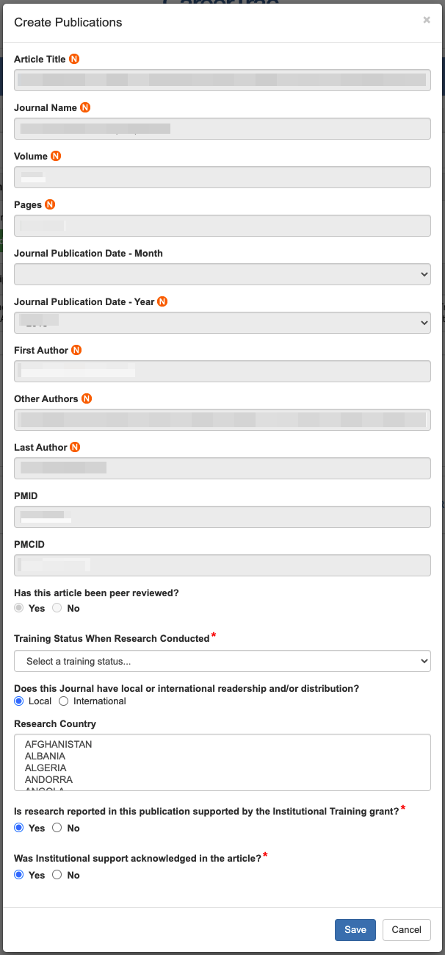

Accomplishments – Publications (Manual Entry)
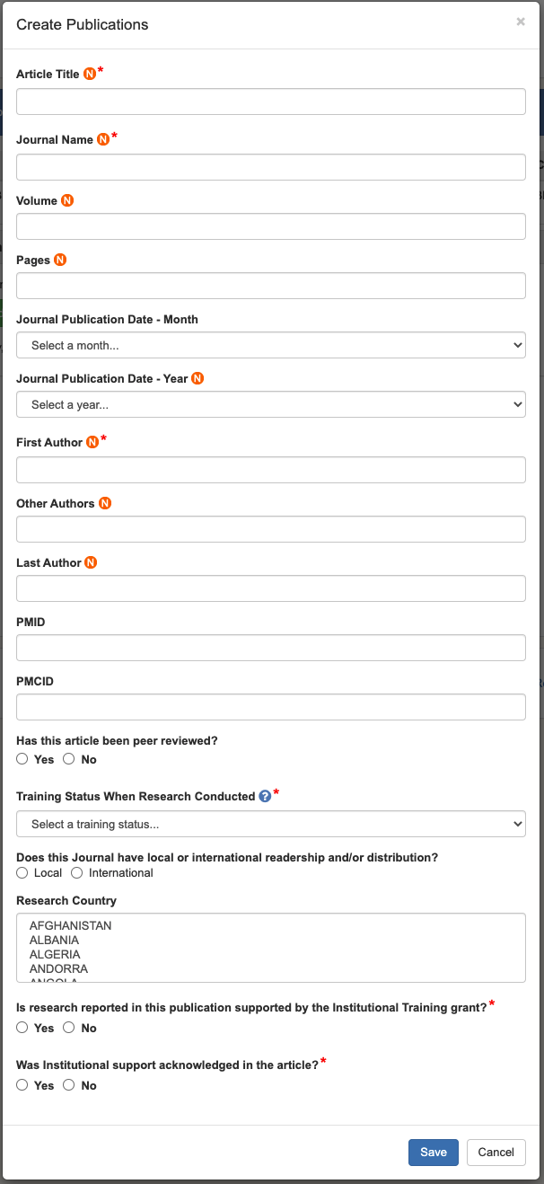

Accomplishments – Students
