NIEHS, NIDDK CareerTrac Screenshots

Login Page / Landing Page
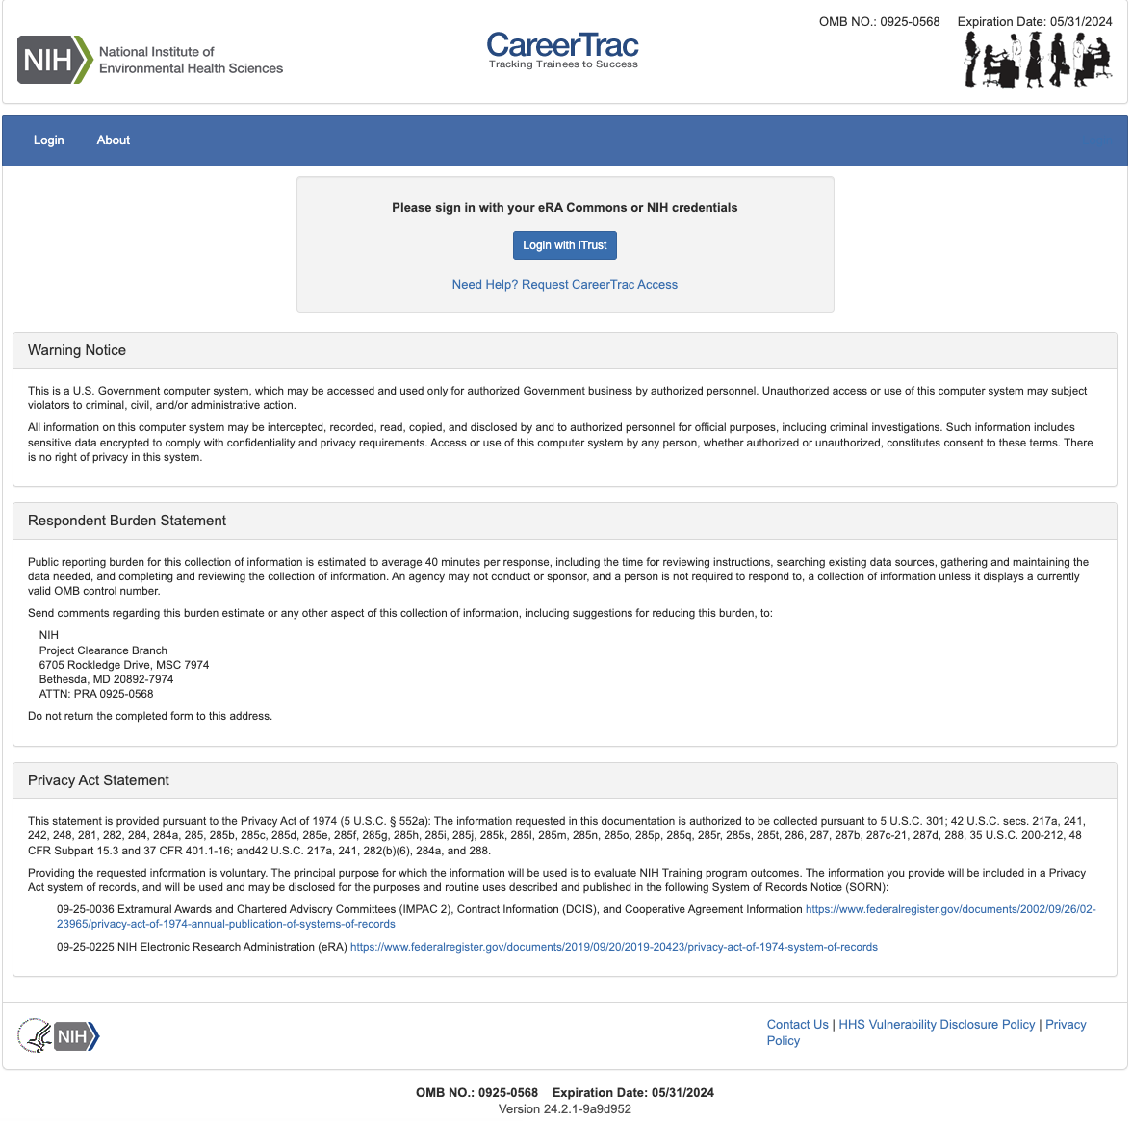

Trainees Page
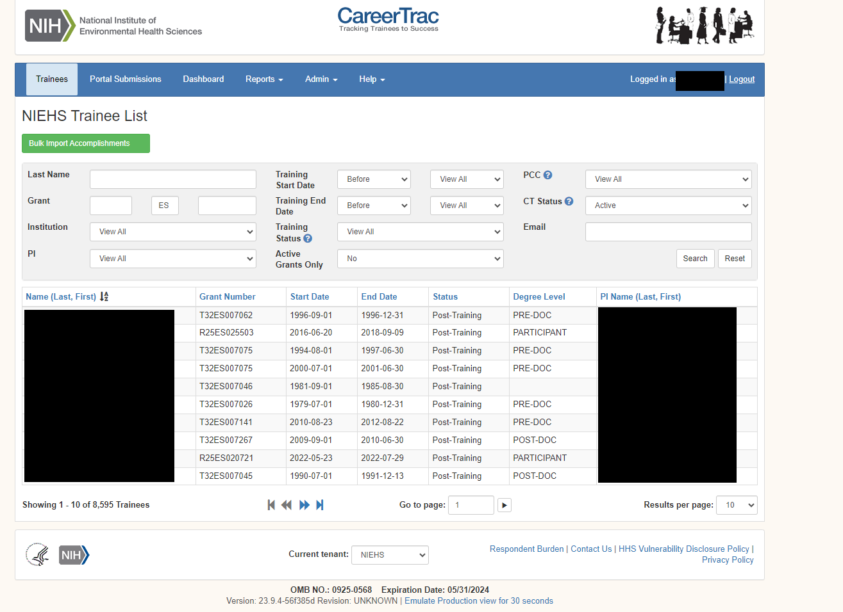

Personal Info Page
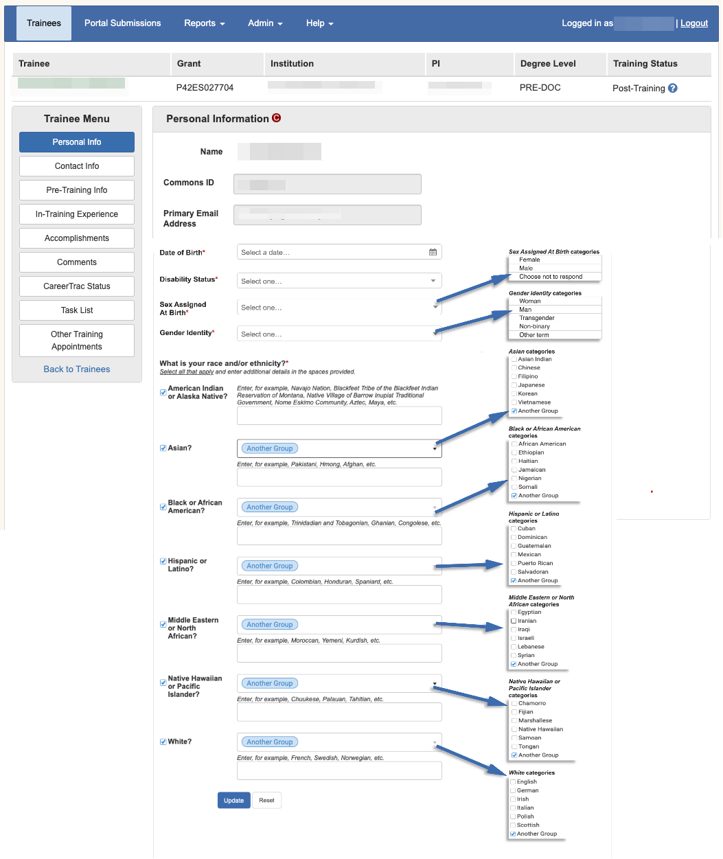

Contact Info Page
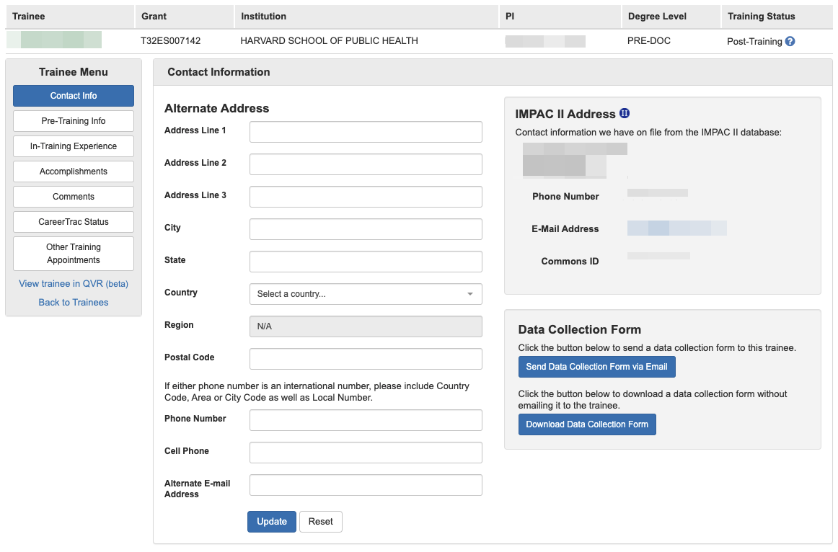

Pre-Training Info
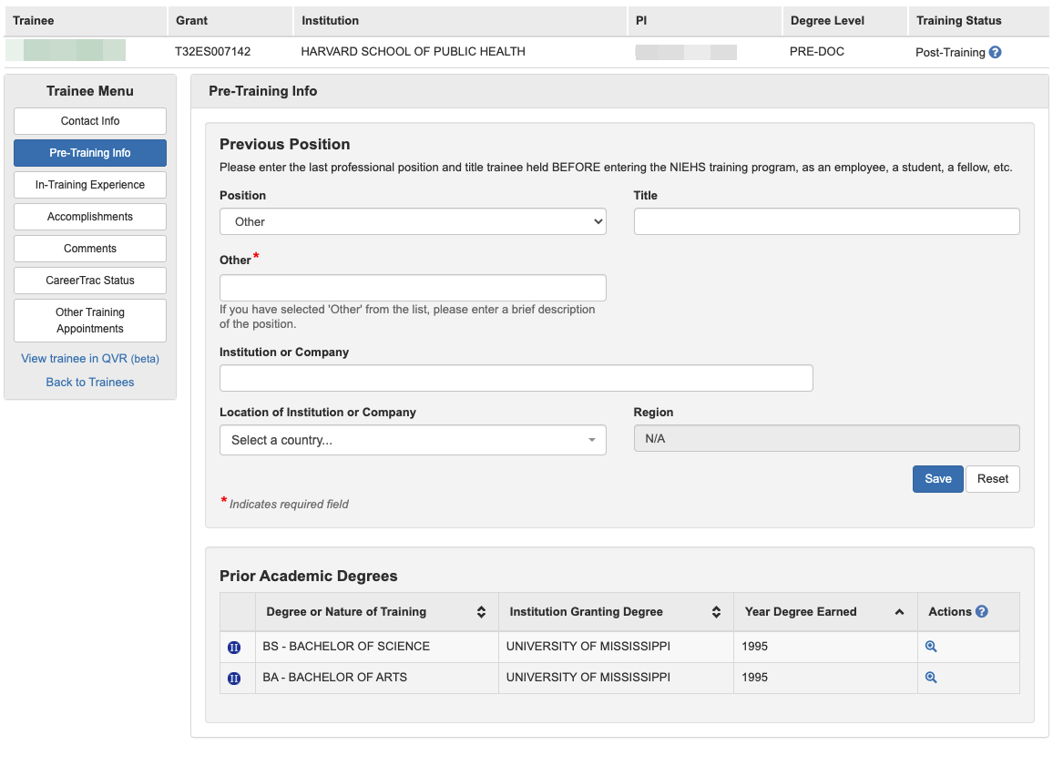

In-Training Info Page
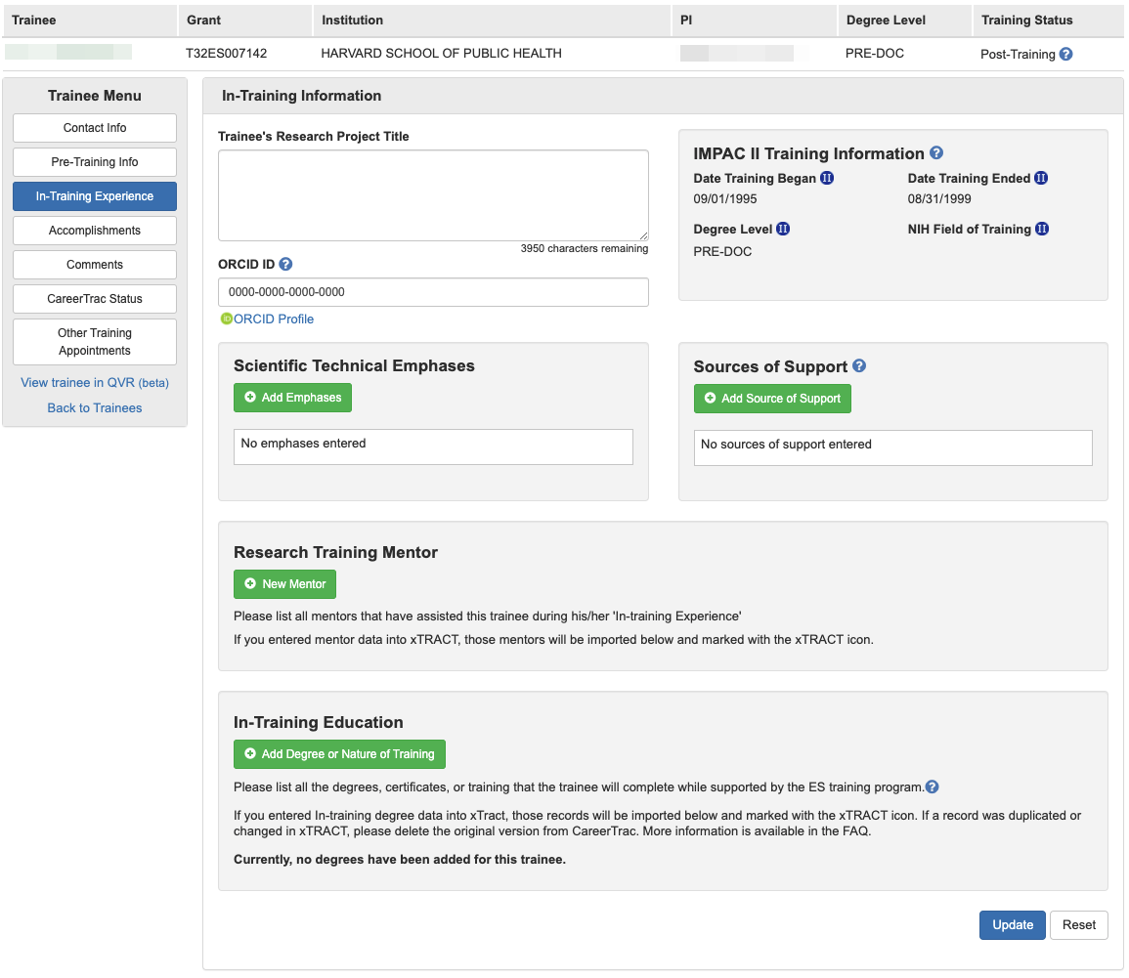

In-Training Info Page – Scientific Technical Emphases
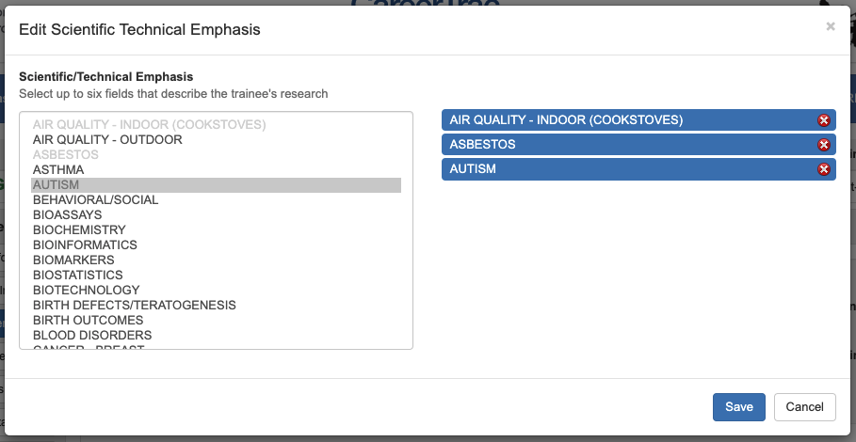

In-Training Info Page – Sources of Support
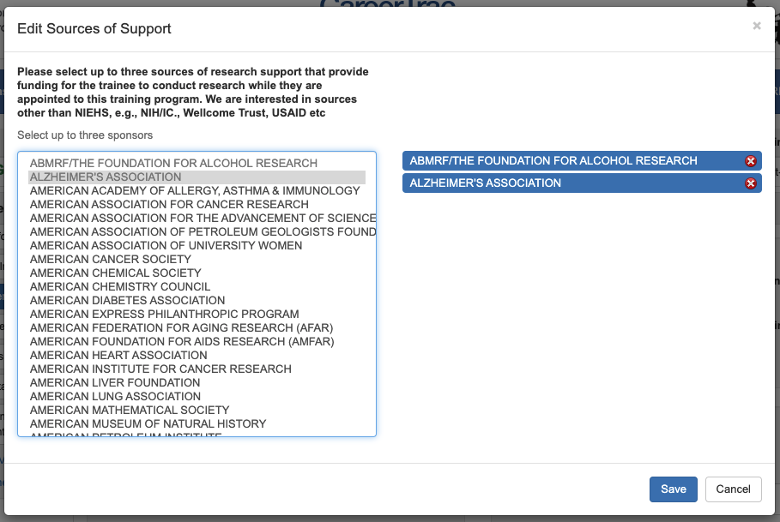

In-Training Info Page – New Mentor (Search)
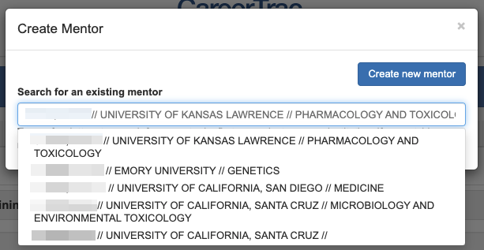

In-Training Info Page – New Mentor (Manual Entry)
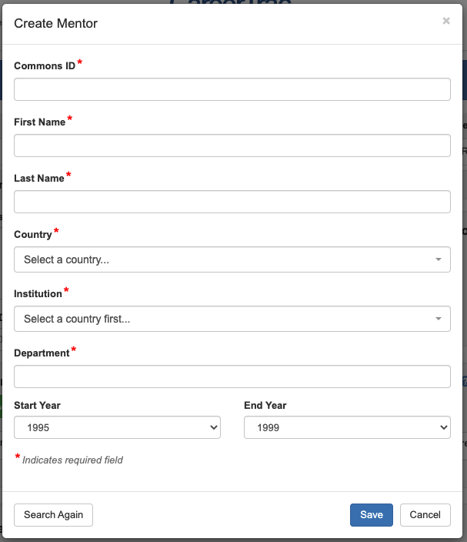

In-Training Info Page – New Education, Search (Commons Trainee)
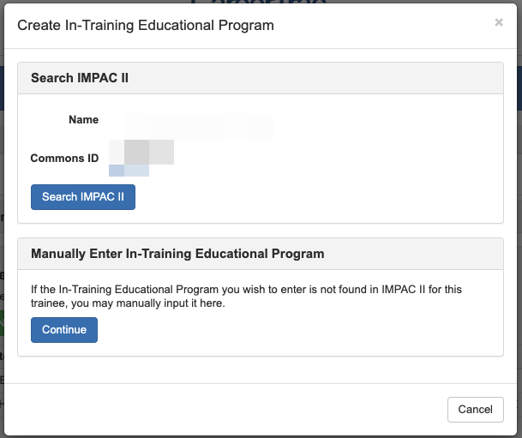

In-Training Info Page – New Education, Search Results (Commons Trainee)
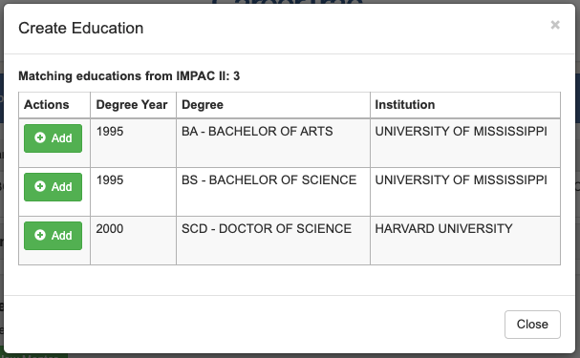

In-Training Info Page – New Education, Import (Commons Trainee)
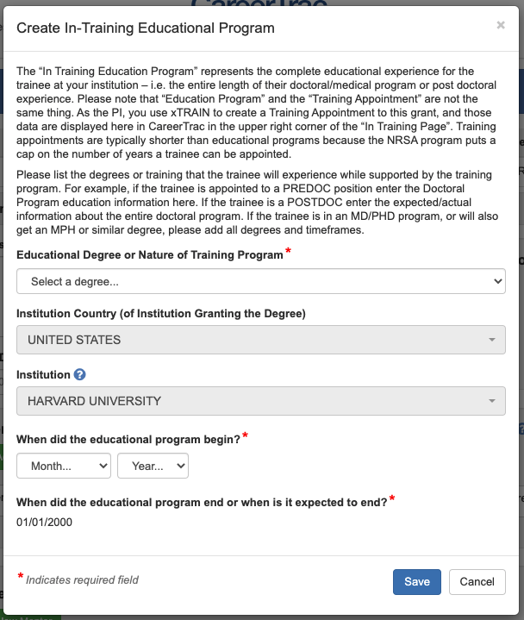

In-Training Info Page – New Education (Manual Entry)
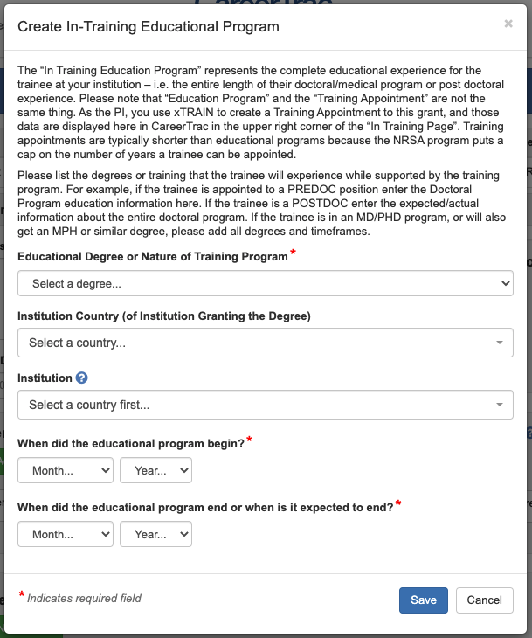

Accomplishments Page
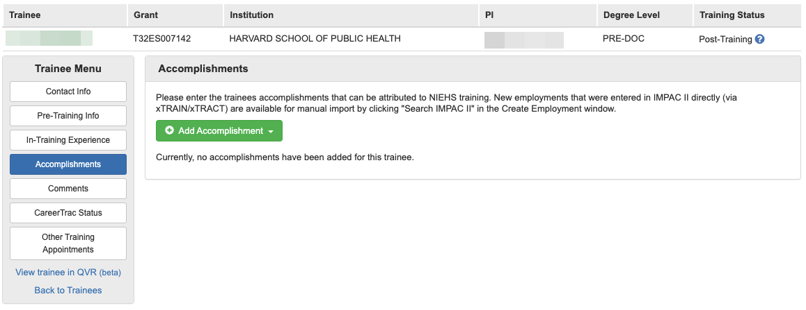

Accomplishments – Career Highlights/Leadership
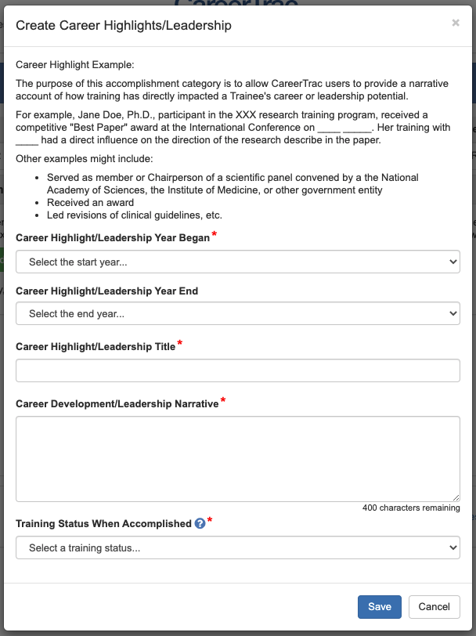

Accomplishments – Employment, Search (Commons Trainee)
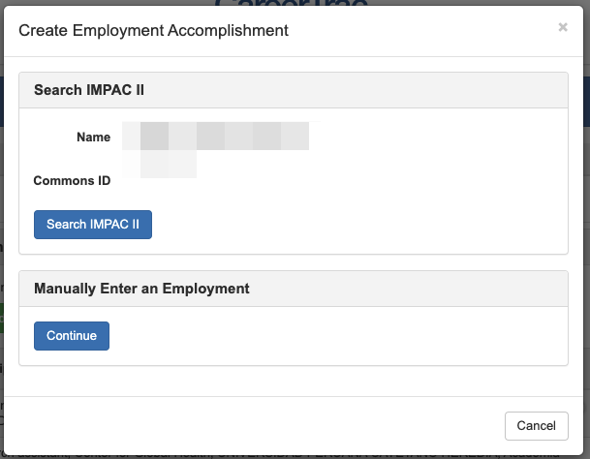

Accomplishments – Employment, Search Results (Commons Trainee)
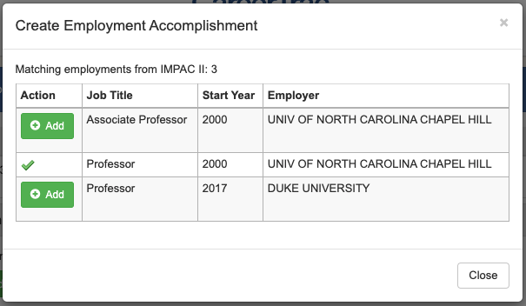

Accomplishments – Employment, Import (Commons Trainee)
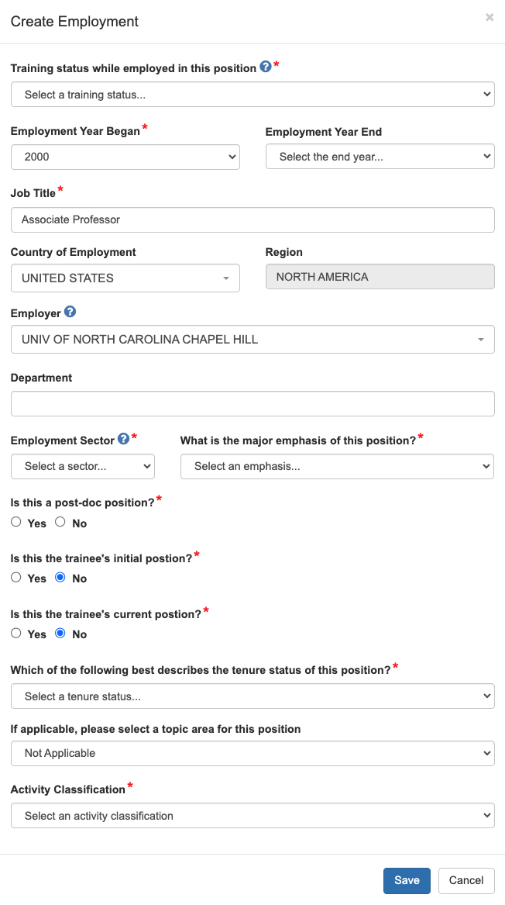

Accomplishments – Employment (Manual Entry)
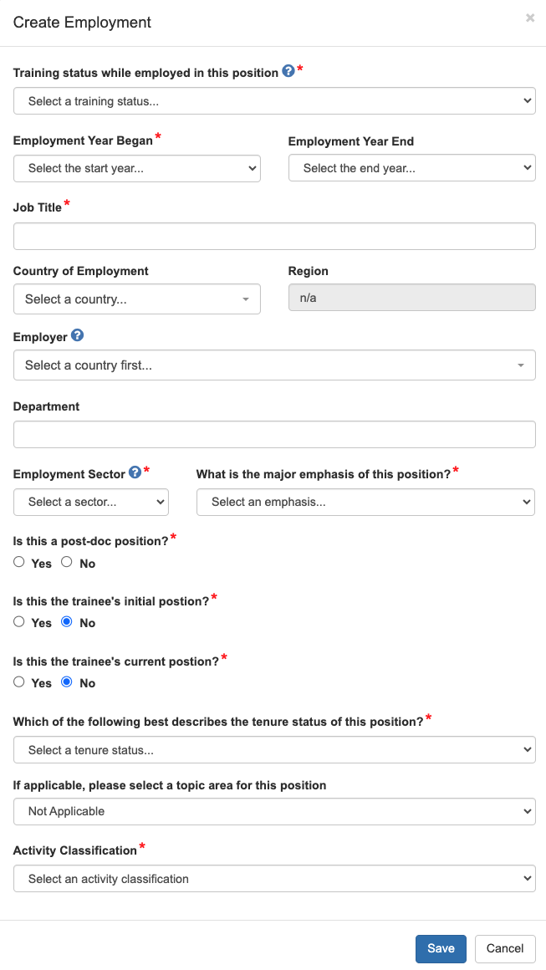

Accomplishments – Fellowship
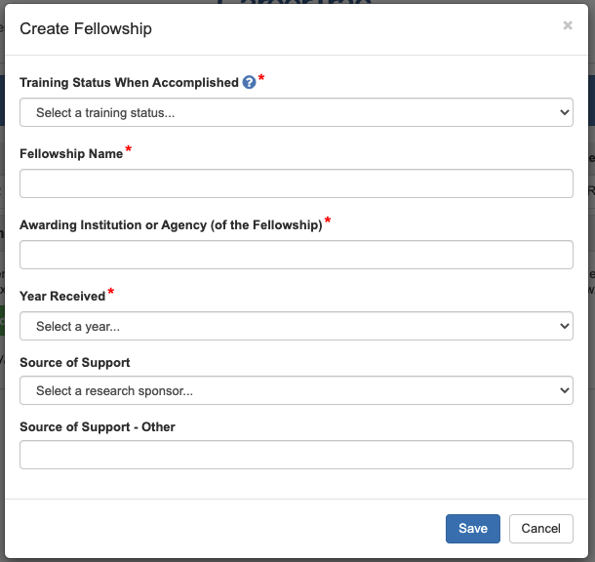

Accomplishments – Honors/Awards
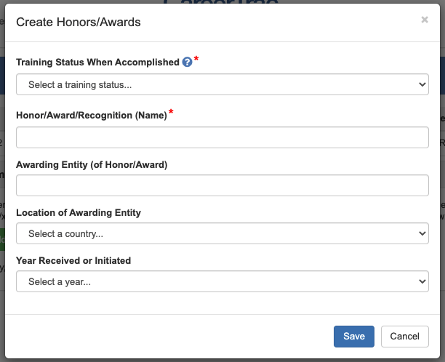

Accomplishments – New Competitive Funding, Search (Commons Trainee)
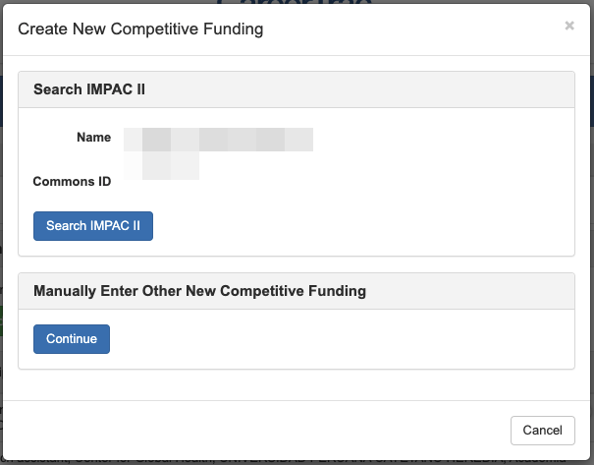

Accomplishments – New Competitive Funding, Search Results (Commons Trainee)
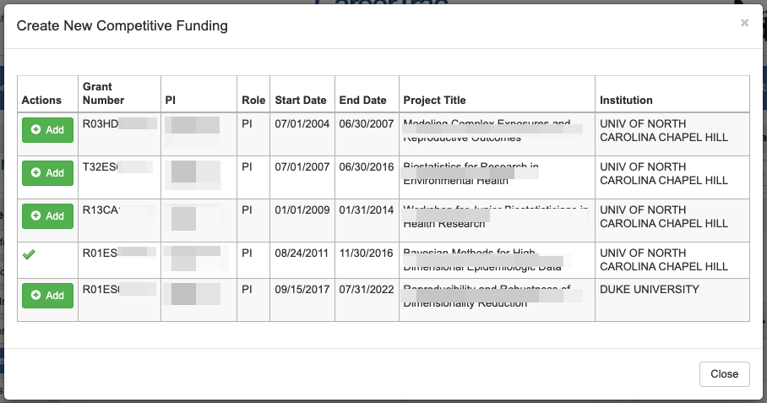

Accomplishments – New Competitive Funding, Import (Commons Trainee)
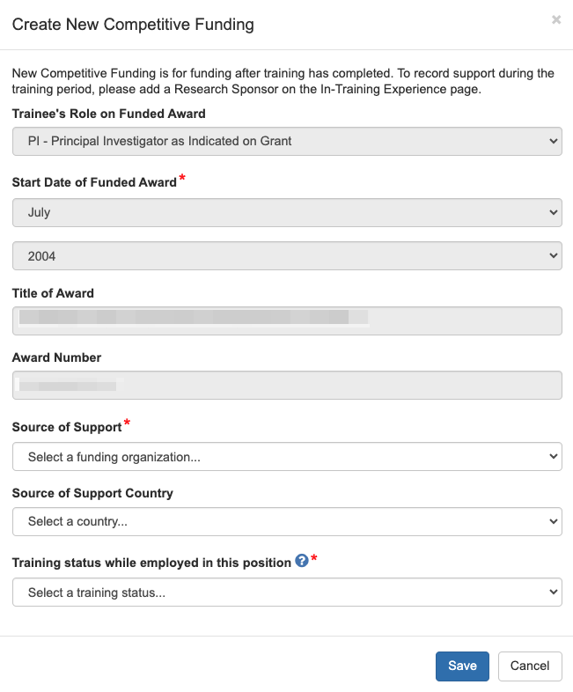

Accomplishments – New Competitive Funding (Manual Entry)
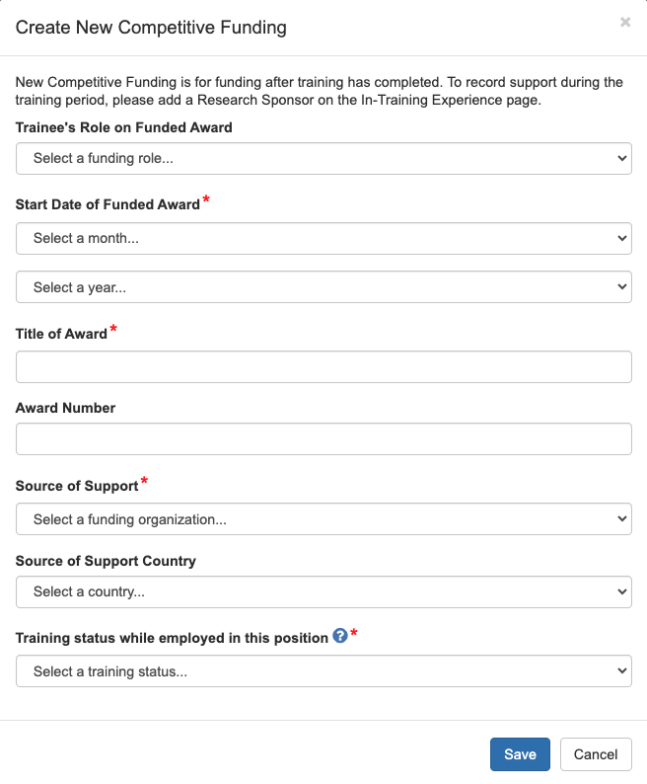

Accomplishments – Post-Training Education, Search (Commons Trainee)
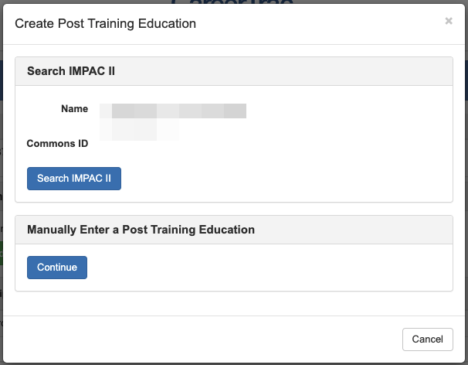

Accomplishments – Post-Training Education, Search Results (Commons Trainee)
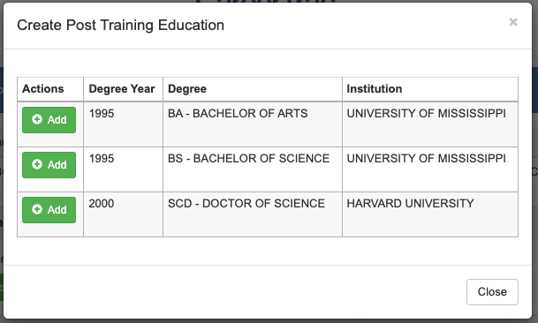

Accomplishments – Post-Training Education, Import (Commons Trainee)
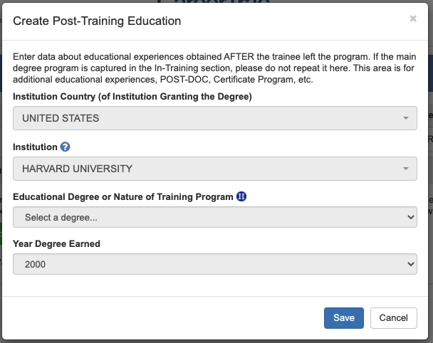

Accomplishments – Post-Training Education (Manual Entry)
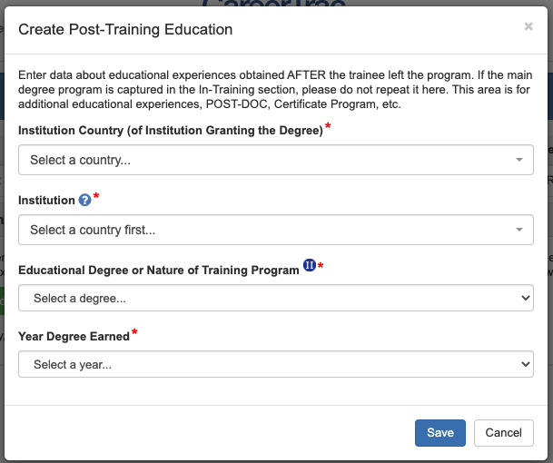

Accomplishments – Posters at Scientific Meetings
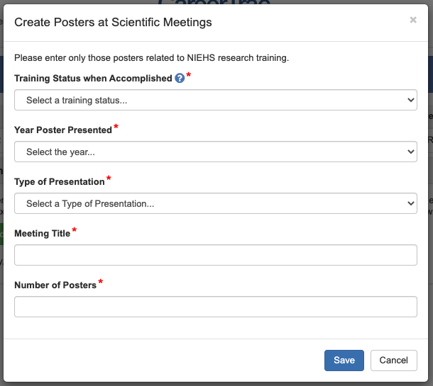

Accomplishments – Product or Policy Development
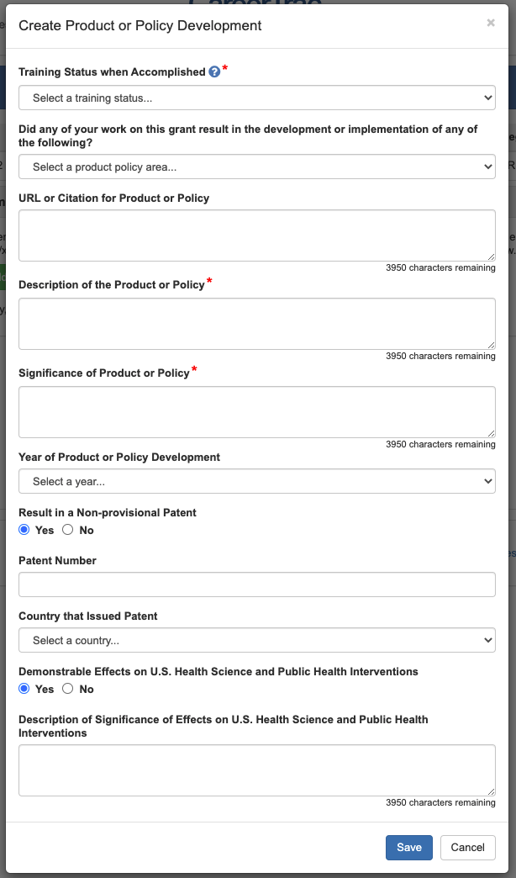

Accomplishments – Publications, Search (PubMed Search)
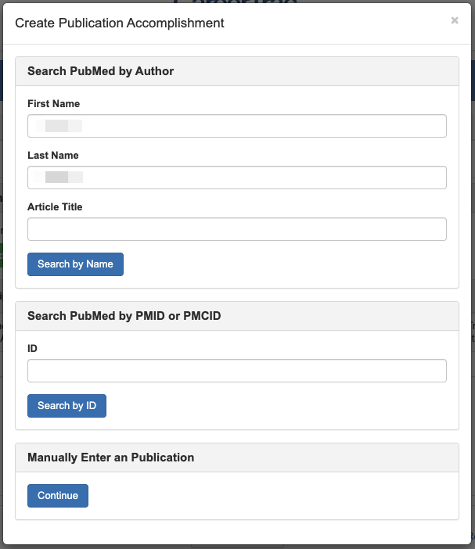

Accomplishments – Publications, Search Results (PubMed Search)
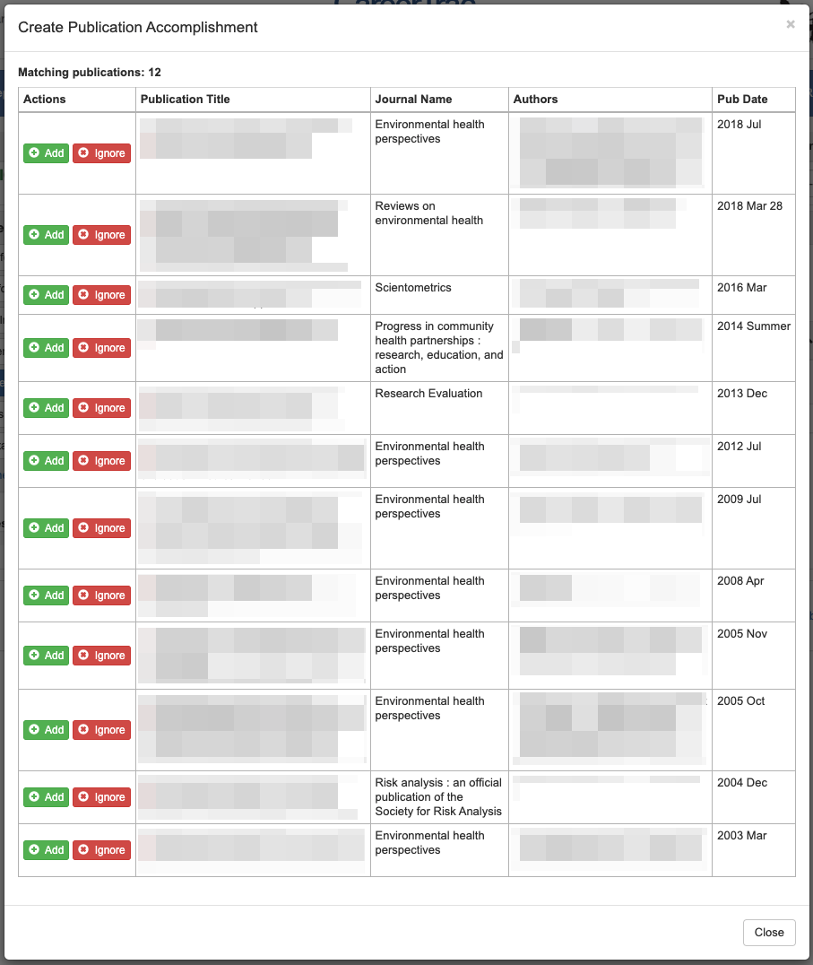

Accomplishments – Publications, Import (PubMed Search)
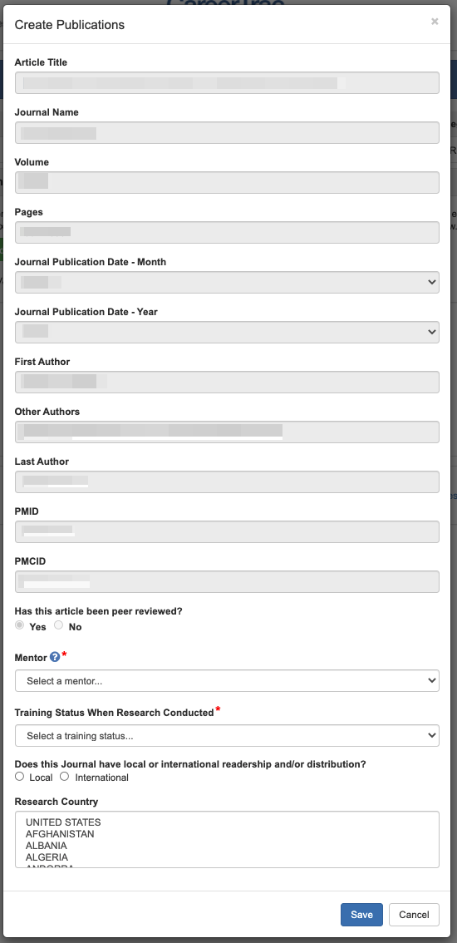

Accomplishments – Publications (Manual Entry)
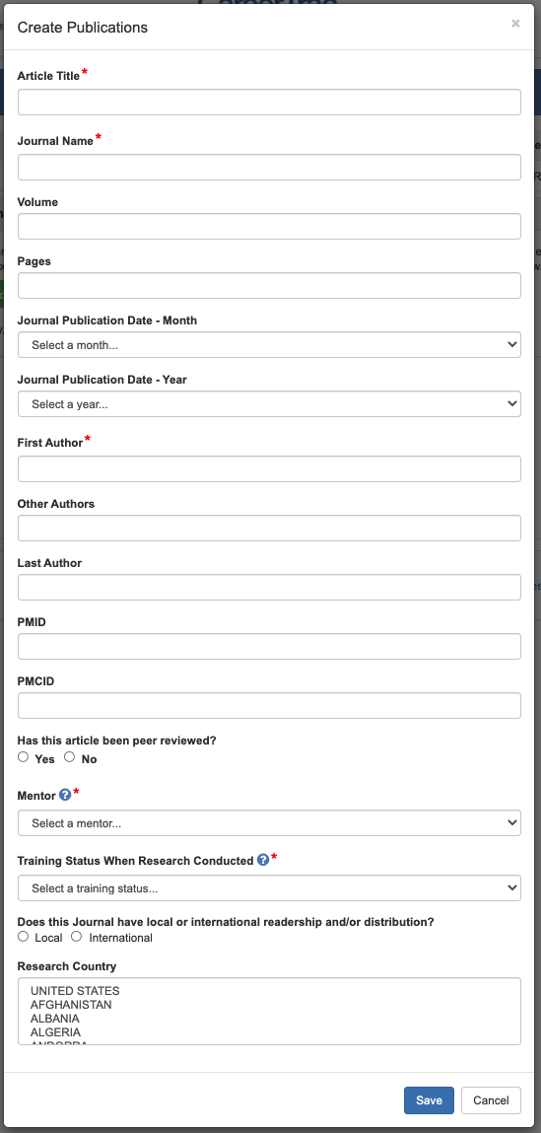

Accomplishments – Students
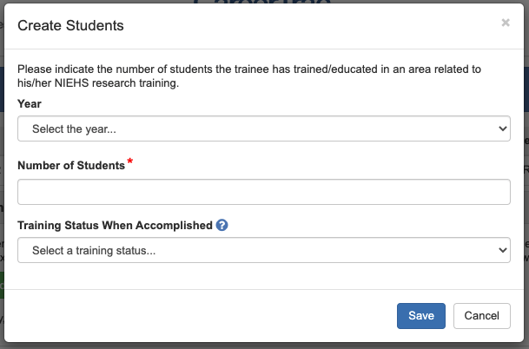

Comments Page
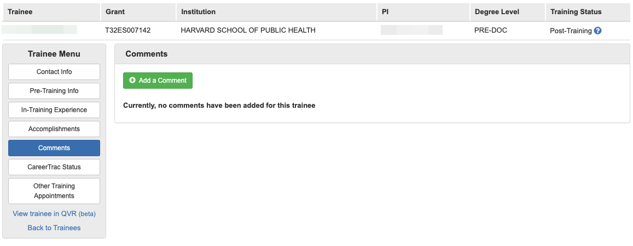

Comments Page – Add Comment
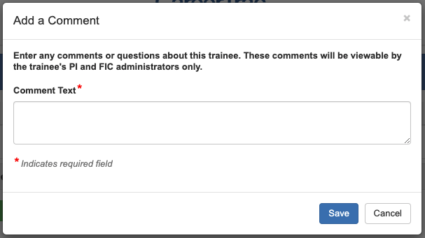

CareerTrac Status Page
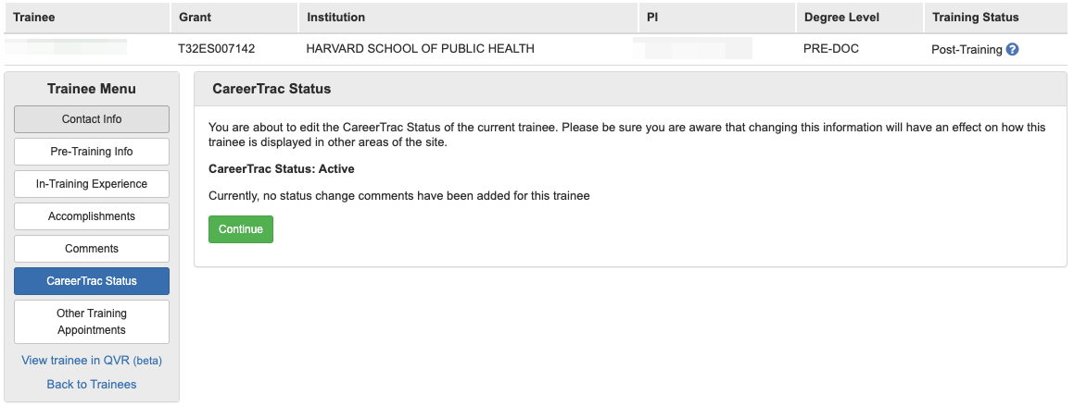

CareerTrac Status Page – Change Status
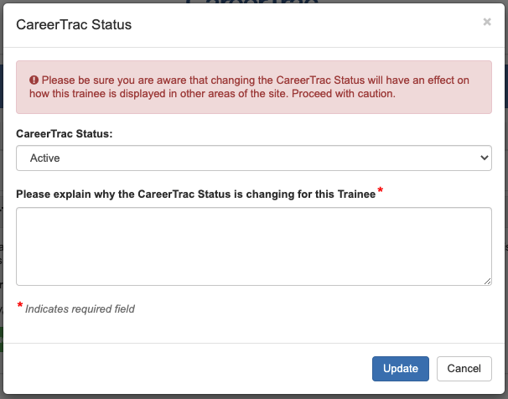

Program Information Page
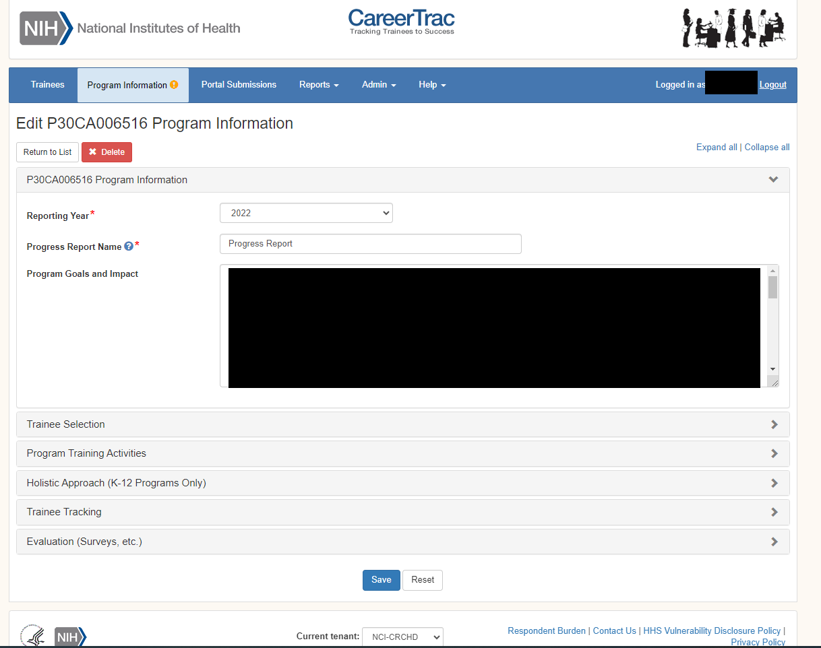

Program Information, Trainee Selection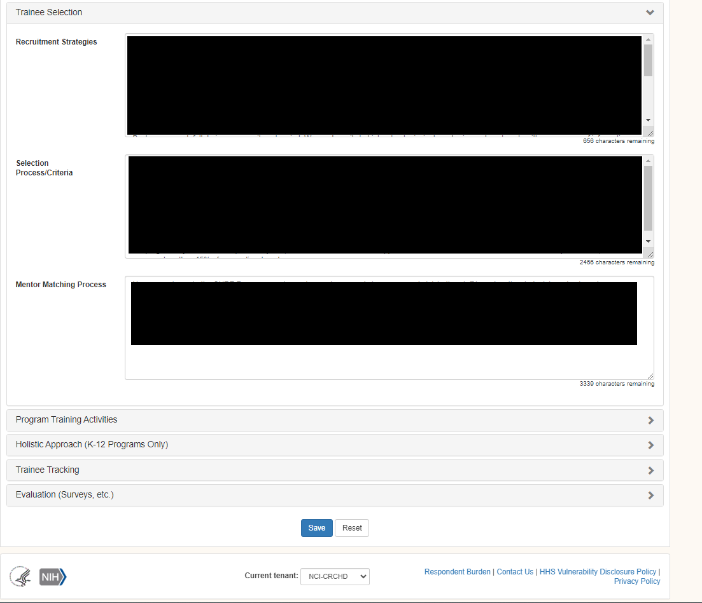

Program Information, Program Training Activities
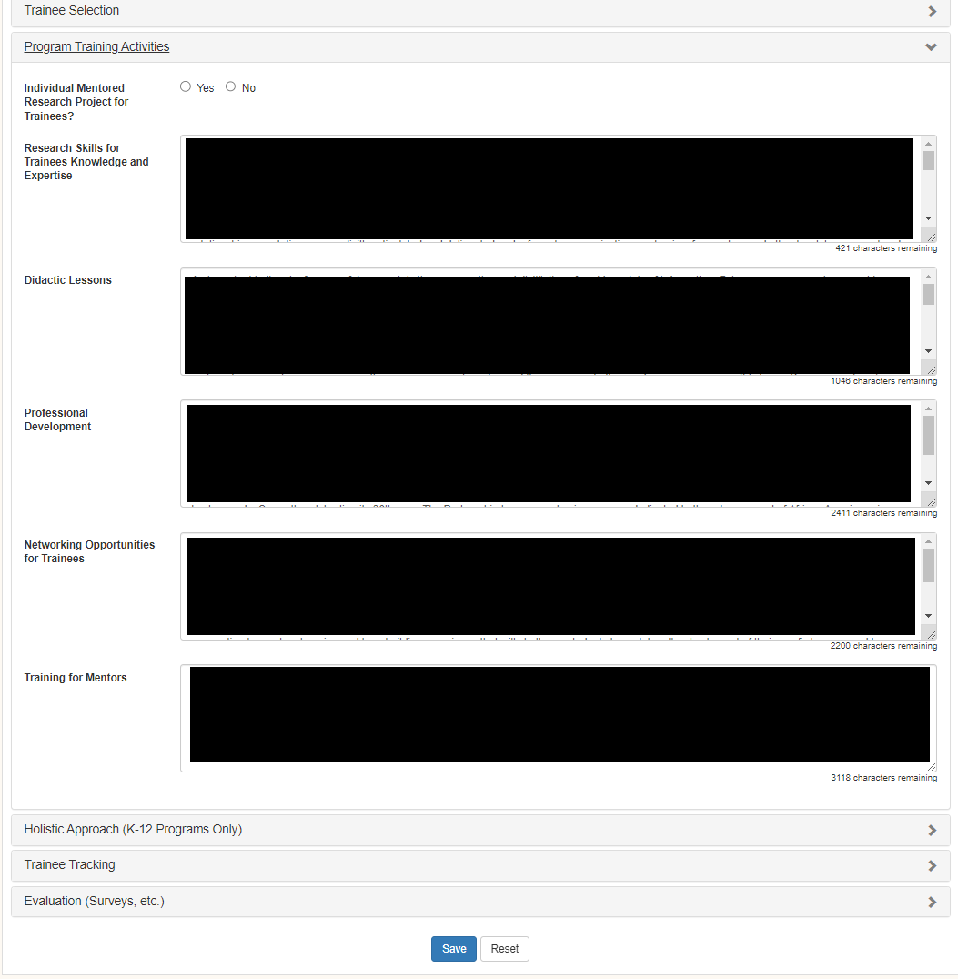

Program Information, Holistic Approach
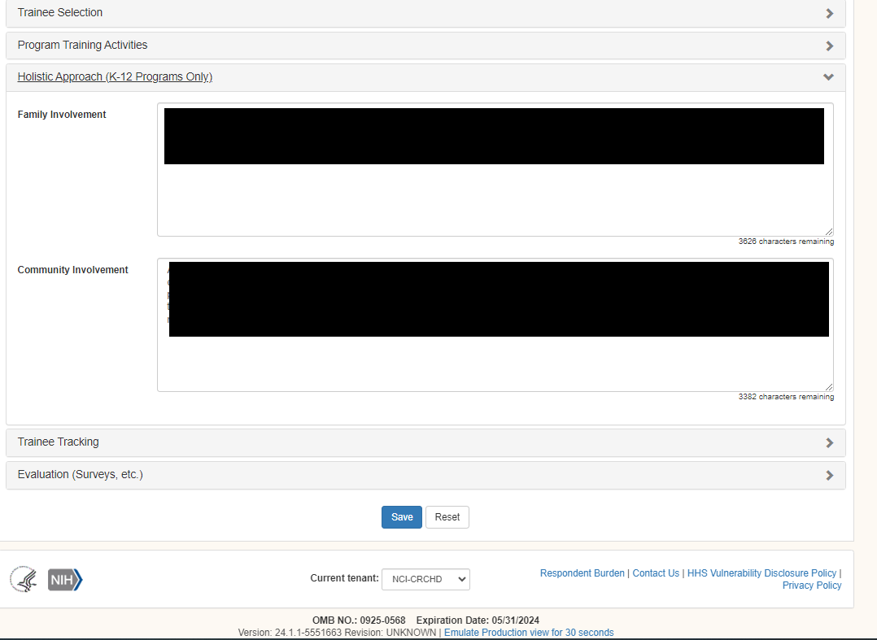

Program Information, Trainee Tracking
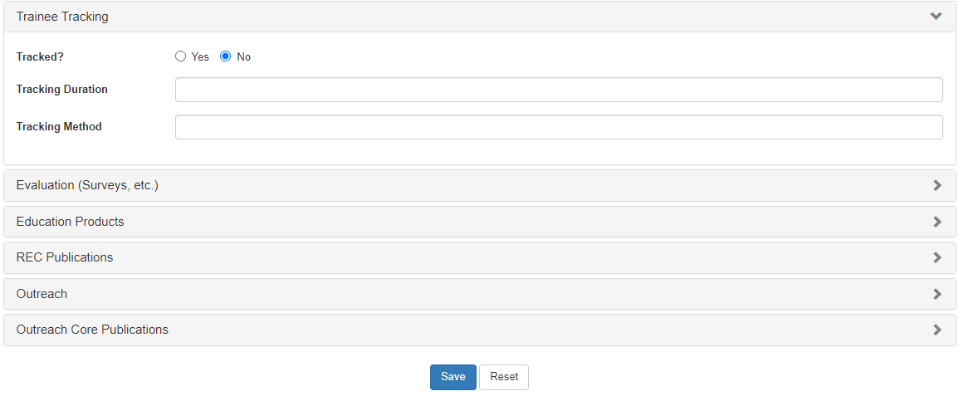

Program Information, Evaluation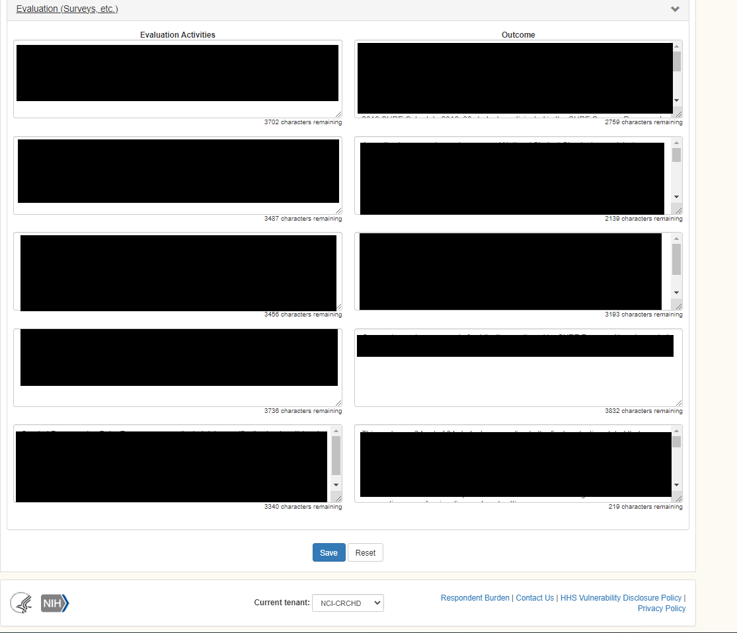

Program Information, Teacher Activities
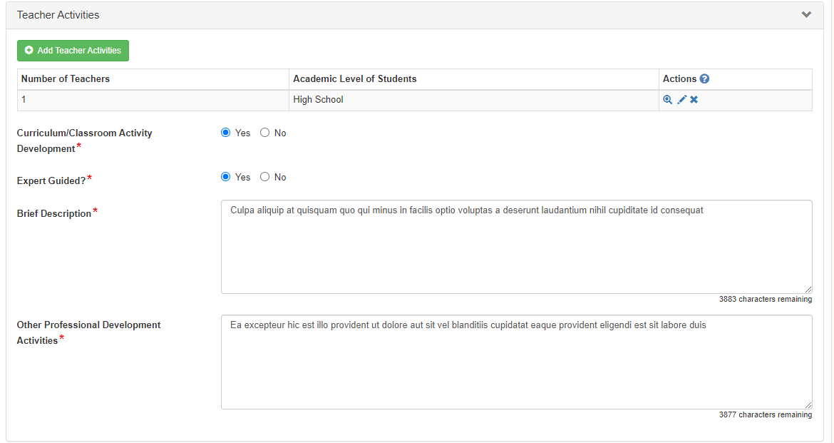

Program Information, Teacher Activities (Create Teacher Activities)
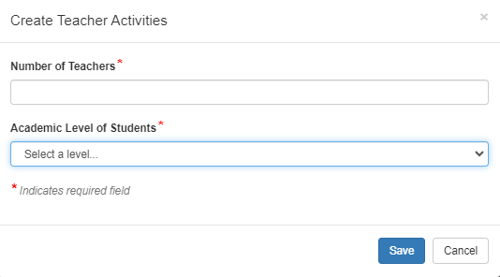

Program Information, Education Products
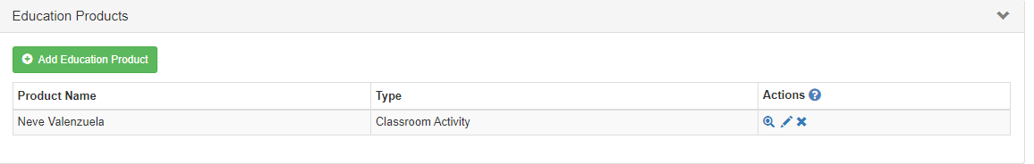

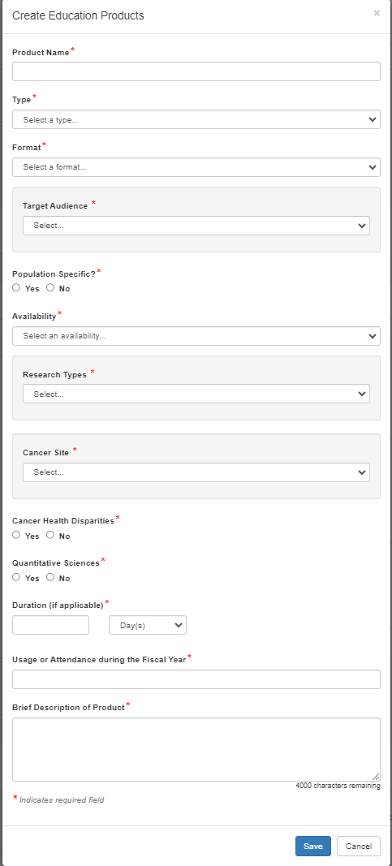
Program Information, Education Products (Create Education Product)

Program Information, Education Products (Create Education Product; conditional Items shown)
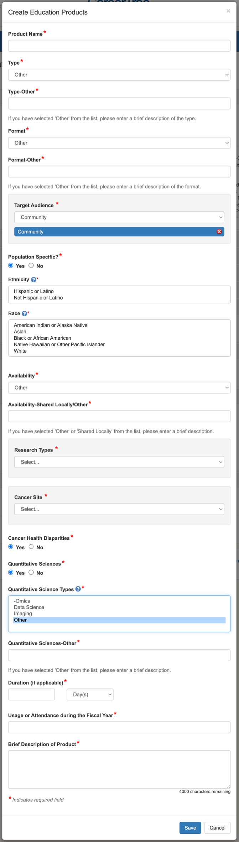

Program Information, Outreach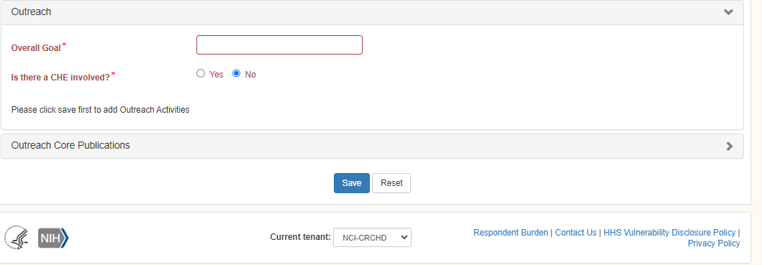

Program Information, Outreach (conditional items shown)
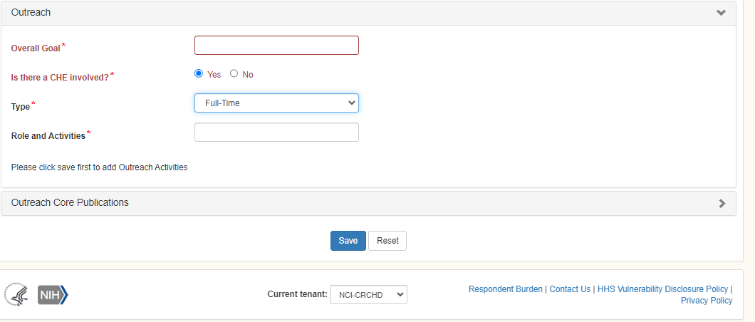

Program Information, Outreach (Create Outreach Activity, Program A)
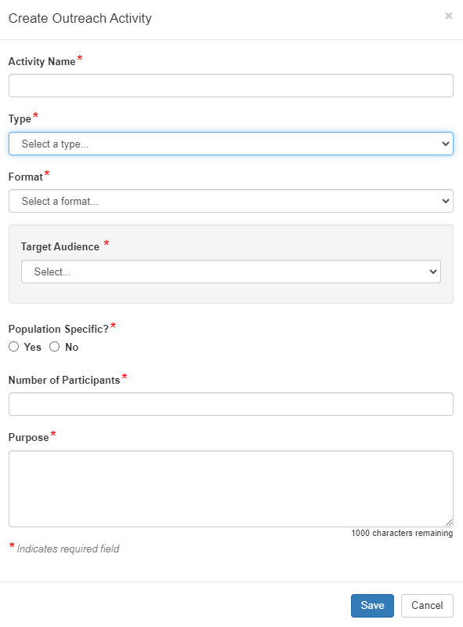

Program Information, Outreach (Create Outreach Activity, Program A; conditional items shown)
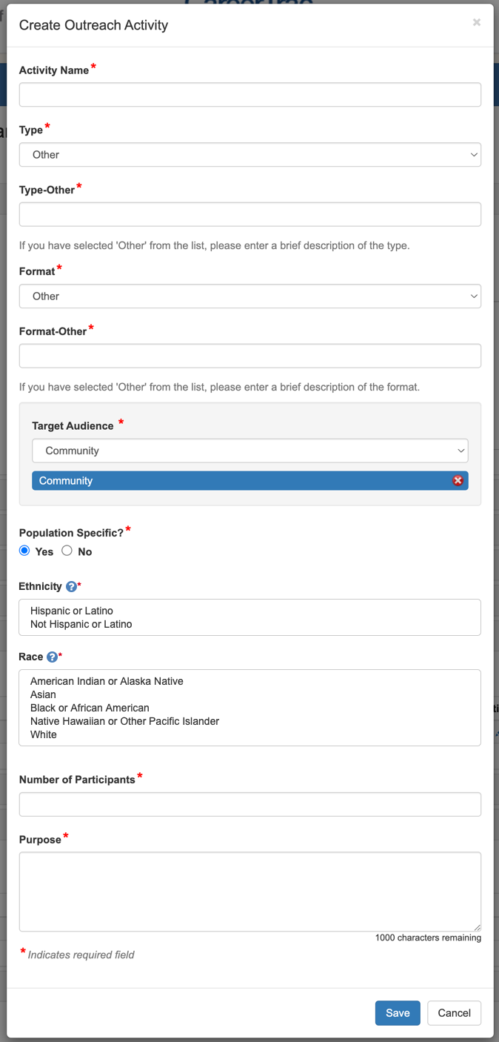

Program Information, Outreach (Create Outreach Activity, Program B)
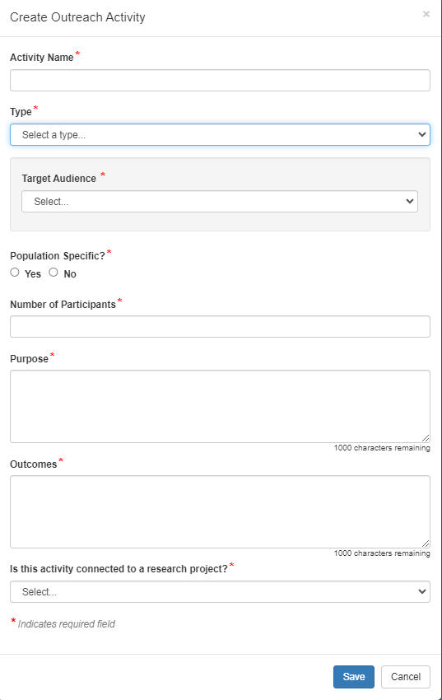

Program Information, Outreach (Create Outreach Activity, Program B; conditional items shown)
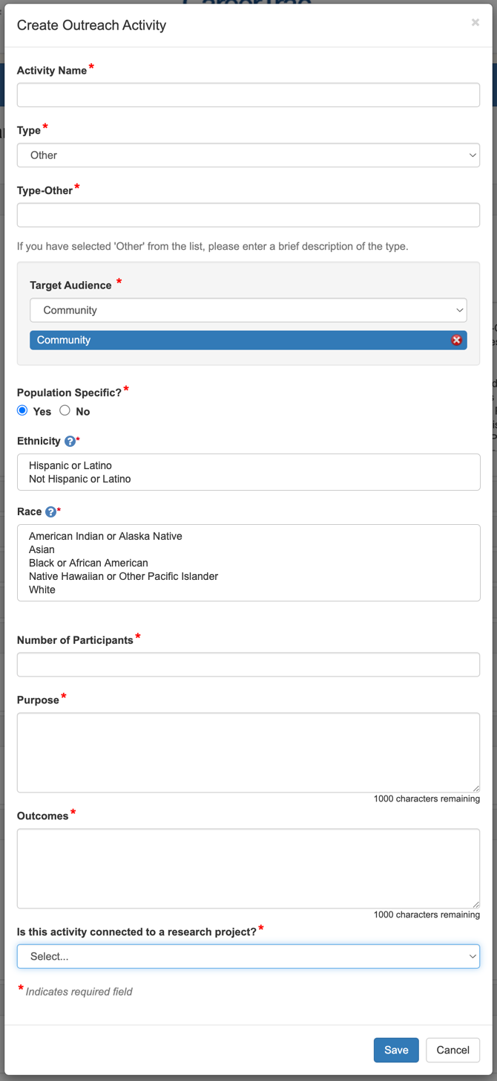

Program Information, Collaboration Efforts
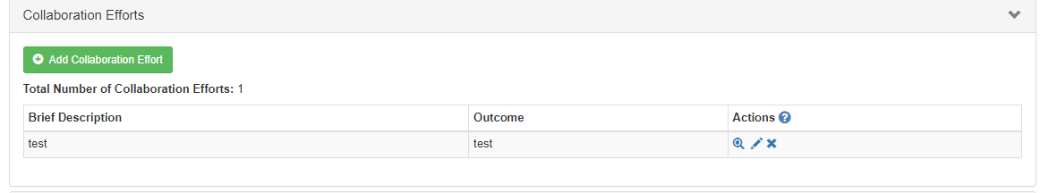

Program Information, Collaboration Efforts (Create Collaboration Effort)
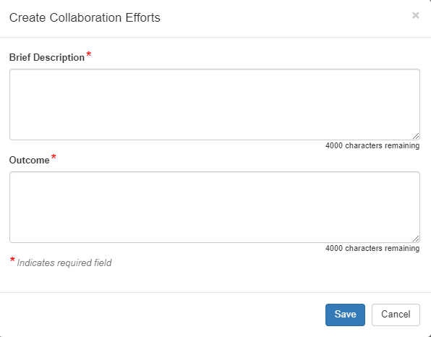

Program Information, Program Publications
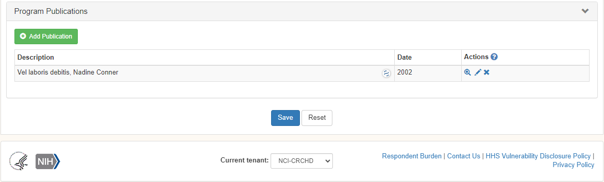

Program Information, Program Publications (Create Publication; Search/Import)
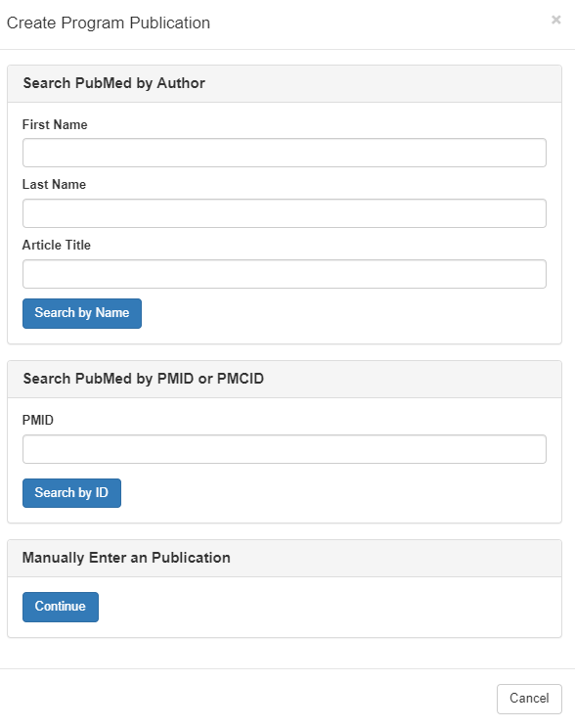

Program Information, Program Publications (Create Publication, manual)
