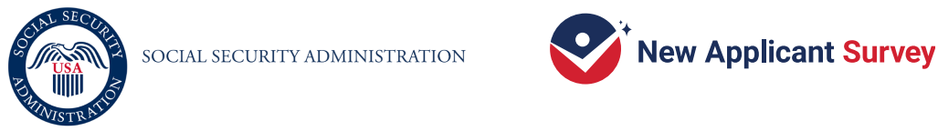
OMB Approval Number: XXXX-XXXX
Approval Expires: mm/dd/yyyy

[Date]

Dear [Respondent Name]:

You are invited to participate in the New Applicant Survey, a national survey conducted by the Social Security Administration (SSA). The survey collects information about people who recently applied for Social Security disability benefits (i.e., Supplemental Security Income [SSI] or Social Security Disability Insurance [SSDI]), their experiences before and during the application process, what led them to apply for disability benefits, and what they might have needed help with. By completing the survey, you may help SSA improve the disability application process. SSA hired Westat, a national research company, to carry out the survey.

Enclosed is 2 dollars to thank you for your taking part in this survey. Your participation is voluntary. Completing the survey will take 35 minutes or less. You can choose not to answer one or more questions and you can stop answering at any time without penalty.

Deciding to participate or not to participate in this survey will not affect your eligibility for benefits now or in the future. As described in the Information Sheet included with this letter, SSA will protect your information and use it for limited purposes in accordance with the Privacy Act and other Federal laws, regulations, and directives. Your name and other identifying information will not be included in any reports.

To participate, use your Internet browser to go to the website link provided below or scan the QR code. Then, when asked, enter your unique PIN (password) to access the survey. [IF IN THE CONCURRENT EXPERIMENT GROUP DISPLAY: You can also complete the survey by paper if you like.]

- [IF SEQUENTIAL, NO EARLY BIRD DISPLAY: To get $40, complete the survey on the website.]
- [IF SEQUENTIAL, EARLY BIRD DISPLAY: To get $40, complete the survey on the website by {INSERT DATE}. You will receive $30 if you complete the survey after {INSERT DATE}.]
- [IF CONCURRENT, NO EARLY BIRD DISPLAY: To get $40, complete the survey on the website. If you prefer to complete the survey on paper, answer the questions in the enclosed booklet. Place your completed survey in the attached postage-paid return envelope to return it to us. You will get $30 after you send us your completed survey.]
- [IF CONCURRENT, EARLY BIRD DISPLAY: To get $40, complete the survey on the website or on paper by {INSERT DATE}. You will receive $30 if you complete the survey after {INSERT DATE}. To complete the survey on paper, answer the questions in the enclosed booklet. Place your completed survey in the attached postage-paid return envelope to return it to us.
- Website: https://xxxxx.org PIN: XXXXXX 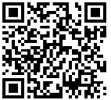

For questions about the survey, please call the Help Desk at 1-855-450-6464. For questions about your rights and welfare as a research participant, call the Westat Human Subjects Protections office at 1-888-920-7631. Leave a message with only your first name, the name of the research study (New Applicant Survey), and your phone number beginning with the area code. Someone will get back to you as soon as possible.

Thank you for helping improve the application process for future applicants.

Sincerely,

[Signature of SSA Official]

