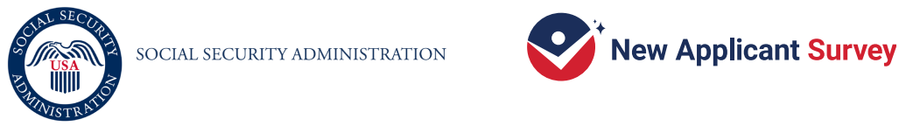
[Date] 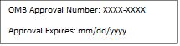

Dear [Respondent Name]:

There’s still time for you to help.
A week ago, we sent you an invitation to participate in the New Applicant Survey (NAS). If you have already responded, thank you!

Your participation is important to the Social Security Administration (SSA). By participating you may help SSA improve the disability application process. SSA hired Westat, a national research company, to carry out the survey. It will take 35 minutes or less to complete.

Deciding to participate or not to participate in this survey will not affect your eligibility for benefits now or in the future. As described in the Information Sheet included with this letter, your participation is voluntary. SSA will protect your information and use it for limited purposes in accordance with the Privacy Act and other Federal laws, regulations, and directives. Your name and other identifying information will not be included in any reports.

To participate, use your Internet browser to go to the website link provided below [DROP IF BEING SENT VIA EMAIL: or scan the QR code]. Then, when asked, enter your unique PIN (password) to access the survey. You can also complete the survey by paper if you like.
- [IF NO EARLY BIRD DISPLAY: To get $40, complete the survey on the website. If you prefer to complete the survey on paper, answer the questions in the enclosed booklet. Place your completed survey in the attached postage-paid return envelope to return it to us. You will get $30 after you send us your completed survey.]
- [IF EARLY BIRD DISPLAY: To get $30, complete the survey on the website or on paper. To complete the survey on paper, answer the questions in the enclosed booklet. Place your completed survey in the attached postage-paid return envelope to return it to us.]
- Website: https://xxxxx.org PIN: XXXXXX 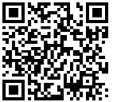

For questions about the survey, please call the Help Desk at 1-855-450-6464. For questions about your rights and welfare as a research participant, call the Westat Human Subjects Protections office at 1-888-920-7631. Leave a message with only your first name, the name of the research study (New Applicant Survey), and a phone number beginning with the area code. Someone will get back to you as soon as possible.

Thank you for helping improve the application process for future applicants.

Sincerely,

[Signature of an SSA Official]

