Below are images of wind turbines seen from five miles away and from 20 miles away. Please review the images. Beyond 30 miles, wind turbines are generally not visible.

Wind turbines five miles away.

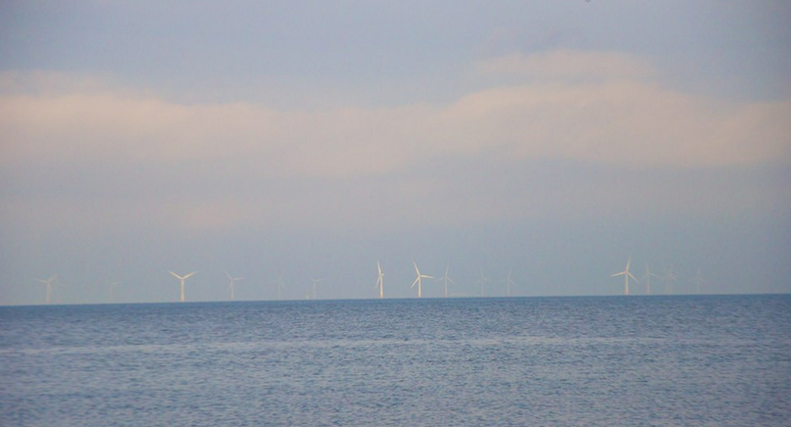
Wind turbines 20 miles away.

