WIND TURBINES IN COOK INLET
12. There are currently no wind turbines in Cook Inlet, but wind turbines have been built in some areas of the United States, both on land in in coastal waters.
Have you personally seen wind turbines on land or in the ocean?
Yes
No
13. What do you think about wind power as a source of energy in the United States?
Favor
Somewhat favor
Neither favor nor oppose
Somewhat oppose
Oppose

Below are images of wind turbines seen from five miles away and from 20 miles away. Please review the images. Beyond 30 miles, wind turbines are generally not visible.
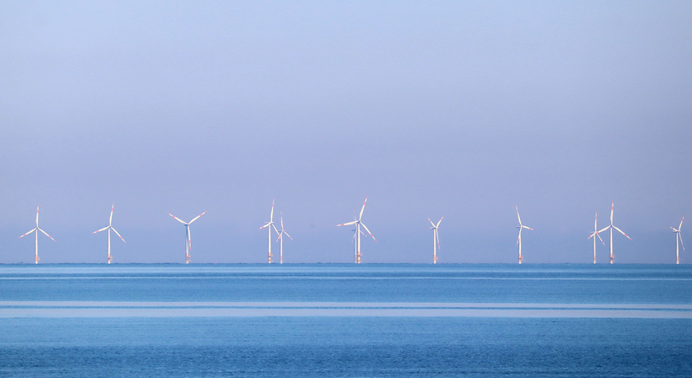
Wind turbines five miles away.

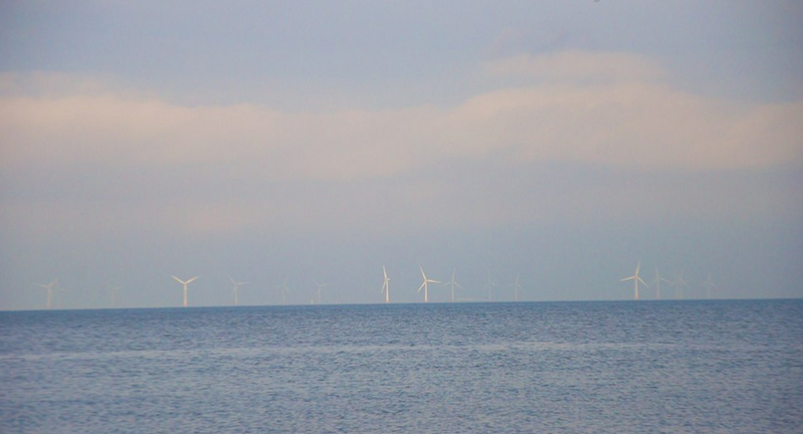
Wind turbines 20 miles away.

14. How would wind turbines affect your recreation experience if you could see them from places you like to go on the shore? My experience would be …
Worse
Somewhat worse
Neither worse nor better
Somewhat better
Better
15. If you go boating or kayaking, how would wind turbines affect your recreation experience if you could see them from places you like to go on the water? My experience would be …
Worse
Somewhat worse
Neither worse nor better
Somewhat better
Better
Not applicable - I don’t go boating or kayaking
16. Wind turbines often create artificial reef habitat that attracts and supports some types of fish. If you go fishing, how would wind turbines affect your recreation experience if they created habitat for fish you liked to catch? My experience would be …
Worse
Somewhat worse
Neither worse nor better
Somewhat better
Better
Not applicable - I don’t go fishing

WIND TURBINES NEAR ANCHOR POINT
For the questions on the next page, suppose there were 15 wind turbines as shown on the map below.
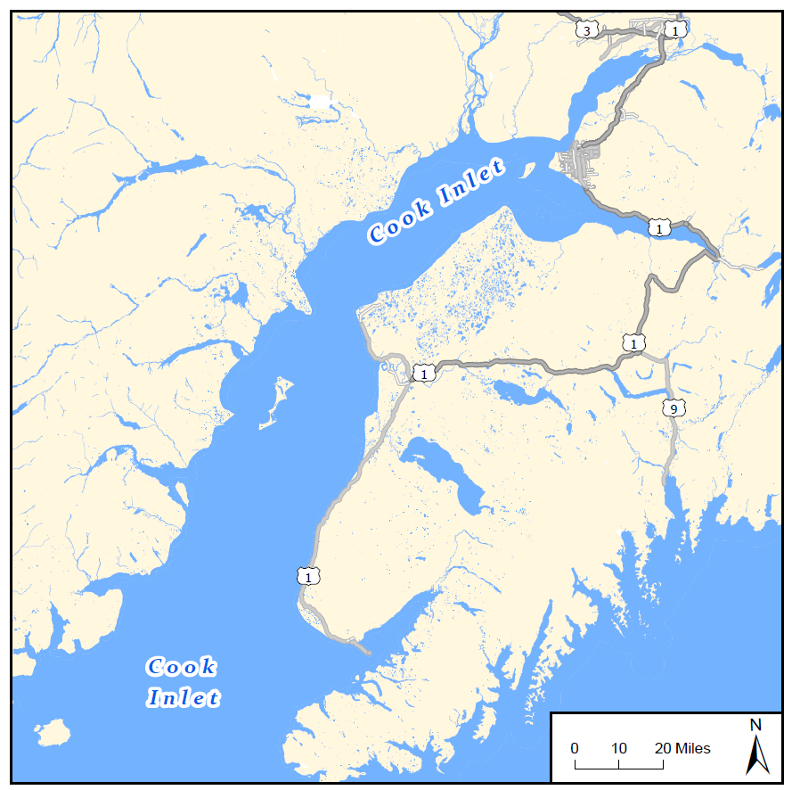

Anchorage

Kenai

Homer
Anchor Point

Wind turbine
A distance of 5 miles from the platforms.
A distance of 20 miles from the platforms.
Wind Turbines Near Anchor Point
There are currently no wind turbines in Cook Inlet. Suppose there were about 15 wind turbines in Lower Cook Inlet near Anchor Point (refer to the map on the opposite page). Suppose that…
- The wind turbines are visible from Anchor Point, Homer, and nearby sites.
- The base of each wind turbine is about 30 feet by 30 feet in size.
- Wind turbines create artificial reef habitat that attracts and supports some types of fish, primarily Rockfish and Lingcod.
- From a boat close to the wind turbines, it would be possible to hear the sound of the wind turbines moving through the air.

17. If there were wind turbines near Anchor Point with the features described above, would you have gone more times, fewer times, or the same number of times in the last 12 months to Anchor Point, Homer, and nearby sites? Please check one box.
More times  Please answer the questions below.  - How many more overnight trips would you have taken to Anchor Point, Homer, and nearby sites?  ______ more overnight trips  - How many more times would you have gone for a day or less to Anchor Point, Homer, and nearby sites?  ______ more times for a day  or less  - Would you continue to go more times year after year, or would you have gone more only at first out of curiosity?  I would go more year after  year  I would go more only at first | Fewer times  Please answer the questions below.  - How many fewer overnight trips would you have taken to Anchor Point, Homer, and nearby sites?  ______ fewer overnight trips  - How many fewer times would you have gone for a day or less to Anchor Point, Homer, and nearby sites?  ______ fewer times for a day  or less  - For the times you wouldn’t have gone to Anchor Point, Homer, and nearby sites, would you have gone to other sites on Cook Inlet instead?  Never  Some of the time  Most of the time | The same  number  of times  Please continue to the next page

NOTICES

Privacy Notice: The Bureau of Ocean Energy Management (BOEM) is conducting this survey to obtain reliable data and information on outdoor recreation and tourism in the Cook Inlet OCS Planning Area and adjacent coastal areas in order to evaluate the extent to which its activities may adversely affect the human environment. Your participation in this survey is voluntary and your responses are confidential. This survey does not collect any data that will allow anyone to associate responses you provide back to you. Anonymized, aggregated data will be shared in a final report. Only approved personnel will have access to the complete data we collect from you. We take the appropriate steps to secure data and prevent any threats to data confidentiality.
PAPERWORK REDUCTION ACT STATEMENT: BOEM is collecting this information subject to the Paperwork Reduction Act (44 U.S.C. 3501 et seq.). BOEM may not conduct or sponsor, and a person is not required to respond to, a collection of information unless it displays a currently valid OMB control number and expiration date. OMB has reviewed and approved this survey and assigned OMB Control Number 1010-#### (expiration date: ##/##/20##).
BURDEN ESTIMATE STATEMENT: BOEM estimates this survey will take you 12 minutes to complete. Comments regarding the burden estimate or any other aspect of this form may be submitted to the Information Collection Clearance Officer, Bureau of Ocean Energy Management, 45600 Woodland Road, Sterling, VA 20166.

