OUTDOOR RECREATION IN COOK INLET AND SHELIKOF STRAIT
This survey is about times you went to Cook Inlet or Shelikof Strait for outdoor activities like fishing, kayaking, or wildlife viewing. It is sponsored by the Bureau of Ocean Energy Management and will help guide decisions about resource use.
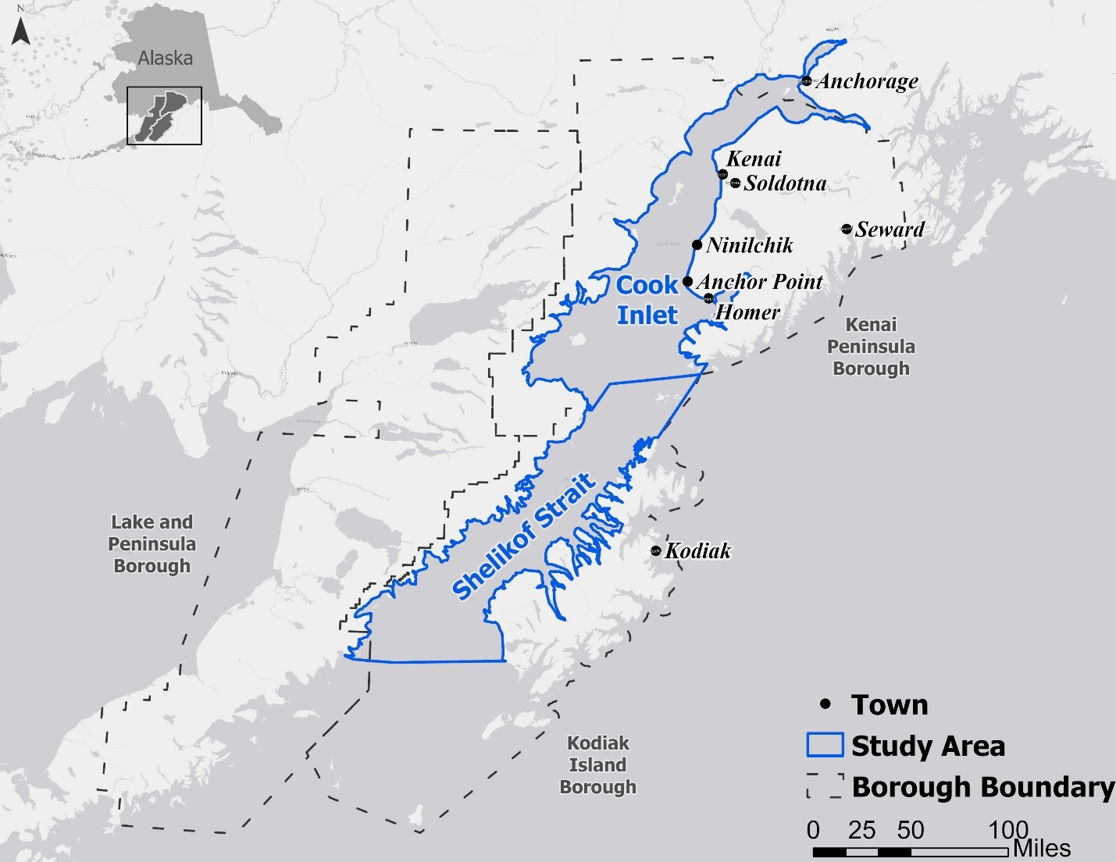

NOTICES

Privacy Notice: The Bureau of Ocean Energy Management (BOEM) is conducting this survey to obtain reliable data and information on outdoor recreation and tourism in the Cook Inlet OCS Planning Area and adjacent coastal areas in order to evaluate the extent to which its activities may adversely affect the human environment. Your participation in this survey is voluntary and your responses are confidential. This survey does not collect any data that will allow anyone to associate responses you provide back to you. Anonymized, aggregated data will be shared in a final report. Only approved personnel will have access to the complete data we collect from you. We take the appropriate steps to secure data and prevent any threats to data confidentiality.
PAPERWORK REDUCTION ACT STATEMENT: BOEM is collecting this information subject to the Paperwork Reduction Act (44 U.S.C. 3501 et seq.). BOEM may not conduct or sponsor, and a person is not required to respond to, a collection of information unless it displays a currently valid OMB control number and expiration date. OMB has reviewed and approved this survey and assigned OMB Control Number 1010-#### (expiration date: ##/##/20##).
BURDEN ESTIMATE STATEMENT: BOEM estimates this survey will take you 12 minutes to complete. Comments regarding the burden estimate or any other aspect of this form may be submitted to the Information Collection Clearance Officer, Bureau of Ocean Energy Management, 45600 Woodland Road, Sterling, VA 20166.

The first questions are about your most recent visit to a place on Cook Inlet or Shelikof Strait, Alaska (please refer to the map on the first page). If you are currently visiting a place on Cook Inlet or Shelikof Strait, consider this your most recent visit.
- What was the date of your most recent visit to a place on Cook Inlet or Shelikof Strait for outdoor activities like fishing, kayaking, or wildlife viewing?
____ /____ /______ mm/dd/yyyy
- What was the location of your most recent visit to a place on Cook Inlet or Shelikof Strait?
Site name: ________________________________________
Nearest city or town: ________________________________
- How many adults and children were with you?
_____1_____ yourself
___________ number of adults 18 and older
___________ number of children under 18
- What activities did you take part in? Please check all that apply.
Saltwater fishing
Sea kayaking
Wildlife viewing
Canoeing
Glacier viewing
Other: _________________

- Was your most recent visit to a place on Cook Inlet or Shelikof Strait part of a trip away from home lasting more than one day? Please check yes or no.
Yes If yes, please answer A and B below.
- Were activities like fishing, kayaking or wildlife viewing the main reason for your trip?
Yes No
- How many days did you spend in Alaska during your trip?
______ days
- How many days did you spend time at Cook Inlet or Shelikof Strait during your trip?
______ days
No

- What kind of car did you drive on your most recent visit to Cook Inlet or Shelikof Strait?
Small car
Medium car
Large car
Small SUV
Medium SUV
Large SUV
Minivan
Pickup truck
Hybrid car
Electric car
Motorcycle
- Did you use a boat that belongs to you? Please check yes or no.
Yes Was the boat kept at the place where you launched, was it trailered,
or was it carried on a vehicle?
Kept where I fished
Trailered
Carried on a vehicle
No
- How much did you and the people with you spend on your most recent visit to Cook Inlet or Shelikof Strait? Fill in the blank for each item.
- If you didn’t spend money on an item, please enter 0.
- If it was an overnight trip away from home, tell us whether the cost was per-day or for the whole trip.
Amount
in Dollars Circle One

- Food and drink .......................................... $ __________ per-day / whole trip
- Gasoline ………………………………………………… $ __________ per-day / whole trip
- Boat launch fees ………............................... $ __________ per-day / whole trip
- Park entrance fees …….............................. $ __________ per-day / whole trip
- Motel/hotel/vacation rental .................... $ __________ per-day / whole trip
- Guide or charter fees ............................... $ __________ per-day / whole trip
- Equipment rental ..................................... $ __________ per-day / whole trip
- Car rental …………….................................... $ __________ per-day / whole trip
- Taxi or rideshare ……….............................. $ __________ per-day / whole trip
- Parking fees and bridge tolls .................... $ __________ per-day / whole trip
- Clothing purchased locally ....................... $ __________ per-day / whole trip
- Bait, lines, lures, hooks, sinkers, etc. ....... $ __________ per-day / whole trip
- Sightseeing flights …….……………………….…. $ __________ per-day / whole trip
- Other flights within Alaska ………………..…. $ __________ per-day / whole trip

OVERNIGHT TRIPS TO COOK INLET IN THE LAST 12 MONTHS
An overnight trip is any time you spent at least one night away from home and activities like fishing, kayaking, or wildlife viewing were the main purpose of your trip.
The map below shows Cook Inlet, Alaska. For each area shown on the map below, please write in the box the number of overnight trips you took, if any, during the last 12 months, up to and including today.
- List each trip once. If you went to more than one place during your trip, list the trip once at the place you spent the most time.
- Use the closest site. If the site you went to is not named on the map, list the trip at the closest place shown.
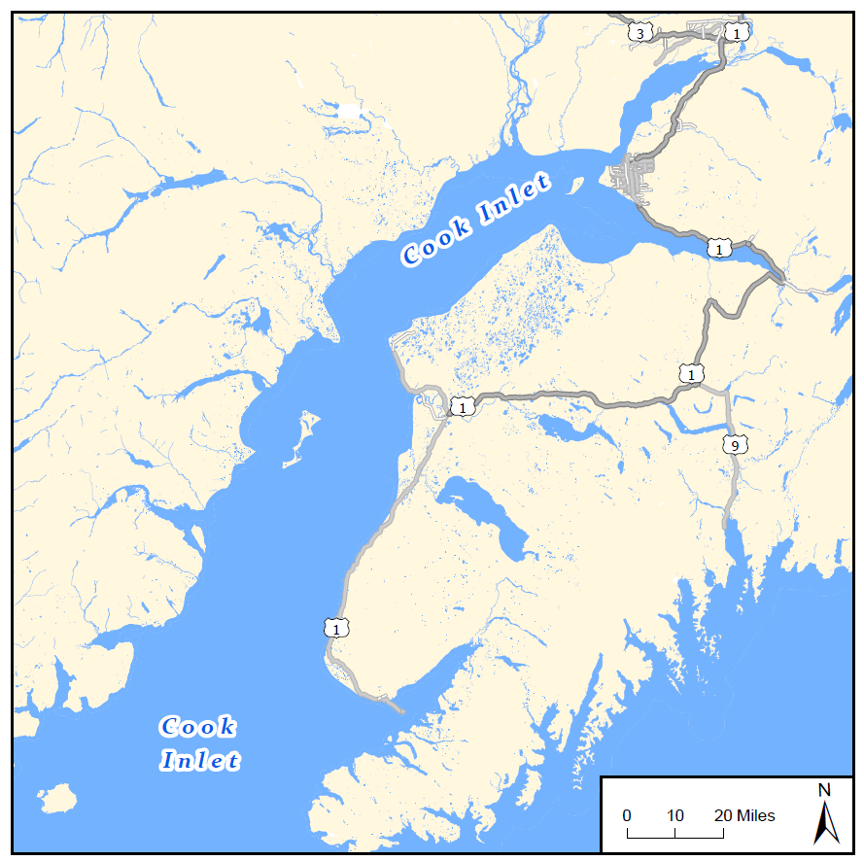
- If you used a boat or charter operator, list the trip at the place where you launched.

Overnight trips to Cook
Inlet in the Anchorage area
Anchorage

Overnight trips to Captain Cook, Nikiski, and nearby sites
Captain Cook Recreation Area
Nikiski
Overnight trips to Kenai and nearby sites
Kenai
Kasilof River Recreation Site
Overnight trips to Kasilof, Clam Gulch, and nearby sites
Clam Gulch Recreation Area

Overnight trips to Ninilchik, Deep Creek, and nearby sites
Ninilchik
Deep Creek Recreation Area
Anchor Point
Overnight trips to Anchor Point, Homer, and nearby sites
Homer

TIMES YOU WENT FOR A DAY OR LESS IN THE LAST 12 MONTHS
This includes any time you spent all or part of a day doing outdoor activities like fishing, kayaking or wildlife viewing, and you returned home the same day.
For each area on the map below, please fill in the number of times you went for a day or less, if any, during the last 12 months, up to and including today.
- Use the closest site. If the site you went to is not named on the map, list the visit at the closest place shown.
- If you used a boat or charter operator, list the visit at the place where you launched.

Times for a day or less to Cook
Inlet in the Anchorage area
Anchorage

Times for a day or less to Captain Cook, Nikiski, and nearby sites
Captain Cook Recreation Area
Nikiski
Times for a day or less to Kenai and nearby sites
Kenai
Kasilof River Recreation Site
Times for a day or less to Kasilof, Clam Gulch, and nearby sites
Clam Gulch Recreation Area
Ninilchik
Times for a day or less to Ninilchik, Deep Creek, and nearby sites
Deep Creek Recreation Area

Times for a day or less to Anchor Point, Homer, and nearby sites
Anchor Point
Homer

- The west side of Cook Inlet includes places like Lake Clark National Park. Did you go to places on the west side of Cook Inlet for activities like fishing, kayaking, or wildlife viewing in the last 12 months?
Yes No
If yes Please describe which places you went, what you did, and how many overnight
or day trips you took to each place.
_____________________________________________________________________
_____________________________________________________________________
_____________________________________________________________________
_____________________________________________________________________

- Shelikof Strait is shown on the map below, and includes places like Katmai National Park, Hallo Bay, and Karluk. Did you go to places on Shelikof Strait for activities like fishing, kayaking, or wildlife viewing in the last 12 months?
Yes No
If yes Please describe which places you went, what you did, and how many
overnight or day trips you took to each place.
_____________________________________________________________________
_____________________________________________________________________
_____________________________________________________________________
_____________________________________________________________________
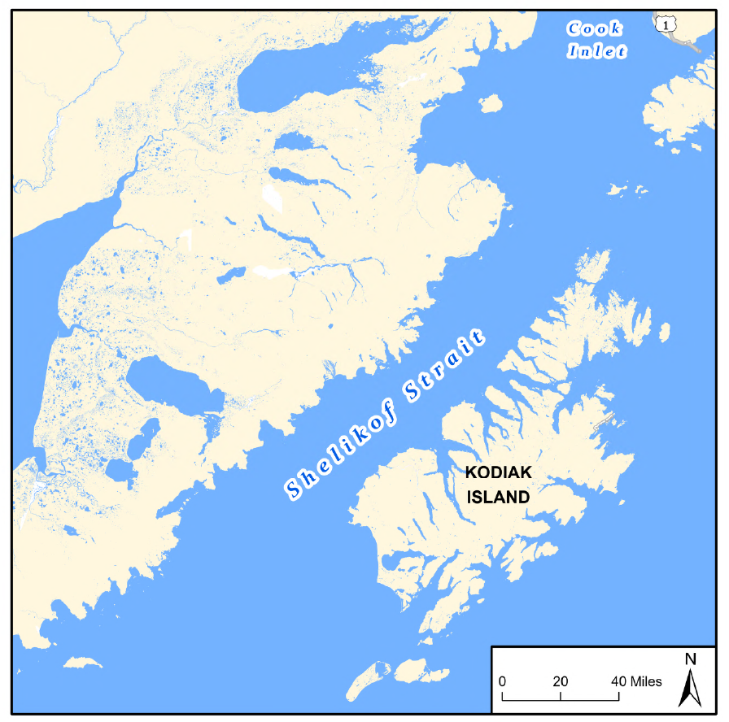

- Thinking about all your recreation visits on Cook Inlet or Shelikof Strait in the last 12 months, how much of it took place in the months of May, June, July, August, or September?
All of it took place in those months
Almost all of it
About 75% of it
About 50% of it
About 25% of it
Something else: Explain __________________________________________

- Thinking about all your recreation visits on Cook Inlet or Shelikof Strait in the last 12 months, how often did you arrive at a recreation site before 8:30 am or after 6 pm?
I never arrived before 8:30 am or after 6 pm
Almost never
About 25% of the time
About 50% of the time
About 75% of the time
Something else: Explain __________________________________________

- When thinking about a place to go for outdoor activities like fishing, kayaking, or wildlife viewing, how much do you like or dislike the following things? Please check one box in each row.
Dislike a lot |  |  |  |  |  | Neutral |  |  |  |  |  | Like a lot
 | 1 |  |  | 2 |  | 3 |  |  |  |  |  | 4 | 5
There are not many people around |  |  | ₁ |  |  | ₂ |  |  | ₃ |  |  |  | ₄ |  |  | ₅
There is little or no vessel traffic in the area |  |  | ₁ |  |  | ₂ |  |  | ₃ |  |  |  | ₄ |  |  | ₅
The view is nice |  |  | ₁ |  |  | ₂ |  |  | ₃ |  |  |  | ₄ |  |  | ₅
You can catch a lot of fish |  |  | ₁ |  |  | ₂ |  |  | ₃ |  |  |  | ₄ |  |  | ₅
You are likely to see wildlife |  |  | ₁ |  |  | ₂ |  |  | ₃ |  |  |  | ₄ |  |  | ₅
Bathrooms are available |  |  | ₁ |  |  | ₂ |  |  | ₃ |  |  |  | ₄ |  |  | ₅
There is enough parking |  |  | ₁ |  |  | ₂ |  |  | ₃ |  |  |  | ₄ |  |  | ₅
Parking is free |  |  | ₁ |  |  | ₂ |  |  | ₃ |  |  |  | ₄ |  |  | ₅
It is close to where you live |  |  | ₁ |  |  | ₂ |  |  | ₃ |  |  |  | ₄ |  |  | ₅
You can see glaciers |  |  | ₁ |  |  | ₂ |  |  | ₃ |  |  |  | ₄ |  |  | ₅
The area is quiet and free of noise |  |  | ₁ |  |  | ₂ |  |  | ₃ |  |  |  | ₄ |  |  | ₅
The is little or no trash on the shore |  |  | ₁ |  |  | ₂ |  |  | ₃ |  |  |  | ₄ |  |  | ₅

OIL PLATFORMS IN COOK INLET
- There are oil platforms in some parts of upper Cook Inlet. Have you personally seen oil platforms in Cook Inlet?
Yes
No
- What do you think about the development of more oil platforms in Cook Inlet?
Favor
Somewhat favor
Neither favor nor oppose
Somewhat oppose
Oppose

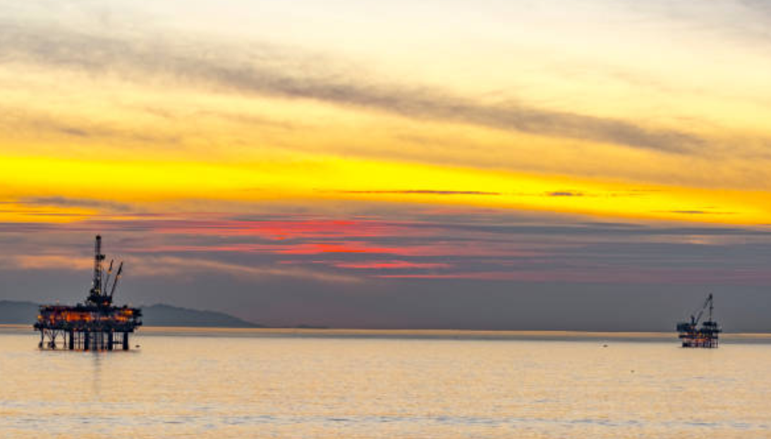
Below are images of oil platforms seen from 5 miles away and from 20 miles away. Please review the images. Beyond 40 miles, oil platforms are not visible.

Oil platforms five miles away.
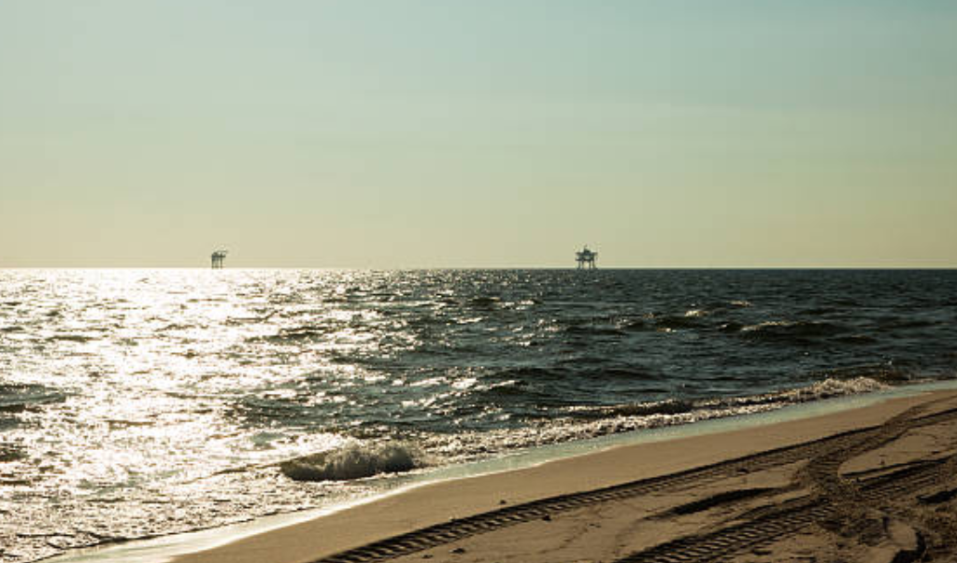

Oil platforms 20 miles away.
- How would oil platforms affect your recreation experience if you could see them from places you like to go on the shore? My experience would be …
Worse
Somewhat worse
Neither worse nor better
Somewhat better
Better
- If you go boating or kayaking, how would oil platforms affect your recreation experience if you could see them from the places you like to go on the water? My experience would be …
Worse
Somewhat worse
Neither worse nor better
Somewhat better
Better
Not applicable - I don’t go boating or kayaking
- Oil platforms often create artificial reef habitat that attracts and supports some types of fish. If you go fishing, how would oil platforms affect your recreation experience if they created habitat for fish you liked to catch? My experience would be …
Worse
Somewhat worse
Neither worse nor better
Somewhat better
Better
Not applicable - I don’t go fishing

OIL PLATFORMS NEAR ANCHOR POINT
For the questions on the next page, suppose there were 3 to 6 oil platforms as shown on the map below.

Anchorage

Kenai

Homer
Anchor Point

Oil platform
A distance of 5 miles from the platforms.
A distance of 20 miles from the platforms.
Oil Platforms near Anchor Point
There are oil platforms in upper areas of Cook Inlet between Kenai and Anchorage. There are no oil platforms south of Kenai. Suppose there were 3 to 6 oil platforms about 10 miles from shore near Anchor Point (refer to the map on the opposite page). Suppose that…
- The oil platforms are visible from Anchor Point, Homer, and nearby sites.
- There is sometimes vessel or helicopter traffic between shore and the platforms.
- There is some noise from machinery close to the platforms.
- The platforms are about 500 feet by 500 feet in size.
- Platforms create artificial reef habitat that attracts and supports some types of fish, including Rockfish and Lingcod.

- If there were oil platforms near Anchor Point with the features described above, would you have gone more times, fewer times, or the same number of times in the last 12 months to Anchor Point, Homer, and nearby sites? Please check one box.
More times  Please answer the questions below.  - How many more overnight trips would you have taken to Anchor Point, Homer, and nearby sites?  ______ more overnight trips  - How many more times would you have gone for a day or less to Anchor Point, Homer, and nearby sites?  ______ more times for a day  or less | Fewer times  Please answer the questions below.  - How many fewer overnight trips would you have taken to Anchor Point, Homer, and nearby sites?  ______ fewer overnight trips  - How many fewer times would you have gone for a day or less to Anchor Point, Homer, and nearby sites?  ______ fewer times for a day  or less  - For the times you wouldn’t have gone to Anchor Point, Homer, and nearby sites, would you have gone to other sites on Cook Inlet instead?  Never  Some of the time  Most of the time | The same  number  of times  Please continue to the next page

- How many adults and children live in your household?
_______ Adults (18 and older)
_______ Children (under 18)
- What is your gender? Please check one box.
Female
Male
Non-binary
- In what year were you born?
_______ Year
- What is your race and/or ethnicity? Select all that apply.
American Indian or Alaska Native
Asian
Black or African American
Hispanic or Latino
Middle Eastern or North African
Native Hawaiian or Pacific Islander
White
Prefer not to say
Other (please specify): ______________________

- What is the highest degree or level of school you have completed? Please check one box.
Less than high school graduate
High school graduate
Some college or associate degree
Bachelor’s degree
Graduate or professional degree, after bachelor’s degree
- What is your zip code?
_______ zip code
- Which of the following income categories best describes your total household income last year, before taxes? Please check one box.
Less than $15,000
$15,000 to $24,999
$25,000 to $34,999
$35,000 to $49,999
$50,000 to $74,999
$75,000 to $99,999
$100,000 to $149,999
$150,000 or more

Please write any comments you have about the survey in the space below.

Thank you for participating!
Please return your survey to the person who provided it to you, or mail it in the prepaid envelope addressed to:

Return Address

