NYC Audubon and Sadhana Partnership Description
February 4th, 2021

Every September, New York City Audubon joins Sadhana: Coalition of Progressive Hindus in a beach cleanup at the National Park Service’s Jamaica Bay Wildlife Refuge’s North Channel Bridge Beach in celebration of the Ocean Conservancy’s International Coastal Cleanup Day. Sadhana’s organizers work with the local Hindu community to highlight issues surrounding the impact of certain ritual prayer practices on Jamaica Bay and organize monthly cleanups at the beach. For their September cleanup, NYC Audubon brings in volunteers to work alongside Sadhana. Much of what needs to be collected falls outside of typical beach debris like cigarette butts and fishing line. Volunteers regularly find devotional items like statues of deities (murthis) and oil lamps (diyas) which are used in the practice of Ganga puja (worship to the waters). During the cleanup Sadhana educates New York City Audubon’s volunteers about these items and practices and the importance of removing the religious offerings in a respectful manner.

Sadhana has found many ways to repurpose such objects, including an exhibit of found items at the Queens Museum. In return, New York City Audubon is given the chance to reach a wider audience, spreading awareness to Sadhana’s volunteers of the importance of Jamaica Bay as bird habitat, particularly for nesting shorebirds like the American Oystercatcher. At the end of the cleanup, everyone gathers together to share lunch, which features delicious dishes provided by Sadhana’s members. These UBT city partners are grateful for the opportunity to reach a wider audience to share and learn each other’s stories--- about the cultural rituals of Hindu neighbors who call NYC home and the amazing birds that call Jamaica Bay home.

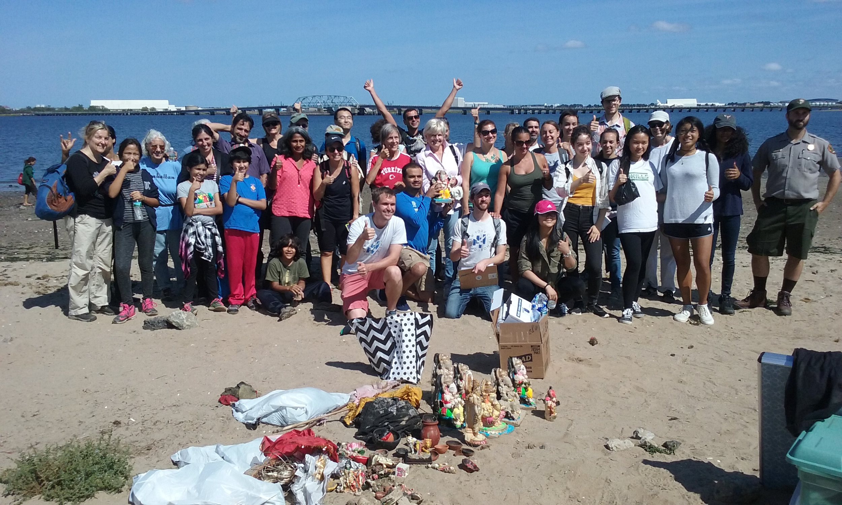
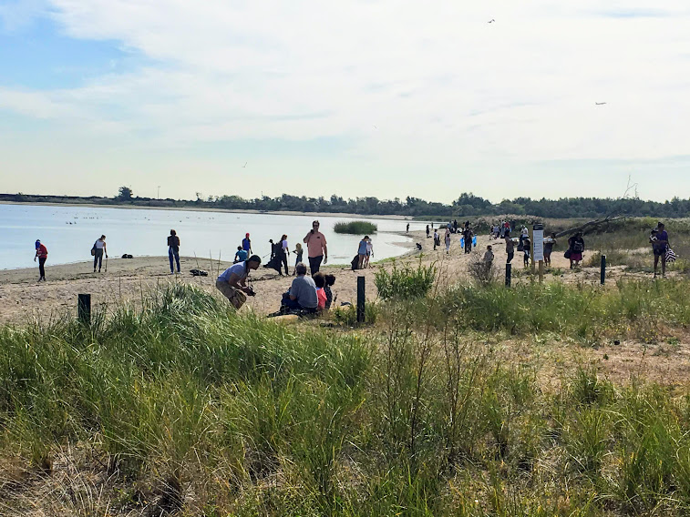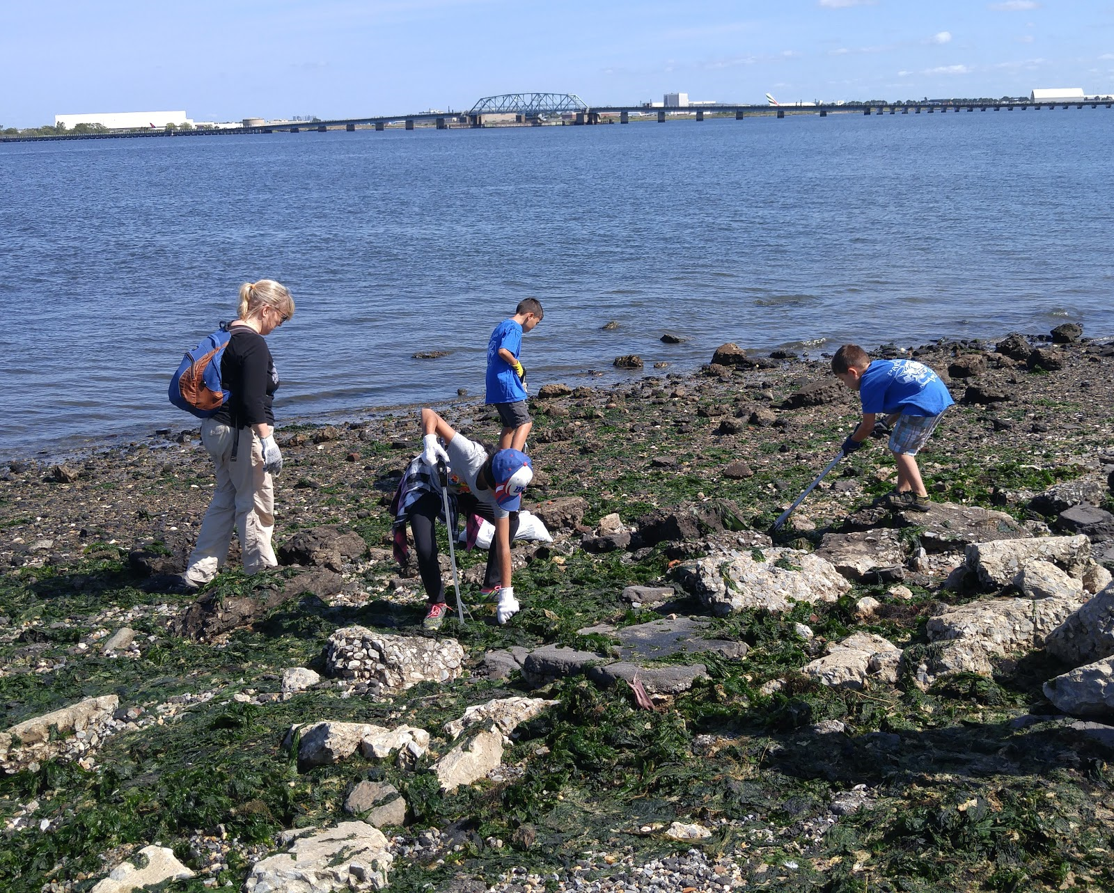

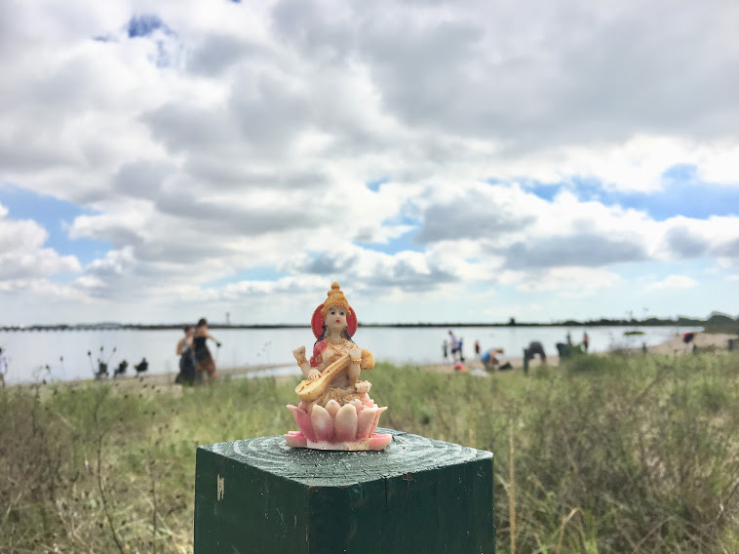

NOTICES

Paperwork Reduction Act Statement

In accordance with the Paperwork Reduction Act (44 U.S.C. 3501 et seq.), the U.S. Fish and Wildlife Service collects information necessary to designate Urban Bird Treaty cities or municipalities, and to respond to requests made under the Freedom of Information Act and the Privacy Act of 1974. Information requested in this form is purely voluntary. However, submission of requested information is required in order to consider applications for designation as an Urban Bird Treaty city. Failure to provide all requested information may be sufficient cause for the U.S. Fish and Wildlife Service to deny the request. According to the Paperwork Reduction Act of 1995, an agency may not conduct or sponsor and a person is not required to respond to a collection of information unless it displays a currently valid OMB control number. OMB has approved this collection of information and assigned Control No. 1018-####.

Estimated Burden Statement

We estimate public reporting for this collection of information to average 3 hours to 80 hours per response, depending on activity, including the time for reviewing instructions, searching existing data sources, gathering and maintaining the data needed, and completing and reviewing the collection of information. Send comments regarding this burden estimate or any other aspect of this collection of information, including suggestions for reducing this burden, to the Service Information Collection Clearance Officer, Division of Policy, Performance, and Management Programs, Fish and Wildlife Service, MS: PRB (JAO/3W), 5275 Leesburg Pike, Falls Church, VA 22041-3803, or via email at Info_Coll@fws.gov.

