SUPPORTING STATEMENT - PART A

Decision Review Request: Trainee Request for Leave (Chapter 31, Veteran Readiness and Employment)– OMB #2900-0034

|  |
| --- |
| Summary of Changes from Previously Approved Collection   * Changed the instructions to incorporate the updated VA contact web address. * Changed wording throughout the form’s questions to plain language. * Changed to updated New Burden Statement Language. * The ICR is being submitted as a revision due to an increase in burden hours. * No comments were received during the 60-day comment period. |

1. **Need for the Information Collection**

The Department of Veterans Affairs (VA) through its Veterans Benefits Administration (VBA) administers an integrated program of benefits and services, established by law, for Veterans, service personnel, and their dependents and/or beneficiaries. Under the authority of Title 38 United States Code (U.S.C.) §501(a) provides VA the authority to collect this information. Information requested by VA Form 28-1905h, Trainee Request for Leave (Chapter 31, Veteran Readiness and Employment) serves as a request for leave of absence under certain conditions that will allow program participants in the Veteran Readiness and Employment (VR&E) program to continue to receive subsistence allowance as though they are participating in a training program under the authority Title 38 U.S.C. §3110 and 38 Code of Federal Regulations (CFR) §21.340 to §21.350. VA must collect this information to ensure program participants receive continuity of services.

2. **Use of the Information**

Both the Department of Veterans Affairs staff from Veteran Readiness and Employment (VR&E) Division, VR&E program participant, and trainer or authorized school official completes the VA Form 28-1905h, Trainee Request for Leave (Chapter 31, Veteran Readiness and Employment). VA Form 28-1905h serves as the only document for requesting leave and for providing the information necessary to determine whether to approve the leave request. A trainer or authorized school official must verify on the form the effect the absence will have on the program participant’s progress in the training program. The case manager (normally a Vocational Rehabilitation Counselor) assigned to the program participant’s case overseeing the training program approves or denies the leave request. Upon approval, the program participant can receive subsistence allowance and other program services during the leave period as if he or she were continuing to attend training under Title 38 (CFR) §21.270.

3. **Use of Information Technology**

VA Form 28-1905h is available on the One-VA internet website in a fillable electronic format. VBA is currently hosting this form on a secure server and does not currently have the technology in place to allow for the complete electronic submission of the form. Validation edits are performed to assure data integrity. There currently is no utility process in place that will allow the data submitted on the form to be incorporated with an existing centralized legacy database. Ninety-eight percent of VR&E participants use e-VA to receive and submit VAF 28-1905h.

4. **Non-duplication**

The information obtained through this collection is unique and is not already available for use or adaptation from another cleared source.

5. **Burden on Small Businesses**

This information collection does not impose a significant economic impact on a substantial number of small businesses or entities.

6. **Less Frequent Collection**

A program participant, and trainer and/or authorized school official uses VAF 28-1905h only when it is necessary to request for leave for the trainee as outlined in 38 CFR §21.340 to §21.350 as part of a rehabilitation program Without the information gathered on this form, VR&E is not able to verify the program participant’s leave of absence to process the continued benefits. This would negatively impact the program participant’s participation in his or her rehabilitation program.

*7.* **Paperwork Reduction Act Guidelines**

This collection of information does not require collection to be conducted in a manner inconsistent with the guidelines delineated in 5 CFR §1320.5(d)(2).

8. **Consultation and Public Comments**

Part A: PUBLIC NOTICE

* A 60-Day Federal Register Notice (FRN) for the collection published on Tuesday, June 18, 2024. The 60-Day FRN citation is 89 FRN 51596. No comments were received during the 60-day comment period.

A 30-Day Federal Register Notice for the collection published on Tuesday, September 3, 2024. The 30-Day FRN citation is 89 FRN 71794.

9. **Gifts or Payment**

No payments or gifts are being offered to respondents as an incentive to participate in the collection.

10. **Confidentiality**

The records are maintained in the appropriate Privacy Act System of Records identified as “Compensation, Pension, Education, and Veteran Readiness and Employment Records-VA (58VA21/22/28),” published at 74 FR 29275 on June 19, 2009, and last amended at 87 FR 8740 (February 16, 2022). This statement is located on the bottom of the VAF 28-1905h.

11. **Sensitive Questions**

No questions considered sensitive are being asked in this collection.

12. **Respondent Burden and its Labor Costs**

Part A: ESTIMATION OF RESPONDENT BURDEN

a. Number of Respondents is estimated at 39,000 per year.

b. Frequency of Response is once on occasion.

c. Annual burden hours are 9,750 hours.

d. The estimated completion time for each form is 15 minutes.

e. The respondent population for VAF 28-1905h is composed of Department of Veteran Affairs staff, VR&E program participants, and trainer and/or authorized school official. Therefore, VBA used general wage data to estimate the respondents’ costs associated with completing the information collection.

The Bureau of Labor Statistics (BLS) gathers information on full-time wage and salary workers. According to the latest available BLS data, the mean hourly wage is $31.48 based on the BLS wage code – “00-0000 All Occupations.” This information was taken from the following website: <https://www.bls.gov/oes/current/oes_nat.htm>.

Legally, respondents may not pay a person or business for assistance in completing the information collection. Therefore, there are no expected overhead costs for completing the information collection. VBA estimates the total cost to all respondents to be $306,930 (9,750 burden hours x $31.48 per hour).

13. **Respondent Costs Other Than Burden Hour Costs**

This submission does not involve any recordkeeping costs.

14. **Cost to the Federal Government**

Estimated Annual Cost to the Federal Government

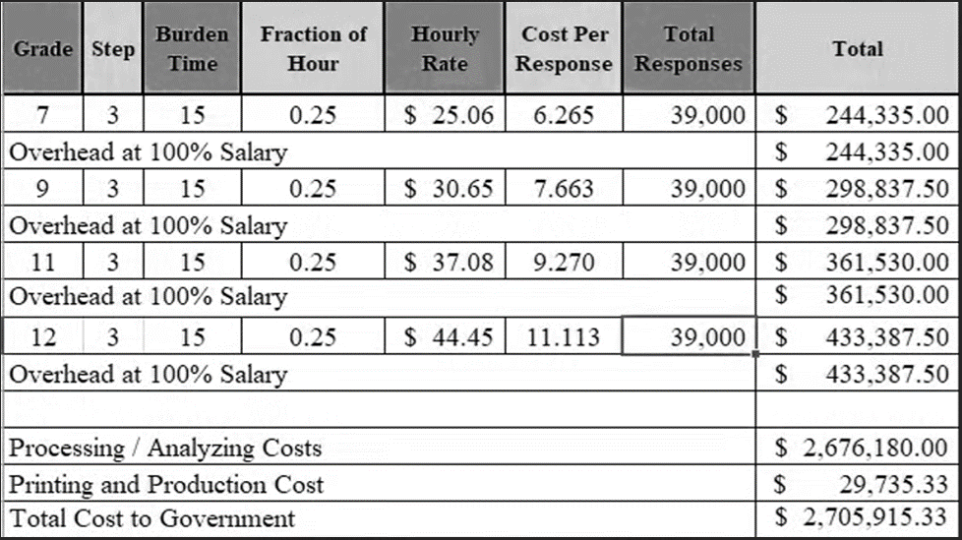

Overhead costs are 100% of salary and are the same as the wage listed above and the amounts are included in the total.

Printing and production costs approximates the cost of printing this information collection per year. (Processing/Analyzing Cost total divided by $90).

Note: The hourly wage information above is based on the hourly 2024 General Schedule (Base) Pay ([SALARY TABLE 2024-GS (opm.gov)](https://www.opm.gov/policy-data-oversight/pay-leave/salaries-wages/salary-tables/pdf/2024/RUS_h.pdf)).This rate does not include any locality adjustment as applicable.

The processing time estimates above are based on the actual amount of time employees of each grade level spend to process to completion a claim received on this form. The within-grade step (3) of each employee represents the average experience of employees within each grade.

15. **Reasons for Change in Burden**

The annual burden hours increased since the number of respondents is estimated at 39,000 per year which also increased.

16. **Publication of Results**

VA neither tabulates nor makes the information collected available for publication.

17. **Non-Display of OMB Expiration Date**

VA Form 28-1905h, the collection instrument, is the sole source for the collection of information vital to the request for VR&E program participant’s leave of absence. The form is submitted to OMB every three years.

18. **Exceptions to “Certification for Paperwork Reduction Submissions”**

This submission does not contain any exceptions to the certification statement.