**NON-SUBSTANTIVE CHANGE REQUEST JUSTIFICATION**

**OMB Control No.** **3060-0798**

FCC Forms 601

The Wireless Telecommunication Bureau (WTB) is submitting this non-substantive change request to the Office of Management and Budget (OMB) for approval of non-substantive correction to the instructions for FCC Forms 601 and item 14.

The FCC Form 601 is a consolidated, multi-part application form that is used for market-based and site-based licensing for wireless telecommunications services, including public safety, which are filed through the Commission’s Universal Licensing System (ULS). The GAO recommended that the FCC add tribal specific information to our licensing forms that allow us to track tribal access to spectrum licenses. To implement this recommendation FCC is proposing to revise the legal entity type question on the FCC Form 601 to include, two additional selections: Tribal Nation and Business Controlled by a Tribal Nation. We are submitting this non-substantive change requests for approval to add these selections. This change will not increase the burden on the tribal applicants.

The FCC Form 601 Instructions are being revised as follows:

**Current text:**

Item 14: This item indicates the legal entity type of the Applicant. Select Individual, Unincorporated Association, Trust, Government Entity, Corporation, Limited Liability Company, General Partnership, Limited Partnership, Limited Liability Partnership, Consortium, or Other. When selecting 'Other', provide a description of the legal entity.

**Note:** Any entity applying or modifying a license acquired via a FCC auction cannot select "Consortium" as its legal entity type. A consortium participating in competitive bidding that is the winning bidder may not apply as a consortium for licenses covered by the winning bids. Individual members of the consortium or new legal entities comprising individual consortium members may apply for the licenses covered by the winning bids of the consortium.

**Revised text:**

Item 14 This item indicates the legal entity type of the Applicant. Select Individual, Unincorporated Association, Trust, Government Entity, Corporation, Limited Liability Company, General Partnership, Limited Partnership, Limited Liability Partnership, Consortium, Tribal Nation, Business Controlled by a Tribal Nation, or Other. When selecting 'Other', provide a description of the legal entity.

**Note:** Any entity applying or modifying a license acquired via a FCC auction cannot select "Consortium" as its legal entity type. A consortium participating in competitive bidding that is the winning bidder may not apply as a consortium for licenses covered by the winning bids. Individual members of the consortium or new legal entities comprising individual consortium members may apply for the licenses covered by the winning bids of the consortium.

**Note:** Tribal Nation includes any Tribal governing body, as well as Tribal government agencies or departments, of a federally recognized Tribal Nation. Business Controlled by a Tribal Nation includes any business entity owned and/or controlled by a federally recognized Tribal Nation.

The FCC Form 601 Item 14 is being revised as follows:

Current item 14:

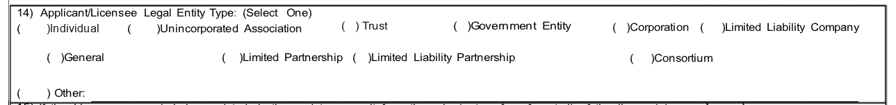

Revised item 14:

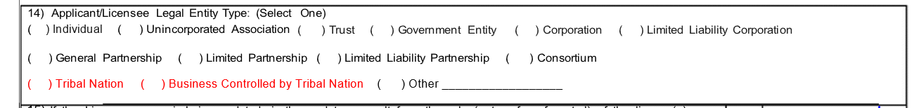

The FCC Form 601 is filed electronically adding the two tribal sections to item 14 will have no impact on the respondent burden.