**NON-SUBSTANTIVE CHANGE REQUEST JUSTIFICATION**

**OMB Control No.** **3060-0800**

FCC Forms 603

The Wireless Telecommunication Bureau (WTB) is submitting this non-substantive change request to the Office of Management and Budget (OMB) for approval of non-substantive correction to the instructions for FCC Forms 603 and items .

The FCC Form 603 is a consolidated, multi-part application form that is used to file transfer and assignment applications for market-based and site-based licensing for wireless telecommunications services, including public safety, which are filed through the Commission’s Universal Licensing System (ULS). The GAO recommended that the FCC add tribal specific information to our licensing forms that allow us to track tribal access to spectrum licenses. To implement this recommendation FCC is proposing to revise the legal entity type questions on the FCC Form 603 to include, two additional selections: Tribal Nation and Business Controlled by a Tribal Nation. This change applies to questions 21, 46 and 71. We are submitting this non-substantive change requests for approval to add these selections. This change will not increase the burden on the tribal applicants.

The FCC Form 603 Instructions are being revised as follows:

**Current instruction text for item 21 Licensee/Assignor:**

Item 21 This item indicates the legal entity type of the Assignor (Assignment) or Licensee (Transfer). Select Individual, Unincorporated Association, Trust, Government Entity, Corporation, Limited Liability Company, General Partnership, Limited Partnership, Limited Liability Partnership, or Other. When selecting ‘Other’, provide a description of the legal entity.

**Revised text:**

Item 21 This item indicates the legal entity type of the Assignor (Assignment) or Licensee (Transfer). Select Individual, Unincorporated Association, Trust, Government Entity, Corporation, Limited Liability Company, General Partnership, Limited Partnership, Limited Liability Partnership, Tribal Nation, Business Controlled by a Tribal Nation or Other. When selecting ‘Other’, provide a description of the legal entity.

Note:  Tribal Nation includes any Tribal governing body, as well as Tribal government agencies or departments, of a federally recognized Tribal Nation.  Business Controlled by a Tribal Nation includes any business entity owned and/or controlled by a federally recognized Tribal Nation.

**Current item 21**:

**Revised item 21**

**Current instruction text for item 46 Transferor:**

Item 46 This item indicates the legal entity type of the Transferor. Select Individual, Unincorporated Association, Trust, Government Entity, Corporation, Limited Liability Company, General Partnership, Limited Partnership, Limited Liability Partnership, or Other. When selecting ‘Other’, provide a description of the legal entity.

**Revised text:**

Item 46 This item indicates the legal entity type of the Transferor. Select Individual, Unincorporated Association, Trust, Government Entity, Corporation, Limited Liability Company, General Partnership, Limited Partnership, Limited Liability Partnership, Tribal Nation, Business Controlled by a Tribal Nation or Other. When selecting ‘Other’, provide a description of the legal entity.

Note:  Tribal Nation includes any Tribal governing body, as well as Tribal government agencies or departments, of a federally recognized Tribal Nation.  Business Controlled by a Tribal Nation includes any business entity owned and/or controlled by a federally recognized Tribal Nation.

**Current item 46**:

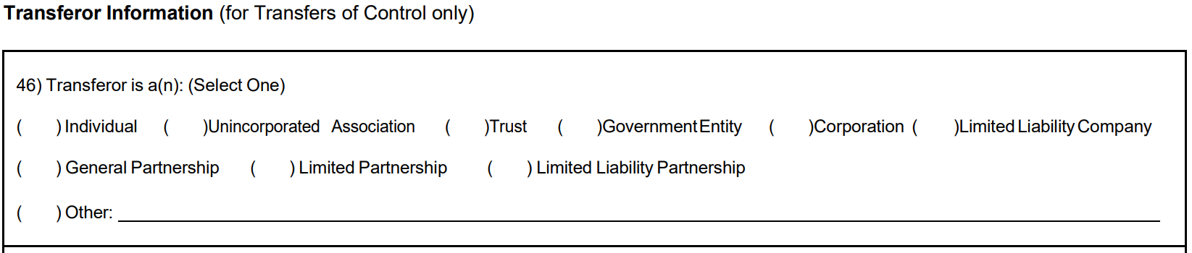

Revised item 46:

**Current instruction text for item 71 Assignee/Transferee:**

Item 71 This item indicates the legal entity type of the Assignee or Transferee. Select Individual, Unincorporated Association, Trust, Government Entity, Corporation, Limited Liability Company, General Partnership, Limited Partnership, Limited Liability Partnership, or Other. When selecting ‘Other’, provide a description of the legal entity.

**Revised text:**

Item 71 This item indicates the legal entity type of the Assignee or Transferee. Select Individual, Unincorporated Association, Trust, Government Entity, Corporation, Limited Liability Company, General Partnership, Limited Partnership, Limited Liability Partnership, Tribal Nation, Business Controlled by a Tribal Nation or Other. When selecting ‘Other’, provide a description of the legal entity.

**Note**: Tribal Nation includes any Tribal governing body, as well as Tribal government agencies or departments, of a federally recognized Tribal Nation. Business Controlled by a Tribal Nation includes any business entity owned and/or controlled by a federally recognized Tribal Nation.

**Current item 71**:

**Revised item 71**:

The FCC Form 603 is filed electronically adding the two tribal sections to items 21,46 and 71 has no impact on the respondent burden.