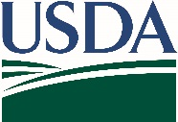
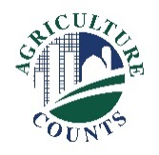
United States Department of Agriculture
National Agricultural Statistics Service

September 28, 2023
What should I do next?

Complete your survey in one of the following ways:

Online at agcounts.usda.gov. Online reporting is fast and secure. All you need is the survey code on the enclosed form to begin.

By mail or fax. Complete the questionnaire and mail it back in the prepaid envelope provided or fax it to (855) 415-3687.

Why am I getting this letter?
Enclosed is your October 2023 Agricultural Labor Survey. Your participation is important. Please complete your questionnaire at your earliest convenience.

You may receive an email reminder to complete your survey. If we do not receive your completed questionnaire by October 18, 2023, we may contact you for an interview.

How will the data be used?

The wage rate data serve as a guide to individual farm producers when hiring workers and estimating expenses for their operations. USDA and the Department of Labor use the data to estimate the demand for and availability of seasonal agricultural workers. The Department of Labor uses the survey data to establish minimum wage rates for agricultural workers and assist legislators in determining labor policies. Farm labor data are also used in the formation of both farm productivity and price indices. Wage data are a component of the Parity Index. Farm labor data provide information for the agricultural component of the Gross Domestic Product.

We recommend you respond online. On the Respondent Portal, you can complete your surveys, track upcoming surveys, access data visualizations and reports of interest, link to other USDA agencies, and more.

The information you provide will be used for statistical purposes only. In accordance with federal law, your responses will be kept confidential and will not be disclosed in identifiable form. NASS will publish the survey data November 22 in the biannual Farm Labor report at nass.usda.gov/publications.

Thank you for your participation and support of U.S. agriculture. For more information about this survey, visit nass.usda.gov/go/labor.
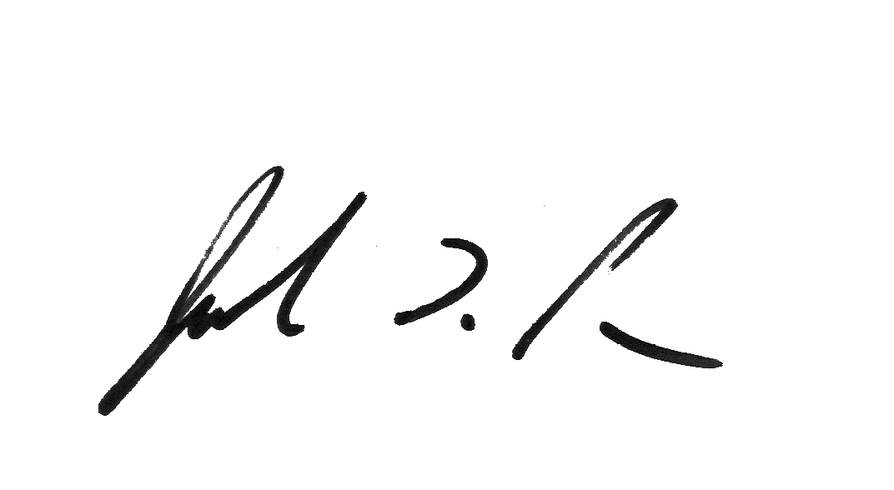
Sincerely,

Joseph L. Parsons
Chair, Agricultural Statistics Board
USDA National Agricultural Statistics Service
Enclosure

