**Request for Non-substantive Changes**

**OMB 0579-0430**

**6/11/2024**

APHIS conducted a review of VS 4-9 and VS 4-10 and requests approval for the following non-substantive changes. These changes does not affect response time or burden.

1. VS Form 4-9: Page 1, at top left of form, updated fax number and email address.

**CURRENT:**  
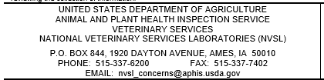

**

1. VS Form 4-10 has three changes: 1) correction to header, 2) correction to email address, and 3) redesign.
2. Correction: OMB header to reflect the currently approved burden from “.1” to “1” hour per response.

**CURRENT**:  


**CHANGE TO:**



1. Correction: Email address at the bottom of the form has been updated, mail address on one line.

**CURRENT:**  
  
**CHANGE TO:**

1. Redesign: This redesign will allow respondents to list more than one individual to the form who may be authorized to submit and incur expenses for the business. As the supporting statement reads, “this form is not required but is offered as a courtesy to customers who wish to proactively inform the NVSL of changes in contact information. The form helps ensure that the NVSL obtains all necessary information to update records efficiently and accurately.”  
     
   **CURRENT**:

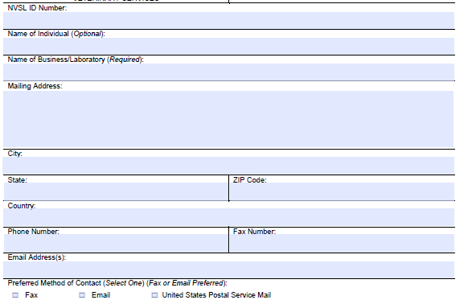

**CHANGE TO:**

