Appendix V. Site-specific Intervention Design Diagrams

This page has been left blank for double-sided copying.

Appendix V. Figure B1.1.a. Colorado intervention design
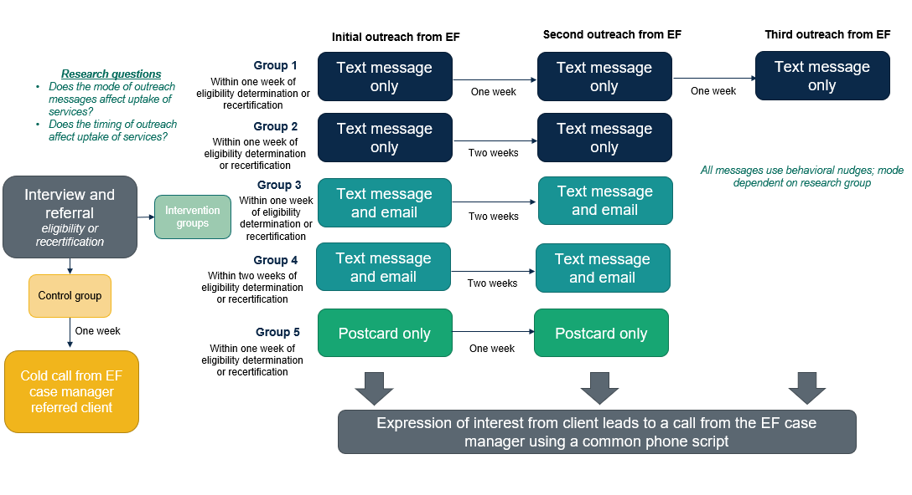
Note: EF = SNAP Employment First program
Appendix V. Figure B1.1.b. Connecticut community colleges intervention design
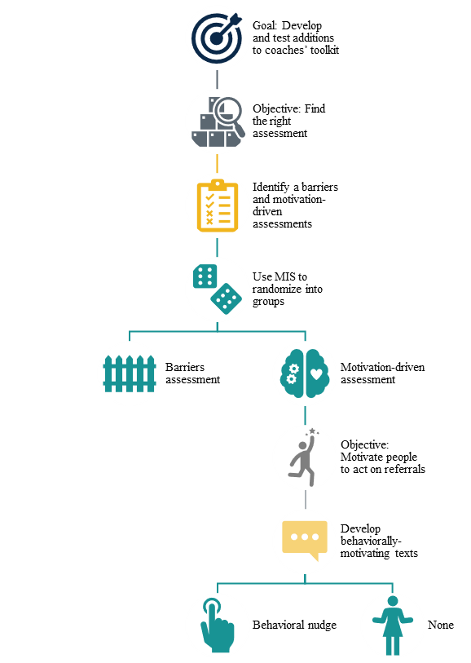

Appendix V. Figure B1.1.c. District of Columbia intervention design
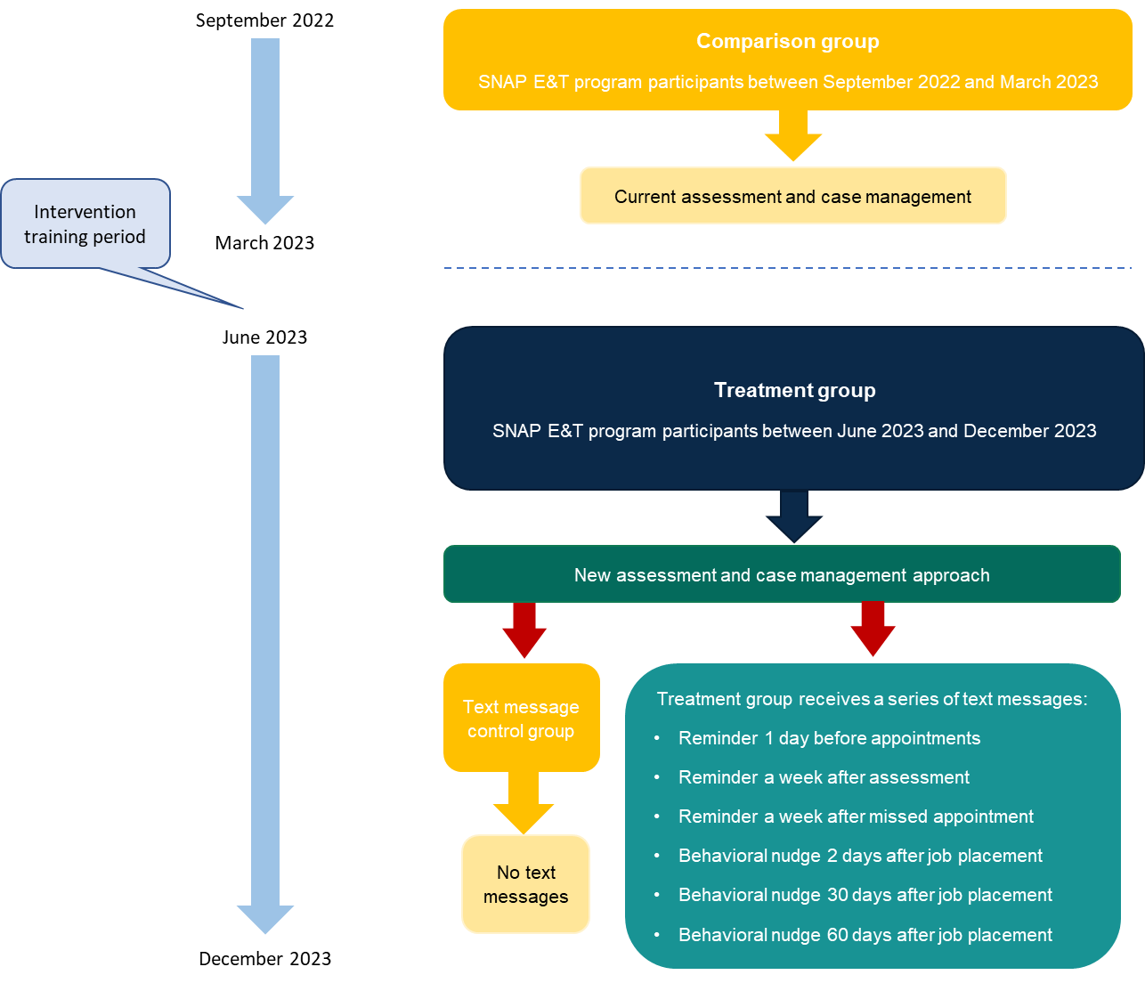
Note: Red arrows indicate points of random assignment

Appendix V. Figure B1.1.d. Kansas intervention design

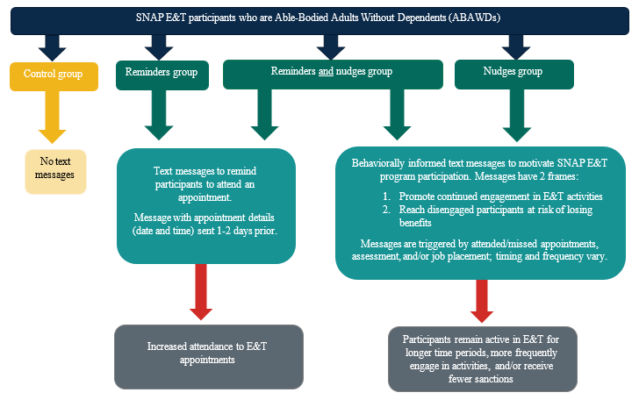

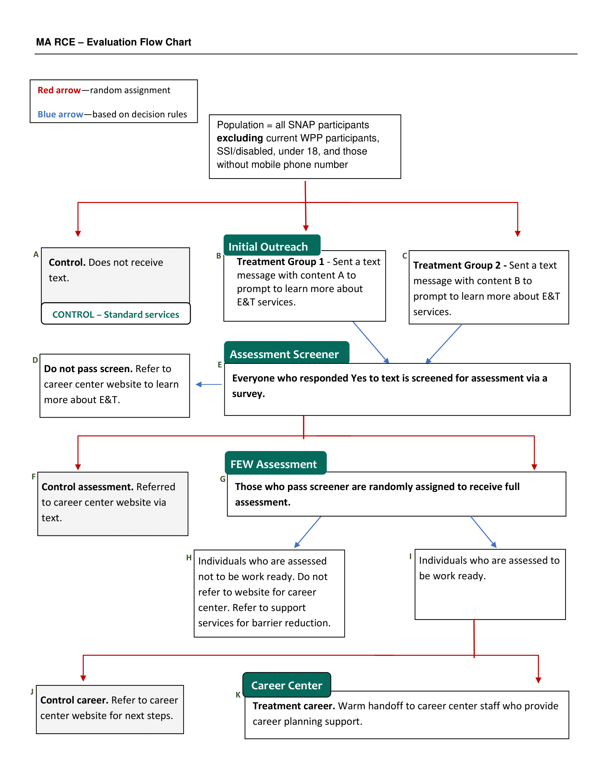
Appendix V. Figure B1.1.e. Massachusetts intervention design
Note: RCE = rapid cycle evaluation; WPP = Work Participant Program

Appendix Q. Figure B1.1.f. Minnesota Hennepin intervention design

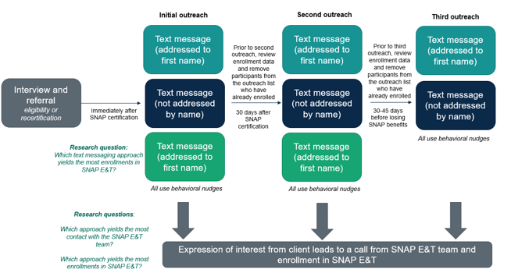

Appendix Q. Figure B1.1.g. Minnesota-Rural intervention design

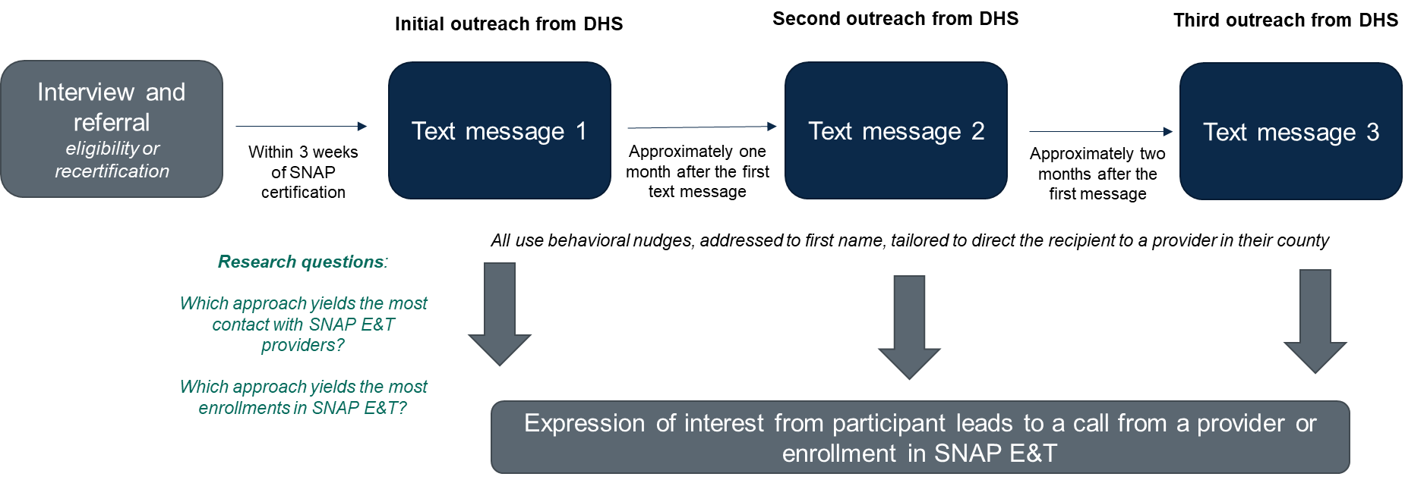
Note: DHS = Minnesota Department of Human Services

Appendix Q. Figure B1.1.h. Rhode Island intervention design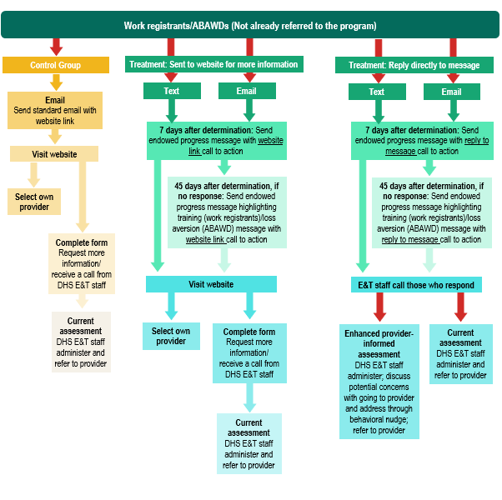

Notes: ABAWD = able-bodied adults without dependents; Red arrows represent random assignment. If sample sizes are large enough, the intervention flow chart will apply separately for work registrants and for ABAWDs.

