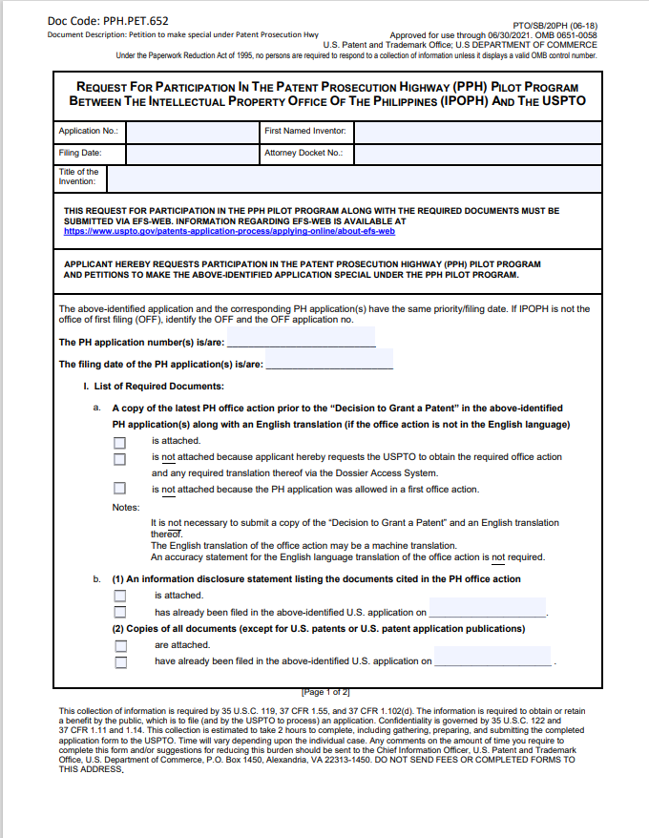
PTO/SB/20PH (06-18)
Approved for use through xx/xx/xxxx. OMB 0651-0058
U.S. Patent and Trademark Office; U.S. DEPARTMENT OF COMMERCE

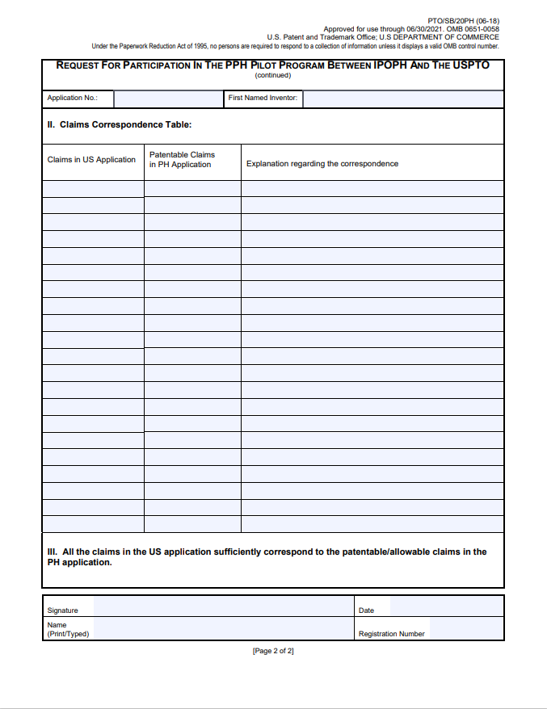

Privacy Act Statement

The Privacy Act of 1974 (P.L. 93-579) requires that you be given certain information in connection with your submission of the attached form related to a patent application or patent. The United States Patent and Trademark Office (USPTO) collects this information under authority of 37 CFR 1.55 and 1.102(a). This information is covered by a System of Records Notice (SORN) which identifies the categories of individuals covered by the system including inventors, legal representatives for inventors, and other persons authorized by law to make applications for patent. The information in this system of records is used to manage all records of applicants and legal representatives including name, citizenship, residence, post office address and other information pertaining to activities in connection with the invention for which a patent is sought.

The information obtain is protected from disclosure to third parties in accordance with the Privacy Act. However, routine uses of this information may include disclosure to the following: to law enforcement and investigation in the event that the system of records indicates a violation or potential violation of law; to a Federal, state, local, or international agency, in response to its request; to an agency, organization, or individual for the purpose of performing audit or oversight operations as authorized by law; to non-federal personnel under contract to the agency; to a court for adjudication and litigation; to the Department of Justice for Freedom of Information Act (FOIA) assistance; to members of congress working on behalf of an individual; to the Office of Personnel Management (OPM) for personnel research purposes; to National Archives and Records Administration for inspection of records; and to the Office of Management and Budget (OMB)for legislative coordination and clearance. Failure to provide any part of the requested information may result in an inability to process requests for access and information. The applicable Privacy Act System of Records Notice for this information is COMMERCE/PAT-TM-7 Patent Application Files, available at Federal Register /Vol. 78, No. 61 / Friday, March 29, 2013 /Notices 19243. https://www.govinfo.gov/content/pkg/FR-2013-03-29/pdf/2013-07341.pdf

[Page 3 of 3]

