SUPPORTING STATEMENT PART A
U. S. Department of Commerce
Generic Program Progress Performance Reports
OMB Control No. 0690-NEW

ABSTRACT
This is a request for a new generic clearance as a means of promoting efficiency and innovative solutions. DOC provides grants that promote the economic and social well-being of individuals, small businesses, and communities with partnerships, funding, guidance, training, and technical assistance. DOC grant funding is intended to expand access to capital, promote economic resiliency, create new jobs, and increase economic opportunity. The Department of Commerce Bureaus manage grant programs that vary in purpose, target population, and activities. Therefore, a critical need for program offices to customize performance measurements has been identified, which led to the request for this umbrella generic program specific Progress Performance Reports (PPR).

Justification
- Explain the circumstances that make the collection of information necessary. Identify any legal or administrative requirements that necessitate the collection.

This request is for an umbrella generic Information Collection that will allow Department of Commerce (DOC) program offices to collect performance and progress data from recipients and sub-recipients who receive funding from DOC under discretionary and non-discretionary grants or cooperative agreements. This information is required under the GPRA Modernization Act of 2010 (Pub. L. 111-352, Sec 12) and the 2 CFR § 200.329, monitoring and reporting program performance.

Currently DOC uses approved standard forms (SFs) and the RPPR (0690-0032) for post award reporting. Unfortunately, this one-size-fits-all approach does not adequately collect the specific data needed for particular grant programs or allow the program offices to assess continuous quality improvement, and program performance. Different grant programs vary in purpose, target population and activities. Therefore, the critical need for program offices to customize performance measurements has been identified leading to the request for this generic program specific PPR. The pool of DOC grant funding oversight responsibilities with various reporting requirements has grown rapidly. As a result, DOC believes its program offices will greatly benefit from the ability to expeditiously create and use a program specific PPR that is more effective and includes specific data elements that reflects a specific program’s indicators, demographics, priorities, and objectives.

A generic PPR that can be tailored for program-specific needs will allow programs to collect useful data in a uniform and systematic manner. The reporting format will allow programs to gather uniform program performance data from each grantee, allowing aggregation at the program level to calculate outputs and outcomes, providing a snapshot, and allowing for longitudinal analysis and program evaluation.

Data from a tailored PPR that demonstrates a program’s successes and challenges will be useful for accountability purposes, such as required reports to Congress. Moreover, it will be useful for program management, such as identifying grantees’ technical assistance needs. Finally, data collected, particularly when combined with other communicative and statistical information can be used to support outcome and/or impact evaluations.

All grantees will need to submit either the standard DOC required PPR, or a program specific PPR. The program specific PPR will be used by grantees and sub-grantees for periodic reports and may be used for the final report. A generic, program specific IC will be submitted to OIRA for each program specific PPR. The program-specific, generic ICs will be noncontroversial, low burden, and provide a significant benefit.

2. Indicate how, by whom, and for what purpose the information is to be used. Except for a new collection, indicate the actual use the agency has made of the information received from the current collection.

A generic program-specific PPR that can be tailored for program-specific needs will allow programs to collect more relevant data in a uniform and systematic manner. The reporting format will allow program offices to gather uniform program performance data from each grantee, allowing aggregation at the program level to calculate outputs and outcomes providing a snapshot and allowing for longitudinal analysis, including comparative analyses across grantees and/or regions.

Data from a tailored PPR that demonstrates a program’s successes and challenges will be useful for accountability purposes, such as required reports to Congress. Moreover, it will be useful for program management and oversight, such as identifying recipients’ technical assistance needs and ensuring compliance with federal and programmatic regulations and policies.
Program or project evaluations provide critical information to inform decisions about current or future programming, effective strategies or interventions, policies, and organizational operations. Evaluations, especially for large grant programs, should be used for the improvement purposes to support research under the departmental Learning Agenda and in support of the work in the Annual Evaluation Plans.
This includes, but is not limited to,
- identifying additional needs for program guidance,
- development or updates to support for recipients, and
- making informed refinements to programs in general and the related activities and supports.

The information from the program specific PPRs will also help DOC to ensure recipients comply with program planning and design requirements that are a new requirement for all funding opportunities. This includes requirements for the agency to develop a clear program plan, design, monitoring, and reporting requirements prior to issuing a NOFO. These consistent elements will allow DOC to then measure recipients’ performance and financial data under a risk management lens.
DOC funding recipients of discretionary awards will continue to submit the standard DOC PPR on a periodic basis unless a program has an alternative approved reporting mechanism. Non-discretionary programs currently require performance progress reports on a program-by-program basis based on the individual program statutes and regulations.
Program offices that decide to develop standardized performance measures for their program can submit the program specific PPR for review and approval under this umbrella generic clearance. In those specific instances where approval is granted, the program specific PPR will be used by recipients for additional periodic reports.
The program specific PPRs will be noncontroversial and provide a significant benefit and ensure federal stewardship and oversight of funding recipient activities. While submission of these reports is required, applying for a grant is a voluntary activity. DOC includes information about performance and progress data that will be expected in all notices of funding, for example in NOFOs, Terms and Conditions, and/or Action Transmittals. Requirements are also included in the governing statue and/or regulation, as applicable.
Information will be collected in accordance with EO 14035 on a voluntary basis from respondents at the application or reporting stage. For information collections involving questions of race/ethnicity, the agency will ensure that the OMB Standards for the Classification of Federal Data on Race and Ethnicity are followed (SPD 15 Revised Race and Ethnicity Data Standards – See Figure 1 below). Additionally, in certain cases where it is appropriate, we may use the following question: Do you or your organization identify with any of the following groups that the federal government, in Executive Order 13985, has identified as underserved? Check all that apply.
- Members of religious minorities
- Lesbian, gay, bisexual, transgender, and queer (LGBTQ+) persons
- Persons with disabilities
- Persons who live in rural areas
- Persons otherwise adversely affected by persistent poverty or inequality.
- No, I do not identify with any of these groups.

SPD 15 Revised Race and Ethnicity Data Standards - Figure 1
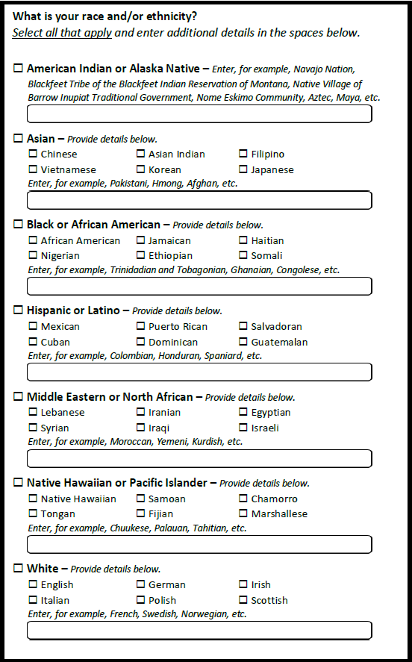
The data is intended to be used as one indicator in targeting and designing outreach activities and is in no way considered to be a statistically significant analysis. For example, it may indicate a need to focus resources in a particular county or region where low participation is indicated by the data. It could also be used as an indicator of whether outreach efforts are working effectively or not, and whether underserved communities are responding to our efforts.

3. Describe whether, and to what extent, the collection of information involves the use of automated, electronic, mechanical, or other technological collection techniques or other forms of information technology, e.g. permitting electronic submission of responses, and the basis for the decision for adopting this means of collection. Also describe any consideration of using information technology to reduce burden.
DOC will use multiple methods to gather information from recipients and sub-recipients. Some program offices will collect information electronically and/or use online performance reporting systems. This could include web pages, email, or other online data management systems. Recipients may be required to enter and retrieve information pertinent to their awards through electronic forms closely resembling the paper forms (i.e., fillable PDFs or tailored online data management systems). Such technology support is expected to improve standardization and timeliness of recipient reporting and to ease further analyses of reported data. Screenshots will be provided for all online data collection instruments. A Privacy Impact Assessment (PIA) and SORN, when appropriate, will be completed for all requests, including online requests, and will be noted in each collection submitted for review.

4. Describe efforts to identify duplication. Show specifically why any similar information already available cannot be used or modified for use for the purposes described in Item 2 above.
DOC will use this collection to reduce duplication of this information throughout the agency. Any known/discovered duplications will be reduced/eliminated.

5. If the collection of information impacts small businesses or other small entities (Item 5 of OMB Form 83-I), describe any methods used to minimize burden.
Small businesses or other small entities may be involved in these efforts, but the agency will try to minimize the burden on them by asking for readily available information, and using short, easy-to-complete information collection instruments.

6. Describe the consequence to Federal program or policy activities if the collection is not conducted or is conducted less frequently, as well as any technical or legal obstacles to reducing burden.
DOC program offices may require reporting on a quarterly, semi-annual, or annual basis. Less frequent submission would mean funding recipients provide less current information on performance and progress to DOC and may result in a violation of statutory requirements.

7. Explain any special circumstances that would cause an information collection to be conducted in a manner:
There are no special circumstances. The information collected will be voluntary and will not be used for statistical purposes.

8. If applicable, provide a copy and identify the date and page number of the publication in the Federal Register of the agency's notice, required by 5 CFR 1320.8 (d), soliciting comments on the information collection prior to submission to OMB. Summarize public comments received in response to that notice and describe actions taken by the agency in response to these comments. Specifically address comments received on cost and hour burden.
We published a notice request for public comments for the proposed information collection in the Federal Register on December 07, 2023 (88 FR 85208). No public comments were received.
In addition to soliciting comments from the public, we consulted with representatives from other government agencies that have similar collections.

9. Explain any decision to provide any payment or gift to respondents, other than remuneration of contractors or grantees.
We will not provide any monetary gifts or payments for this generic to respondents for completing any of the data collection instruments.

10. Describe any assurance of confidentiality provided to respondents and the basis for the assurance in statute, regulation, or agency policy.
Information provided will be kept private to the extent permitted by law.
Personal Identifiable Information (PII) will only be collected to the extent necessary. In these instances, the rationale for collecting PII will be fully explained. Respondents will be assured that neither their participation nor lack of participation will have any effect on their eligibility for participation in events or receipt of services.
In addition, respondents will be advised of the purpose of the information collection, the use of information collection, DOC sponsorship, that their participation is voluntary, and that they may choose to discontinue or have their name and/or related information withdrawn at any time.

11. Provide additional justification for any questions of a sensitive nature, such as sexual behavior or attitudes, religious beliefs, and other matters that are commonly considered private. This justification should include the reasons why the agency considers the questions necessary, the specific uses to be made of the information, the explanation to be given to persons from whom the information is requested, and any steps to be taken to obtain their consent.
Most questions that will be asked are typically not considered sensitive. PII may be collected for some requests as appropriate.
As a general matter, information collections under this generic collection request will not result in any new system of records containing privacy information and will not ask questions of a sensitive nature that have not been approved for use by OMB, such as sexual behavior and attitudes, religious beliefs, and other matters that are commonly considered private.
For example, data about gender identity or other similar data described in Question 2 may be requested to support a DOC-wide focus on equity. This will most commonly be done in aggregate and in accordance with OMB guidelines. This information will allow DOC to understand if and how specific groups are being offered services and to provide support to grantees, as needed. Each Gen IC will provide information about any data elements that may be considered sensitive.
Information will also be collected in accordance with The American Rescue Plan Act of 2021, and The SSBCI Technical Assistance Grant Program Guidelines published on April 28, 2022.1
1 The SSBCI Technical Assistance Grant Program Guidelines in effect as of the date of this guidance are available at https://home.treasury.gov/system/files/136/SSBCI-Technical-Assistance-Guidelines-April-2022.pdf.

12. Provide estimates of the hour burden of the collection of information. Indicate the number of respondents, frequency of response, annual hour burden, and an explanation of how the burden was estimated.
A variety of instruments and platforms will be used to collect information from respondents, and each will vary by number of respondents and average time per response. However, the annual burden hours requested (10,000) is based on the number of collections we expect to conduct over the requested period for this clearance. The average time per response is 1 hour semi-annually.
Estimated Annualized Burden Table
Instrument | Number of Respondents | Number of Responses per Respondent | Average Burden (in hours) per Response | Total Burden Hours
Various Program Performance Progress Reports | 7,500 | Varies | 1 | 15,000
Total annually | 7,500 |  |  | 15,000
Three-year period | 22,500 |  |  | 67,500

13. Provide estimates of the total annual cost burden to respondents or record keepers resulting from the collection of information, (do not include the cost of any hour burden shown in items 12 and 14). The cost estimates should be split into two components: (a) a total capital and start-up cost component annualized over its expected useful life; and (b) a total operation and maintenance and purchase of services component.
There are no capital/start-up or ongoing operation/maintenance costs associated with this information collection.

14. Provide estimates of annualized costs to the Federal government. Provide a description of the method used to estimate costs and any other expense that would not have been incurred without this collection of information.
The annualized cost to the Federal Government for the proposed data collection effort is $78,990 ($78.99/hour, 10% of time x 10,000).
Cost Descriptions | Grade/Step | Salary | % of Effort | Fringe (if applicable) | Total Cost to Gov’t
Federal Oversight
Federal staff | multiple | Avg - $78.99 hour | 10% |  | $78,990
Total |  |  |  |  | $78,990

15. Explain the reasons for any program changes or adjustments reported in Items 13 or 14 of the OMB Form 83-1.
This is a new collection.
16. For collections of information whose results are planned to be published, outline plans for tabulation and publication.
The information collected through this request is primarily for internal review. However, data collected from generic PPRs may be published on the DOC Bureau websites and used to fulfill requirements such as reports to Congress, which are made public or included in a printed or online program for the activity or subsequent publication describing the activity. Any plans to publish results will be described in individual ICs under this generic clearance. Additionally, a privacy notice/statement, when appropriate, will be completed and will be noted in the related collection.

17. If seeking approval to not display the expiration date for OMB approval of the information collection, explain the reasons that display would be inappropriate.
We are not seeking a waiver of this requirement. There are no reasons to preclude display of the OMB expiration date on the instruments.

18. Explain each exception to the certification statement identified in Item 19 "Certification for Paperwork Reduction Act."

A. Certification Statement
The agency is able to certify compliance with all provisions under Item 19 of OMB Form 83-I.
There are no exceptions to the certification statement.

