Tab 2: Survey Questions
20223695
#40025779.0
OMB Control Number: 0704-OBFS
Expiration Date: XX/XX/XXXX

All potential respondents will be asked the following demographic questions before starting with question 1, below. In some cases, the panel company might already have this information because the respondent is a known panelist from previous surveys.

- Are you currently serving in the US military as either active duty, National Guard, National Guard serving as active duty, reservist, or reservist serving as active duty? (Yes/No)? (Only those currently serving in one of these capacities will be invited to answer the survey. Those who respond “No” will not be asked questions B through I, below, and do not qualify for the survey).)
- Which of the following best describes your current military status? (Please choose one)
- Currently serving as active duty in a military branch
- Currently serving in the National Guard
- Currently serving in the National Guard on active duty
- Currently serving as a reservist on active duty
- Currently serving as a reservist
- None of the above [Those responding “None of the above” will not be asked C-I, below, and do not qualify for the survey]
- In which branch of the military do you currently serve? (Please choose one)
a) Air Force
b) Army
c) Marine Corps
d) Navy
e) Space Force
f). None of these
D. In what age group do you belong? (Please choose one)
a) 18 – 22
b) 23 – 29
c) 30 - 39
d) 40 - 49
e) 50 - 59
f) 60 or more
E. What describes your current rank? (Please choose one)
a) Officer
b) Enlisted
c) Warrant Officer
F. What is your gender? (Please choose one)
a) Male
b) Female
G. What is your current marital status? (Please choose one)
a) Married
b) Separated
c) Divorced
d) Widowed
e) Never married
H. What is your race and/or ethnicity?

Please select ALL that apply to you. Note, you may report more than one group

White
Hispanic or Latino
Black or African American
Asian
American Indian or Alaska Native
Middle Eastern or North African
Native Hawaiian or Pacific Islander
Some other race and/or ethnicity, please specify: [TEXTBOX; LIMIT 50]

Base: WHITE (H=White)
You said that you are White. Which of the following are you? Please select ALL that apply to you.

English
Italian
German
Polish
Irish
Scottish
French
Swedish
Norwegian
Spanish
Another White group, please specify: [TEXTBOX; LIMIT 50]

Base: HISPANIC (H=Hispanic or Latino)
You said that you are Hispanic or Latino. Which of the following are you? Please select ALL that apply to you.

Mexican
Cuban
Puerto Rican
Dominican
Salvadoran
Guatemalan
Colombian
Honduran
Spaniard
Another Hispanic or Latino group, please specify: [TEXTBOX; LIMIT 50]

Base: BLACK (H=Black or African American)
You said that you are Black or African American. Which of the following are you? Please select ALL that apply to you.

African American
Nigerian
Jamaican
Ethiopian
Haitian
Somali
Trinidadian and Tobagonian
Ghanaian
Congolese
Another Black or African American group, please specify: [TEXTBOX; LIMIT 50]

Base: ASIAN (H=Asian)
You said that you are Asian. Which of the following are you? Please select ALL that apply to you.

Chinese
Vietnamese
Asian Indian
Korean
Filipino
Japanese
Pakistani
Hmong
Afghan
Another Asian group, please specify: [TEXTBOX; LIMIT 50]

Base: AIAN (H=American Indian or Alaska Native)
You said that you are American Indian or Alaska Native. Which of the following are you? Please select ALL that apply to you.

Aztec
Navajo Nation
Cherokee Nation
Maya
Choctaw Nation
Lumbee Tribe of North Carolina
Muscogee (Creek) Nation
Chippewa
Apache
Blackfeet Nation
Sioux
Haudenosaunee Nations
Another American Indian or Alaska Native group, please specify: [TEXTBOX; LIMIT 50]

Base: MENA (H=Middle Eastern or North African)
You said that you are Middle Eastern or North African. Which of the following are you? Please select ALL that apply to you.

Lebanese
Syrian
Iranian
Iraqi
Egyptian
Israeli
Moroccan
Yemeni
Kurdish
Another Middle Eastern or North African group, please specify: [TEXTBOX; LIMIT 50]

Base: NHPI (H=Native Hawaiian or Pacific Islander)
You said that you are Native Hawaiian or Pacific Islander. Which of the following are you? Please select ALL that apply to you.

Native Hawaiian
Tongan
Samoan
Fijian
Chamorro
Marshallese
Chuukese
Palauan
Tahitian
Another Native Hawaiian or Pacific Islander group, please specify: [TEXTBOX; LIMIT 50]

Your Current Living Arrangements
- Do you currently live on or off a military installation or DOD property? (Please choose only one answer)
- I reside on a military installation
- I live off a military installation but on other DOD-owned or DOD-operated property (e.g., on a ship)
- I reside on neither a military installation nor any other DOD-owned or DOD-operated property

- In what type of housing do you currently live? (Please mark “yes” to your primary residence)
- On a ship
- In government-owned family housing (e.g. housing intended for married occupants)
- In government-owned non-family housing (e.g., barracks intended for unmarried occupants)
- In privatized family housing (e.g., housing intended for married occupants)
- In privatized non-family housing (e.g., housing intended for unmarried occupants)
- In civilian/community housing
- Other (Please specify, do not include identifiable information such as names in your response): _________________

- On an average day, how far do you currently have to travel to go to work as a servicemember?
- Less than a mile
- 1 to less than 5 miles
- 5 to less than 20 miles
- 20 to less than 50 miles
- 50 miles or more

- Does your household use any of the following methods to keep your home or place where you live safe? (Please select one response for each method to keep your home safe)
- Method to keep your home or place where you live safe | - Yes | No | Prefer not to answer
- Locks in doorknobs or lever handle locks on outside doors
- Deadbolts, chains, or slide locks on doors
- Window locks
- Bar, rod, or other device that prevents windows or doors from sliding open
- Bars over doors or windows
- Alarm system
- Motion detectors
- Security cameras or video devices
- Signs or stickers indicating the use of an alarm system
- “Beware of dog” signs
- “Do not trespass” signs
- Dog(s)
- Fencing

Your Opinions About Firearms
- To what extent do you agree with the following statement?
“Having a firearm in the house makes it a safer place to be.”
- Strongly agree
- Agree
- Neither agree nor disagree
- Disagree
- Strongly disagree
- It depends

- To what extent do you agree with the following statement?
“Having a firearm in the home increases the risk of suicide.”
- Strongly agree
- Agree
- Neither agree nor disagree
- Disagree
- Strongly disagree
- It depends

- To what extent do you agree with the following statement?
“If a firearm user has to take the time to unlock or load their firearm, it’s no good for self-protection.”
- Strongly agree
- Agree
- Neither agree nor disagree
- Disagree
- Strongly disagree
- It depends

- If you had a firearm(s) stored at home, how open would you be to storing that firearm using the following storage methods to prevent suicide or other adverse events? (Select 1 option for each row)
Method | Not at all open | Somewhat open | Very open | Extremely open | Prefer not to answer
Store unloaded
Store separated from ammunition
Store in a locked location (e.g., a gun safe)
Store with a locking device (e.g., a trigger or cable lock)
Store temporarily away from home with a trusted friend or family member
Store temporarily away from home at a firearms retailer
Store temporarily away from home with a law enforcement agency
Have a trusted person change the code on a gun safe or lock box
Store the key to a gun safe or lock box with another person
Store near reasons to stay alive (e.g., photos of loved ones)
Store near a list of suicide prevention resources

9). If you were to acquire new or additional firearms, how likely would you be to store firearms with the following precautions?
Method | Would not | Somewhat likely | Very likely | Prefer not to answer
Locked with a cable or trigger lock
Locked in a case or safe
Stored unloaded
Stored separately from ammunition

Please view the following message [one of four following images included below will be shown to respondent].
We will ask you some questions about the message after you view it.
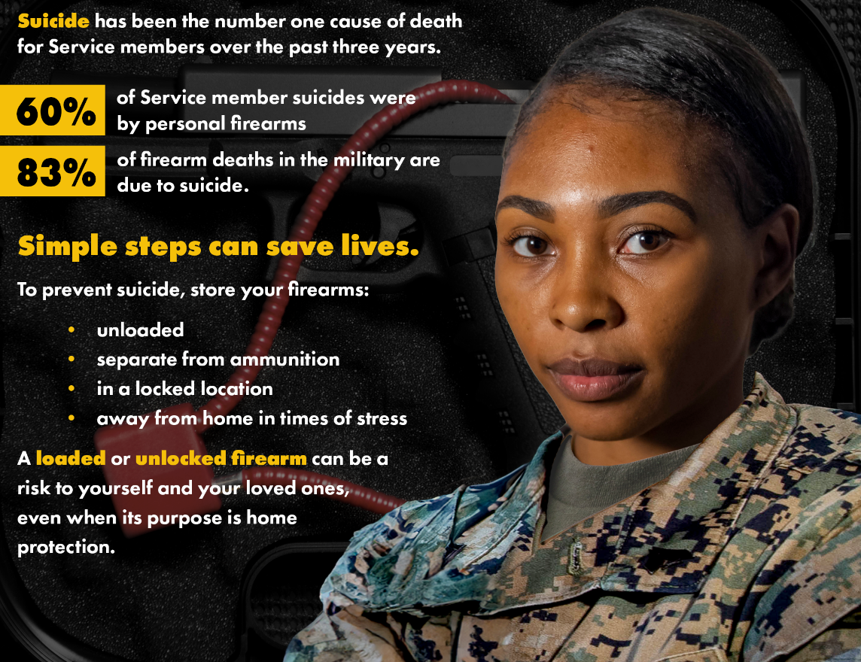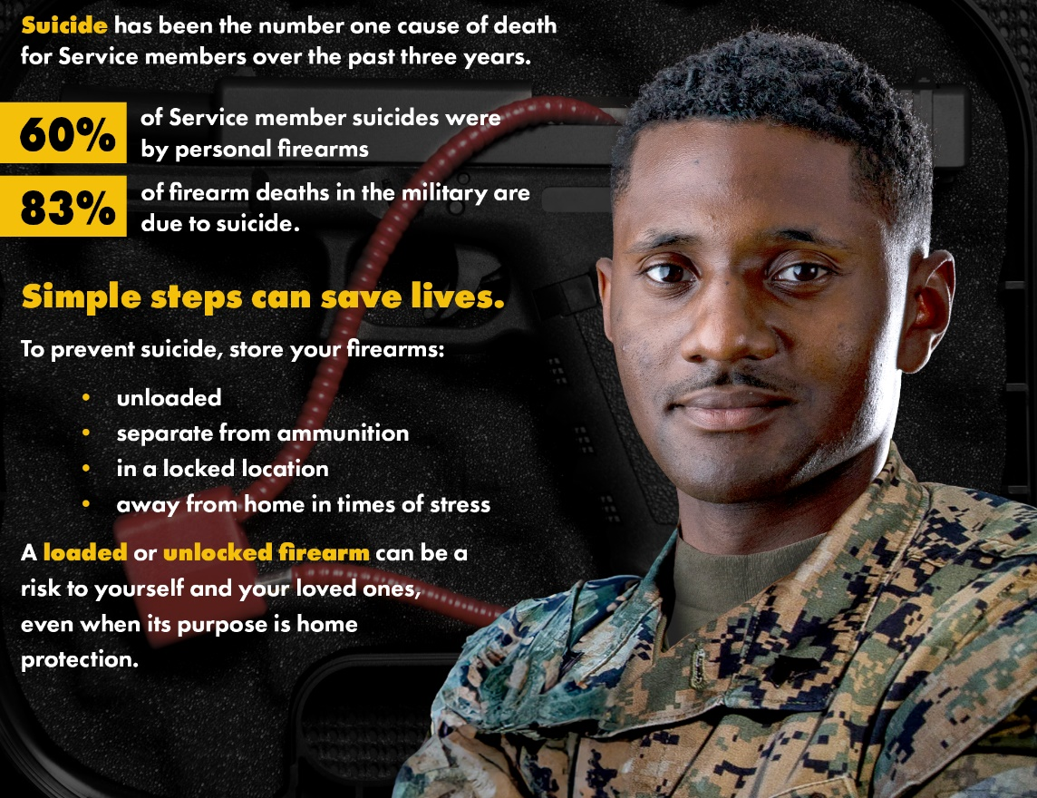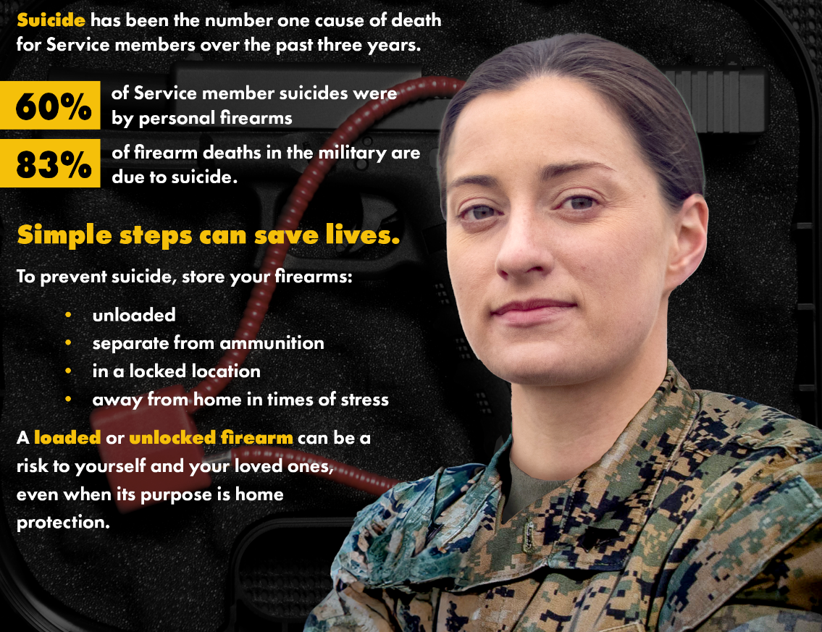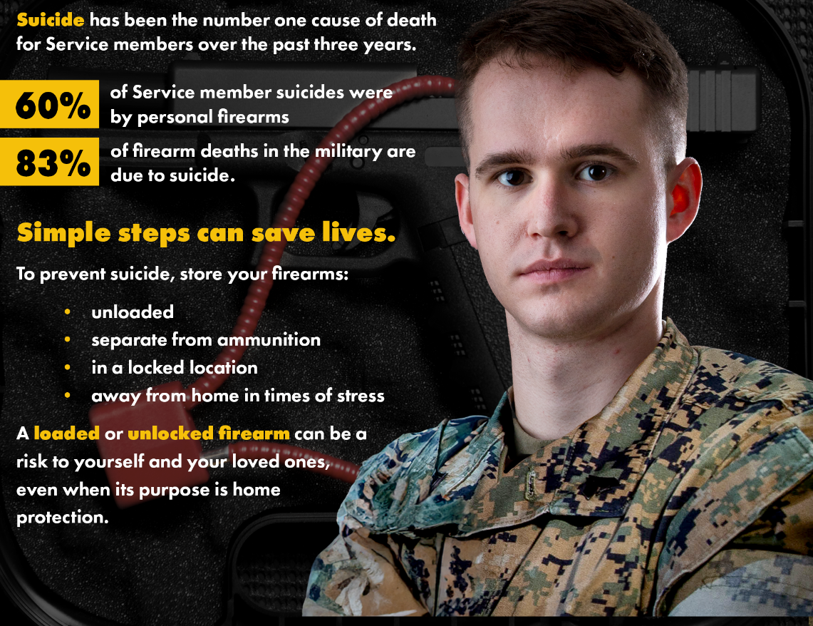
Photo credit: Defense Visual Information Distribution Service (DVIDS). The photo has been edited for purposes of this survey.

Now that you have seen the message, please answer a few questions about the message.
- If you or a friend were acquiring a firearm, which, if any details from this message would be persuasive to keep the firearm locked and unloaded? [In your write-in, please do not include identifiable information such as names]
___________

- As a source of information, how trustworthy does the person in the picture appear to you?
a) Not at all trustworthy
b) Somewhat trustworthy
d) Very trustworthy
e) Extremely trustworthy

- Is the information in the message relevant for you, your family, or your friends?
a) Not at all relevant
b) Somewhat relevant
d) Very relevant
e) Extremely relevant

- How much the information in the message get your attention?
a) Not at all attention-getting
b) Somewhat attention-getting
c) Very attention-getting
d) Extremely attention-getting

- How engaging did you find the information in the message?
a) Not at all engaging
b) Somewhat engaging
c) Very engaging
d) Extremely engaging

- How motivating was each of the parts of the message that you saw earlier in this survey? By “motivating,” we mean that this part of the message influenced you to either adopt or continue to practice safe firearms storage. (Please provide one answer for each row).
Message part | Not motivating | Somewhat motivating | Very motivating | Extremely motivating | Prefer not to answer
“Suicide has been the number one cause of death for Servicemembers over the past three years.”
“60% of Servicemember suicides were by personal firearms.”
“83% of firearms deaths in the military are due to suicide.”
- “To prevent suicide, store your firearms: unloaded, separate from ammunition, in a locked location, and away from home in times of stress.”
- “A loaded or unlocked firearm can be a risk to yourself and your loved ones, even when its purpose is home protection.”
- The image of the person in the message

- Is there anything else you would like to tell us about the message (or parts of the message) that you just saw? If so, please explain here [In your write-in, please do not include identifiable information such as names]: ____________

We asked you the following questions earlier in the survey. Our research design requires us to repeat a few questions in the survey. Please answer the following 4 questions again.
- To what extent do you agree with the following statement?
“Having a firearm in the house makes it a safer place to be.”
- Strongly agree
- Agree
- Neither agree nor disagree
- Disagree
- Strongly disagree

- To what extent do you agree with the following statement?
“Having a firearm in the home increases the risk of suicide.”
        - Strongly agree
        - Agree
        - Neither agree nor disagree
        - Disagree
        - Strongly disagree

- If you had firearm(s) stored at your home, how open would you be to storing that firearm using the following storage methods to prevent suicide or other adverse events? (Select 1 option for each)
Method | Not open | Somewhat open | Very open | Extremely open | Prefer not to answer
Store unloaded
Store separated from ammunition
Store in a locked location (e.g., a gun safe)
Store with a locking device (e.g., a trigger or cable lock)
Store temporarily away from home with a trusted friend or family member
Store temporarily away from home at a firearms retailer
Store temporarily away from home with a law enforcement agency
Have a trusted person change the code on a gun safe or lock box
Store the key to a gun safe or lock box with another person
Store near reasons to stay alive (e.g., photos of loved ones)
Store near a list of suicide prevention resources

20). If you were to acquire your first or additional firearms, how likely would you be to store firearms with the following precautions?
Method | Would not | Somewhat likely | Very likely | Prefer not to answer
Locked with a cable or trigger lock
Locked in a case or safe
Stored unloaded
Stored separately from ammunition

The next two questions involve the opinions of your peers.
- Do you think your peers approve of having firearms always stored locked and unloaded?
- My peers do not approve at all
- My peers somewhat disapprove
- My peers are neutral
- My peers somewhat approve
- My peers strongly approve
- Don’t know

- How often do you think your peers store their own firearms locked and unloaded?
- Not at all
- Infrequently
- Frequently
- Always
- Don’t know

These final four questions involve your opinion.
- How much effort do you think it takes to store all firearms locked and unloaded at all times?
- No effort at all
- A little effort
- Some effort
- A large effort

- In your opinion, what are the major barriers to servicemembers storing firearms locked and unloaded at all times? (please check all that apply)
- They do not believe that way you store a firearm changes the risk of suicide or fatal accidents
- They do not believe that they or anyone they live with would attempt suicide or have a firearms accident causing injury
- They do not feel that their family is protected unless they keep a firearm loaded and unlocked at home
- They do not feel that their property is protected unless they keep a firearm loaded and unlocked at home
- They feel that the disadvantages of storing a firearm locked and unloaded outweigh the benefits
- They do not think that there are effective methods other than firearms to adequately protect themselves, their family, and property
- They believe that others will disapprove of storing firearms locked and unloaded
- Other [In your write-in, please do not include identifiable information such as names]: ___________________

- In your opinion, what media for messages would be most effective to influence servicemembers to store firearms locked and unloaded? (please respond to each row)
Type of message | Not effective at all | Somewhat effective | Moderately effective | Very effective | Prefer not to answer
Posters
Podcasts
Social media posts
Articles or newsletters sent electronically
- Radio
- TV
- Other [Please specify, do not include identifiable information such as names in your response]:

- How effective do you believe the following safety equipment would be in influencing servicemembers to store firearms locked and unloaded?
- Method | Not effective at all | Somewhat effective | Moderately effective | Very effective | Prefer not to answer
- Firearms safes that can be opened quickly when needed
- Ammunition safes that can be opened quickly when needed
- Alarm systems
- Motion detectors
- Security cameras or video devices
- Signs or stickers indicating the use of an alarm system
- Fencing
- Other [Please specify, do not include identifiable information such as names in your response]:

Thank you for answering this survey!

Calibration questions
[Calibration weighting question required for the opt-in panel only. If a respondent attempts to skip a question, the question will be asked a second time.]
You are now exiting the CNA survey and will be directed to a series of questions required by the survey provider to properly weight and calibrate your responses. Your responses to these questions will not be provided to CNA or included in the analysis of the survey you just completed.
C1. How old are you? [Numeric box, range 0-120] years old
C2. What is the highest level of school you have completed?
a). Some high school or less – no diploma or GED
b). High school graduate – high school diploma or the equivalent (GED)
c). Some college, no degree
d). Associate degree
e). Bachelor’s degree
f). Master’s degree
g). Professional or Doctorate degree
C3. How much is the combined income of all members of YOUR HOUSEHOLD for the PAST 12 MONTHS?
Please include your income PLUS the income of all members living in your household (including cohabitating partners and armed forces members living at home). Please count income BEFORE TAXES and from all sources (such as wages, salaries, tips, net income from a business, interest, dividends, child support, alimony, and Social Security, public assistance, pensions, or retirement benefits).
a). Below $50,000
b). $50,000 or more
c). Don’t know
Your answer will help represent the entire U.S. population and will be kept confidential. Thank you!
C3a. [If C3=a] We would like to get a better estimate of your total HOUSEHOLD income in the past 12 months before taxes. Was it…
a). Less than $5,000
b). $5,000 to $7,499
c). $7,500 to $9,999
d). $10,000 to $12,499
e). $12,500 to $14,999
f). $15,000 to $19,999
g). $20,000 to $24,999
h). $25,000 to $29,999
i). $30,000 to $34,999
j). $35,000 to $39,999
k). $40,000 to $49,999
Your answer will help represent the entire U.S. population and will be kept confidential. Thank you!

C3b. [If C3=b] We would like to get a better estimate of your total HOUSEHOLD income in the past 12 months before taxes. Was it…
a). $50,000 to $59,999
a). $60,000 to $74,999
a). $75,000 to $84,999
a). $85,000 to $99,999
a). $100,000 to $124,999
a). $125,000 to $149,999
a). $150,000 to $174,999
a). $175,000 to $199,999
a). $200,000 to $249,999
a). $250,000 or more
Your answer will help represent the entire U.S. population and will be kept confidential. Thank you!
C4. In which state do you live?
- Alabama
- Alaska
- Arizona
- Arkansas
- California
- Colorado
- Connecticut
- Delaware
- District of Columbia
- Florida
- Georgia
- Hawaii
- Idaho
- Illinois
- Indiana
- Iowa
- Kansas
- Kentucky
- Louisiana
- Maine
- Maryland
- Massachusetts
- Michigan
- Minnesota
- Mississippi
- Missouri
- Montana
- Nebraska
- Nevada
- New Hampshire
- New Jersey
- New Mexico
- New York
- North Carolina
- North Dakota
- Ohio
- Oklahoma
- Oregon
- Pennsylvania
- Rhode Island
- South Carolina
- South Dakota
- Tennessee
- Texas
- Utah
- Vermont
- Virginia
- Washington
- West Virginia
- Wisconsin
- Wyoming

C5. What is the ZIP code where you live? [number box]
C6. Approximately, how many hours of television do you watch on an average day?
[number box]
C7. In a typical week, about how many hours do you spend on the Internet for personal use? If none, enter “0”. If less than an hour in a week, enter “1”. [number box]
C8. How often, if at all, have you used the Internet to express your opinions about POLITICAL or COMMUNITY issues within the last 12 months? Select one answer only.
- Basically every day
- A few times a week
- A few times a month
- Once a month
- Less than once a month
- Not at all
C9. I usually try new products before other people.
- Not at all
- Somewhat
- A lot
- Completely

