Attachment I: Clinical Sustainability Assessment Tool (CSAT)

Form Approved
OMB No. 0935-XXXX
Exp. Date XX/XX/20XX

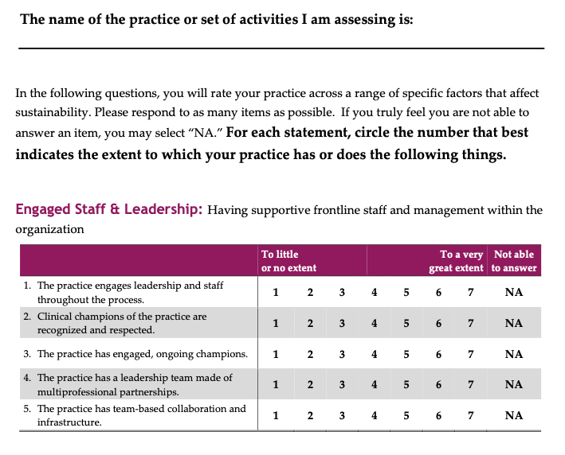
This survey is authorized under 42 U.S.C. 299a. This information collection is voluntary and the confidentiality of your responses to this survey is protected by Sections 944(c) and 308(d) of the Public Health Service Act [42 U.S.C. 299c-3(c) and 42 U.S.C. 242m(d)]. Information that could identify you will not be disclosed unless you have consented to that disclosure. Public reporting burden for this collection of information is estimated to average 15 minutes per response, the estimated time required to complete the survey. An agency may not conduct or sponsor, and a person is not required to respond to, a collection of information unless it displays a currently valid OMB control number. The data you provide will help AHRQ’s mission to produce evidence to make health care safer, higher quality, more accessible, equitable, and affordable. Send comments regarding this burden estimate or any other aspect of this collection of information, including suggestions for reducing this burden, to: AHRQ Reports Clearance Officer Attention: PRA, Paperwork Reduction Project (0935-xxxx) AHRQ, 5600 Fishers Lane, Room #07W42, Rockville, MD 20857, or by email to the AHRQ MEPS Project Director at MEPSPROJECTDIRECTOR@ahrq.hhs.gov.

