

April 17, 2024

Dear «Name»,

On behalf of the Department of Health and Human Services, I thank you for participating in the Medical Expenditure Panel Survey (MEPS). By being a participant in this important national research effort, you are fulfilling a valuable public service.

As a member of the quality assurance team, it is my responsibility to see that all interviews are completed according to study procedures. The questions on the enclosed form refer to your most recent MEPS interview. Please answer these questions for me, and feel free to offer any comments you may have about the interview or the interviewer.

Thank you for your time and participation in this important survey. Please return the form using the enclosed postage-paid envelope.

Sincerely,

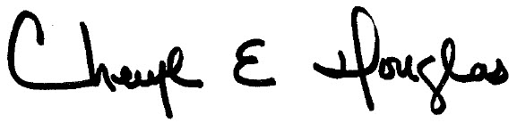

Cheryl E. Douglas

MEPS Quality Assurance Team

Encl (2)

MEPS POST-INTERVIEW FORM

1. Approximately how long did your most recent MEPS interview take?

_____ HOURS AND _____ MINUTES

2. Were you interviewed in person or over the telephone?

IN PERSON

VIDEO *(GO TO Q4)*

TELEPHONE *(GO TO Q4)*

*Comment*: _________________________________

__________________________________________

__________________________________________

3. Did the interviewer use a laptop computer to record your answers?

YES

NO *(Please comment.)*

*Comment*: _________________________________

__________________________________________

__________________________________________

4. Were you asked about everyone living in your household?

YES

NO *(Please comment.)*

NOT APPLICABLE

*Comment*: _________________________________

__________________________________________

__________________________________________

5. Did you receive a monetary gift from the interviewer at the end of the interview?

YES  **5a.** How much did you receive? ________________________________

NO

6. Did you receive any token gifts for your participation?

YES **6a.** What gifts did you receive? _________________________________

NO

7. Was your interviewer courteous and professional?

YES

NO *(Please comment.)*

*Comment*: _________________________________

__________________________________________

__________________________________________

8. Please add any comments you have about the interview or the person who interviewed you.

______________________________________________________________________________________________________________________________________________________________

_______________________________________________________________________________