Custom MEPS Validation Form Section

Overview
All on-path survey questions will appear in order based on question flow.
If a question is not on path, do not display it.
If displayed, a response is required, unless noted otherwise at question level.

Fills:
Validator Name = User name based on login

Project Fill = "the Medical Expenditure Panel Survey being conducted for the Department of Health and Human Services"

FI Name = Full name of FI who completed the task

Task Date = Date on which the task was completed (M/D/YY)

Phone = {Respondent Phone}

Full Address = Address Line 1, Address Line 2, City, ST, ZIP

Project Name = MEPS

User Interface
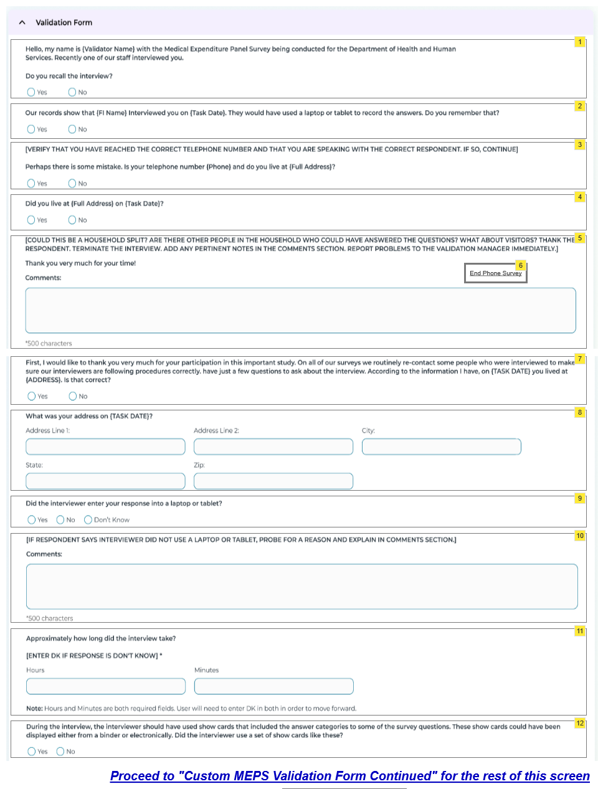

Widget Table
Footnote | Name | Requirements
1 | VF Intro and Recall | Display/Enable  Always  Question Text:  "Hello, my name is {Validator Name} with {Project Fill}. Recently one of our staff interviewed you.  Do you recall the interview?"  Response:  Yes/No  Flow:  If Yes, go to VF Begin Survey  If No, go to VF FI and Date Prompt
2 | VF FI and Date Prompt | Display/Enable  Only when VF Intro and Recall = No  Question Text:  "Our records show that {FI Name} interviewed you on {Task Date}. They would have used a laptop or tablet to record the answers. Do you remember that?"  Response:  Yes/No  Flow:  If Yes, go to VF Begin Survey  If No, go to VF Verify Phone and Address
3 | VF Verify Phone and Address | Display/Enable  Only when VF FI and Date Prompt = No  Question Text:  "[VERIFY THAT YOU HAVE REACHED THE CORRECT TELEPHONE NUMBER AND THAT YOU ARE SPEAKING WITH THE CORRECT RESPONDENT. IF SO, CONTINUE.]  Perhaps there is some mistake. Is your telephone number {Phone} and do you live at {Full Address}?"  Response:  Yes/No  Flow:  If Yes, go to VF Terminate Survey Comments  If No, go to VF Confirm Address
4 | VF Confirm Address | Display/Enable  Only when VF Verify Phone and Address = No  Question Text:  "Did you live at {Full Address} on {Task Date}?"  Response:  Yes/No  Flow:  If Yes, go to VF Begin Survey  If No, go to VF Terminate Survey Comments
5 | VF Terminate Survey | Display/Enable  Only when  Verify Phone and Address = Yes or  VF Confirm Address = No  If this question is displayed, enable End Interview Button.  Question Text:  "[COULD THIS BE A HOUSEHOLD SPLIT? ARE THERE OTHER PEOPLE IN THE HOUSEHOLD WHO COULD HAVE ANSWERED THE QUESTIONS? WHAT ABOUT VISITORS? THANK THE RESPONDENT. TERMINATE THE INTERVIEW. ADD ANY PERTINENT NOTES IN THE PHONE VALIDATOR SUMMARY SECTION. REPORT PROBLEMS TO THE VALIDATION MANAGER IMMEDIATELY.]  Thank you very much for your time!"  Include End Phone Survey Button.  On click...display Breakoff Warning Dialog. Collaps section and enable Validator summary in expanded view.
6 | End Phone Survey Button | Enable  Only if VF Terminate Survey is displayed.  On click End Phone survey Button, display Finish Survey Warning Dialog.  Once confirmed, store Phone Survey responses collected thus far.  Set Phone Survey Call Outcome to Breakoff.  Set Phone Validation Status to Call Terminated.  Set Final Record of Call with values based on current system date, time and user log in.  Enable/Open Phone Validator Summary Screen.  Phone Validation Status will be prefilled with "Call Terminated"
7 | VF Begin Survey | Display/Enable  Only when  VF Intro and Recall = Yes or  VF FI and Date Prompt = Yes or  VF Confirm Address = Yes  Question Text:  "First, I would like to thank you very much for your participation in this important study. On all our surveys, we routinely re-contact some people who were interviewed to make sure our interviewers are following procedures correctly. I have just a few questions to ask about the interview. according to the information I have, on {Task Date} you live at {Full Address}. Is that correct?  Response:  Yes/No  Flow:  If Yes, go to VF Confirm Laptop Use  If No, go to VF Correct Respondent Address
8 | VF Correct Respondent Address | Display/Enable  Only when VF Begin Survey = No  Question Text:  "What was your address on {Task Date}?"  Response:  Allow entry of Full Address information in fields for Address Line 1, Address Line 2, City, ST, ZIP  Flow:  Go to VF Confirm Laptop Use
9 | VF Confirm Laptop Use | Display/Enable  Only when  VF Begin survey = Yes or  VF Correct Respondent Address = Not Empty  Question Text:  "Did the interviewer enter your response into a laptop or tablet?"  Response:  Yes/No/Don't Know  Flow:  If Yes or DK, go to VF Task Timing  If No, go to VF Reason No Laptop Probe
10 | VF Reason No Laptop Probe | Display/Enable  Only when VF Confirm Laptop Use = No  Question Text:  "[IF RESPONDENT SAYS INTERVIEWER DID NOT USE A LAPTOP OR TABLET, PROBE FOR A REASON AND EXPLAIN IN COMMENTS.]  Response:  Allow entry of up to 500 characters in Comments field.  Flow:  Go to VF Task Timing
11 | VF Task Timing | Display/Enable  Only when  VF Confirm Laptop Use = Yes/DK or  VF Reason No Laptop Probe = Not Empty  Question Text:  "Approximately how long did the interview take?"  [IF RESPONSE IS DON'T KNOW, ENTER DK IN BOTH FIELDS]  Response:  Allow entry of Hours and Minutes  NOTE: If the response was Don't Know, user must enter DK in both fields to move forward. No other text strings are allowed.  Flow:  Go to VF Confirm Show Cards Use
12 | VF Confirm Show Cards Use | Display/Enable  Only when VF Task Timing = Not Empty  Question Text:  "During the interview, the interviewer should have used show cards that included the answer categories to some of the survey questions. These show cards could have been displayed either from a binder or electronically. Did the interviewer use a set of show cards like these?"  Response:  Yes/No  Flow:  If Yes, go to VF Confirm Records Use  If No, go to VF Reason No Show Cards Probe

Custom MEPS Validation Form cont'd

User Interface
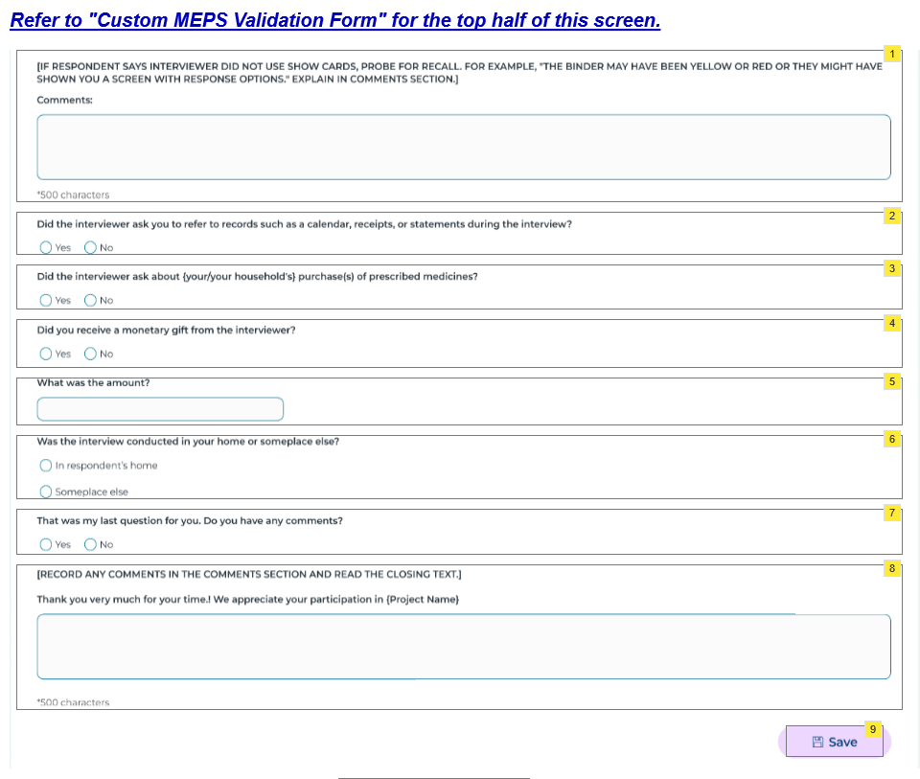

Widget Table
Footnote | Name | Requirements
1 | VF Reason No Show Cards Probe | Display/Enable  Only when VF Confirm Show Cards Use = No  Question Text:  "[IF RESPONDENT SAYS INTERVIEWER DID NOT USE SHOW CARDS, PROBE FOR RECALL. FOR EXAMPLE, "THE BINDER MAY HAVE BEEN YELLOW OR RED OR THEY MIGHT HAVE SHOWN YOU A SCREEN WITH RESPONSE OPTIONS." EXPLAIN IN COMMENTS.]  Response:  Allow entry of up to 500 characters in Comments field.  Flow:  Go to VF Confirm Records Use
2 | VF Confirm Records Use | Display/Enable  Only when  VF Confirm Show Cards Use = Yes or  VF Reason No Show Cards Probe = Not Empty  Question Text:  "Did the interviewer ask you to refer to records such as a calendar, receipts, or statements during the interview?"  Response:  Yes/No  Flow:  Go to VF Confirm Prescription Questions
3 | VF Confirm Prescription Questions | Display/Enable  Only when VF Confirm Records Use = Not empty  Question Text:  "Did the interviewer ask about (your/your household's) purchase(s) of prescribed medicines?"  Response:  Yes/No  Flow:  Go to VF Confirm Monetary Gift
4 | VF Confirm Monetary Gift | Display/Enable  Only when VF Confirm Prescription Questions = Not Empty  Question Text:  "Did you receive a monetary gift from the interviewer?"  Response:  Yes/No  Flow:  If Yes, go to VF Confirm Gift Amount  If No, go to VF Confirm Interview Location
5 | VF Confirm Gift Amount | Display/Enable  Only when VF Confirm Monetary Gift = Yes  Question Text:  "What was the amount?"  Response:  Yes/No  Flow:  Go to VF Confirm Interview Location
6 | VF Confirm Interview Location | Display/Enable  Only when  VF Confirm Monetary Gift = No or  VF Confirm Gift Amount = Not Empty  Question Text:  "Was the interview conducted in your home or someplace else?"  Response:  Yes/No  Flow:  Go to VF Closing Question
7 | VF Closing Question | Display/Enable  Only when VF Closing Question = Not Empty  Question Text:  "That was my last question for you. Do you have any comments?"  Response:  Yes/No  Flow:  Go to VF Thank You and Comments
8 | VF Thank You and Comments | Display/Enable  Only when  Question Text:  "[RECORD ANY RESPONDENT COMMENTS IN THE FIELD BELOW AND READ THE CLOSING TEXT. ADD YOUR OWN COMMENTS IN THE PHONE VALIDATOR SUMMARY SECTION.]  Thank you very much for your time! We appreciate your participation in {Project Name}"  Response:  Allow entry of up to 500 characters in Comments field.  Flow:  If Yes, go to  If No, go to
9 | Save Button | Enable  When...  On click,  No Further Edits Warning Dialog  ELSE, if any required values are missing, display Finish Survey Warning  Once confirmed save entries.  On click Complete Button,  Store Phone Survey responses.  Set Call Outcome to Survey Complete and Phone Status to Pending.  Set Final Record of Call with values based on current system date, time and user log in.  Enable/Open Phone Validator Summary Screen.  Phone Validation Status will be set to Complete when the Validator Summary questions are answered and submitted.

