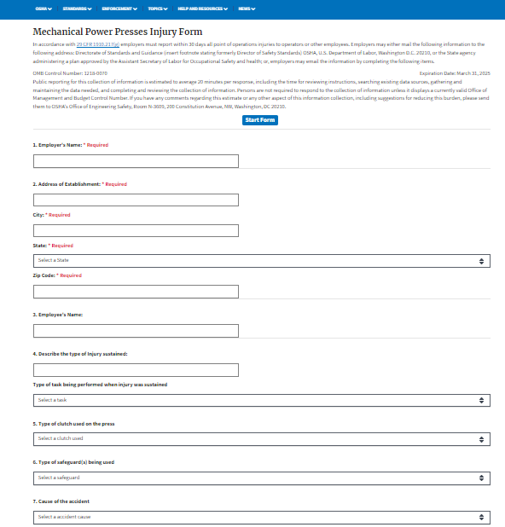

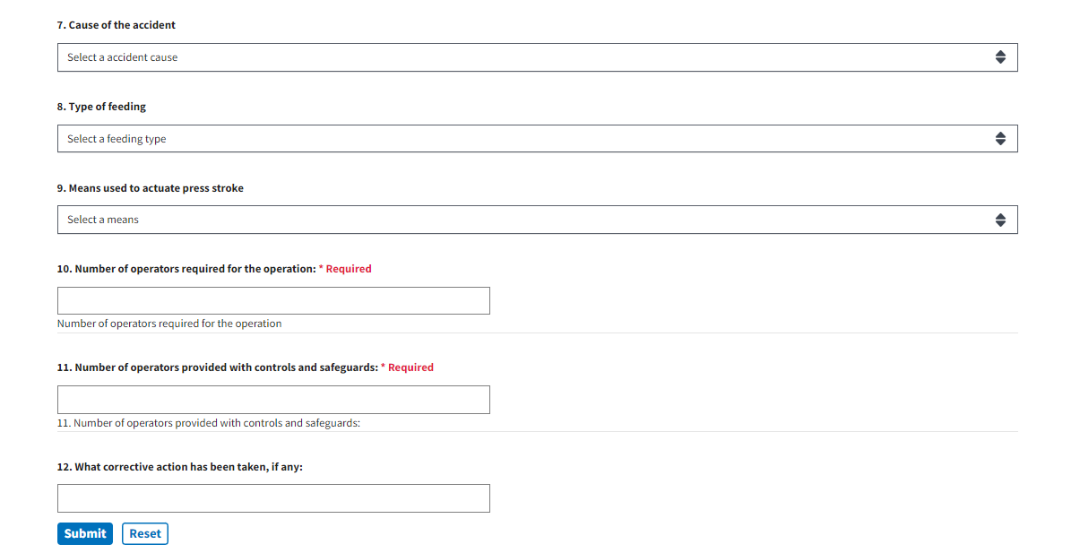

ENLARGED WORDING BELOW OF VISUAL OF FORM ABOVE IS AS FOLLOWS

**Mechanical Power Presses Injury Form**

In accordance with [29 CFR 1910.217(g)](https://www.osha.gov/laws-regs/regulations/standardnumber/1910/1910.217#1910.217(g)) employers must report within 30 days all point of operations injuries to operators or other employees. Employers may either mail the following information to the following address: Directorate of Standards and Guidance (insert footnote stating formerly Director of Safety Standards) OSHA, U.S. Department of Labor, Washington D.C. 20210, or the State agency administering a plan approved by the Assistant Secretary of Labor for Occupational Safety and health; or, employers may email the information by completing the following items.

OMB Control Number: 1218-0070Expiration Date: March 31, 2025  
Public reporting for this collection of information is estimated to average 20 minutes per response, including the time for reviewing instructions, searching existing data sources, gathering and maintaining the data needed, and completing and reviewing the collection of information. Persons are not required to respond to the collection of information unless it displays a currently valid Office of Management and Budget Control Number. If you have any comments regarding this estimate or any other aspect of this information collection, including suggestions for reducing this burden, please send them to OSHA's Office of Engineering Safety, Room N-3609, 200 Constitution Avenue, NW, Washington, DC 20210.

Top of Form

[**Start Form**](https://www.osha.gov/form/mechanical-power-presses)

Mechanical Power Presses Injury Form

In accordance with 29 CFR 1910.217(g) employers must report within 30 days all point of operations injuries to operators or other employees. Employers may either mail the following information to the following address: Directorate of Standards and Guidance (insert footnote stating formerly Director of Safety Standards) OSHA, U.S. Department of Labor, Washington D.C. 20210, or the State agency administering a plan approved by the Assistant Secretary of Labor for Occupational Safety and health; or, employers may email the information by completing the following items.

OMB Control Number: 1218-0070Expiration Date: March 31, 2025

Public reporting for this collection of information is estimated to average 20 minutes per response, including the time for reviewing instructions, searching existing data sources, gathering and maintaining the data needed, and completing and reviewing the collection of information. Persons are not required to respond to the collection of information unless it displays a currently valid Office of Management and Budget Control Number. If you have any comments regarding this estimate or any other aspect of this information collection, including suggestions for reducing this burden, please send them to OSHA's Office of Engineering Safety, Room N-3609, 200 Constitution Avenue, NW, Washington, DC 20210.

Start Form

1. Employer's Name: * Required

2. Address of Establishment: * Required

City: * Required

State: * Required

Select a State

Zip Code: * Required

3. Employee's Name:

4. Describe the type of Injury sustained:

Type of task being performed when injury was sustained

Select a task

5. Type of clutch used on the press

Select a clutch used

6. Type of safeguard(s) being used

Select a safeguard

7. Cause of the accident

Select a accident cause

8. Type of feeding

Select a feeding type

9. Means used to actuate press stroke

Select a means

10. Number of operators required for the operation: * Required

Number of operators required for the operation

11. Number of operators provided with controls and safeguards: * Required

11. Number of operators provided with controls and safeguards:

12. What corrective action has been taken, if any:

Submit Reset