**DEPARTMENT OF HOMELAND SECURITY**

**Federal Emergency Management Agency**

**Emergency Notification System (ENS)**

**OMB Control Number:** 1660-0137

**Expiration Date:**

**PAPERWORK BURDEN DISCLOSURE NOTICE**

Public reporting burden for this data collection is estimated to average 1 minute per response and 5 minutes for the initial set up. The burden estimate includes the time for reviewing instructions, searching existing data sources, gathering and maintaining the data needed, and completing and submitting this form. This collection of information is voluntary. You are not required to respond to this collection of information unless a valid OMB control number is displayed on this form. Send comments regarding the accuracy of the burden estimate and any suggestions for reducing the burden to: Information Collections Management, Department of Homeland Security, Federal Emergency Management Agency, 500 C Street, SW, Washington, DC20472-3100, Paperwork Reduction Project (1660-0137). **NOTE: Do not send your completed form to this address.**

**System Screen shots for Emergency Notification System (ENS) (Response Time)**

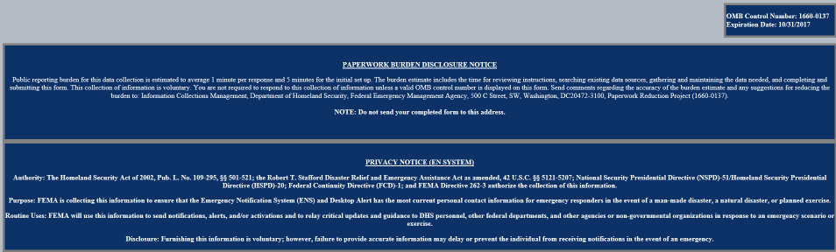http://ens1auth.dhs.gov

FEMA Users Log-In Page:

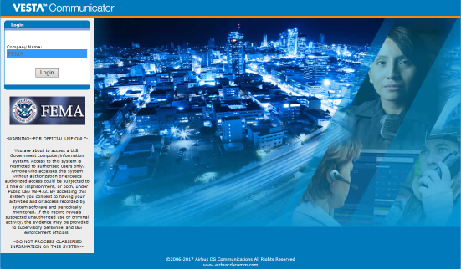

All other DHS users Log-In Page:

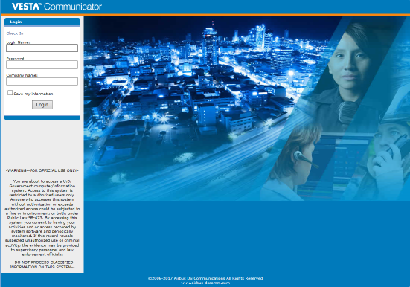

User’s contact information page. Here they can modify their device information (email, phone number, etc.) or add/remove devices.

