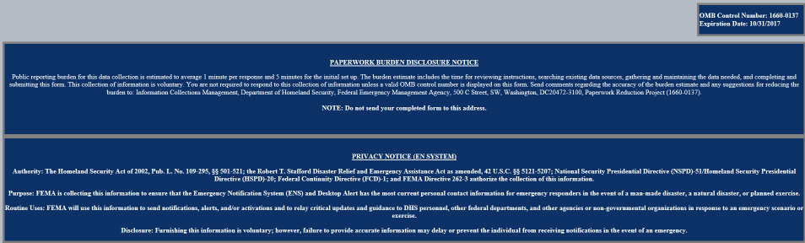http://ens1auth.dhs.gov

FEMA Users Log-In Page:

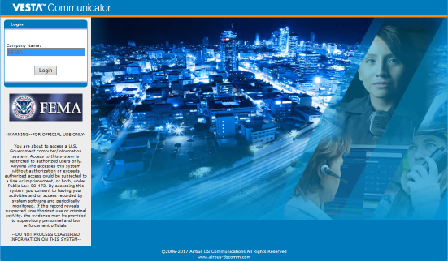

All other DHS users Log-In Page:

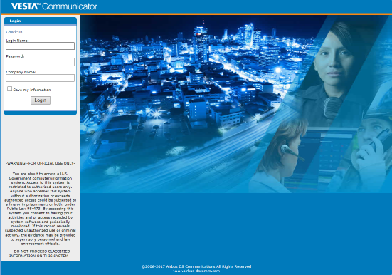

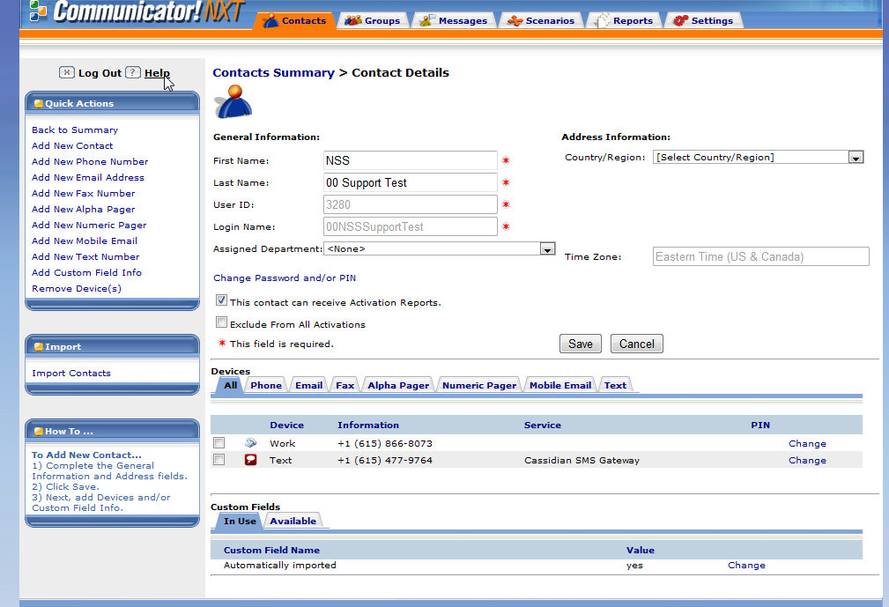

User’s contact information page. Here they can modify their device information (email, phone number, etc.) or add/remove devices.