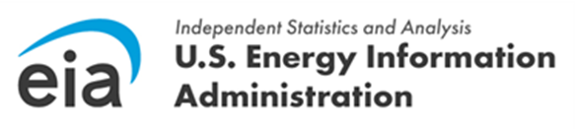 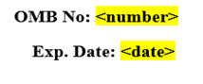

Dear <Respondent>,

Your company has been selected by the U.S. Energy Information Administration (EIA) to respond to the **Quarterly Electricity Imports and Exports Survey (EIA-111).** Form EIA-111 is used to collect U.S electricity import and export data from importers and exporters of electricity, border balancing authorities, and entities authorized to export electric energy and to construct, operate or maintain facilities for the transmission of electric energy at an international boundary as required by 10 CFR 205.308 and 205.325. These data are collected pursuant to the Federal Energy Administration (FEA) Act of 1974, Public Law 93-275, and response to this survey is mandatory under the FEA Act.

The data collection cycle for EIA-111 **[quarter, year]** will begin on **[open date]** and data are due on **[due date]**.

Based on information gathered by EIA, you have been identified as the initial point of contact for providing information needed to complete the EIA-111 form. If you are not the appropriate contact, please forward the appropriate person's contact information to [EIA4USA@eia.gov](mailto:EIA4USA@eia.gov) and we will contact them directly.

To submit your data, you may log into the U.S. Energy Information Administration [Respondent Submission Portal](http://survey.eia.gov/), select the appropriate survey cycle from the Respondent Submission Portal **Home** or **To Do** tab, and submit your data.

In order to register for the EIA Respondent Portal, please continue to the portal [here](http://survey.eia.gov/). **NOTE**: Please use Google Chrome browser to access the portal. Click the "**REGISTER**" button on the right side of the screen, and copy and paste the information below into the corresponding fields in the registration page. Once completed, click the "**REGISTER**" button. You will then receive a temporary password email, which will provide further instructions to set up your password.

|  |  |
| --- | --- |
| Email: |  |
| First Name: |  |
| Last Name: |  |
| Entity ID: |  |
| Phone: |  |

For more information about registration and how to use the [**EIA Respondent Portal**](https://survey.eia.gov/), view the recorded[**EIA-111 Information Session**](https://www.eia.gov/survey/form/eia_111/portal_instructions.mp4) or the corresponding [**Power Point presentation**](https://www.eia.gov/survey/form/eia_111/portal_instructions.pdf).

If you have any questions or concerns, please contact the U.S. Energy Information Administration Customer Care Team via e-mail at [EIA4USA@eia.gov](mailto:EIA4USA@eia.gov), or call 1-855-EIA-4USA (1-855-342-4872) Monday through Friday, 8:00 AM - 6:00 PM ET.

Sincerely,

Joseph Wilson

Director, Office of Survey Operations

U.S. Energy Information Administration

U.S. Department of Energy