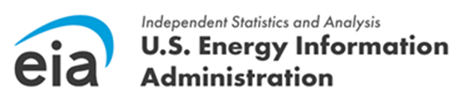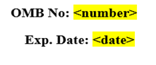
Dear <Respondent Name>,

This is a reminder that the <Quater, Year> data submission for the Quarterly Electricity Imports and Exports Survey (EIA-111) is due in less than a week on <Due Date>. If you have already submitted your form, thank you for your submission.

These data are collected pursuant to the Federal Energy Administration (FEA) Act of 1974, Public Law 93-275, and response to this survey is mandatory under the FEA Act.

Please log into the EIA Respondent Portal to access the form and submit your data. The survey cycle can be accessed from the U.S. Energy Information Administration Respondent Submission Portal Home or To Do tab. For more information on how to submit your data, view the recorded EIA-111 Information Session or the corresponding Power Point presentation.

Thank you for your time and effort in diligently completing this form. We appreciate your timely submission of <Quater, Year> data by <Due Date>.

If you need more time to complete the survey, please contact us either via e-mail at EIA4USA@eia.gov, or by phone at 1-855-EIA-4USA (1-855-342-4872). Our Customer Care Center is open Monday through Friday, 8:00 AM - 6:00 PM ET to serve you.

Sincerely,

Joseph Wilson
Director, Office of Survey Operations
U.S. Energy Information Administration
U.S. Department of Energy

