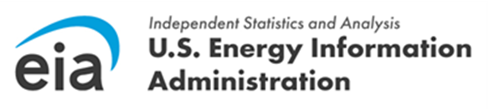 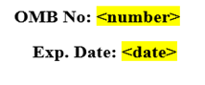

Dear <Respondent Name>,

The Quarterly Electricity Imports and Exports Survey (EIA-111) for the **<Quater, Year>** reporting period was due on **<Due Date>**. These data are collected pursuant to the Federal Energy Administration (FEA) Act of 1974, Public Law 93-275, and timely response to this survey is mandatory under the FEA Act.

Please log into the [**EIA Respondent Portal**](https://survey.eia.gov/) to access the form and submit your data. The survey cycle can be accessed from the U.S. Energy Information Administration Respondent Submission Portal **Home** or **To Do** tab. For more information about registration and how to use the [**EIA Respondent Portal**](https://survey.eia.gov/), view the recorded[**EIA-111 Information Session**](https://www.eia.gov/survey/form/eia_111/portal_instructions.mp4) or the corresponding [**Power Point presentation**](https://www.eia.gov/survey/form/eia_111/portal_instructions.pdf).

If you have any questions or concerns, please contact the U.S Energy Information Administration Customer Care Center via e-mail at [**EIA4USA@eia.gov**](mailto:eia4usa@eia.gov), or call 1-855-EIA-4USA (1-855-342-4872) Monday through Friday, 8:00 AM - 6:00 PM ET.

Sincerely,

Joseph Wilson

Director, Office of Survey Operations

U.S. Energy Information Administration

U.S. Department of Energy