Attachment A: Contact and Other Information Gathering Form
Introductory text:
The Institute of Museum and Library Services (IMLS) aims to advance, support, and empower America’s museums through grantmaking, research, and policy development.
As a part of this work, IMLS is developing a new National Museum Survey (NMS) aimed at museums of all kinds – including botanical gardens, arboretums, and nature centers; zoos and aquariums; science and technology centers/museums and planetariums; history museums and historic sites; art museums; children’s museums; natural history and anthropology museums; and general and specialized museums to capture the scope and scale of museums’ presence and reach within the U.S.
Please provide the requested information to ensure that IMLS can include your institution in this important survey!
Providing this information will not affect any past, current, or future relationship you or your institution may have with IMLS in any way.
[ONE QUESTION PER SCREEN]
INSTITUTION DISCIPLINE
Which of the following disciplines best represents your institution? Required
(Select all that apply)
- Anthropology museum
- Aquarium
- Arboretum
- Art museum
- Botanical garden
- Children's museum
- General or specialized museum
- Historic house and/or site
- History museum
- Natural history museum
- Nature center
- Planetarium
- Science and technology center/museum
- Zoo
- Other: [Open text box]

STATE
In which state is your [insert discipline; if a discipline with “museum” in title OR “other,” insert “museum”] based? Required
[State drop-down menu]
INSTITUTION NAME
Which of the following institutions are you affiliated with? If your institution is not listed, please select Other.
Begin by typing any part of your institution name in the text box to more quickly find it in the list. Required
[Key word searchable drop-down menu of institution names based on the state selected for physical address]
[IF OTHER]
What is the name of your [insert discipline; if a discipline with “museum” in title OR “other,” insert “museum”]? Required
[Open text box]
[SINGLE SCREEN]
What is [INSTITUTION NAME]’s physical address? Required
Street address: [Open text box]
City: [Open text box]
Zip code: [Text box with Postal Code verification]
[SINGLE SCREEN]
INSTITUTION MAILING ADDRESS
Is [INSTITUTION NAME]’s mailing address the same as its physical address?
- Yes
- No
[IF NO] Required
Mailing Street address: [Open text box]
City: [Open text box]
State: [State drop-down menu]
Zip code: [Text box with Postal Code verification]
[ONE QUESTION PER SCREEN]
SMALL INSTITUTION
Do you consider [INSTITUTION NAME] to be a small [INSERT TYPE BASED ON DISCIPLINE ANSWER]? Please only consider [INSTITUTION NAME] and not any parent institution [POPUP DEFINITION] it might be affiliated with when answering this question. Required
- Yes
- No
- Not sure
NUMBER OF DAYS OPEN TO THE PUBLIC
Under normal circumstances, is [INSTITUTION NAME] open to the public 90 days or more per year through specific hours of operation and/or appointment? Required
- Yes
- No

SURVEY RESPONDENT ID
As a part of our preparation, we are identifying the primary point-of-contact who is best suited to steward or shepherd completion of the National Museum Survey by [INSTITUTION NAME].

Is that person you or someone else? The NMS will request high-level information about [INSTITUTION NAME]’s institutional characteristics, facilities, finances, human resources, admissions and visitors, and digital presence.
Optional
- Me
- Someone else

[IF ME]
[SINGLE SCREEN]
YOUR NAME Required
First name: [Open text box]
Last name: [Open text box]
WORK PHONE NUMBER Required
[Text box with phone number format verification]
WORK EMAIL ADDRESS Required
[Text box with email format verification]
TITLE
Which of the following best describes your role at your [insert discipline; if a discipline with “museum” in title OR “other,” insert “museum”]? Required
- CEO
- Executive Director or Director
- Head of Finance or CFO
- Director of Operations
- Director of Development or Advancement
- Director of Communications or External Relations
- Other (please specify): [Open text box]

[IF SOMEONE ELSE]
[SINGLE SCREEN]
Please provide the name and contact information for the person at [INSTITUTION NAME] who is best suited to coordinate the completion of the NMS. Optional [Soft verify]
First name: [Open text box]
Last name: [Open text box]
Work Phone number: [Text box with phone number format verification]
Work Email address: [Text box with email format verification]
Job Title/Role: [Open text box]
[SINGLE SCREEN]
Please provide [INSTITUTION NAME]’s general contact information below.
This is typically the main phone number and email address listed on your website to get in touch with your institution. Optional

Main phone number: [Text box with phone number format verification]
For example, a reception desk, main office, or customer service number.
Main email address: [Text box with email format verification]
For example, info@museumname.org or contactus@museumname.org. mailto:

[ONE QUESTION PER SCREEN]

ADDITIONAL CONTACT
Would you like to provide the contact information for another representative of your [insert discipline; if a discipline with “museum” in title OR “other,” insert “museum”]? Optional
- Yes ->
  - [SINGLE SCREEN] Ask First Name, Last Name, Work Phone Number, Work Email Address, Job Title/Role for additional contact
- No
[ONE QUESTION PER SCREEN]
LEGAL CLASSIFICATION OF INSTITUTION
Which category best describes your [insert discipline; if a discipline with “museum” in title OR “other,” insert “museum”]’s legal classification? Optional
- Non-profit organization
- Non-profit college/university
- For-profit company/business
- For-profit college/university
- Public college/university (e.g., state college)
- Local government (e.g., municipal, county)
- State/territorial government
- Tribal government
- Federal government
- Other (please specify): [Open text box]

ANNUAL OPERATING BUDGET
What was [INSTITUTION NAME]’s annual operating budget [POPUP: Annual operating budget is an estimate of expenditures for the 12-month fiscal year.] in Fiscal Year 2023? Optional
This information will only be available to the NMS team and will not be shared with any grantmaking staff at IMLS. It will be used to help the NMS team field the survey and will make your response to the National Museum Survey easier. It will not affect any past, current, or future relationship you or your institution may have with IMLS in any way.
If unsure, use your best estimate.

- $49,999 or less
- $50,000 – $249,999
- $250,000 – $499,999
- $500,000 – $999,999
- $1,000,000 – $2,499,999
- $2,500,000 – $4,999,999
- $5,000,000 – $9,999,999
- $10,000,000 or more
- I don’t know
- I am unable to report this separately from our parent institution

Thank you for submitting this information to ensure your [insert discipline; if a discipline with “museum” in title OR “other,” insert “museum”] is included in the National Museum Survey.
In addition to the NMS, IMLS is developing a list of institutions’ general information to help the public find museums to visit. This list would only include your institution’s name, its physical address, its phone number and its email address. It would NOT include any other information you submitted on this form, including any specific individual’s work email address or work phone number.
Does IMLS have your consent to include [MUSEUM NAME]’s name, physical address, main phone number and main email address to be shared publicly?
- Yes
- No
- I cannot answer for my [insert discipline; if a discipline with “museum” in title OR “other,” insert “museum”]

Finally, do you know of another museum that should also be included in the National Museum Survey that might be hard for the IMLS team to reach? If so, please provide its name below so that the NMS team can be sure they are included. Please provide the name of no more than one museum:
[OPEN TEXT]

Thanks again, for your time in providing this information. If there are museums you believe may not have received this information, please share widely with those in your network using this link: [Contact form link]

Attachment B: Text to accompany open link form to use in various communications

Short version (envision using on a flyer or other short posting for social media, etc.):

IMLS needs your help to ensure that we can reach you when the NMS launches in early 2025!

The United States’ primary federal funder of museums, the Institute of Museum and Library Services (IMLS), has developed a new National Museum Survey (NMS) aimed at capturing the scope and scale of museums’ presence and reach within the U.S.

Please visit:
[link]

to provide contact and basic information about your institution to be sure your museum – including botanical gardens, arboretums, and nature centers; zoos and aquariums; science and technology centers/museums and planetariums; history museums and historic sites; art museums; children’s museums; natural history and anthropology museums; and general and specialized museums – can participate in this important survey.

More information about the NMS, including the pilot survey IMLS successfully ran in 2023, can be found at [link].

We also welcome you to email [email] with the name, title, and work email address of your best contact for the NMS, along with any specific questions you may have.

Long version (this text may be used in the same way as the short version, but gives more detail):

IMLS needs your help to ensure that we can reach you when the NMS launches in early 2025!

The United States’ primary federal funder of museums, the Institute of Museum and Library Services (IMLS), aims to empower the field through policy and research. To that end, IMLS has developed a new National Museum Survey (NMS) aimed at capturing the scope and scale of museums’ presence and reach within the U.S.

We ask that you help us ensure the upcoming 2025 survey reaches the right person at your institution. We are currently gathering contact information for the thousands of institutions across the country that should be included in this survey—please provide contact information for your institution by visiting [link].

Results from the NMS will help your institution contextualize its work and will help policymakers, the museum field, and the public by providing badly needed baseline statistics about the impact and reach of our nation’s museums, including:

- Botanical Gardens, Arboretums, and Nature Centers
- Zoos and Aquariums
- Science and Technology Centers/Museums and Planetariums
- History Museums and Historic Sites
- Art Museums
- Children’s Museums
- Natural History and Anthropology Museums
- General and Specialized Museums

More information about the NMS, including the pilot survey IMLS successfully ran in 2023, can be found at [link].

We also welcome you to email [email] with the name, title, and work email address of the best person to contact at your institution for this survey, along with any specific questions you may have.

Attachment C: Telephone Script

Phone answered:

Hello,

My name is [NAME] and I’m calling on behalf of the United States’ primary federal funder of museums, the Institute of Museum and Library Services, about its National Museum Survey. May I speak with [Institution Name]’s Executive Director or CEO?

[If yes, can speak with Executive Director or CEO]

I’m calling from ICF on behalf of the Institute of Museum and Library Services, commonly known as IMLS, which is the largest federal grant maker to the nation’s museums. In early 2025, IMLS will conduct the National Museum Survey that will collect data directly from institutions like yours to inform policymakers, the museum field, and the public about the role that the nation’s museums play in society.

We are currently collecting contact information to ensure that the survey reaches the appropriate contact at [institution name], as well as basic information about [institution name]. Are you the best person for us to speak to about this upcoming survey?

[If no] Can you direct me to the best person to provide this information, or provide their name and work email so that I may contact them via email?
[If yes]
Do you have 5 minutes to answer a few questions about [institution name]?
[If yes, proceed with contact form questions]

[If no]

When would be a good time to call back? I can also direct you to [link] to complete this information online.

[If respondent wants more information about NMS, answer specific questions or direct to NMS website]

More information about the NMS can be found at [link].

[If no, cannot speak with Executive Director or CEO]

I’m calling from ICF on behalf of the Institute of Museum and Library Services, commonly known as IMLS, which is the largest federal grant maker to the nation’s museums. In early 2025, IMLS will conduct the National Museum Survey that will collect data directly from institutions like yours to inform policymakers, the museum field, and the public about the social, cultural, educational, and economic roles that the nation’s museums play in American society. I am looking to speak to the executive director (or CEO) of [institution name] or someone else who might be able to provide basic information about [institution name]. Could you please direct me to someone that would have this information, or provide me with a name and work email address for someone I can reach out to?

[If respondent wants more information about NMS, answer specific questions or direct to NMS website]

More information about the NMS can be found at [link].

Voicemail:

Hello,

My name is [NAME] and I am calling on behalf of the United States’ primary federal funder of museums, the Institute of Museum and Library Services, about its new annual National Museum Survey. This survey will help inform policymakers, the museum field, and the public about the impact and reach of vital institutions like yours. The survey will be sent in early 2025. We are hoping to retrieve the appropriate contact information for [institution name] to ensure that [institution name] can be included in this important survey.

Please visit [link] to provide contact information for [institution name].

You may also email us back at [email] and provide the name, title, and work email address of the best contact at [institution name] for this survey.

Thank you for your time!

Attachment D: Postcard

See next page.

*12345678A* 12345678A
Institution Name
980 Beaver Creek Drive Suite 2
Martinsville, VA 24112
***************AUTO**MIXED AADC 270
DDFAAAAATATFFATTDFDATATATT
Dear Colleague,
We are preparing for the Institute of Museum and Library Services’ (IMLS) National Museum Survey (NMS), which will launch in early 2025. This national survey will help inform policymakers, the museum field, and the public about the impact and reach of institutions like yours.
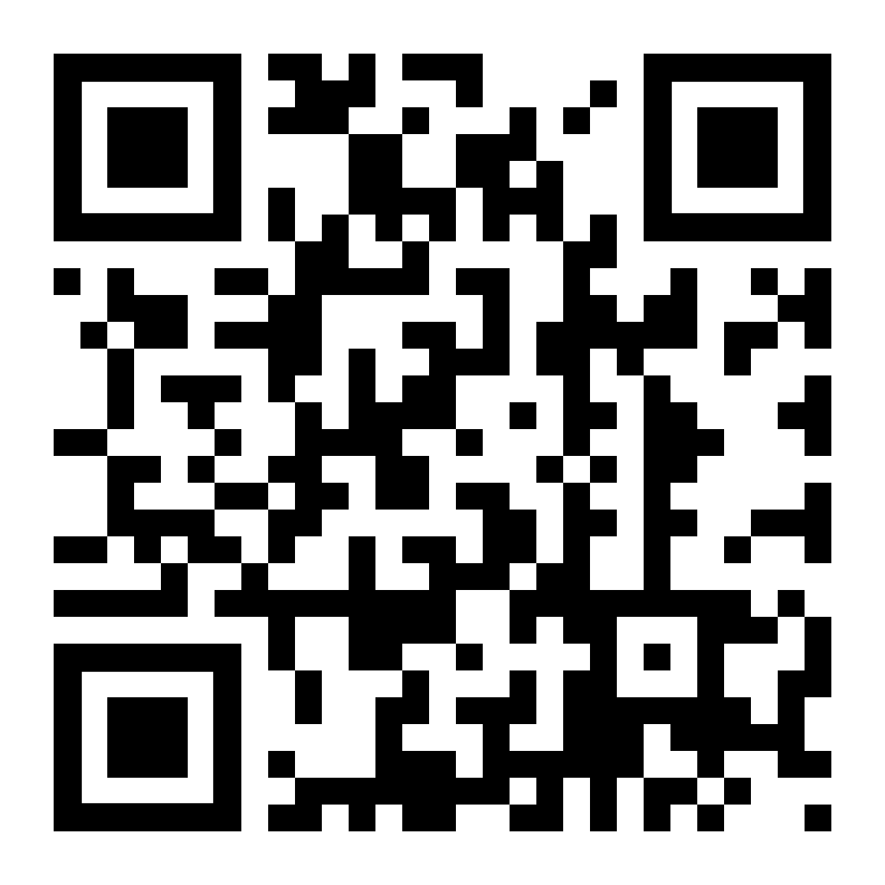
We need your help — please provide contact information for [Institution Name] to be sure you can be reached!
Scan this QR code to go directly to the contact information form.
Just point your cell phone camera at the QR code and click on the link that appears.
To complete the requested information about your institution, please visit:
www.linktoform.com

OR

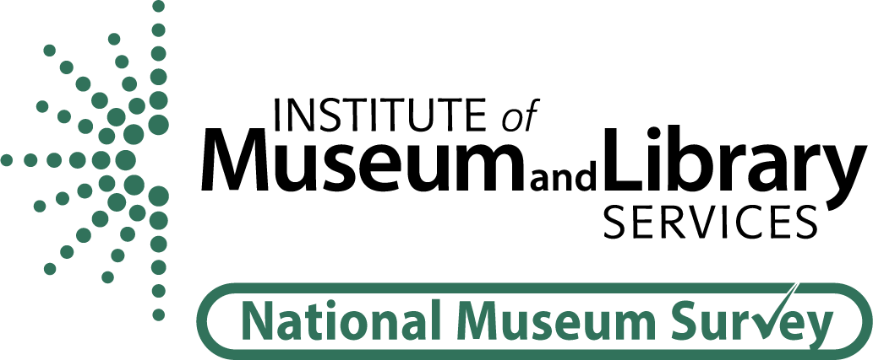
Thank you for your help!
Sincerely,
[Signature]
Firstname Lastname
Title

Attachment E: Email Communications
Subject: Don’t be left out of the National Museum Survey

Dear Colleague,

The Institute of Museum and Library Services (IMLS) needs your help preparing for the first annual National Museum Survey (NMS) launching in early 2025.

Please visit [link] to provide your institution’s contact information to be sure that you are included in this important annual survey!

In addition to serving as the largest federal grant maker to museums, IMLS aims to empower the field through policy and research. The NMS will help your institution contextualize its work and will inform policymakers, the museum field, and the public by providing badly needed baseline statistics about the impact and reach of our nation’s museums, including:

- Botanical Gardens, Arboretums, and Nature Centers
- Zoos and Aquariums
- Science and Technology Centers/Museums and Planetariums
- History Museums and Historic Sites
- Art Museums
- Children’s Museums
- Natural History and Anthropology Museums
- General and Specialized Museums

More information about the NMS, including the pilot survey IMLS successfully ran in 2023, can be found at [link].

We also welcome you to email [email] with the name, title, and work email address of your best contact for this survey, along with any specific questions you may have.

