Non-substantive Change Request
0535-0003 – Ag Prices
GRAIN PRICES RECEIVED BY FARMERS FOR GRAINS AND PULSE CROPS – 2024
This non-substantive change request affects the Grain Prices Received by Farmers for Grain and Pulse Crops. The change is being requested by the survey team to reduce respondent confusion. The specific changes are itemized below and highlighted in the draft questionnaire.
FROM:
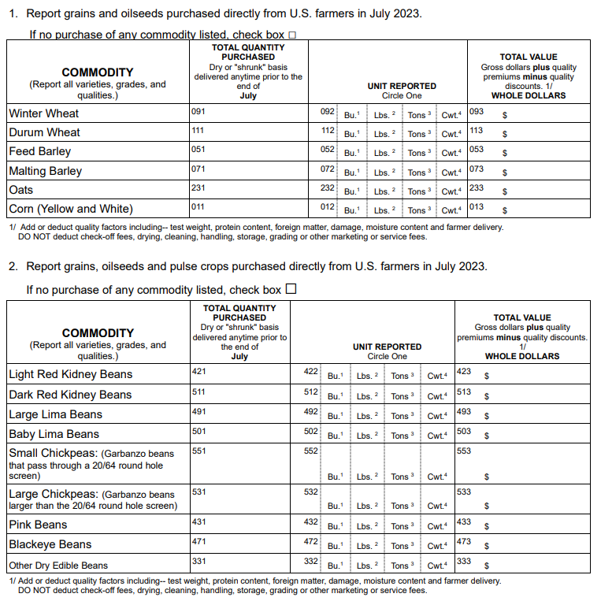
TO:
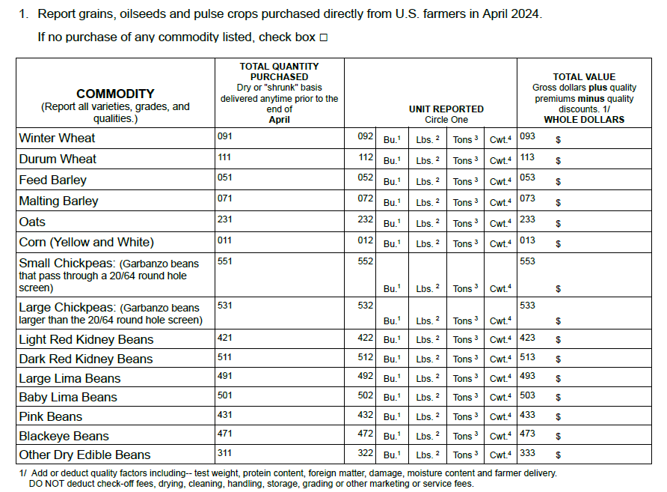
These changes will not impact the current sample size or respondent burden.
The revised questionnaire is loaded to ROCIS.

