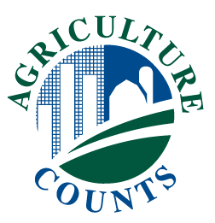

**United States Department of Agriculture**

National Agricultural Statistics Service

Your Guide for the

**Tenure, Ownership, and**

**Transition of Agricultural Land Survey**

**\*\* Example from 2014 Survey \*\***

**Final 2024 Guide in Development**

This guide gives helpful information on completing your survey form. If you need more help, call 1‑800‑XXX–XXXX. The telephone call is free. After you have completed your survey form, **please return it in the postage-paid envelope** we have provided.

**YOUR ANSWERS ARE CONFIDENTIAL AND REQUIRED BY LAW**

The law, Title 7, U.S. Code, authorizing the Tenure, Ownership, and Transition of Agricultural Land Survey, also provides that your answers are confidential. No one except National Agricultural Statistics Services employees may see your completed form and they can be fined and/or imprisoned for any disclosure of your answers. The same law that protects the confidentiality of your answers **requires** that you provide the information asked in this survey to the best of your knowledge.

**OMB No. 0535-0240**

**How to Complete the Tenure, Ownership, and Transition of Agricultural Land Form**

Use **BLUE** or **BLACK** ink to complete the form. Please mark the category or categories as they apply to your land. Enter whole numbers. If you have ½ of an acre, convert to the nearest whole number. If you do not have exact figures, please give your best estimates. For all dollar items, enter dollar amounts, excluding cents. (See the **Example** below.)

To answer questions with an answer box, use an X or shade inside the box to record your answer.

**Example of Printed and Marked Entries**

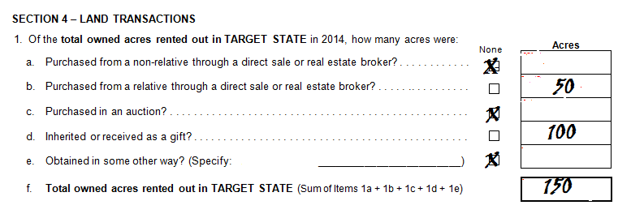

**Or Respond Online**

* Data reported online is safe, secure, and will be kept confidential.
* Reporting online is the most economical method to report and save taxpayer money.
* Reporting online saves paper and is environmentally friendly.

**How to Complete the Tenure, Ownership, and Transition of Agricultural Land Form, by Section**

**Section 1 - Land Ownership**

Answer question 1 and follow the instructions after the checked box. Report for only the land you rent out in the target state specified in Question 1.

**Section 2 - Acres and Use**

Questions 2 – 5 refer to the total owned acres rented out in question 1 in section 2. Enter the amount of acres for each land use item.

**Section 3 - Rental Agreements**

This section refers to the tenants who you rent land to in the target state. Complete questions 2a – 2h for your 3 largest tenants in the target state.

**Section 4 - Land Transactions**

Be sure to consider the most likely future land transactions to answer question 3.

**Section 5 - Landlord Farm Income**

In addition to cash and share rent income, this section captures landlord income as a measure of income and expenses for the entire farming operation. For question 2, be sure to include the full income received in 2014, even if rent payments were for a 2013 or prior year’s lease.

**Section 6 - Landlord Farm Assets**

Exclude the tenant’s share of any asset value. Be sure to provide total assets for any partnership, corporation, or other operating arrangement that you are involved with as a landlord.

**Section 7 - Landlord Capital Expenses**

Exclude the tenant’s share of capital expenses. Include capital expenses for any partnership, corporation, or other operating arrangement that you are involved with as a landlord.

**Section 8 - Landlord Operating Expenses**

Exclude the tenant’s share of operating expenses. Be sure to provide operating expenses for any partnership, corporation, or other operating arrangement that you are involved with as a landlord.

**Section 9 - Landlord Farm Debt**

The acres in question 1a and 1b must equal the total owned acres rented out in the target state, previously recorded in section 2, question 1. Questions 2a – 2h have 2 columns that break out debt between real estate and non-real estate debt. Question 2h is the total for the questions 2a-2g. If you are unsure of the breakout, record the total in question 2h.

**Section 10 - Individual and Partnership Ownership**

Questions 2a-2c refers to the number of total acres that you own as an individual and as a partnership. Questions 2ci and 2cii refer to the number of male and female landlord partners. Question 11 refers to the percent of the farm’s net income you, the landlord, receive from the total owned acres rented out in the target state, to measure profit and loss. The acres in this section plus sections 11 and 12 should equal the total owned acres rented out in the target state recorded for question 1, section 2.

**Section 11 - Corporate Ownership**

This section refers to total owned acres rented out in the target state that were owned as a corporation. Question 3 is designed to measure the importance of agriculture to the corporation as a percent of sales.

**Section 12 - Other Ownership**

This section refers to total owned acres rented out in the target state that were owned as an arrangement other than an individual, partnership, or corporation.

**Section 13 - Conclusion**

If you indicate that you want the results of the survey, you will be mailed a Fact Sheet later in the year.

**Frequently Asked Questions --**

***Why is the USDA NASS conducting this survey?***

***The National Agricultural Statistics Service is conducting*** the Tenure, Ownership, and Transition of Agricultural Land survey to provide valuable information on the details of land ownership expenses, income and other information. Data collected from this survey will be combined with data from a similar survey that is being conducted of farm operators to generate a complete representation of farm economics. Policymakers have supported this Census follow-on survey because of the importance of making informed decisions on farm policies based on complete and accurate data.

***What does the National Agricultural Statistics Service do with the information you provide?***

NASS will publish results of The Tenure, Ownership, and Transition of Agricultural Land survey in the fall of 2015 to provide valuable insight on trends in land ownership in the agricultural economy. Results will be available on the NASS website, <http://www.nass.usda.gov/index.asp>. Only aggregate level data will be published, so that no individual reports or land owner information will be disclosed in the summary data. The information will be available to everyone from the general public to your leaders from government, business, and non-profit organizations to have more information when considering land ownership policy and program decisions.

***How was this address selected?***

Your address was scientifically selected to represent other agricultural land owners in your community. As part of a sample, you represent many other people. Agricultural land owners in the sample are required to complete the survey form. Land owners from the 48 contiguous States have been selected to participate in this very important survey. Please return the completed form in the postage-paid envelope as soon as possible.

***Is it safe to provide my information over the Internet?***

Yes. The Tenure, Ownership, and Transition of Agricultural Land survey is encrypted at all times. Our secure servers ensure the encrypted transmission of data between your browser and the National Agricultural Statistics Service. This means your browser and our server encode or scramble all data using a security key.