Apppendix F08.02. AMPM (24-Hour Dietary Recall) (Group 2A) and AMPM (In-School Intake Dietary Recall) (Group 2b)

**This page has been left blank for double-sided copying.**

This information is being collected to assist the Food and Nutrition Service in understanding school food purchasing practices, the nutritional quality of school meals and snacks, the cost to produce school meals, and student participation and dietary intakes. This is a voluntary collection and FNS will use the information to monitor program operations. This collection does not request any personally identifiable information under the Privacy Act of 1974. According to the Paperwork Reduction Act of 1995, an agency may not conduct or sponsor, and a person is not required to respond to, a collection of information unless it displays a valid OMB control number. The valid OMB control number for this information collection is 0584-[xxxx]. The time required to complete this information collection is estimated to average [IF G2a, FILL: 0.80 hours per response for students’ first dietary recall, 0.75 hours per response for students’ second dietary recall, 0.25 hours per response for parents assisting with the first dietary recall, and 0.75 hours per response for parents assisting with the second dietary recall][IF G2b, FILL: 0.30 hours per response], including the time for reviewing instructions, searching existing data sources, gathering and maintaining the data needed, and completing and reviewing the collection of information. Send comments regarding this burden estimate or any other aspect of this collection of information, including suggestions for reducing this burden, to: U.S. Department of Agriculture, Food and Nutrition Service, Office of Policy Support, 1320 Braddock Place, 5th Floor, Alexandria, VA 22314 ATTN: PRA (0584-xxxx). Do not return the completed form to this address.

OMB Number: 0584-xxxx

Expiration Date: xx/xx/20xx

The 24-hour dietary recall for Group 2a and the “in-school intakes” dietary recall for Group 2b will be conducted using the U.S. Department of Agriculture (USDA) Automated Multiple Pass Method (AMPM). The AMPM interview consists of five steps that utilize different strategies to encourage respondents to think about their intake in different ways in order to maximize their ability to remember and report the foods they have eaten. AMPM is designed for collecting 24-hour dietary recalls (Group 2a); however, the system will be customized for the “in school” dietary recalls (Group 2b) so that respondents are asked to recall a different time period. The five steps of the AMPM dietary recall include:

* **Step 1 - Quick List:** The first step obtains a quick report of easily remembered foods and beverages. The interviewer reads a standard memory prompt that suggests strategies for remembering foods and beverages consumed during the specified time period (see Exhibit A).
* **Step 2 - Forgotten Foods List:** The interviewer encourages respondents to think about specific categories of foods that are frequently forgotten, such as beverages, sweets, savory snacks, fruits, vegetables, cheese, breads, tortillas, and rolls (see example in Exhibit B).
* **Step 3 - Time and Occasion pass:** The interviewer encourages additional recall and reporting by helping the respondent to think about eating patterns, including the times that foods and beverages were consumed and the types of eating occasions like at breakfast, for a snack, or at lunch (see Exhibit C).
* **Step 4 - Detail and Review Cycle:** At this step, the interviewer probes for food descriptions and amounts, where foods were obtained, and where they were eaten. Each eating occasion and the periods between are reviewed to check whether the respondent remembers any additional foods. Respondents use measuring guides to help estimate the amounts of foods and beverages consumed (see example in Exhibit D).
* **Step 5 - Final Review**: The respondent is asked one last time to remember anything else consumed in the previous day (see Exhibit E).

**Exhibit A. Quick List Screenshot**

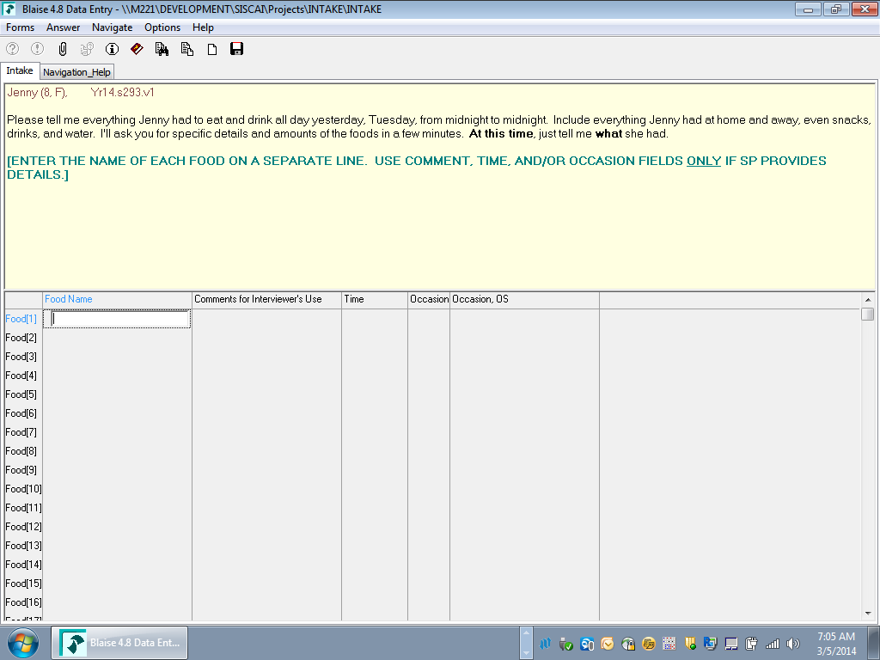

**Exhibit B. Forgotten Foods List Screenshot (Example question)**

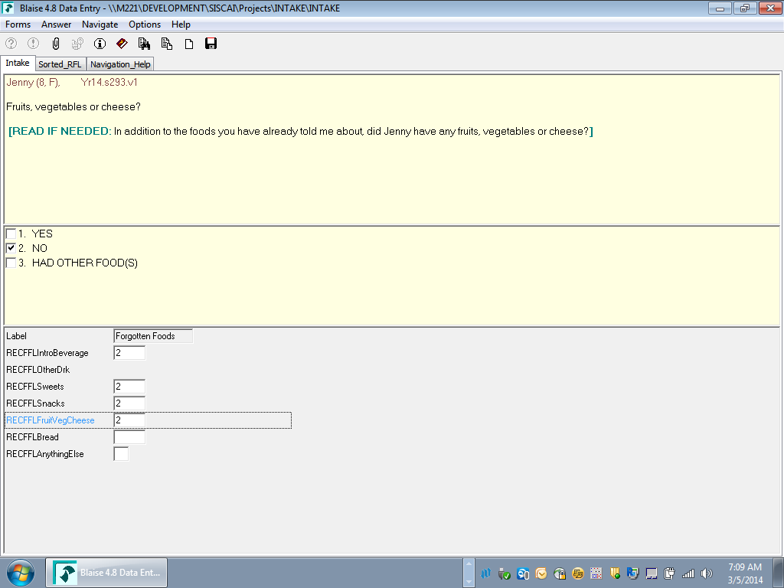

**Exhibit C. Time and Occasion Pass Screenshot**

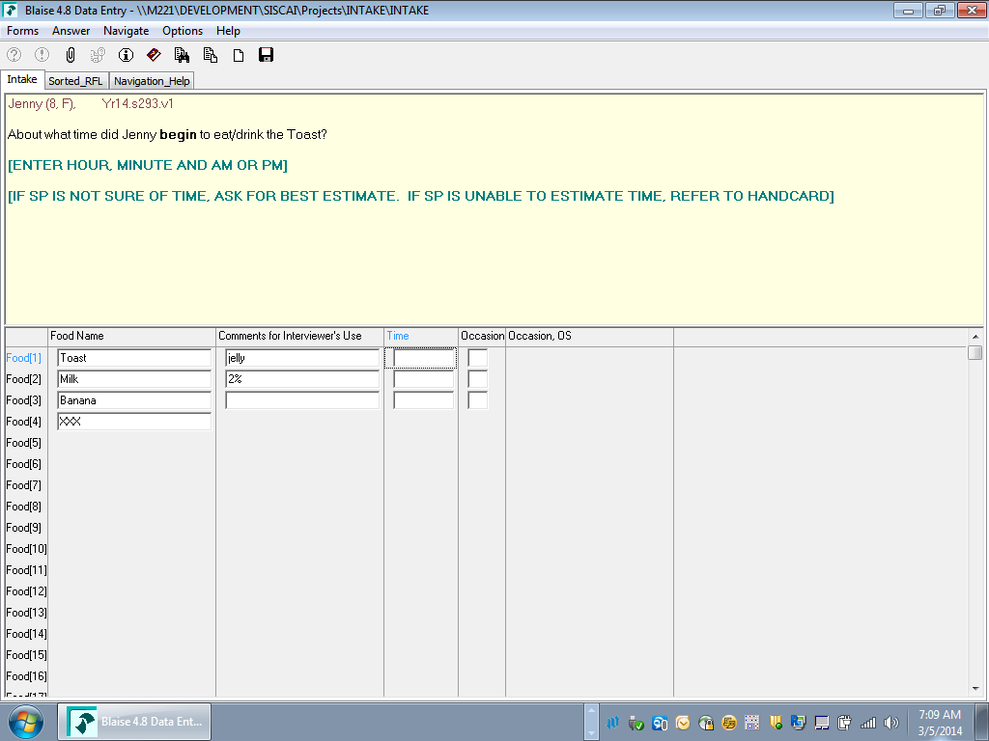

**Exhibit D. Detail and Review Cycle Screenshot (Example question)**

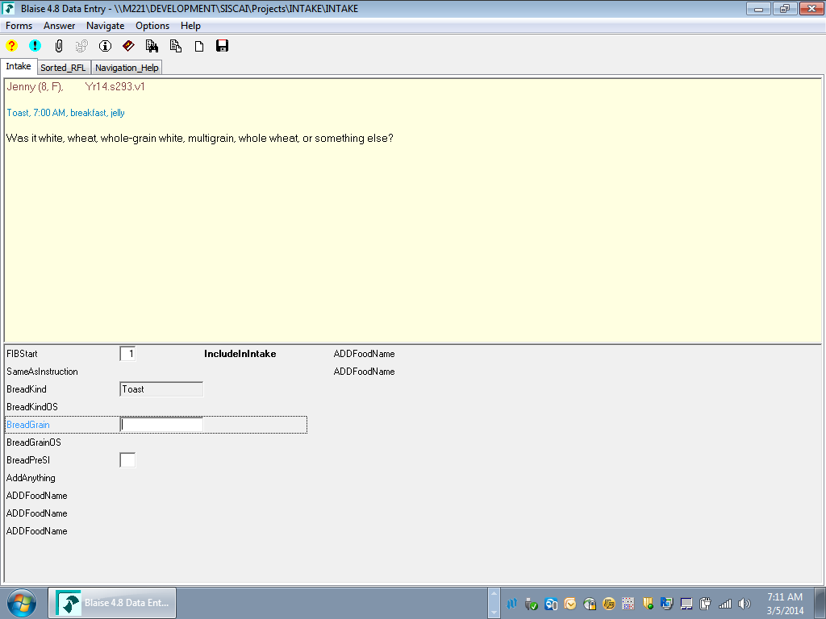

**Exhibit E. Final Review Cycle Screenshot**

