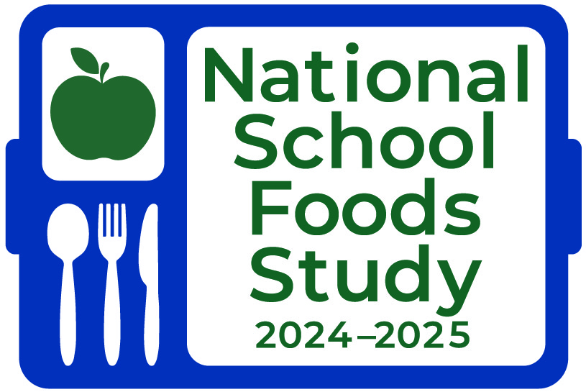
This information is being collected to assist the Food and Nutrition Service in understanding school food purchasing practices, the nutritional quality of school meals and snacks, the cost to produce school meals, and student participation and dietary intakes. This is a mandatory collection and FNS will use the information to monitor program operations. This collection does not request any personally identifiable information under the Privacy Act of 1974. According to the Paperwork Reduction Act of 1995, an agency may not conduct or sponsor, and a person is not required to respond to, a collection of information unless it displays a valid OMB control number. The valid OMB control number for this information collection is 0584-0698. The time required to complete this information collection is estimated to average 0.03 hours per response, including the time for reviewing instructions, searching existing data sources, gathering and maintaining the data needed, and completing and reviewing the collection of information. Send comments regarding this burden estimate or any other aspect of this collection of information, including suggestions for reducing this burden, to: U.S. Department of Agriculture, Food and Nutrition Service, Office of Policy Support, 1320 Braddock Place, 5th Floor, Alexandria, VA 22314 ATTN: PRA (0584-0698). Do not return the completed form to this address.
OMB Number: 0584-0698
Expiration Date: 06/30/2027

Title, SFAName
Address 1
City, State, Zip]
Dear [SFADName]:
Your school food authority (SFA) has been chosen to participate in the 2024-2025 National School Foods Study. I am writing to provide some general information about this USDA Food and Nutrition Service study and to request your full support. We selected Mathematica (IF G1a/G1b/G3: [IF COMPANYID=2: ProTeam Foodservice Advisors,] and Decision Information Resources) to conduct this study.
With better data comes better policy; we seek to collect data to fully understand the school food environment.
I have enclosed two documents about the study for your review:
- [ORGANIZATION] Endorsement Letter
- Study Overview

Within the next few weeks, a member of the study team will contact you by telephone to discuss the study in more detail and learn more about your SFA. Below are a few key details:
Data collection efforts will primarily occur [Group 1a/1b: for one quarter between September 2024 and September 2025 /// GROUP 2a, 2b, 3: between January and June 2025]. [IF G2a, G2b, G3: The time leading up to that period will be used to coordinate study activities, such as establishing points of contact in each school listed below,][IF G2a & 2b: identifying a student sample for study participation,][[IF G2a, G2b, G3: and scheduling a target week for data collection.
- [In-Sample School 1]
- [In-Sample School 2]
- [In-Sample School 3]
- [In-Sample School 4]
- [In-Sample School 5]]

You will receive a separate request to complete an online survey of SFA directors after other data collection activities in your district are complete. The survey includes a variety of topics needed to characterize the school environment; food service operating policies and practices; and other characteristics of SFAs, schools, and students. There are no known benefits to taking part in this study. You may feel uncomfortable answering some questions. You can choose not to answer any question.
Your SFA was selected as part of a scientific sample, so your responses will represent not only your own SFA, but other SFAs that are similar to yours. For this reason, participation of all selected SFAs is critical to the completeness of the study’s findings. [ORGANIZATION] encourages your participation in collecting this critical data. All information gathered for this study is for research purposes only and will not affect meal reimbursements to participating schools or school meal program benefits of participating households. Participation by selected state agencies, school districts, and schools is required under Section 28 of the Richard B. Russell National School Lunch Act.

Thank you in advance for your assistance with this important study. If you have questions about the study, please contact [MATHEMATICA CONTACT NAME] at [PHONE] or [EMAIL]. Additionally, the study team will hold an informational webinar on September 9th. We will circulate a meeting invitation in the coming weeks. If you have any questions about your rights as a research participant, please call HML IRB at 202-246-8504. I am also happy to provide any assistance and answer any questions that I can.

Sincerely,

Ashley Chaifetz
Study Project Officer
Office of Policy Support
USDA Food and Nutrition Service

Enclosures: ENDORSEMENT LETTER; Study Overview
cc: District Superintendent’s Office

