APPENDIX F01.09. SFPS SFA YEAR END FOLLOW-UP SURVEY INVITATION (GROUPS 1A AND 1B)
This information is being collected to assist the Food and Nutrition Service in understanding school food purchasing practices, the nutritional quality of school meals and snacks, the cost to produce school meals, and student participation and dietary intakes. This is a mandatory collection and FNS will use the information to monitor program operations. This collection does not request any personally identifiable information under the Privacy Act of 1974. According to the Paperwork Reduction Act of 1995, an agency may not conduct or sponsor, and a person is not required to respond to, a collection of information unless it displays a valid OMB control number. The valid OMB control number for this information collection is 0584-0698. The time required to complete this information collection is estimated to average 0.05 hours per response, including the time for reviewing instructions, searching existing data sources, gathering and maintaining the data needed, and completing and reviewing the collection of information. Send comments regarding this burden estimate or any other aspect of this collection of information, including suggestions for reducing this burden, to: U.S. Department of Agriculture, Food and Nutrition Service, Office of Policy Support, 1320 Braddock Place, 5th Floor, Alexandria, VA 22314 ATTN: PRA (0584-0698). Do not return the completed form to this address.

OMB Number: 0584-0698
Expiration Date: 06/30/2027

PROJECT EMAIL:[EMAIL]
EMAIL SUBJECT: National School Foods Study end of year survey
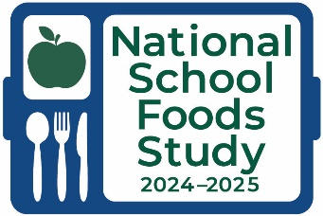

Dear [SFA NAME],

Thank you for participating in the 2024-2025 National School Foods Study, funded by the USDA Food and Nutrition Service. Our records show we still need you to complete the end of year survey about your SFA’s annual food sales and expenditures for the 2024-2025 school year.
Your response will help provide national estimates on the food purchases made by SFAs participating in the NSLP and SBP, to understand the composition of the school food market basket, purchasing practices, and relative costs. With better data comes better policy; we seek to collect data to fully understand the school food environment. Please click on the link below to access the survey and complete it.
Survey Web site:
(SFA Follow-up Survey LINK/[ID])

If you have any questions, please email [EMAIL] or call [PHONE]. Thank you for your help and cooperation.

Sincerely,
Alice Ann Gola
National School Foods Study

