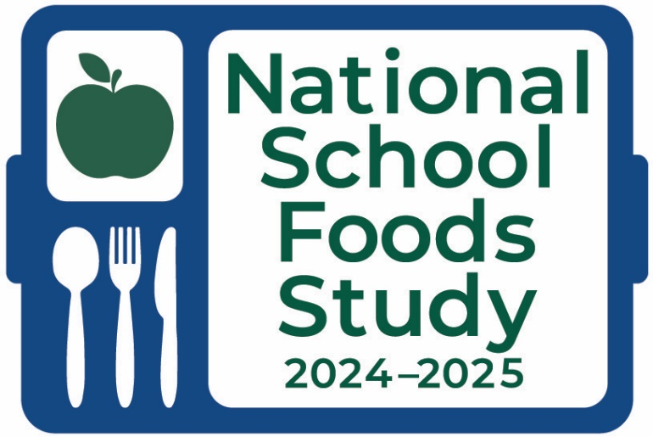
APPENDIX F03.06. SFA DIRECTOR SURVEY REMINDER CALL SCRIPT
(GROUPS 1A, 1B, 1C, 2A, & 3)
This page has been left blank for double-sided copying.

SFA DIRECTOR SURVEY REMINDER CALL SCRIPT
This information is being collected to assist the Food and Nutrition Service in understanding school food purchasing practices, the nutritional quality of school meals and snacks, the cost to produce school meals, and student participation and dietary intakes. This is a mandatory collection and FNS will use the information to monitor program operations. This collection does not request any personally identifiable information under the Privacy Act of 1974. According to the Paperwork Reduction Act of 1995, an agency may not conduct or sponsor, and a person is not required to respond to, a collection of information unless it displays a valid OMB control number. The valid OMB control number for this information collection is 0584-0698. The time required to complete this information collection is estimated to average 0.08 hours per response, including the time for reviewing instructions, searching existing data sources, gathering and maintaining the data needed, and completing and reviewing the collection of information. Send comments regarding this burden estimate or any other aspect of this collection of information, including suggestions for reducing this burden, to: U.S. Department of Agriculture, Food and Nutrition Service, Office of Policy Support, 1320 Braddock Place, 5th Floor, Alexandria, VA 22314 ATTN: PRA (0584-0698). Do not return the completed form to this address.
OMB Number: 0584-0698
Expiration Date: 06/30/2027
Hello, my name is [INTERVIEWER NAME]. I am calling on behalf of the National School Foods Study for the U.S. Department of Agriculture. May I please speak with [SFA Director NAME]?
IF SFA DIRECTOR IS NOT AVAILABLE:
Is there a better time to call to reach [SFA Director NAME]? Ok, great. Thank you. I will call back then.
[LOG DATE/TIME FOR CALL BACK IN SHARE POINT]
IF VOICEMAIL BOX NAME MATCHES CONTACT NAME, LEAVE VOICEMAIL:
Hello, this message is for [SFA Director NAME]. My name is [INTERVIEWER NAME]. I am calling on behalf of the 2024-2025 National School Foods Study for the U.S. Department of Agriculture. As part of this study, the USDA is conducting a survey of School Food Authority Directors to learn how school meal programs operate at the local level. You should have received an email with a link to this survey. The survey will be closing next week and we really want to include your district in the study. Please go online today to complete the survey. If you have any questions or need your login information, please call our toll-free line at [PHONE NUMBER].We greatly appreciate your participation.
IF SFA DIRECTOR IS AVAILABLE:
Hi, my name is [INTERVIEWER NAME]. I’m calling on behalf of the National School Foods Study for the U.S. Department of Agriculture. As part of this study, the USDA is conducting a survey of School Food Authority Directors to learn how school meal programs operate at the local level. You should have received an email with a link to this survey. I’m calling to remind you to complete the survey online and to see if you have any questions about logging in or completing the survey. The survey will be closing next week, so it’s important we hear from you soon so that we can include your district in our study. Do you have the email with the link?
IF SFA DIRECTOR DOES NOT RECALL EMAIL:
If this is a good time, I can share some information regarding the study. The National School Foods Study will help the USDA learn more about the school meal programs and the students who use these programs. The study will look at how schools follow the nutrition guidelines and how school meals meet students’ nutritional needs. With better data comes better policy; we seek to collect data to fully understand the school food environment.
IF SFA DIRECTOR MISPLACED EMAIL:
I would be happy to email you a link to the web survey. First, let me confirm your email address: [FILL EMAIL ADDRESS].
IF R IS RESISTANT:
The information you provide is critical to provide a complete picture of how changes to the National School Lunch and Breakfast programs are implemented across the U.S. This study is designed to learn more about how school meal programs operate at the local level. Your responses are not connected to any personal identifying information and cannot be connected to you. No one in your school district will have access to the responses that you share with us. The survey can be taken online and should take approximately 40 minutes to complete. [suggest a pause here] Participation by selected states, districts, and schools is required under Section 28 of the Richard B. Russell National School Lunch Act. Do you have questions I might be able to answer?
IF R IS SKEPTICAL:
This is a critical study sponsored by the U.S. Department of Agriculture and is not conducted often. You can learn more about the results of the first School Nutrition and Meal Cost Study at [FILL URL] on the USDA website. With better data comes better policy; we seek to collect data to fully understand the school food environment. Do you have any questions about the study?
AGREES TO PARTICIPATE:
Great, thank you very much for agreeing to take part in this important study. Do you need the survey link or your username or password information? I would be happy to look that up for you! Lastly, please feel free to call our toll-free helpline with any questions or to get help with the survey ([PHONE NUMBER]).

FAQs
Survey URL: [LINK]
What is the purpose of the study?
This important study will (1) describe the food and nutrient content of school meals, (2) collect information on food service policies and practices, (3) estimate the cost to produce school meals, and (4) collect information on student satisfaction and dietary intake. Having updated information about the school meals programs will help States, SFAs, and schools better serve students.
Who can complete the survey?
While the survey is intended for the School Food Authority, or SFA Director, it can be completed by any staff member who is very familiar with the food service characteristics of the schools within your SFA and with the SFA Director's role within your SFA.
When is the survey due?
The survey is closing next week, so we need your completed survey as soon as possible.
Can I have a hard copy?
Some questions get skipped based on how you answer—a hard copy would have too many unnecessary questions! It is better to fill the survey out on-line.
I am not [NAME]. You have the wrong person.
Collect their name, title and district affiliations. Email/phone

