July 1, 2024

BE-185 ID#: (Organization_code_here)
(Name_code_here)
Attn: (Attn:_code_here)
(Street 1_code_here)
(Street 2_code_here)
(City_code_here), (State_code_here) (Zip_code_here)

Mandatory Quarterly Survey of Financial Services Transactions between
U.S. Financial Services Providers and Foreign Persons (BE-185)
Second Quarter 2024: Due July 30, 2024

The Bureau of Economic Analysis (BEA) requests your participation in the Quarterly Survey of Financial Services Transactions between U.S. Financial Services Providers and Foreign Persons (BE-185) for second quarter 2024, a mandatory survey that collects data to produce timely economic statistics. By law, the information collected is CONFIDENTIAL and can only be used for statistical purposes.

Due date – Survey responses are due 30 days after the close of the quarter. A response is required whether or not you have transactions to report. If you do not have transactions to report, please complete the form through the exemption claim and submit it to BEA.

Please submit your survey using BEA’s eFile system (www.bea.gov/eFile). For assistance, call (301) 278-9303, send us a secure message through eFile, or email us at be-185help@bea.gov. For more survey information visit www.bea.gov/ssb.

Thank you in advance for your time and cooperation. Your response makes a difference in producing accurate and objective statistics on the U.S. economy, including U.S. international trade in services and U.S. gross domestic product (GDP).

Sincerely,
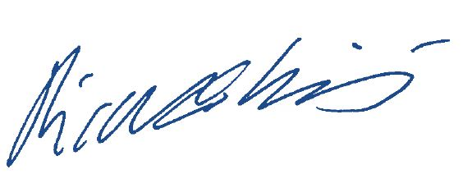
Ricardo Limes
Chief, Balance of Payments Division

