TRICARE Select Enrollment, Disenrollment, and Change Form – OMB Control Number

0720-0061

Screenshot #1 – BWE Dashboard

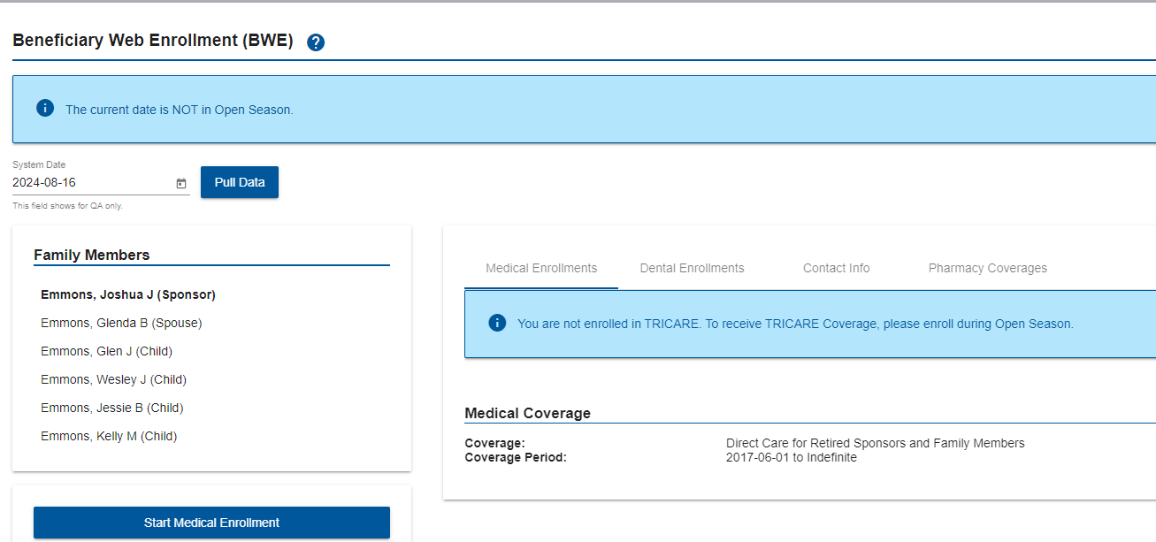

Screenshot #2 – Select Family Members to Enroll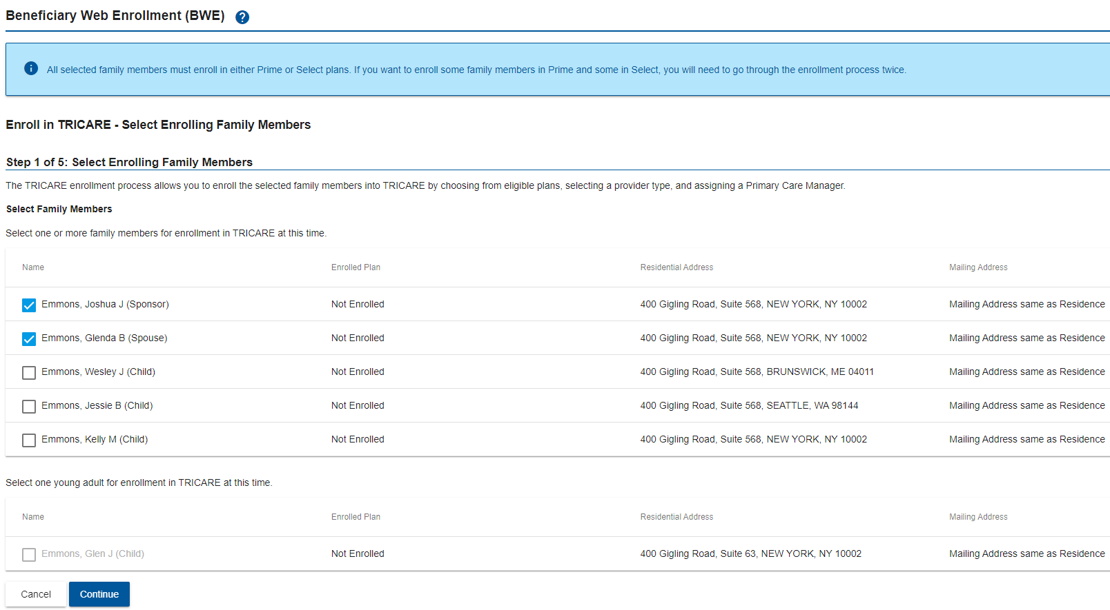



Screenshot #3 – Select QLE



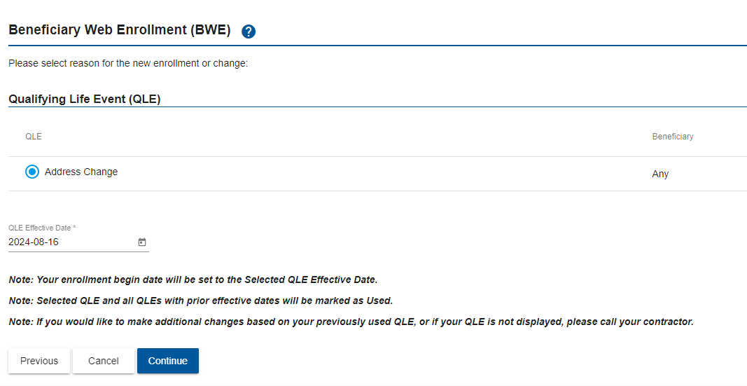

Screenshot #4 – Confirm Address

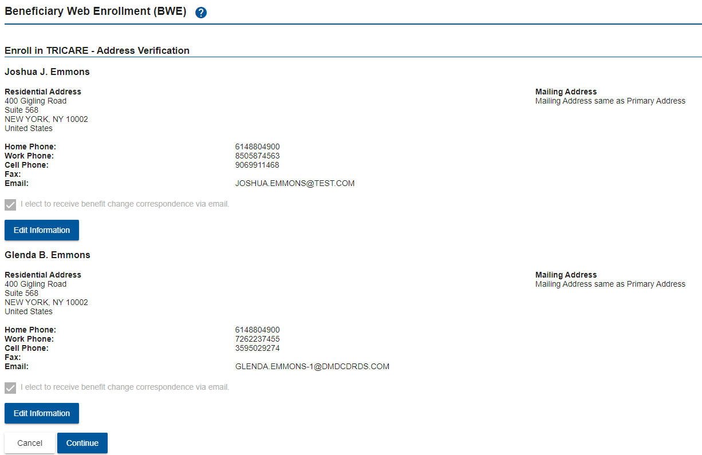



Screenshot #5 – Check Compliance Boxes

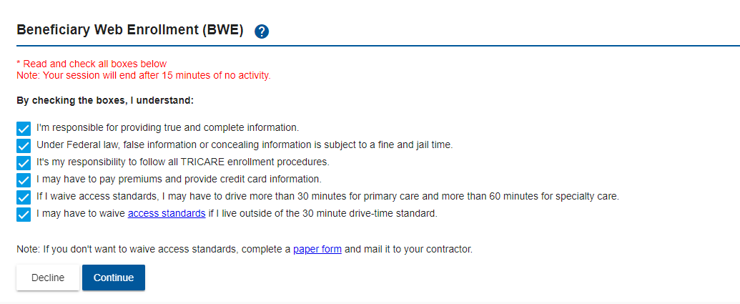

Screenshot #6 – Select A Plan

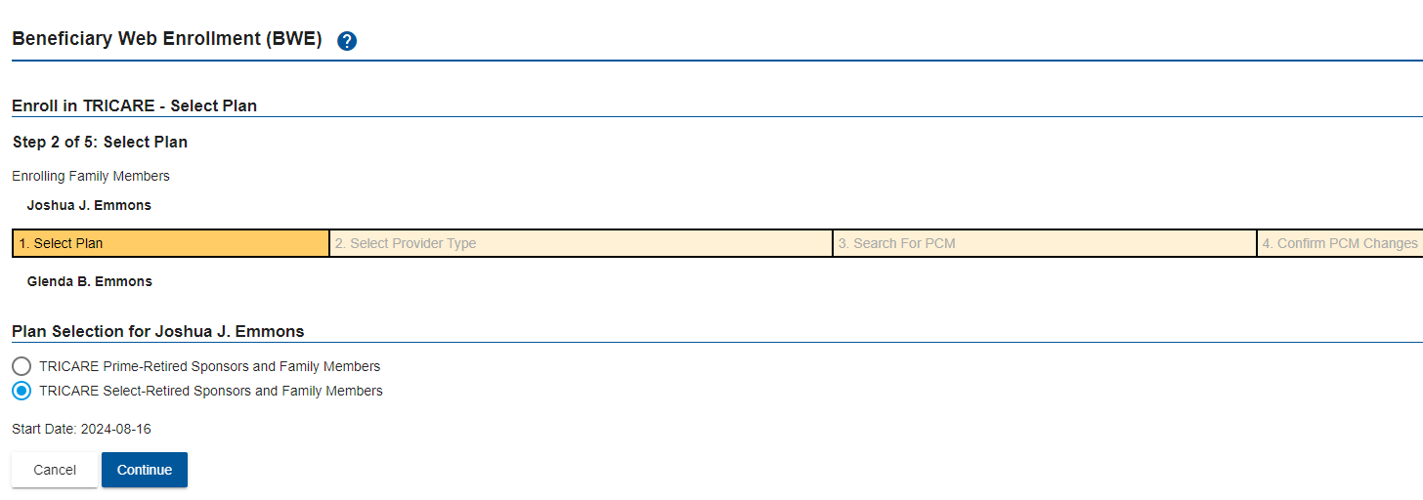

Screenshot #7 – Verify Plan and Contractor Information

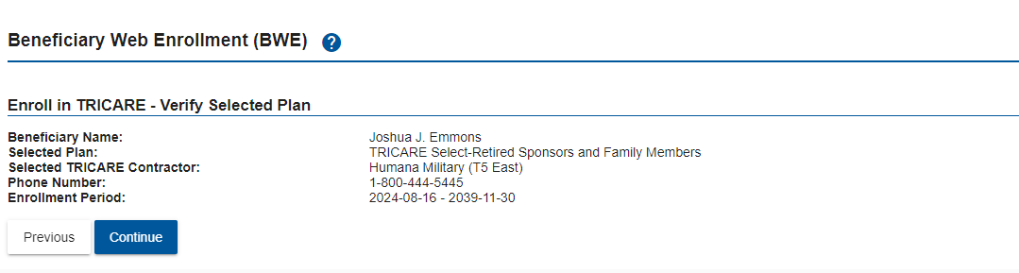

Screenshot #8 – Collect Premiums



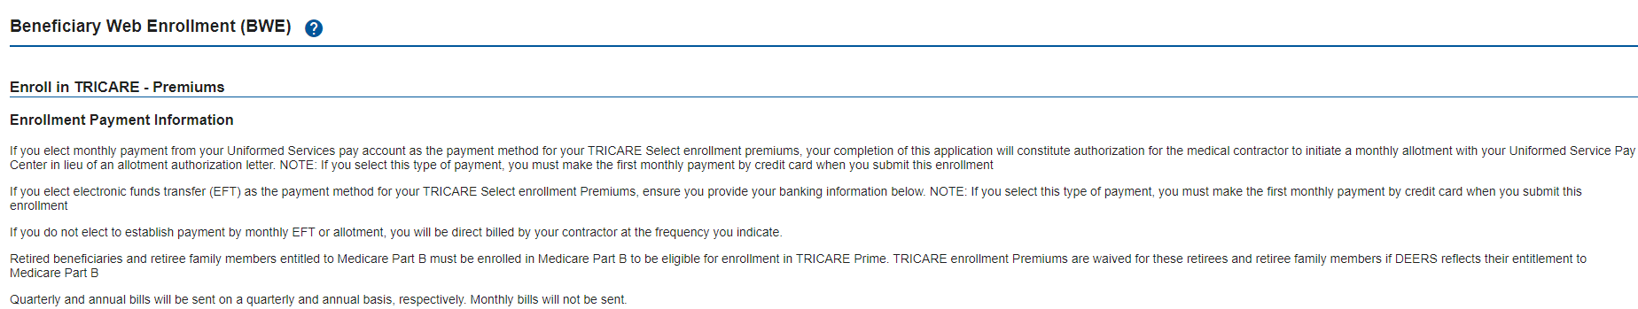

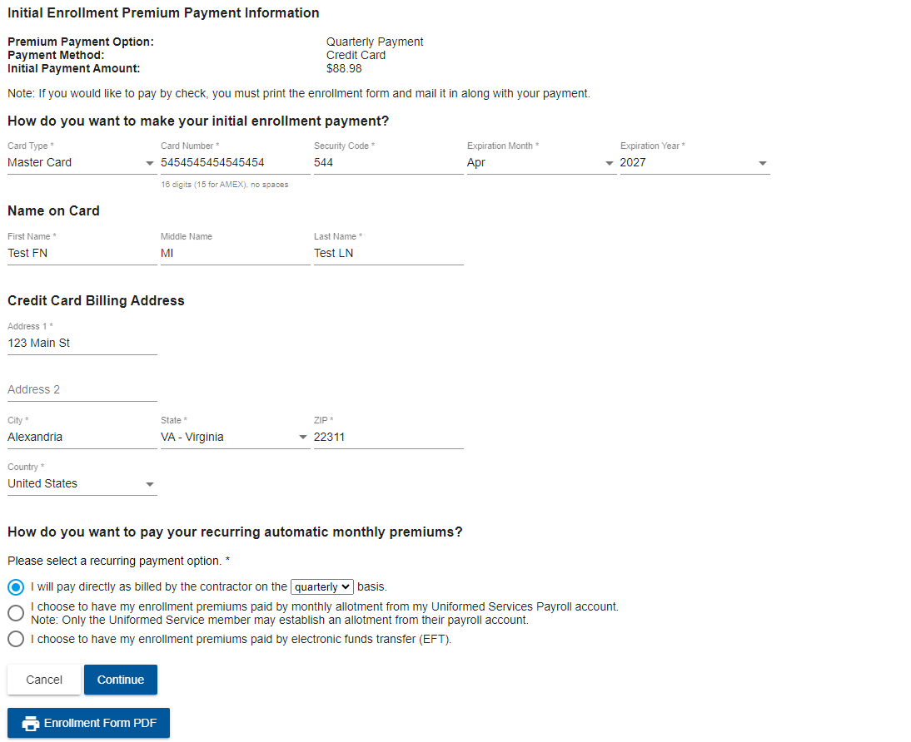



Screenshot #9 – Confirm Premium Information

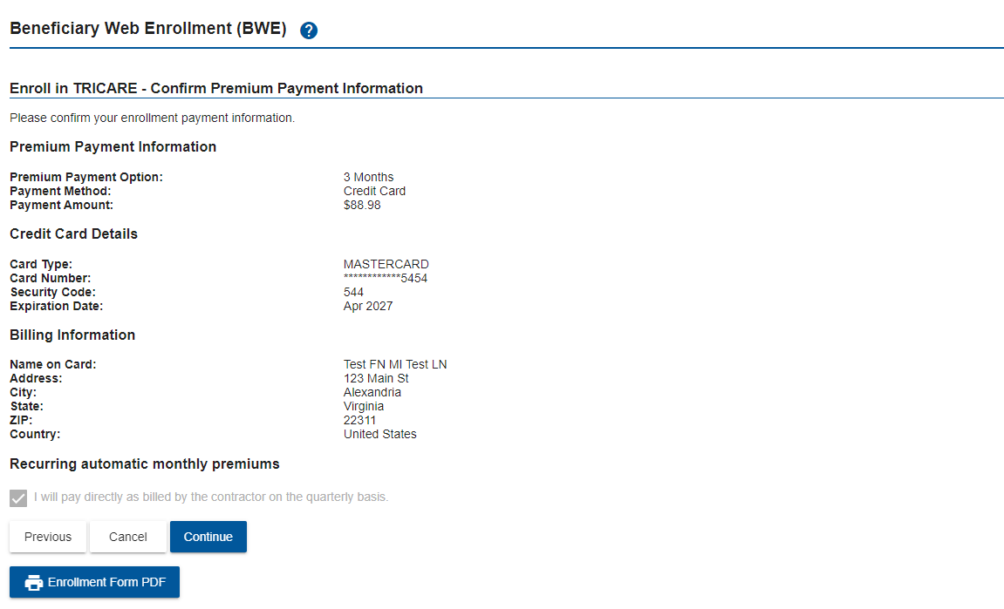

Screenshot #10 – Confirm Enrollment Information

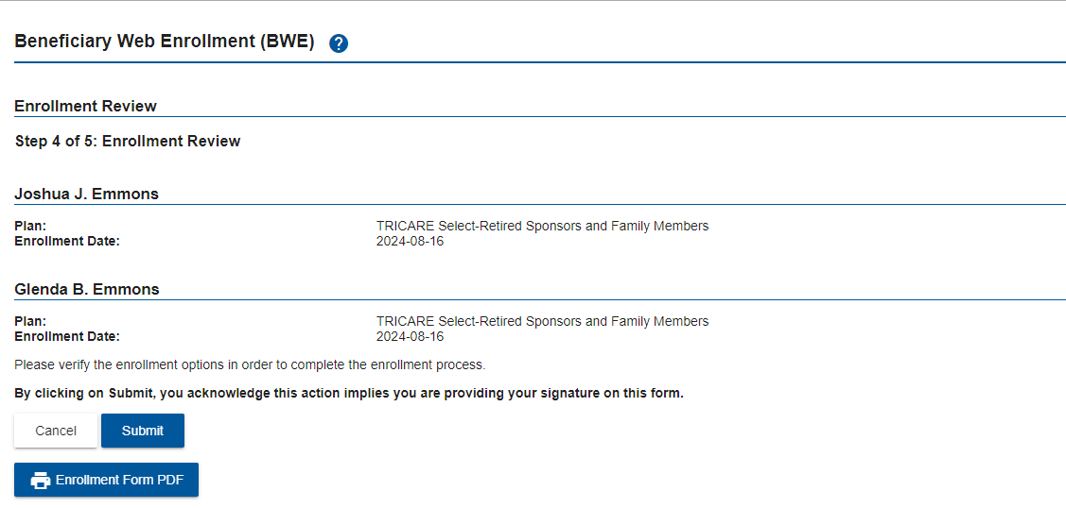

Screenshot #11 – Print Enrollment Form

