Design Specifications Document

OSSNAP Screen Package

Table of Contents
1. U.S. Original Self - Landing 9
2. All Paths - Privacy Act Statement 10
3. U.S. Original Self - Age 18 or Older 11
3.1. U.S. Original Self - Age 18 or Older – No 12
4. U.S. Original Self - U.S. Mailing Address Available 13
4.1. U.S. Original Self - U.S. Mailing Address Available – No 14
5. U.S. Original Self - Have an SSN 15
6. U.S. Original Self - Citizenship 16
7. U.S. Original Self - Applying For 17
8. U.S. Original Self - Date of Birth 18
9. U.S. Original Self - Place of Birth 19
9.1. U.S. Original Self - Place of Birth - International 20
10. U.S. Original Self - Name 21
10.1. U.S. Original Self – Name – Dynamic Content Expanded 22
11. U.S. Original Self - Sex 23
12. U.S. Original Self - Parents Names 24
13. U.S. Original Self - U.S. Mailing Address 25
14. U.S. Original Self – Race and Ethnicity 26
15. U.S. Original Self - U.S. Documentation – Age 28
16. U.S. Original Self – Citizenship 35
17. U.S. Original Self – Documentation – Identity 49
18. U.S. Original Self - Review and Edit 65
19. U.S. Original Self - Attestation 67
19.1. U.S. Original Self – Attestation – Acknowledgement Checked 68
20. U.S. Original Self - Success 69
21. U.S. Original Someone Else Adult - Landing 72
22. U.S. Original Someone Else Adult - Age 18 or Older 73
23. U.S. Original Someone Else Adult - U.S. Mailing Address Available 74
24. U.S. Original Someone Else Adult - Have an SSN 75
25. U.S. Original Someone Else Adult - Citizenship 76
26. U.S. Original Someone Else Adult - Applying For 77
27. U.S. Original Someone Else Adult - Applying For Someone Else Name 78
28. U.S. Original Someone Else Adult – Individual’s Date of Birth 79
29. U.S. Original Someone Else Adult - Relationship Adult 80
29.1. U.S. Original Someone Else Adult - Relationship Adult – None of the Above 81
30. U.S. Original Someone Else Adult - Individual Capabilities 82
30.1. U.S. Original Someone Else Adult - Individual Capabilities – Yes 83
31. U.S. Original Someone Else Adult - Individual's Place of Birth 84
32. U.S. Original Someone Else Adult - Individual's Name 85
33. U.S. Original Someone Else Adult - Individual's Sex 86
34. U.S. Original Someone Else Adult - Individual's Parents Names 87
35. U.S. Original Someone Else Adult - U.S. Mailing Address 88
36. U.S. Original Someone Else – Adult – Race and Ethnicity 89
37. U.S. Original Someone Else – Adult – Proof of Identity 90
38. U.S. Original Someone Else – Adult – Proof of Age for Individual 91
39. U.S. Original Someone Else – Adult – Proof of Citizenship for Individual 92
40. U.S. Original Someone Else – Adult – Proof of Identity for Individual 93
41. U.S. Original Someone Else Adult - Review and Edit 94
42. U.S. Original Someone Else Adult - Attestation 97
43. U.S. Original Someone Else Adult - Success 98
44. U.S. Original Someone Else Child - Landing 99
45. U.S. Original Someone Else Child - Age 18 or Older 100
46. U.S. Original Someone Else Child - U.S. Mailing Address Available 101
47. U.S. Original Someone Else Child - Have an SSN 102
48. U.S. Original Someone Else Child - Citizenship 103
49. U.S. Original Someone Else Child - Applying For 104
50. U.S. Original Someone Else Child - Applying For Someone Else Name 105
51. U.S. Original Someone Else Child – Individual’s Date of Birth 106
52. U.S. Original Someone Else Child - Relationship Child 107
53. U.S. Original Someone Else Child - Individual's Place of Birth 108
54. U.S. Original Someone Else Child - Individual's Name 109
55. U.S. Original Someone Else Child - Individual's Sex 110
56. U.S. Original Someone Else Child - Individual's Parents Names 111
57. U.S. Original Someone Else Child - U.S. Mailing Address 112
58. U.S. Original Someone Else Child – Race and Ethnicity 113
59. U.S. Original Someone Else Child - Individual's Identity 114
60. U.S. Original Someone Else Child – Proof of Age for Child 115
61. U.S. Original Someone Else Child – Proof of Citizenship for Child 116
62. U.S. Original Someone Else Child – Proof of Identity for Child 117
63. U.S. Original Someone Else Child - Review and Edit 118
64. U.S. Original Someone Else Child - Attestation 121
65. U.S. Original Someone Else Child - Success 122
66. U.S. Replacement Self - Landing 123
67. U.S. Replacement Self - Age 18 or Older 124
68. U.S. Replacement Self - U.S. Mailing Address Available 125
69. U.S. Replacement Self - Have an SSN 126
70. U.S. Replacement Self - Citizenship 127
71. U.S. Replacement Self - Applying For 128
72. U.S. Replacement Self - Date of Birth 129
73. U.S. Replacement Self - Name Change 130
74. U.S. Replacement Self - Place of Birth 131
75. U.S. Replacement Self - SSN 132
76. U.S. Replacement Self - Name 133
65. U.S. Replacement Self - Parents Names 134
66. U.S. Replacement Self - U.S. Mailing Address 135
67. U.S. Replacement Self - U.S. Documentation 136
68. U.S. Replacement Self - U.S. Documentation - Name Change 137
68.1. U.S. Replacement Self - U.S. Documentation - Name Change – Amended Birth Certificate 139
68.2. U.S. Replacement Self - U.S. Documentation - Name Change – Court Order for a Name Change 140
68.3. U.S. Replacement Self - U.S. Documentation - Name Change – Marriage Document/U.S. only 141
68.4. U.S. Replacement Self - U.S. Documentation - Name Change – Divorce decree 142
69. U.S. Replacement Self - Review and Edit 143
70. U.S. Replacement Self - Attestation 146
71. U.S. Replacement Self - Success 147
72. U.S. Replacement Someone Else Adult - Landing 150
73. U.S. Replacement Someone Else Adult - Age 18 or Older 151
74. U.S. Replacement Someone Else Adult - U.S. Mailing Address Available 152
75. U.S. Replacement Someone Else Adult - Have an SSN 153
76. U.S. Replacement Someone Else Adult - Citizenship 154
77. U.S. Replacement Someone Else Adult - Applying For 155
78. U.S. Replacement Someone Else Adult - Applying For Someone Else Name 156
79. U.S. Replacement Someone Else Adult – Individual’s Date of Birth 157
80. U.S. Replacement Someone Else Adult - Relationship Adult 158
81. U.S. Replacement Someone Else Adult - Individual Capabilities 159
82. U.S. Replacement Someone Else Adult - Name Change 160
83. U.S. Replacement Someone Else Adult - Individual's Place of Birth 161
84. U.S. Replacement Someone Else Adult - Individual's SSN 162
85. U.S. Replacement Someone Else Adult - Individual's Name 163
86. U.S. Replacement Someone Else Adult - Individual's Parents Names 164
87. U.S. Replacement Someone Else Adult - U.S. Mailing Address 165
88. U.S. Replacement Someone Else Adult - Individual's U.S. Documentation 166
89. U.S. Replacement Someone Else Adult - Individual's U.S. Documentation - Name Change 168
90. U.S. Replacement Someone Else Adult - Review and Edit 170
91. U.S. Replacement Someone Else Adult - Attestation 173
92. U.S. Replacement Someone Else Adult - Success 174
93. U.S. Replacement Someone Else Child - Landing 175
94. U.S. Replacement Someone Else Child - Age 18 or Older 176
95. U.S. Replacement Someone Else Child - U.S. Mailing Address Available 177
96. U.S. Replacement Someone Else Child - Have an SSN 178
97. U.S. Replacement Someone Else Child - Citizenship 179
98. U.S. Replacement Someone Else Child - Applying For 180
99. U.S. Replacement Someone Else Child - Applying For Someone Else Name 181
100. U.S. Replacement Someone Else Child – Individual’s Date of Birth 182
101. U.S. Replacement Someone Else Child - Relationship Child 183
102. U.S. Replacement Someone Else Child - Name Change 184
103. U.S. Replacement Someone Else Child - Individual's Place of Birth 185
104. U.S. Replacement Someone Else Child - Individual's SSN 186
105. U.S. Replacement Someone Else Child - Individual's Name 187
106. U.S. Replacement Someone Else Child - Individual's Parents Names 188
107. U.S. Replacement Someone Else Child - U.S. Mailing Address 189
108. U.S. Replacement Someone Else Child - Individual's U.S. Documentation 190
109. U.S. Replacement Someone Else Child - Individual's U.S. Documentation - Name Change 192
110. U.S. Replacement Someone Else Child - Review and Edit 194
111. U.S. Replacement Someone Else Child - Attestation 197
112. U.S. Replacement Someone Else Child - Success 198
113. Non-U.S. Original Self - Landing 199
114. Non-U.S. Original Self - Age 18 or Older 200
115. Non-U.S. Original Self - U.S. Mailing Address Available 201
116. Non-U.S. Original Self - Have an SSN 202
117. Non-U.S. Original Self - Citizenship 203
118. Non-U.S. Original Self - Applying For 204
119. Non-U.S. Original Self - Date of Birth 205
120. Non-U.S. Original Self - Place of Birth 206
121. Non-U.S. Original Self - Name 207
122. Non-U.S. Original Self - Sex 208
123. Non-U.S. Original Self - Parents Names 209
124. Non-U.S. Original Self - U.S. Mailing Address 210
125. Non-U.S. Original Self - Documentation 211
126. Non-U.S. Original Self - Review and Edit 213
127. Non-U.S. Original Self - Attestation 215
128. Non-U.S. Original Self - Success 216
129. Non-U.S. Original Someone Else Adult - Landing 217
130. Non-U.S. Original Someone Else Adult - Age 18 or Older 218
131. Non-U.S. Original Someone Else Adult - U.S. Mailing Address Available 219
132. Non-U.S. Original Someone Else Adult - Have an SSN 220
133. Non-U.S. Original Someone Else Adult - Citizenship 221
134. Non-U.S. Original Someone Else Adult - Applying For 222
135. Non-U.S. Original Someone Else Adult - Applying For Someone Else Name 223
136. Non-U.S. Original Someone Else Adult – Individual’s Date of Birth 224
137. Non-U.S. Original Someone Else Adult - Relationship Adult 225
138. Non-U.S. Original Someone Else Adult - Individual Capabilities 226
139. Non-U.S. Original Someone Else Adult - Individual's Place of Birth 227
140. Non-U.S. Original Someone Else Adult - Individual's Name 228
141. Non-U.S. Original Someone Else Adult - Individual's Sex 229
142. Non-U.S. Original Someone Else Adult - Individual's Parents Names 230
143. Non-U.S. Original Someone Else Adult - U.S. Mailing Address 231
144. Non-U.S. Original Someone Else Adult - Individual's Documentation 232
145. Non-U.S. Original Someone Else Adult - Review and Edit 235
146. Non-U.S. Original Someone Else Adult - Attestation 238
147. Non-U.S. Original Someone Else Adult - Success 239
148. Non-U.S. Original Someone Else Child - Landing 240
149. Non-U.S. Original Someone Else Child - Age 18 or Older 241
150. Non-U.S. Original Someone Else Child - U.S. Mailing Address Available 242
151. Non-U.S. Original Someone Else Child - Have an SSN 243
152. Non-U.S. Original Someone Else Child - Citizenship 244
153. Non-U.S. Original Someone Else Child - Applying For 245
154. Non-U.S. Original Someone Else Child - Applying For Someone Else Name 246
155. Non-U.S. Original Someone Else Child – Individual’s Date of Birth 247
156. Non-U.S. Original Someone Else Child - Relationship Child 248
157. Non-U.S. Original Someone Else Child - Individual's Place of Birth 249
158. Non-U.S. Original Someone Else Child - Individual's Name 250
159. Non-U.S. Original Someone Else Child - Individual's Sex 251
160. Non-U.S. Original Someone Else Child - Individual's Parents Names 252
161. Non-U.S. Original Someone Else Child - U.S. Mailing Address 253
162. Non-U.S. Original Someone Else Child - Individual's Documentation 254
163. Non-U.S. Original Someone Else Child - Review and Edit 256
164. Non-U.S. Original Someone Else Child - Attestation 259
165. Non-U.S. Original Someone Else Child - Success 260
166. Non-U.S. Replacement Self - Landing 261
167. Non-U.S. Replacement Self - Age 18 or Older 262
168. Non-U.S. Replacement Self - U.S. Mailing Address Available 263
169. Non-U.S. Replacement Self - Have an SSN 264
170. Non-U.S. Replacement Self - Citizenship 265
171. Non-U.S. Replacement Self - Applying For 266
172. Non-U.S. Replacement Self - Date of Birth 267
173. Non-U.S. Replacement Self - Name Change 268
174. Non-U.S. Replacement Self - Place of Birth 269
175. Non-U.S. Replacement Self - SSN 270
176. Non-U.S. Replacement Self - Name 271
177. Non-U.S. Replacement Self - Parents Names 272
178. Non-U.S. Replacement Self - U.S. Mailing Address 273
179. Non-U.S. Replacement Self - Documentation 274
180. Non-U.S. Replacement Self - Documentation - Name Change 276
181. Non-U.S. Replacement Self - Review and Edit 278
182. Non-U.S. Replacement Self - Attestation 280
183. Non-U.S. Replacement Self - Success 281
184. Non-U.S. Replacement Someone Else Adult - Landing 282
185. Non-U.S. Replacement Someone Else Adult - Age 18 or Older 283
186. Non-U.S. Replacement Someone Else Adult - U.S. Mailing Address Available 284
187. Non-U.S. Replacement Someone Else Adult - Have an SSN 285
188. Non-U.S. Replacement Someone Else Adult - Citizenship 286
189. Non-U.S. Replacement Someone Else Adult - Applying For 287
190. Non-U.S. Replacement Someone Else Adult - Applying For Someone Else Name 288
191. Non-U.S. Replacement Someone Else Adult – Individual’s Date of Birth 289
192. Non-U.S. Replacement Someone Else Adult - Relationship Adult 290
193. Non-U.S. Replacement Someone Else Adult - Individual Capabilities 291
194. Non-U.S. Replacement Someone Else Adult - Name Change 292
195. Non-U.S. Replacement Someone Else Adult - Individual's Place of Birth 293
196. Non-U.S. Replacement Someone Else Adult - Individual's SSN 294
197. Non-U.S. Replacement Someone Else Adult - Individual's Name 295
198. Non-U.S. Replacement Someone Else Adult - Individual's Parents Names 296
199. Non-U.S. Replacement Someone Else Adult - U.S. Mailing Address 297
200. Non-U.S. Replacement Someone Else Adult - Individual's Documentation 298
201. Non-U.S. Replacement Someone Else Adult - Individual's Documentation - Name Change 301
202. Non-U.S. Replacement Someone Else Adult - Review and Edit 304
203. Non-U.S. Replacement Someone Else Adult - Attestation 307
204. Non-U.S. Replacement Someone Else Adult - Success 308
205. Non-U.S. Replacement Someone Else Child - Landing 309
206. Non-U.S. Replacement Someone Else Child - Age 18 or Older 310
207. Non-U.S. Replacement Someone Else Child - U.S. Mailing Address Available 311
208. Non-U.S. Replacement Someone Else Child - Have an SSN 312
209. Non-U.S. Replacement Someone Else Child - Citizenship 313
210. Non-U.S. Replacement Someone Else Child - Applying For 314
211. Non-U.S. Replacement Someone Else Child - Applying For Someone Else Name 315
212. Non-U.S. Replacement Someone Else Child – Individual’s Date of Birth 316
213. Non-U.S. Replacement Someone Else Child - Relationship Child 317
214. Non-U.S. Replacement Someone Else Child - Name Change 318
215. Non-U.S. Replacement Someone Else Child - Individual's Place of Birth 319
216. Non-U.S. Replacement Someone Else Child - Individual's SSN 320
217. Non-U.S. Replacement Someone Else Child - Individual's Name 321
218. Non-U.S. Replacement Someone Else Child - Individual's Parents Names 322
219. Non-U.S. Replacement Someone Else Child - U.S. Mailing Address 323
220. Non-U.S. Replacement Someone Else Child - Individual's Documentation 324
221. Non-U.S. Replacement Someone Else Child - Individual's Documentation - Name Change 326
222. Non-U.S. Replacement Someone Else Child - Review and Edit 329
223. Non-U.S. Replacement Someone Else Child - Attestation 332
224. Non-U.S. Replacement Someone Else Child - Success 333

- U.S. Original Self - Landing
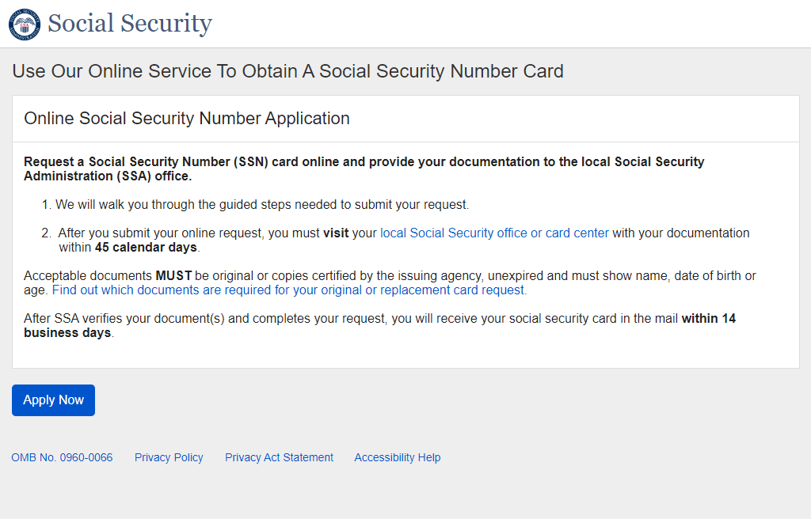

- All Paths - Privacy Act Statement
This screen appears after the landing page for ALL paths.
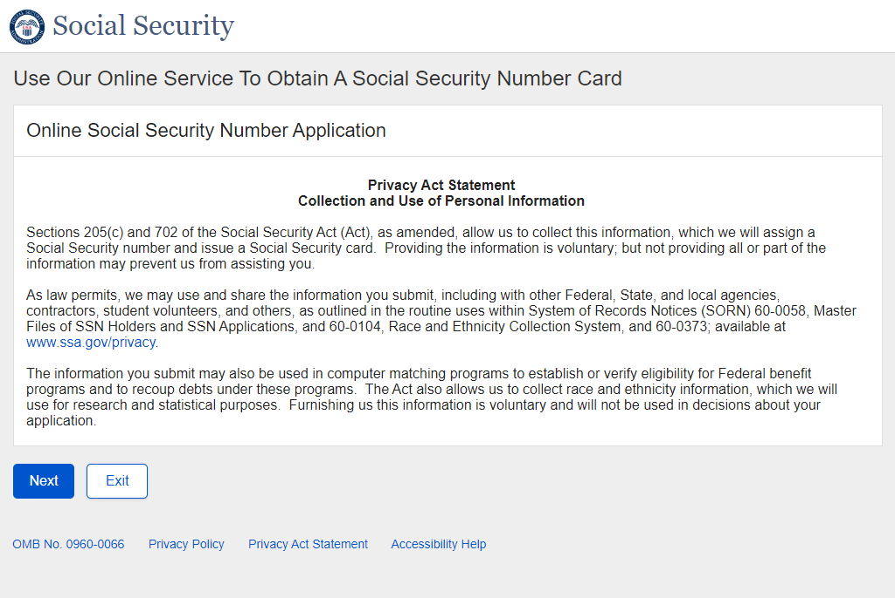
- U.S. Original Self - Age 18 or Older
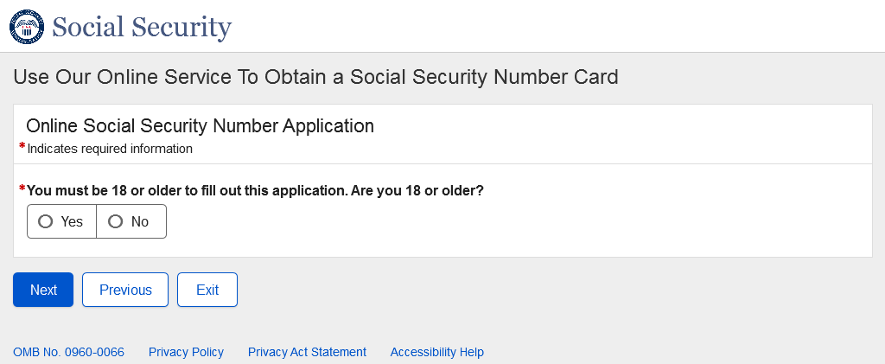

  - U.S. Original Self - Age 18 or Older – No
* The messaging and behavior in the screenshot below is the same in all paths and will not be shown in future paths.
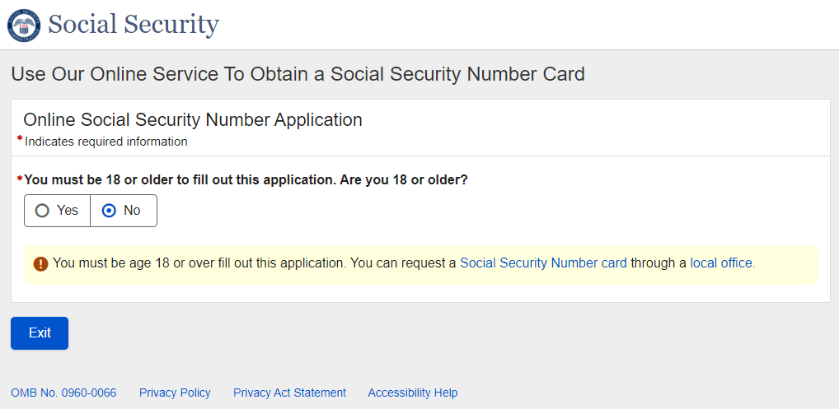
- U.S. Original Self - U.S. Mailing Address Available
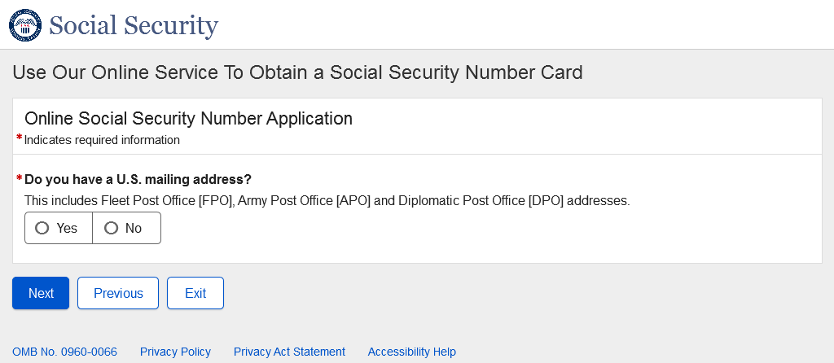

  - U.S. Original Self - U.S. Mailing Address Available – No
* The messaging and behavior in the screenshot below is the same in all paths and will not be shown in future paths.
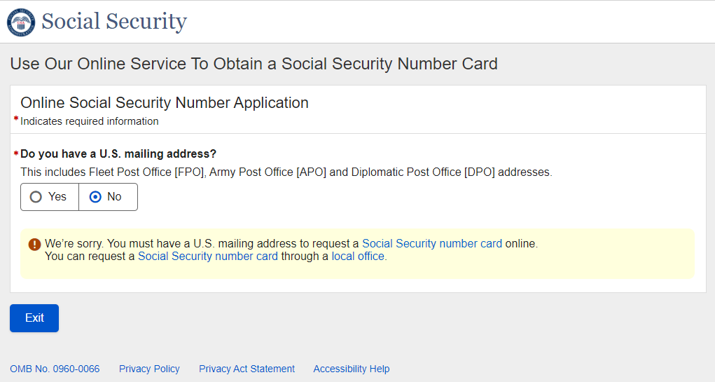
- U.S. Original Self - Have an SSN
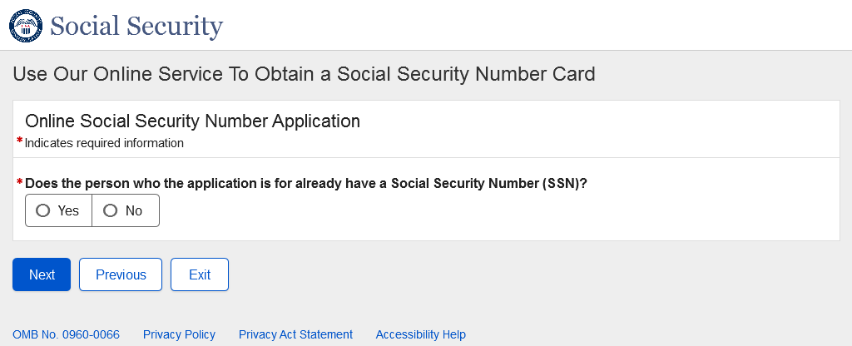
- U.S. Original Self - Citizenship
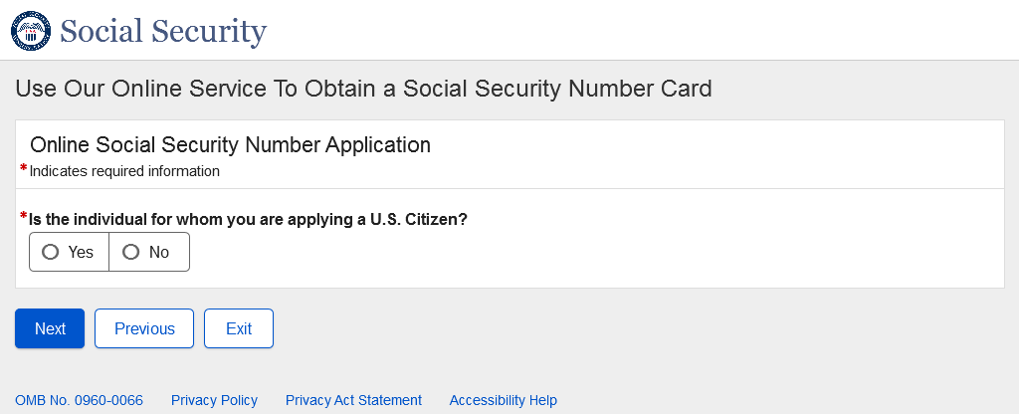
- U.S. Original Self - Applying For
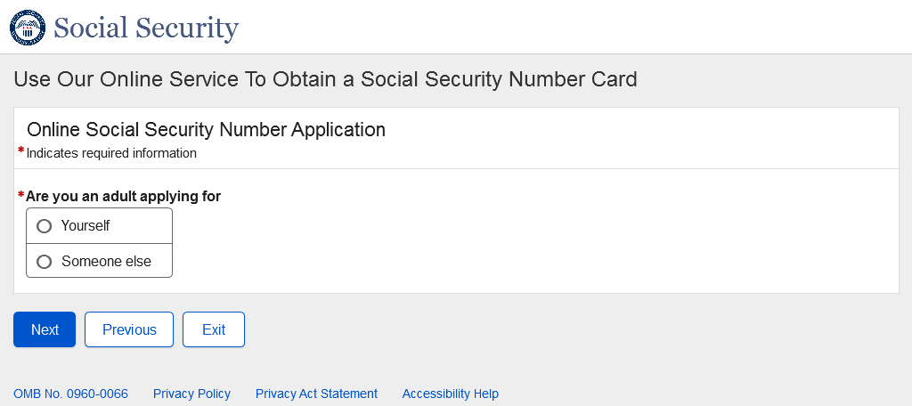
- U.S. Original Self - Date of Birth
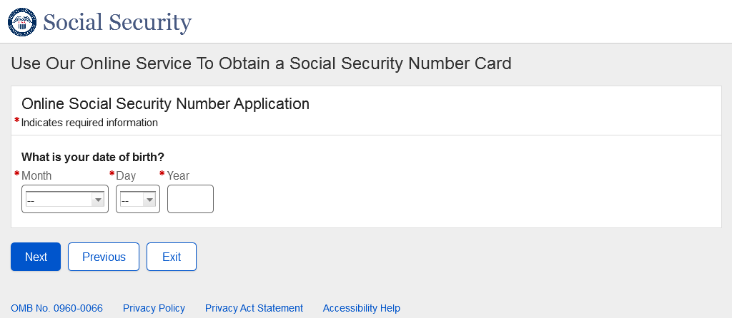
- U.S. Original Self - Place of Birth
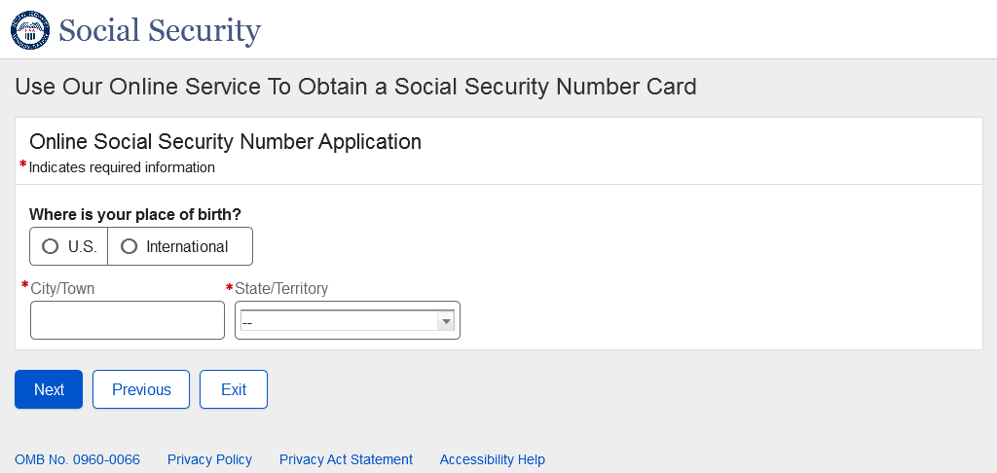

  - U.S. Original Self - Place of Birth - International
* The behavior in the screenshot below is the same for all Place of Birth fields in all paths and will not be shown in future paths.
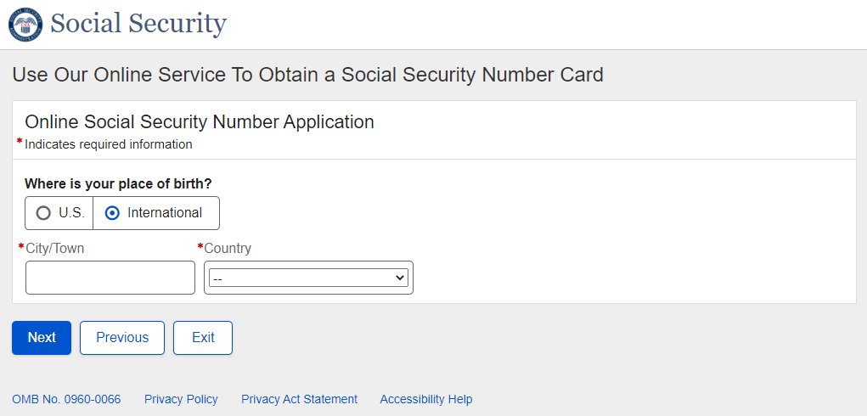
- U.S. Original Self - Name
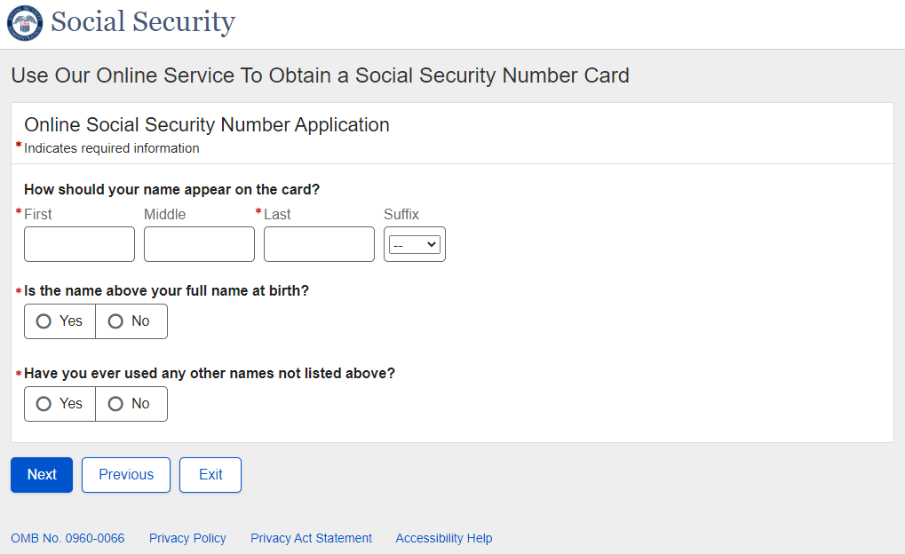

  - U.S. Original Self – Name – Dynamic Content Expanded
* The non-expanded Name page preceding this one will be shown in all paths due to wording differences, but the expanded content shown in the screenshot below is the same in all paths and will not be shown in future paths.
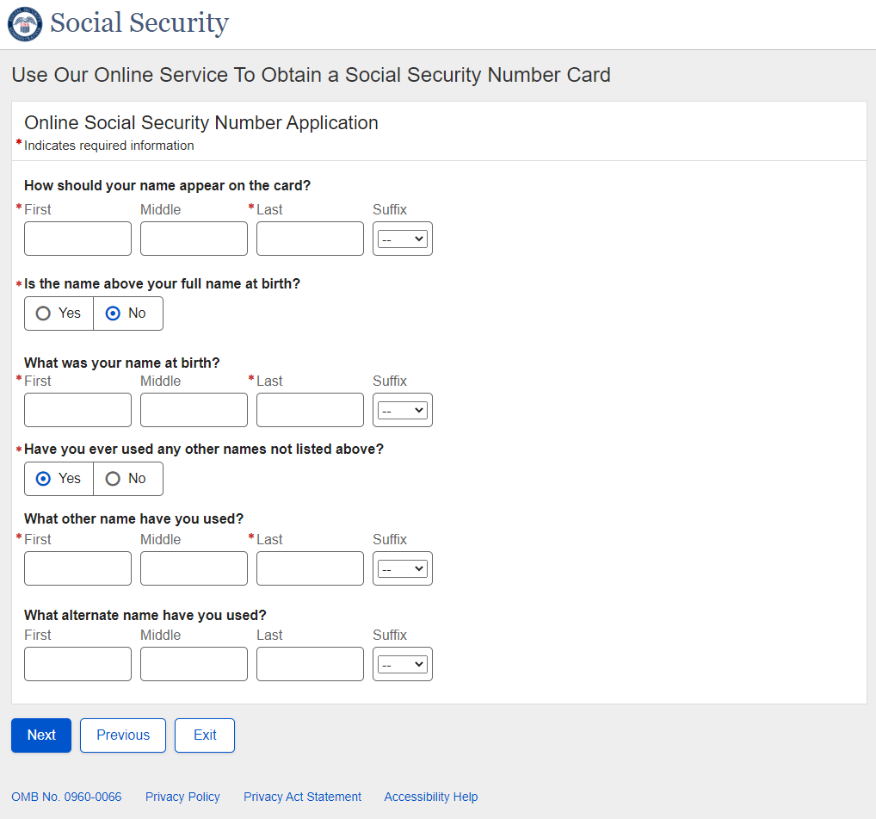
- U.S. Original Self - Sex
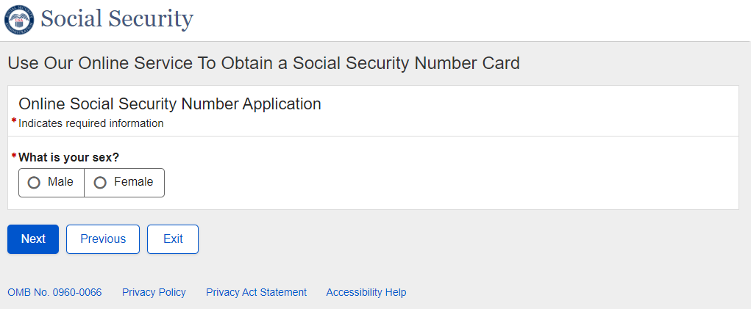
- U.S. Original Self - Parents Names
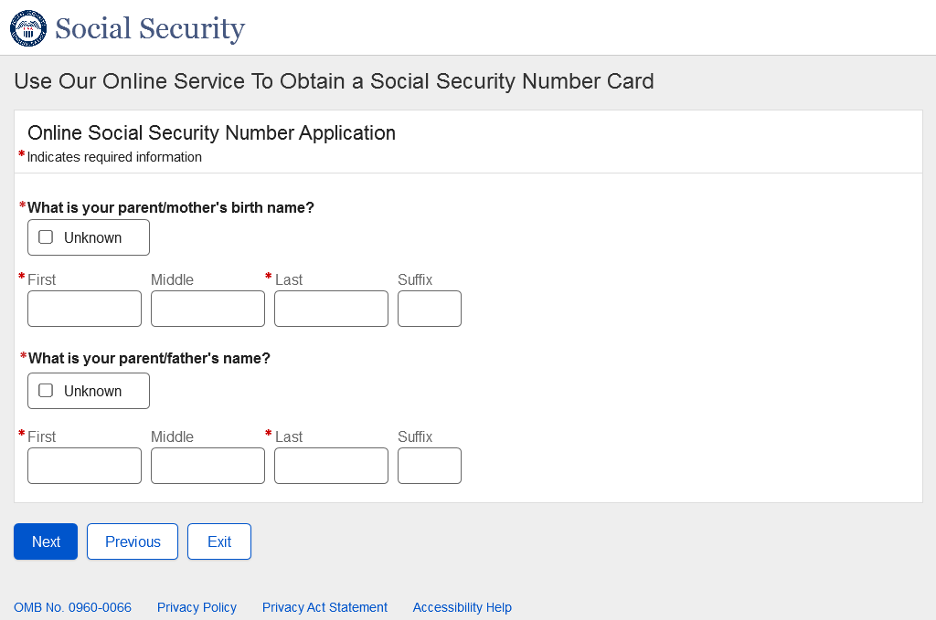
- U.S. Original Self - U.S. Mailing Address
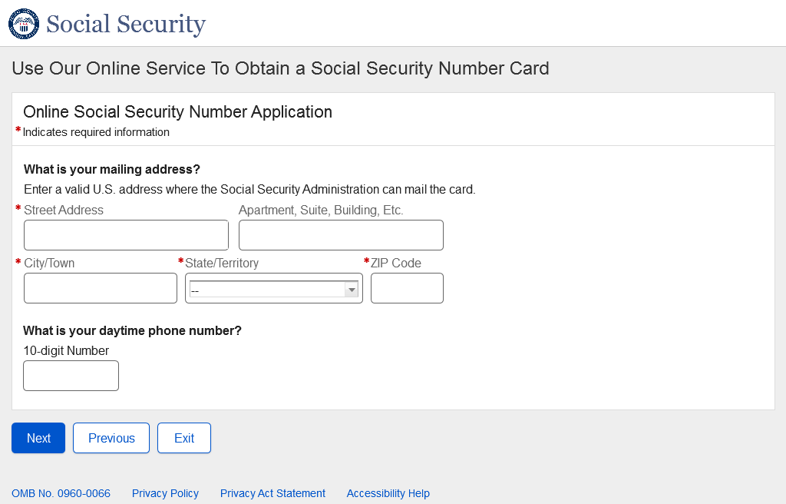
- U.S. Original Self – Race and Ethnicity
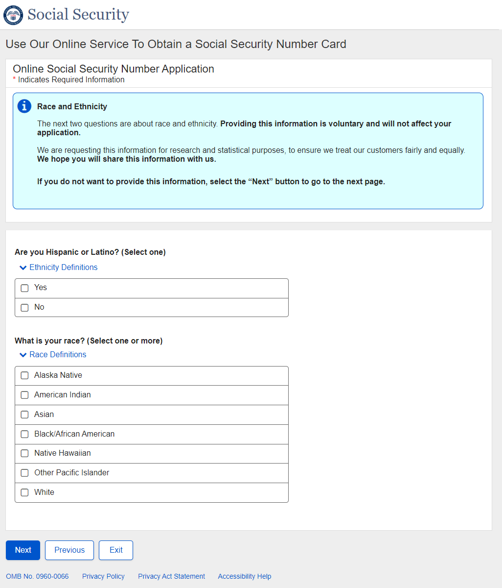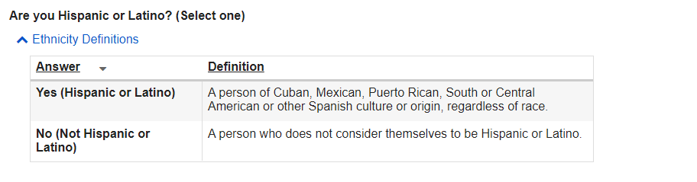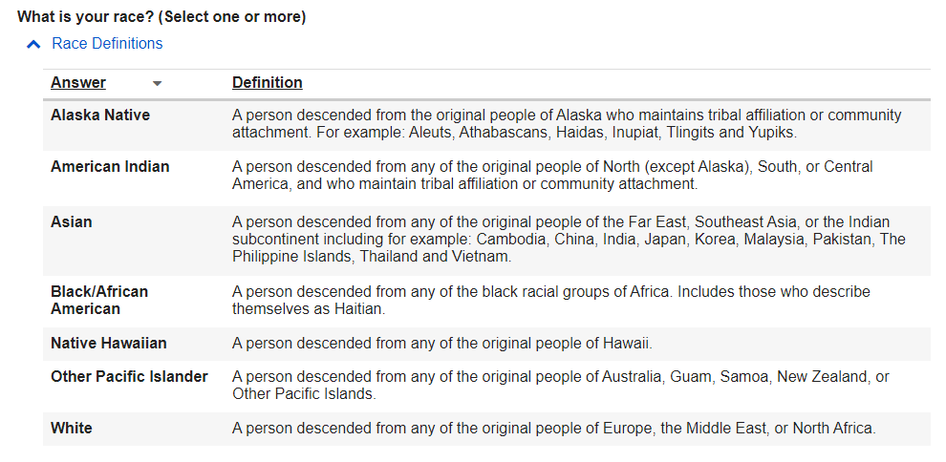

- U.S. Original Self - U.S. Documentation – Age
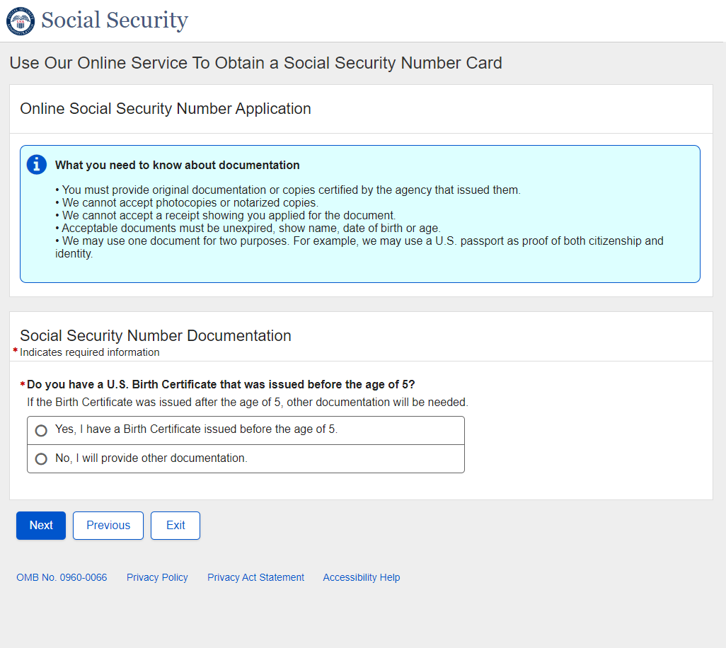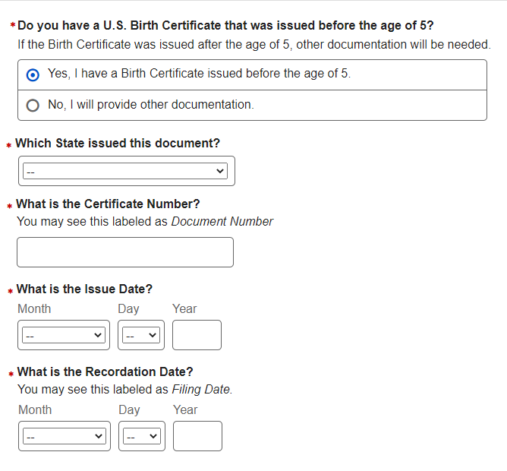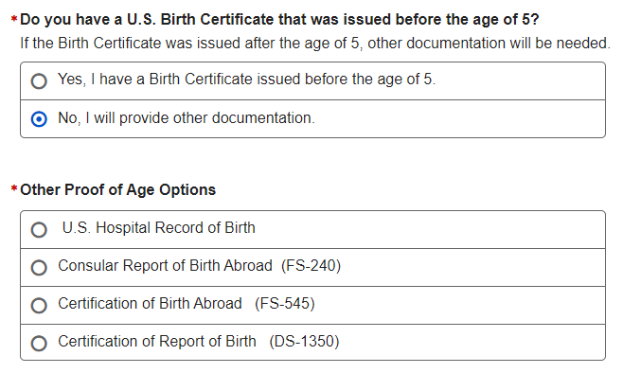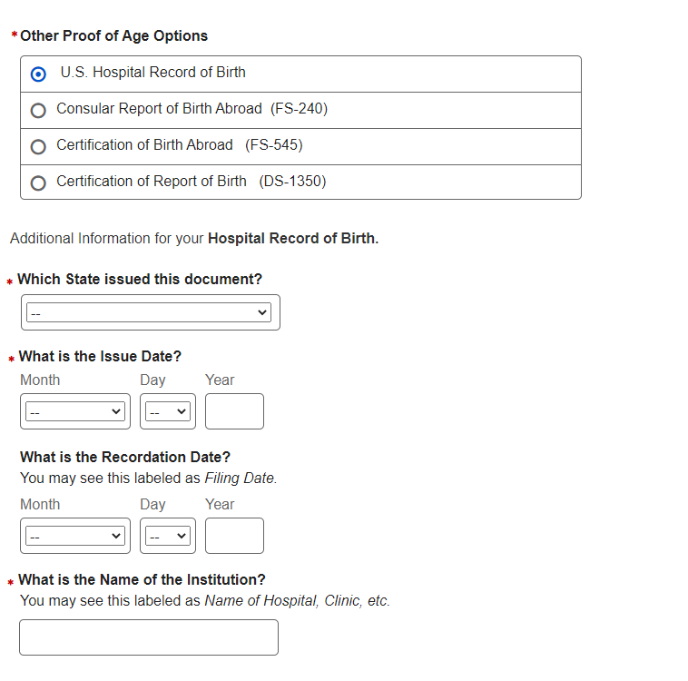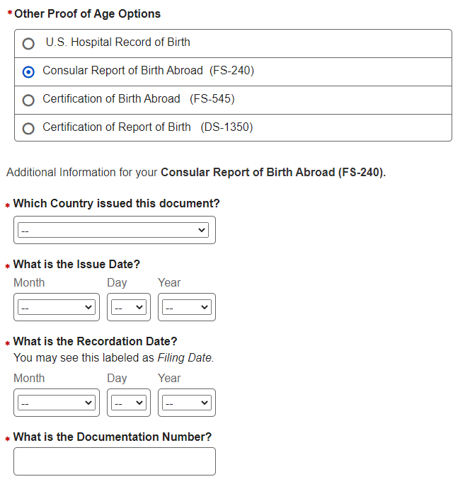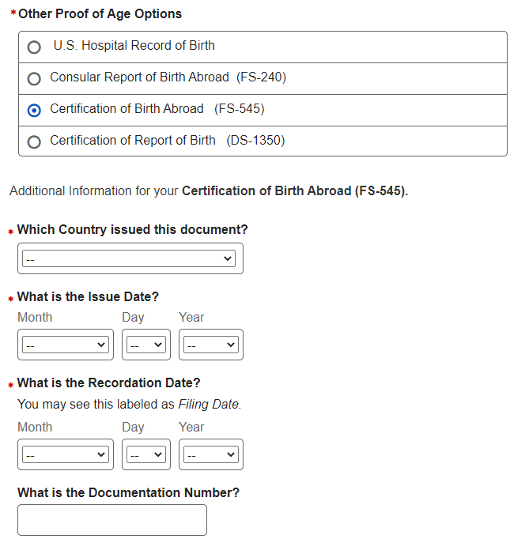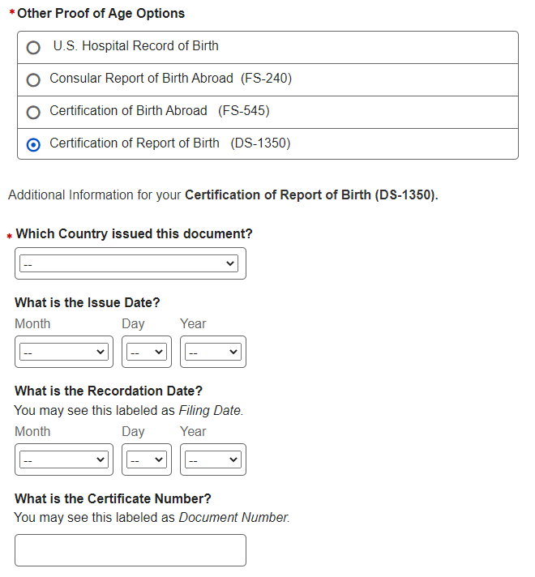

- U.S. Original Self – Citizenship
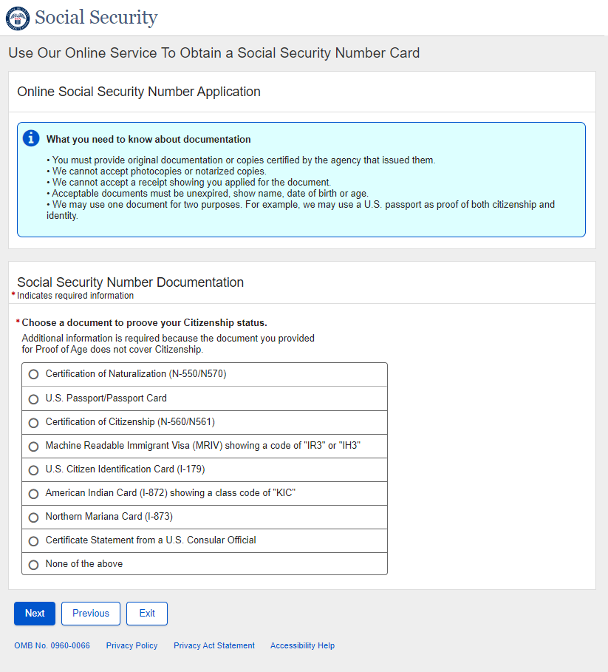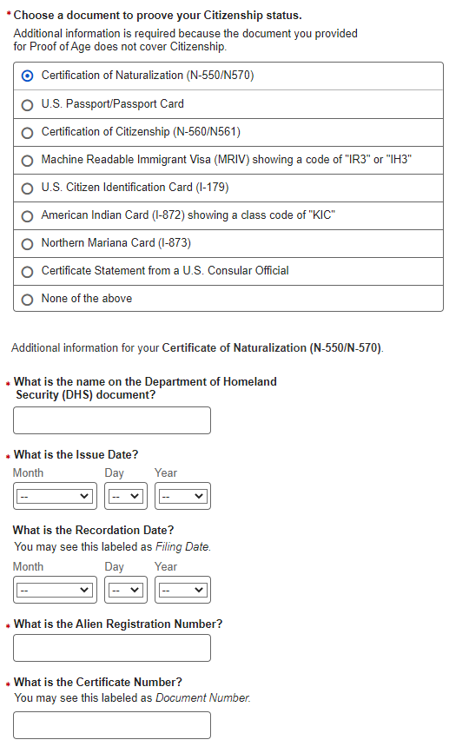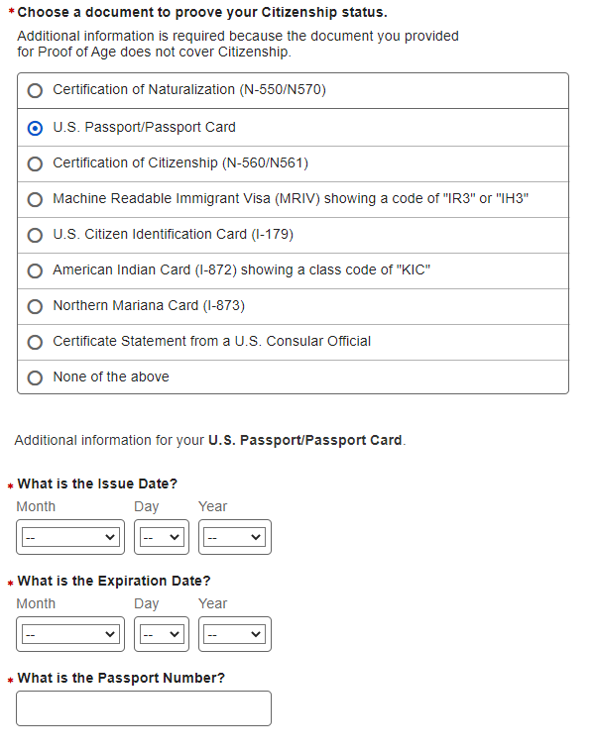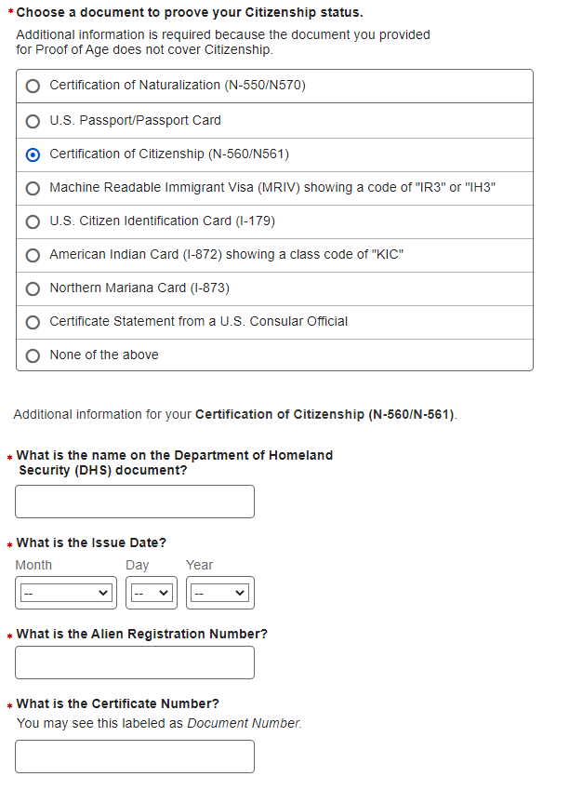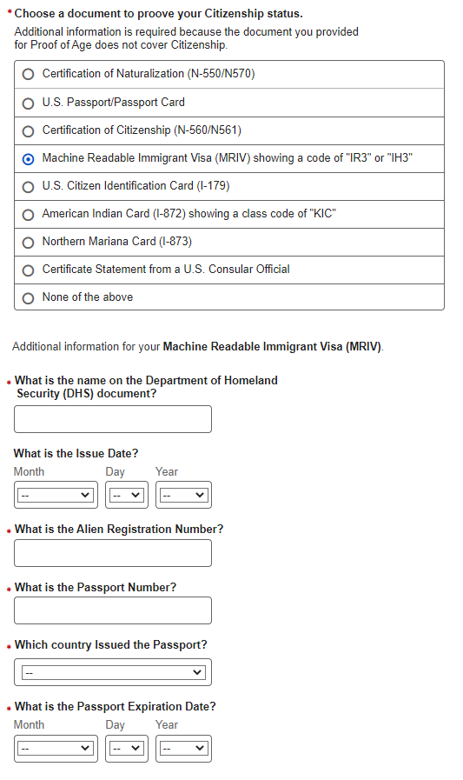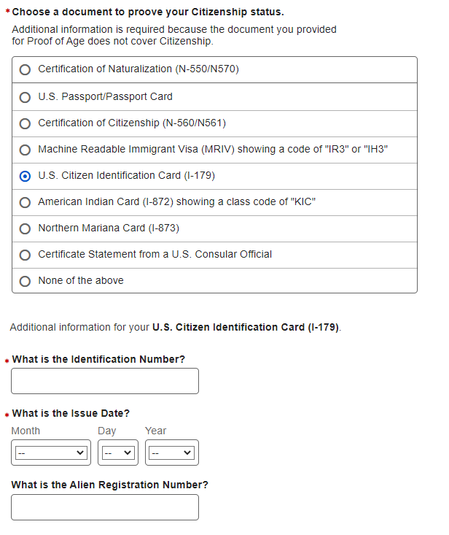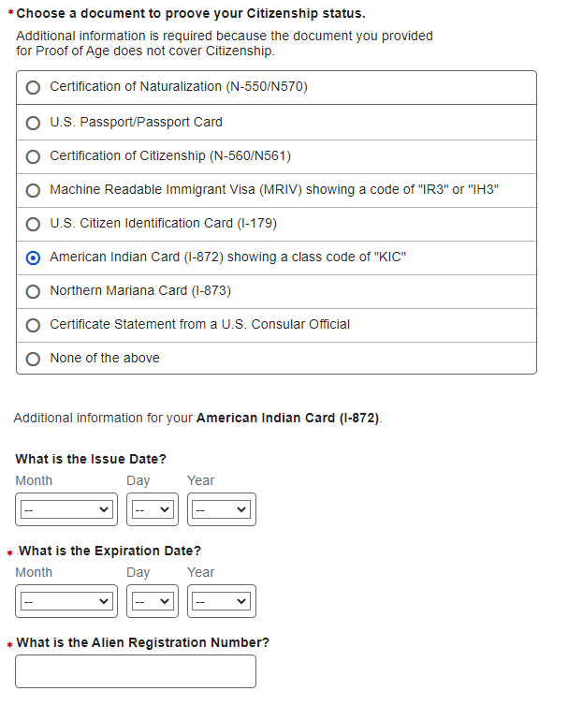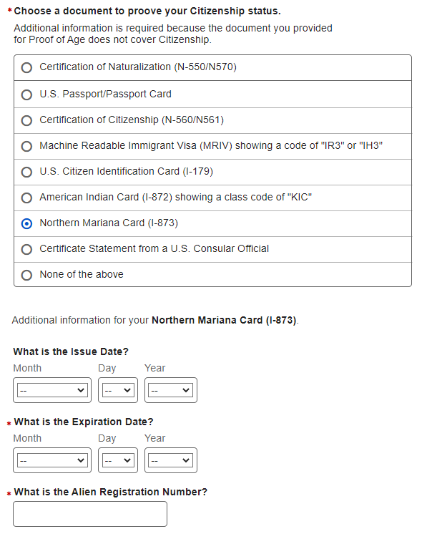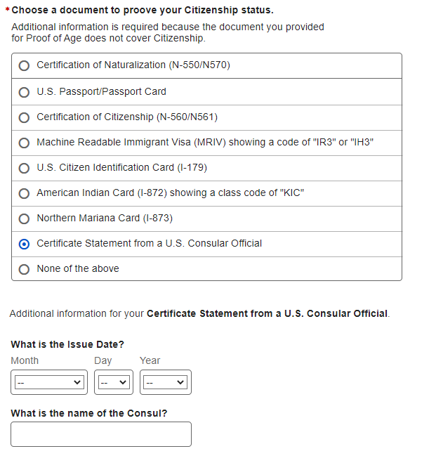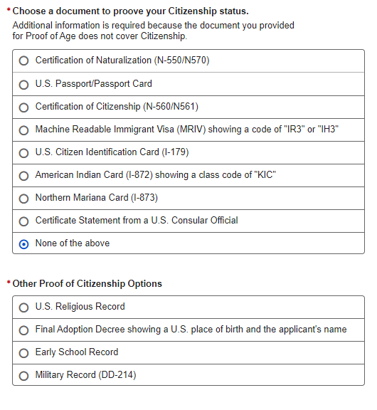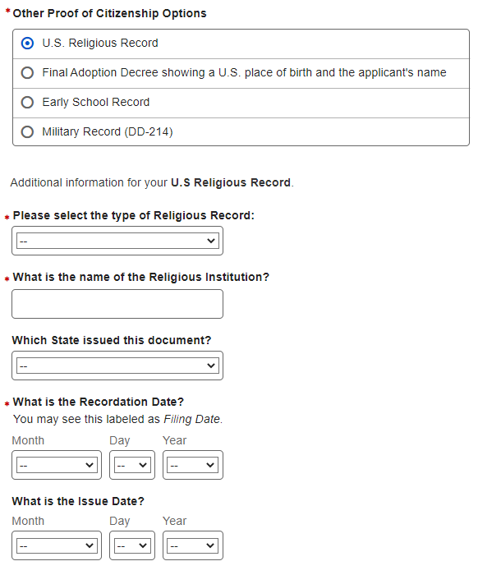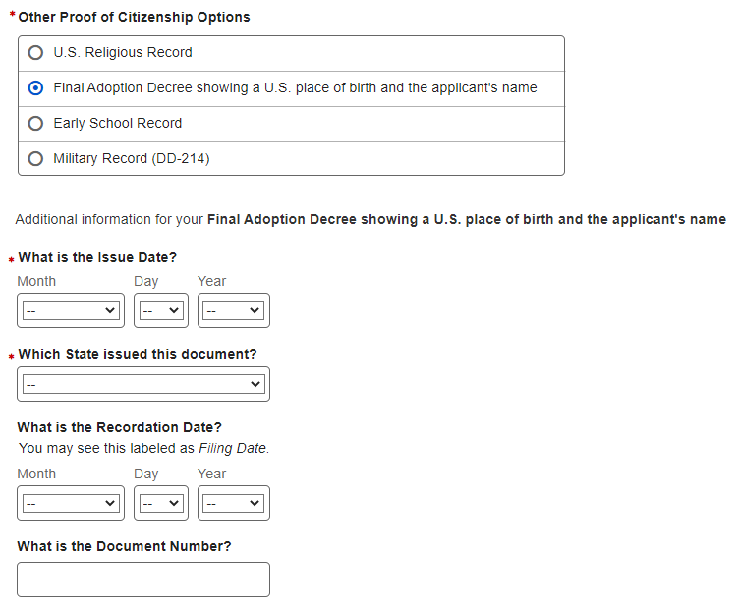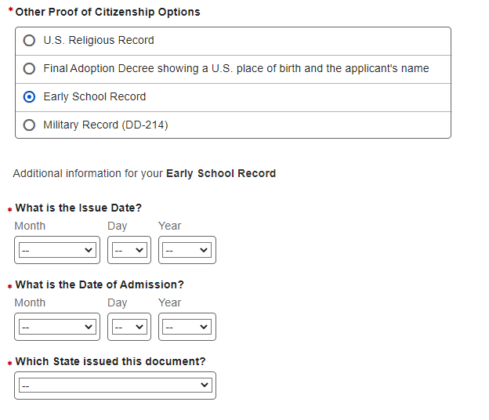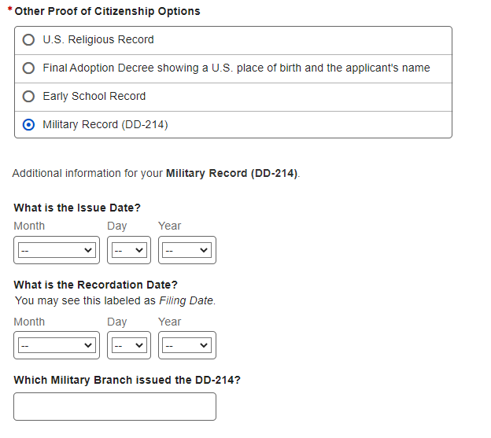
- U.S. Original Self – Documentation – Identity
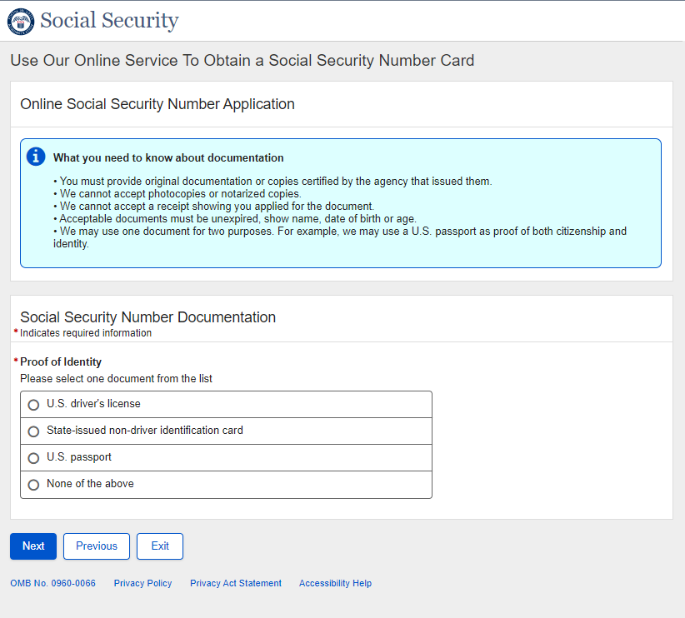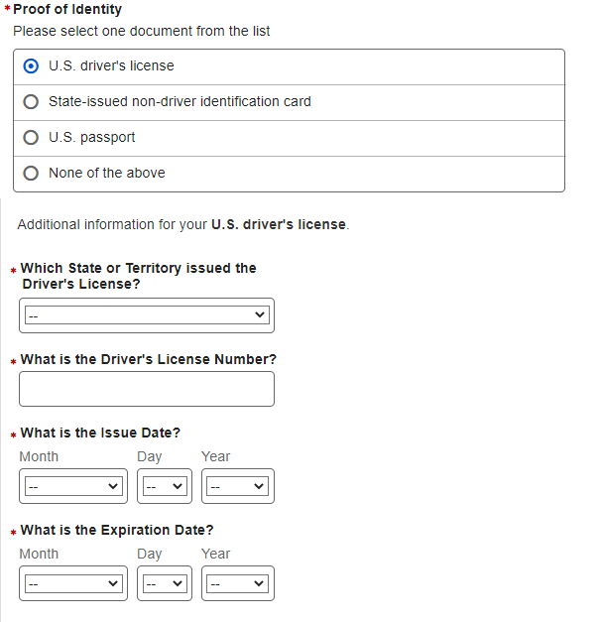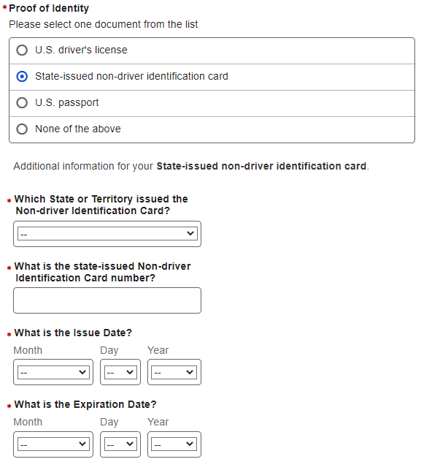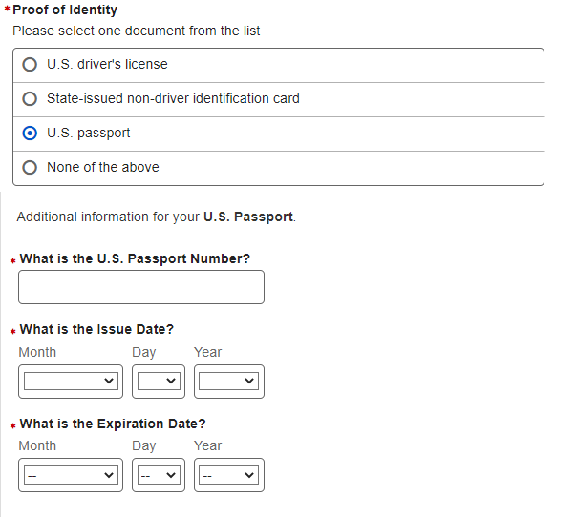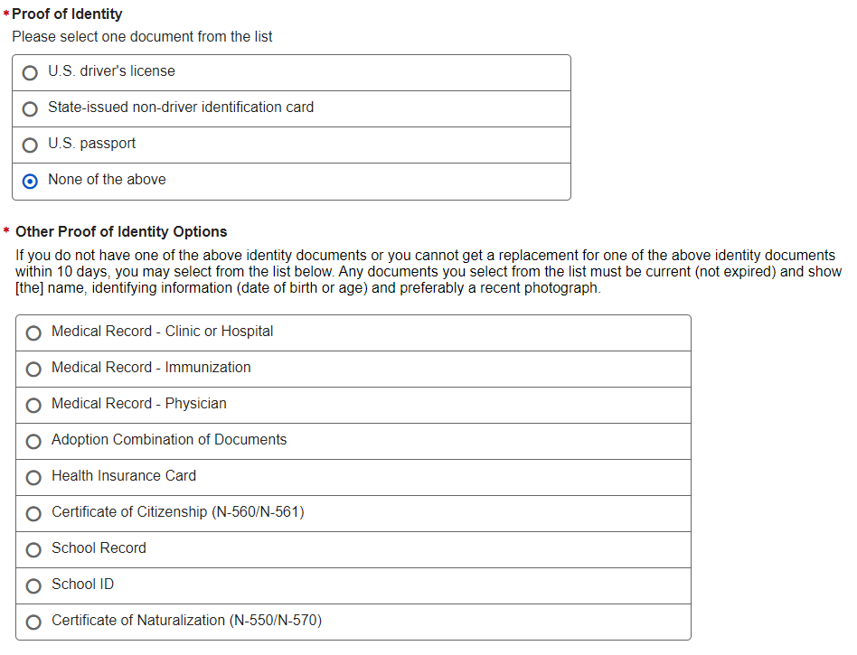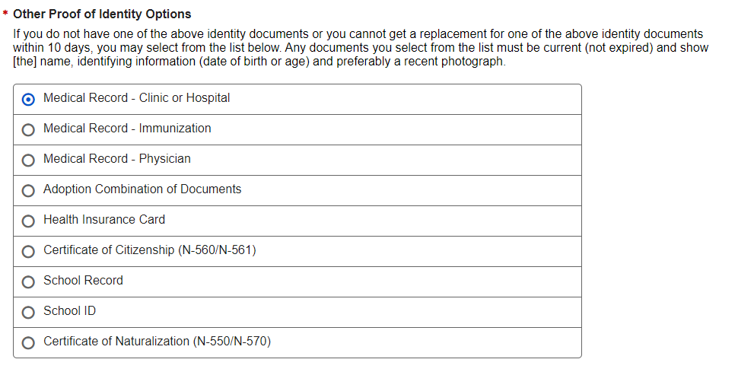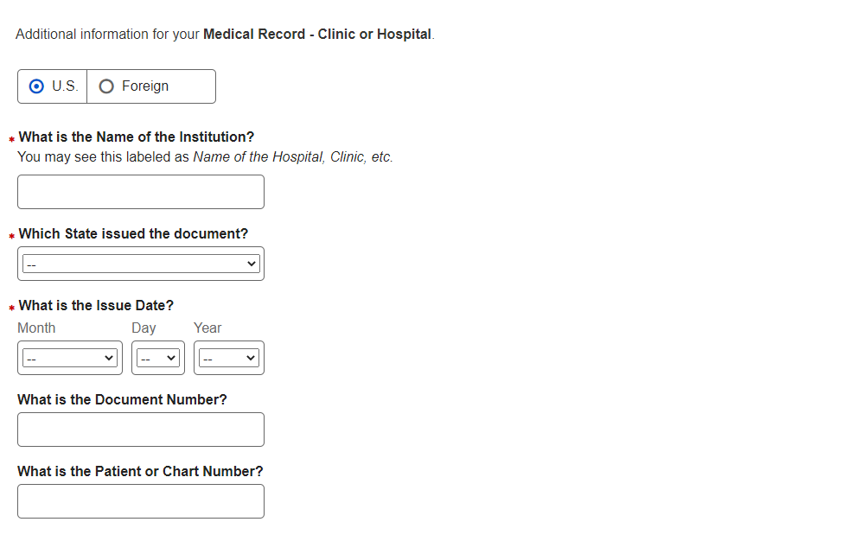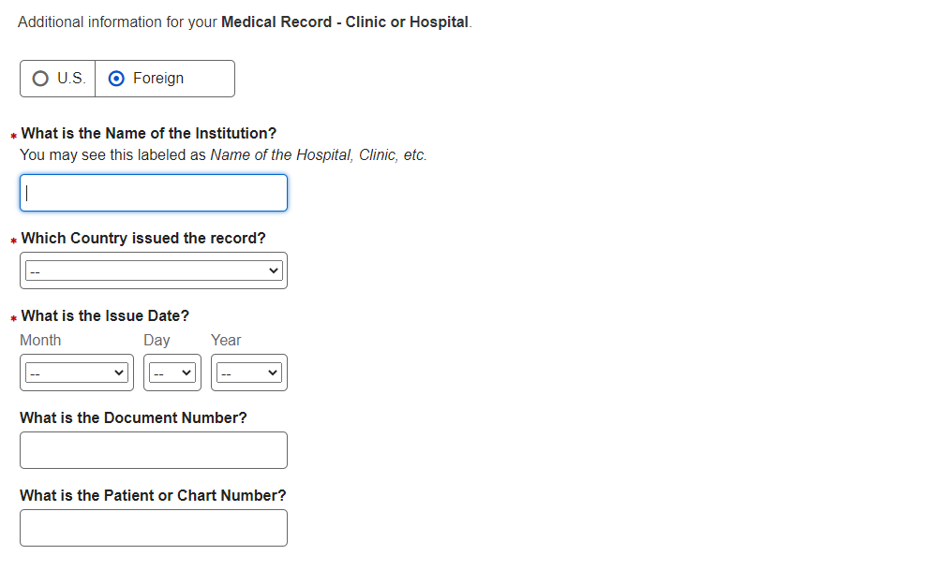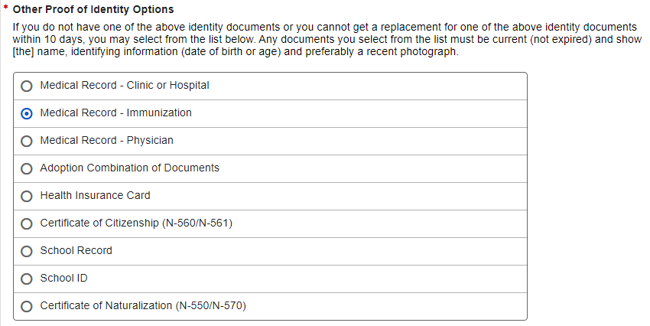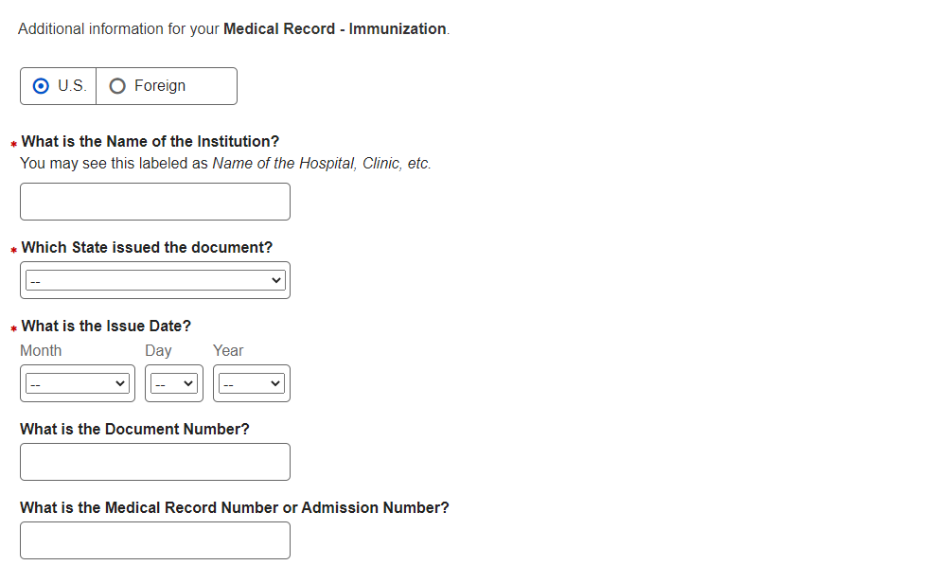
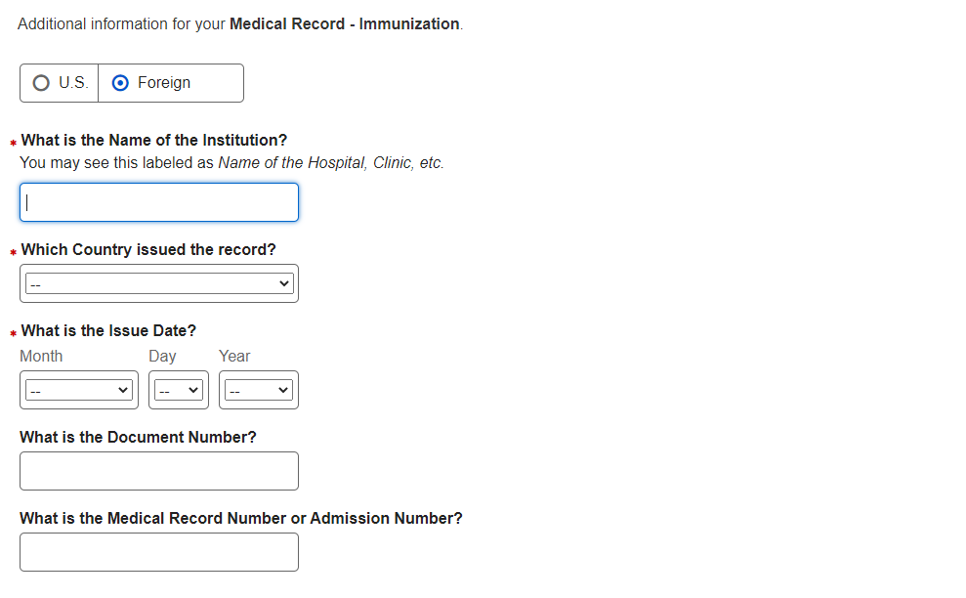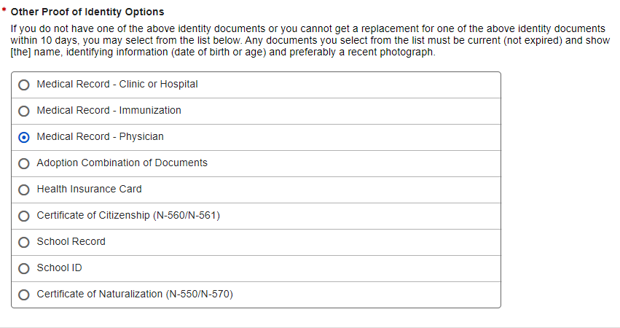
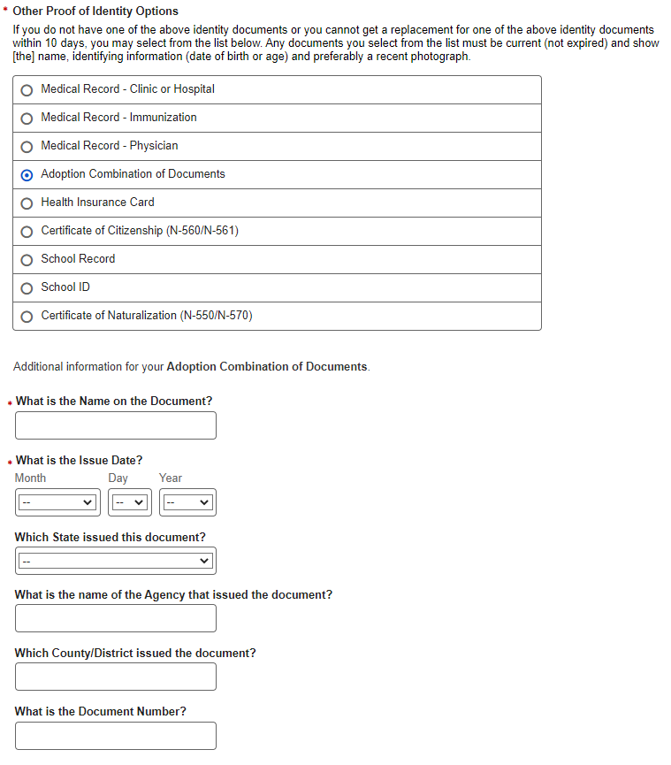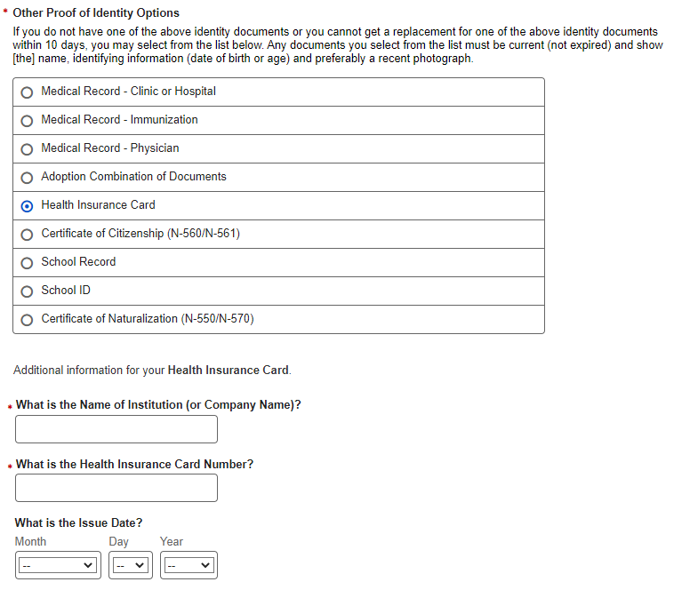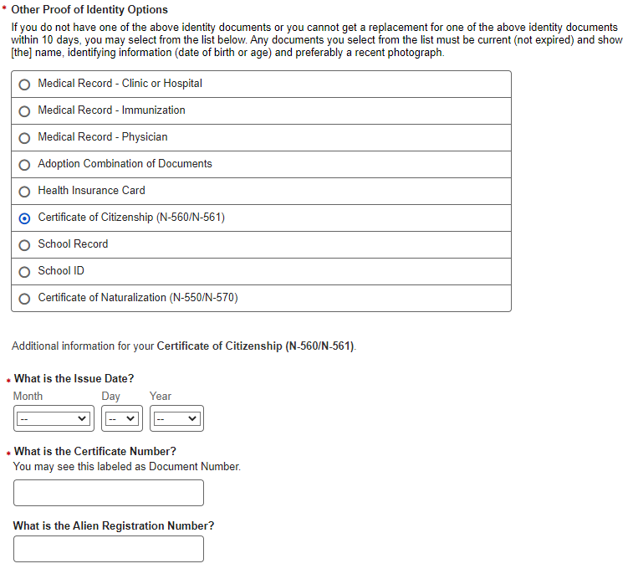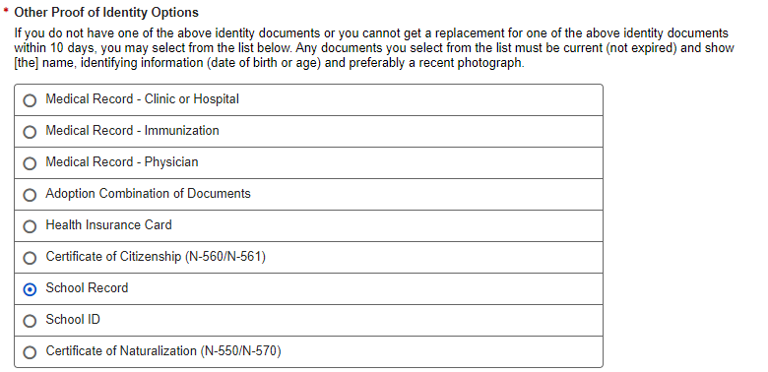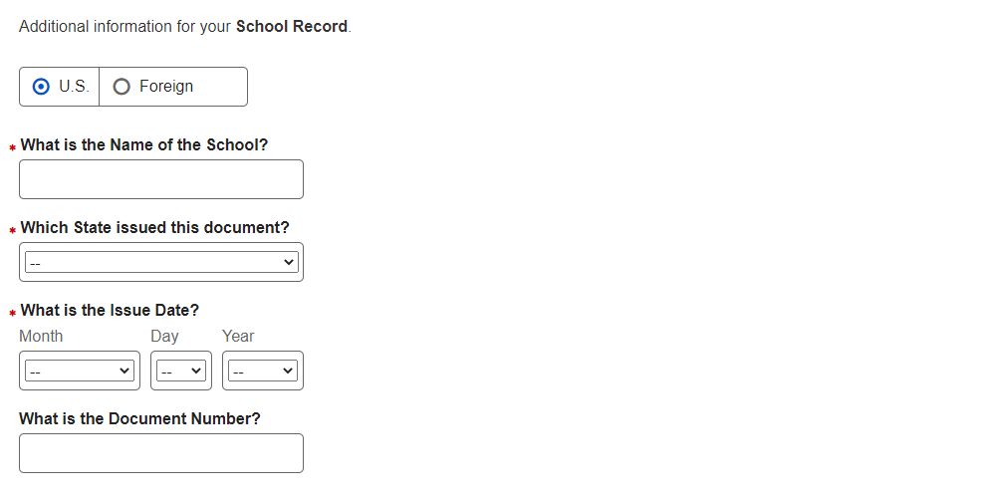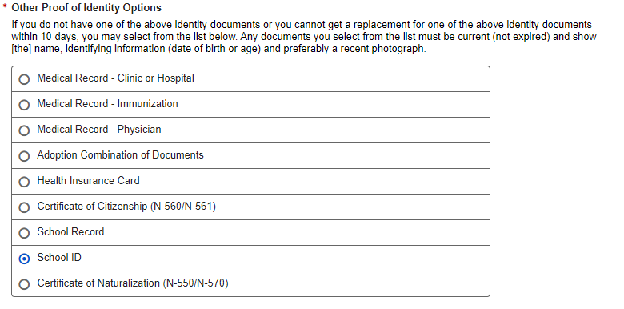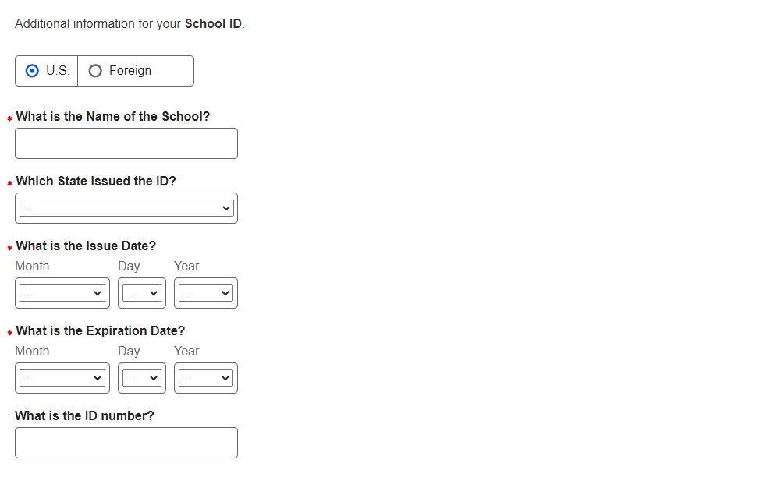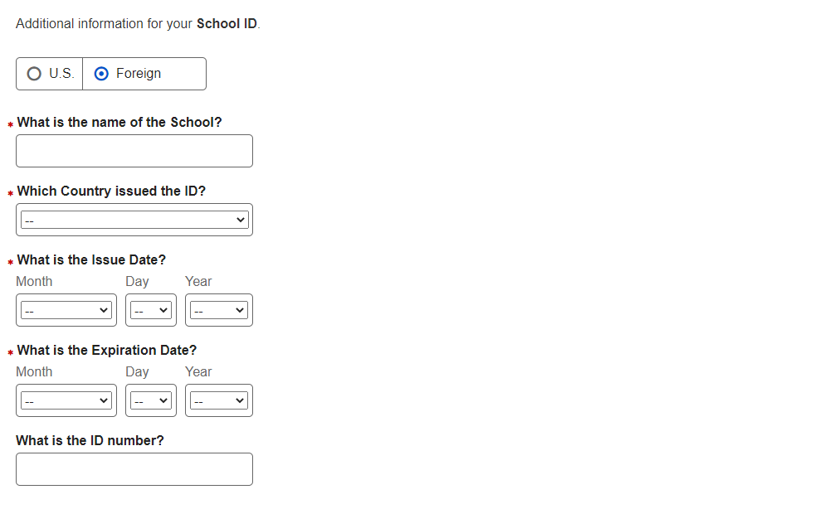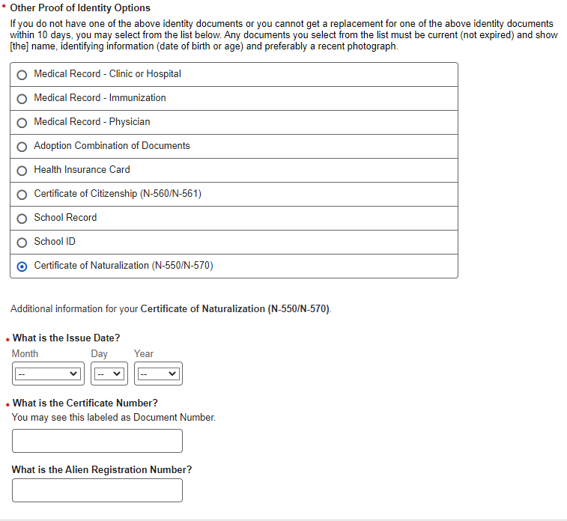

- U.S. Original Self - Review and Edit
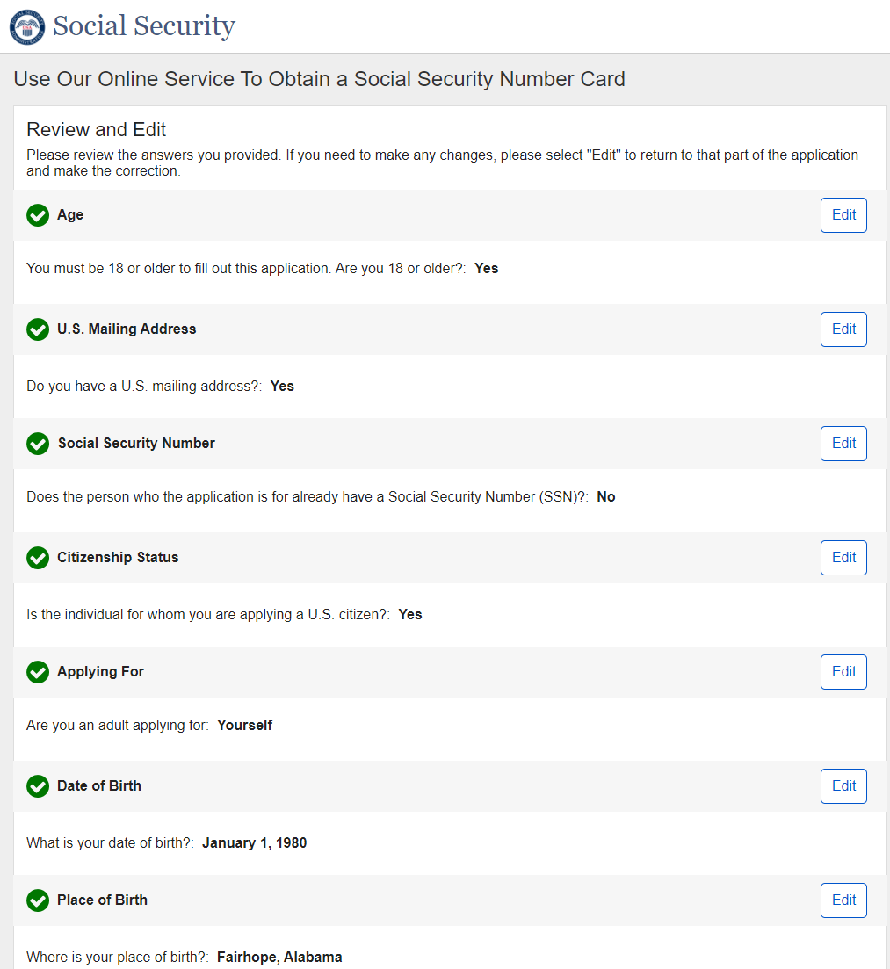
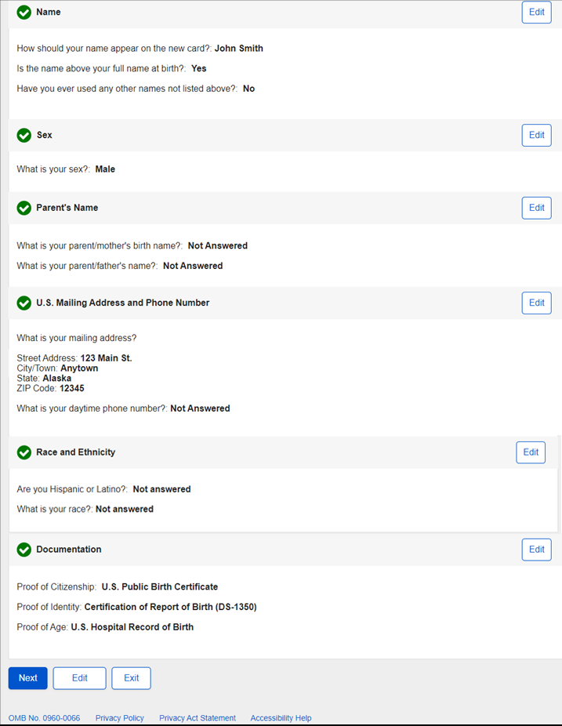
- U.S. Original Self - Attestation
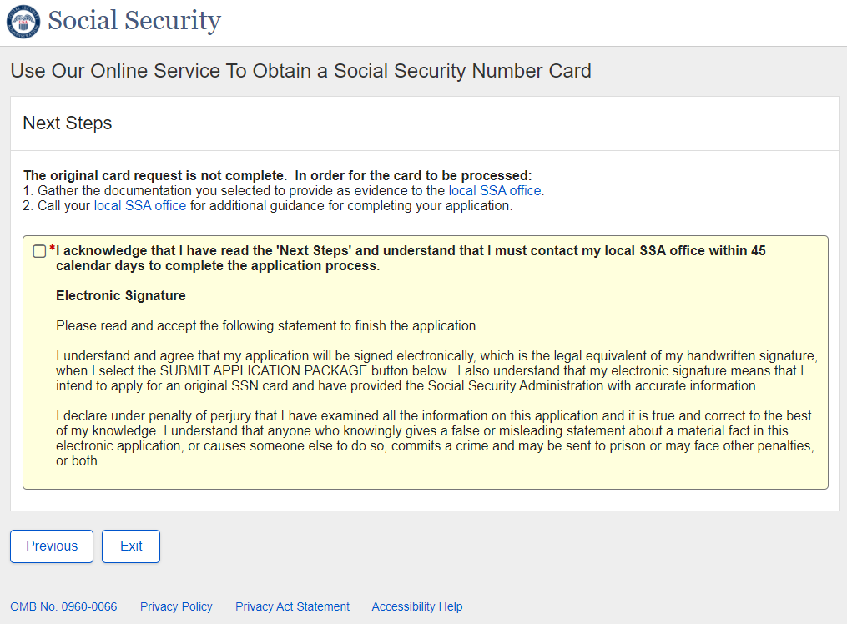

  - U.S. Original Self – Attestation – Acknowledgement Checked
* The dynamic behavior shown in the screenshot below is the same in all paths and will not be shown in future paths.
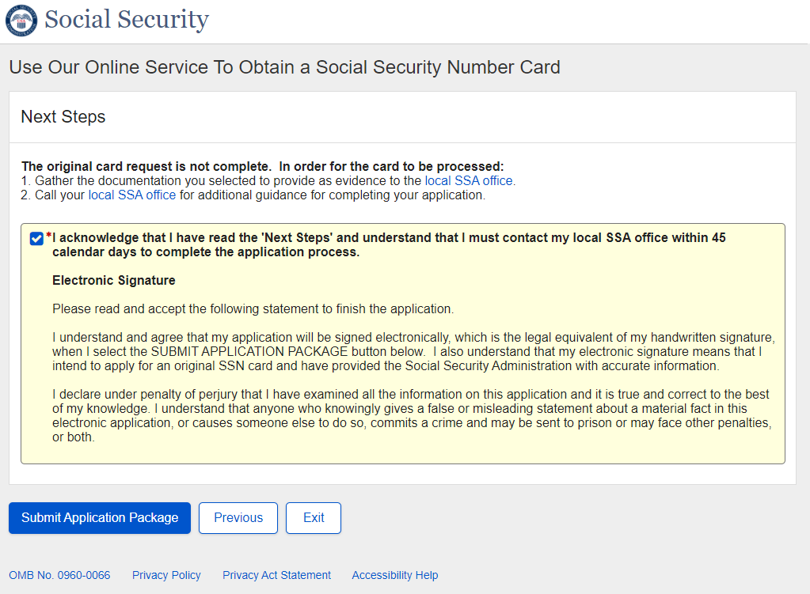

- U.S. Original Self - Success
Success – Non-ESS:
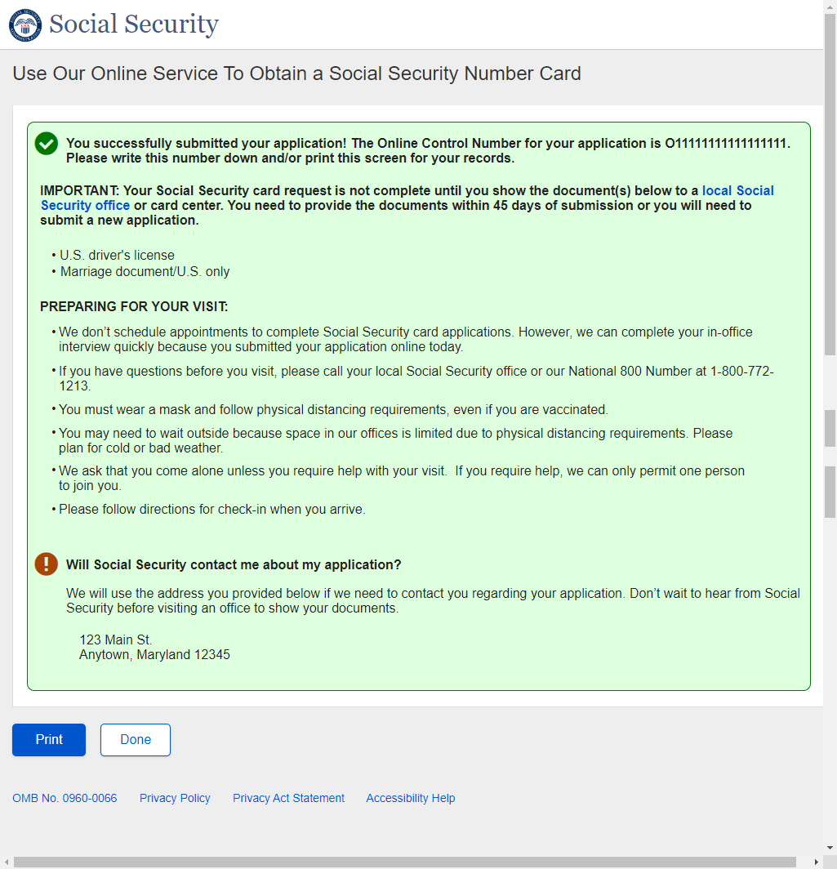

Success - Banned:
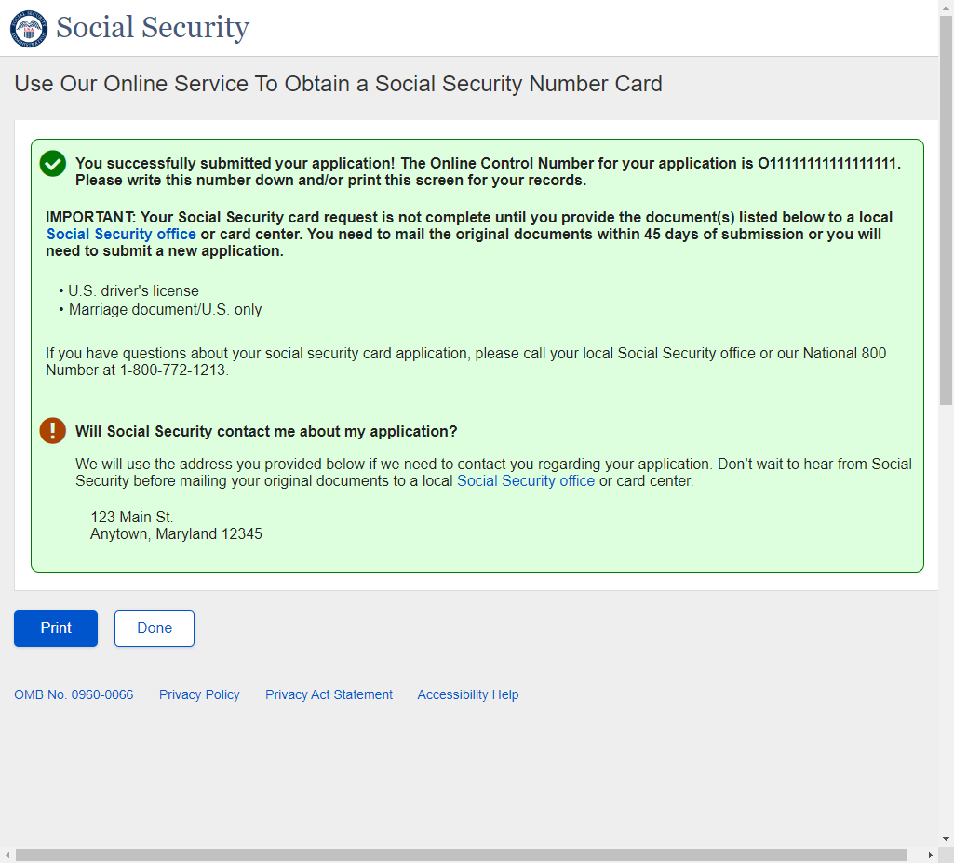

Success - ESS
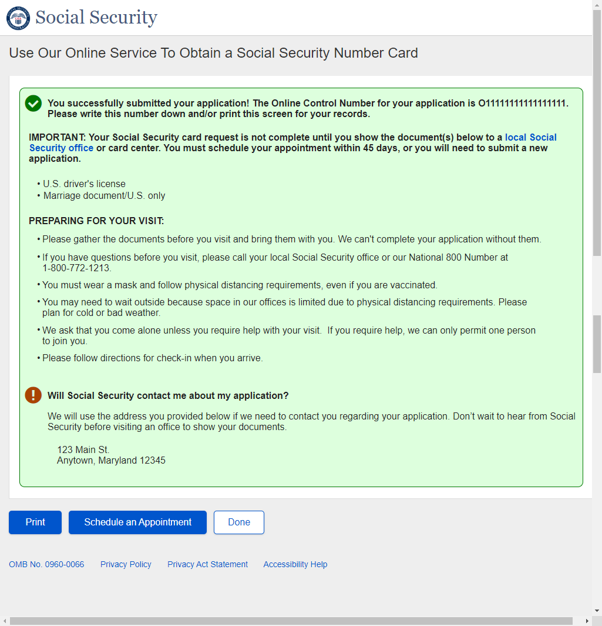

- U.S. Original Someone Else Adult - Landing
- U.S. Original Someone Else Adult - Age 18 or Older
- U.S. Original Someone Else Adult - U.S. Mailing Address Available
- U.S. Original Someone Else Adult - Have an SSN
- U.S. Original Someone Else Adult - Citizenship
- U.S. Original Someone Else Adult - Applying For
- U.S. Original Someone Else Adult - Applying For Someone Else Name
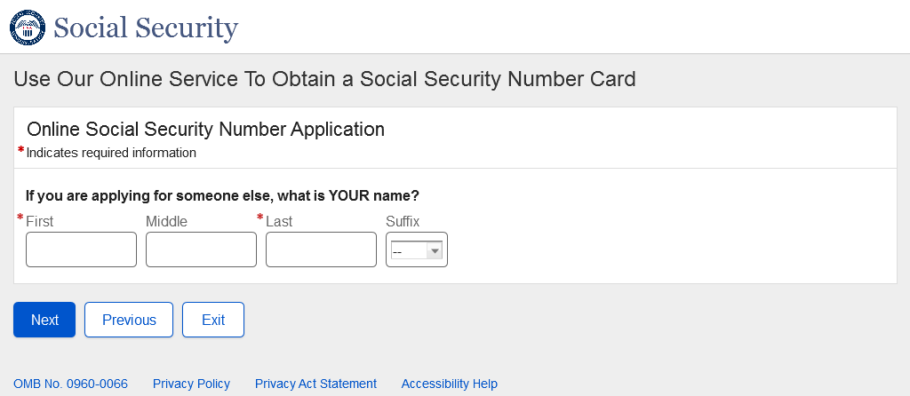
- U.S. Original Someone Else Adult – Individual’s Date of Birth
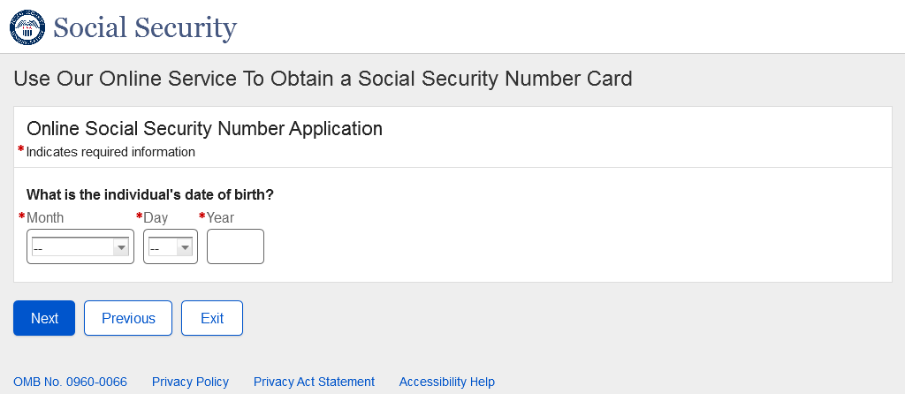
- U.S. Original Someone Else Adult - Relationship Adult
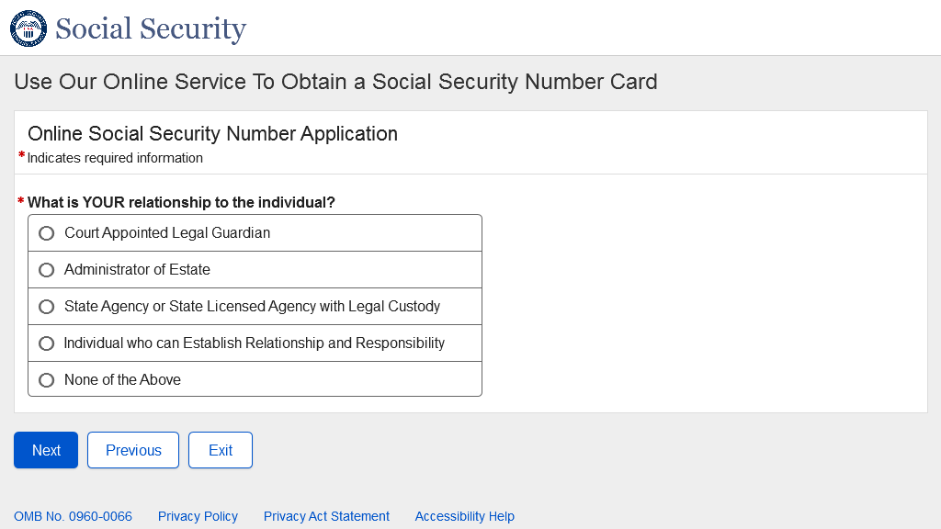

  - U.S. Original Someone Else Adult - Relationship Adult – None of the Above
* The messaging and behavior in the screenshot below is the same in all Someone Else Adult/Child paths and will not be shown in future paths.
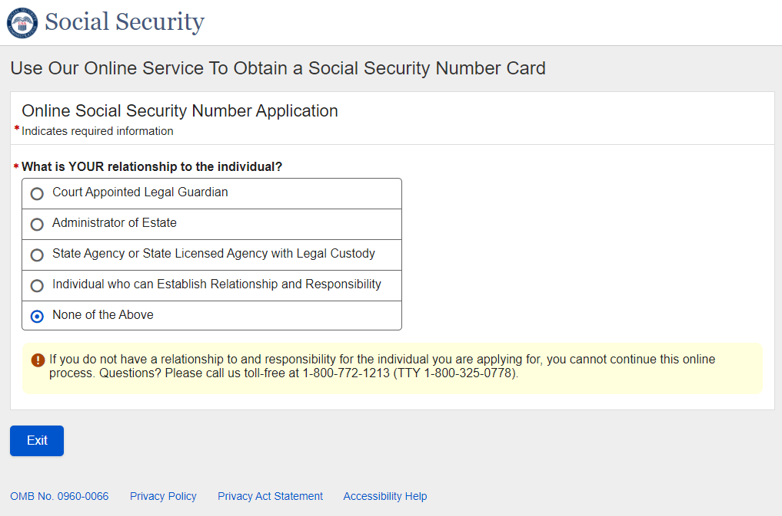
- U.S. Original Someone Else Adult - Individual Capabilities
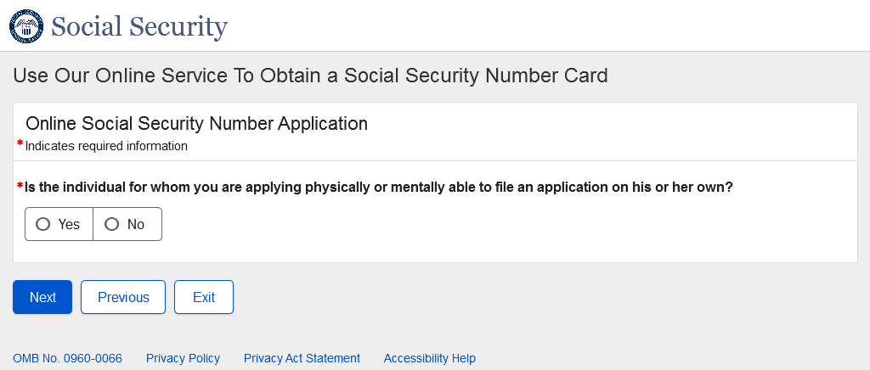

  - U.S. Original Someone Else Adult - Individual Capabilities – Yes
* The messaging and behavior in the screenshot below is the same in all Someone Else Adult paths and will not be shown in future paths.
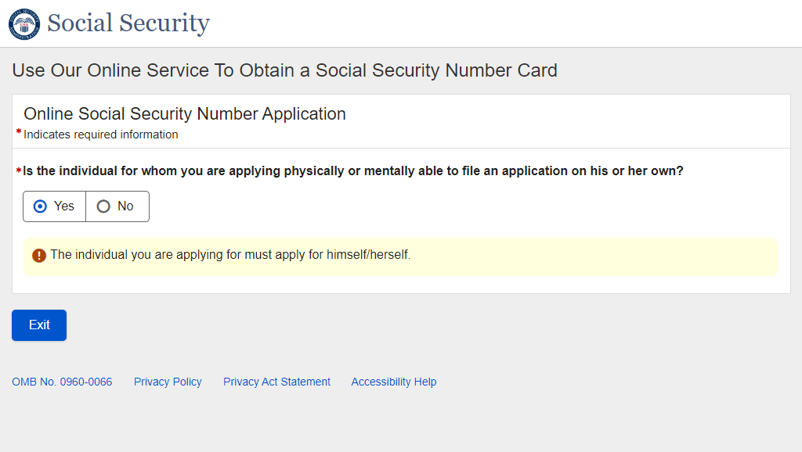
- U.S. Original Someone Else Adult - Individual's Place of Birth
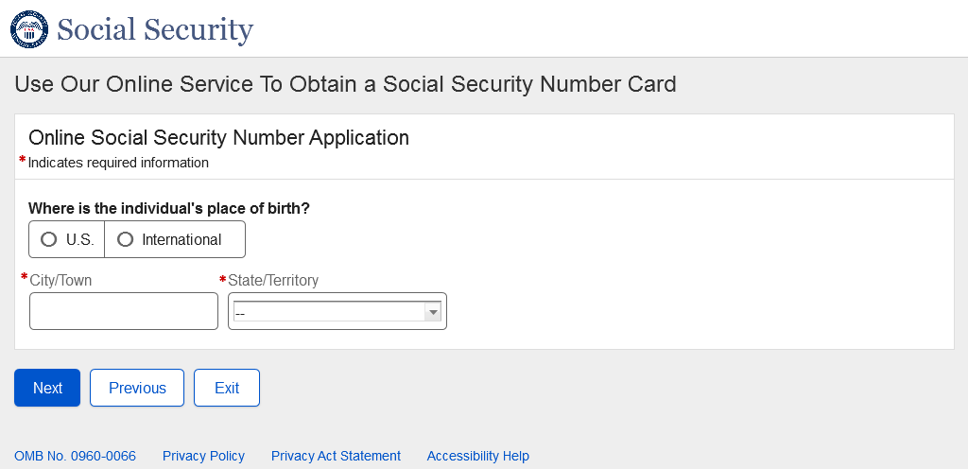
- U.S. Original Someone Else Adult - Individual's Name
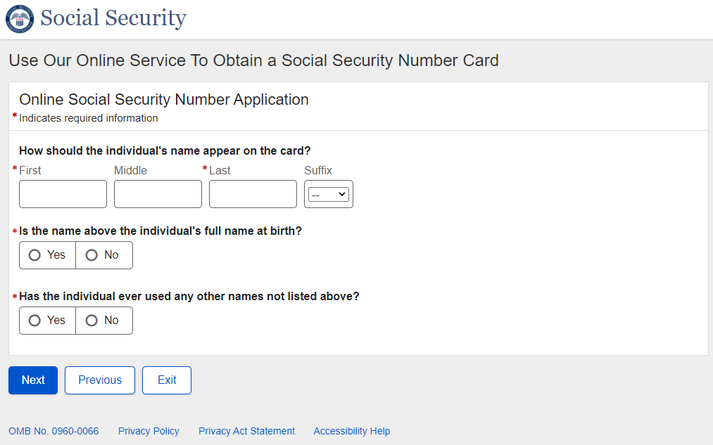
- U.S. Original Someone Else Adult - Individual's Sex
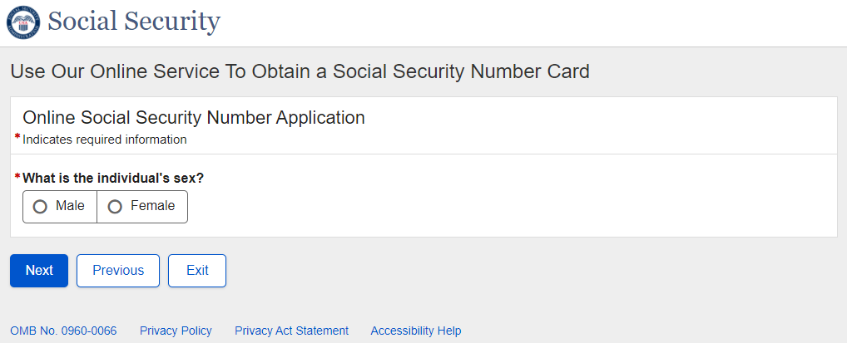
- U.S. Original Someone Else Adult - Individual's Parents Names
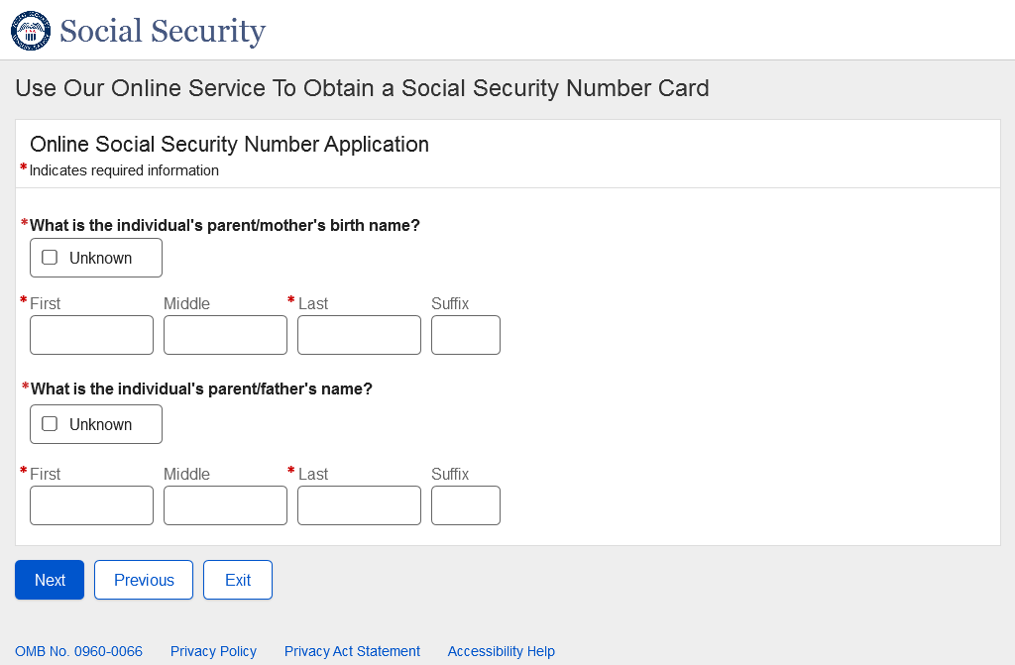
- U.S. Original Someone Else Adult - U.S. Mailing Address
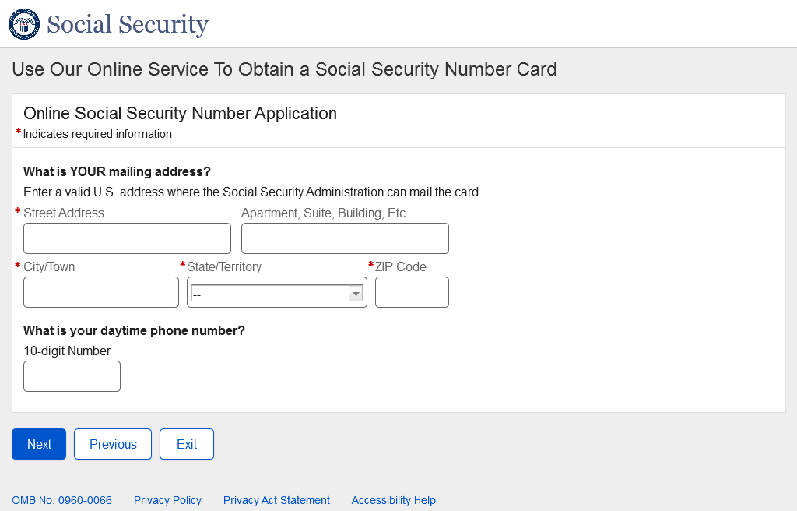

- U.S. Original Someone Else – Adult – Race and Ethnicity
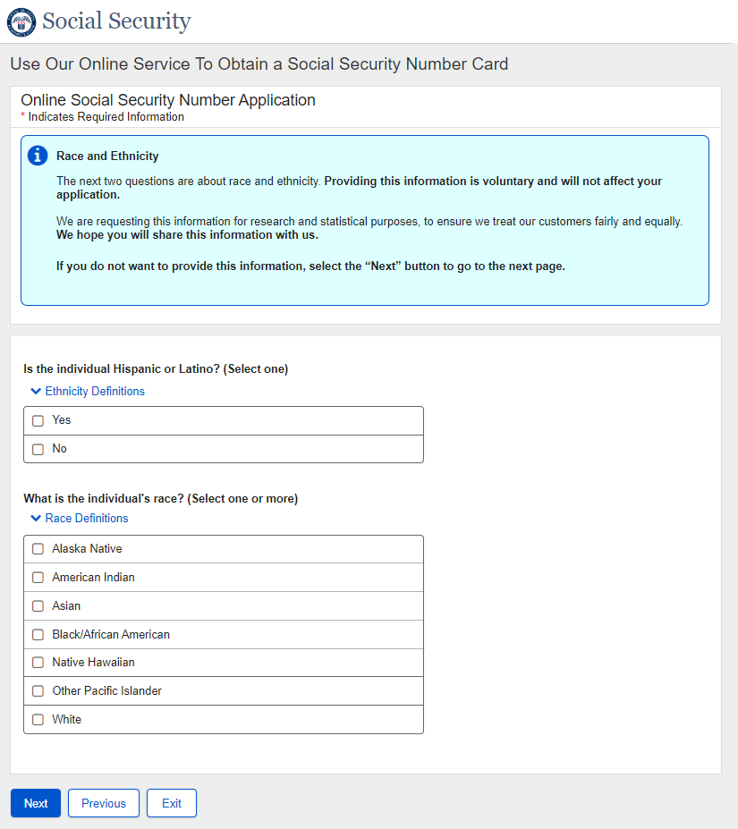
- U.S. Original Someone Else – Adult – Proof of Identity
*The Field Level Data collection is the same as U.S. Original Self Documentation screens and will not be repeated in most cases.
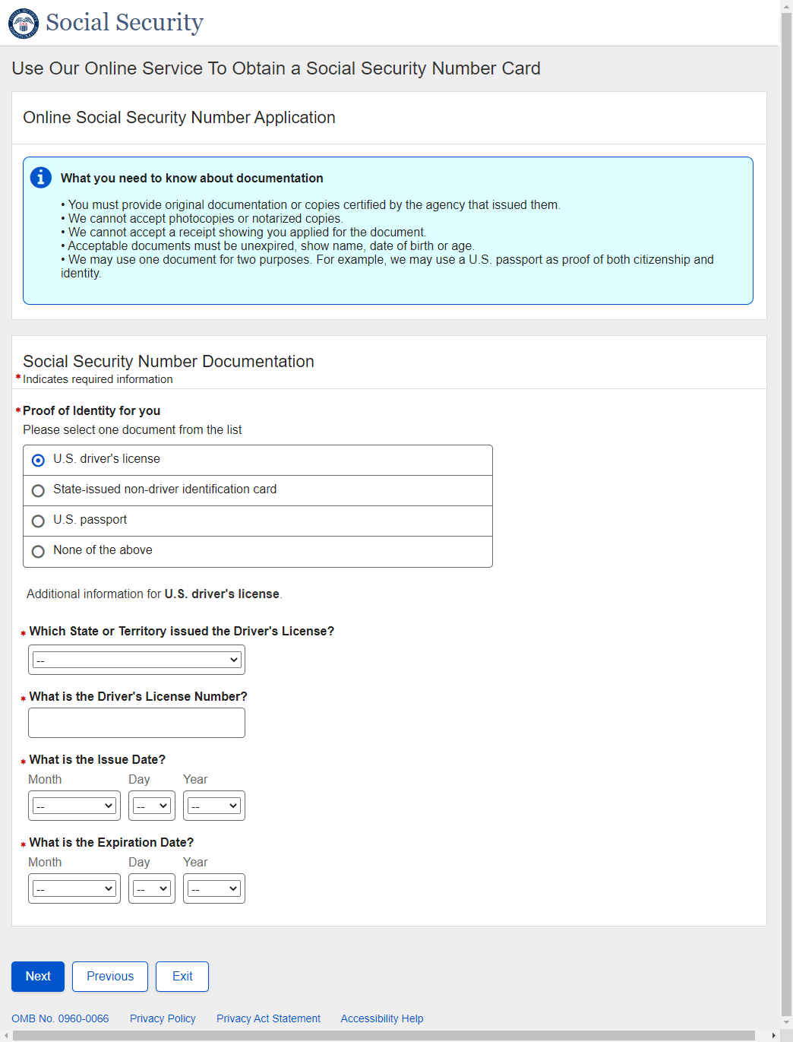
- U.S. Original Someone Else – Adult – Proof of Age for Individual
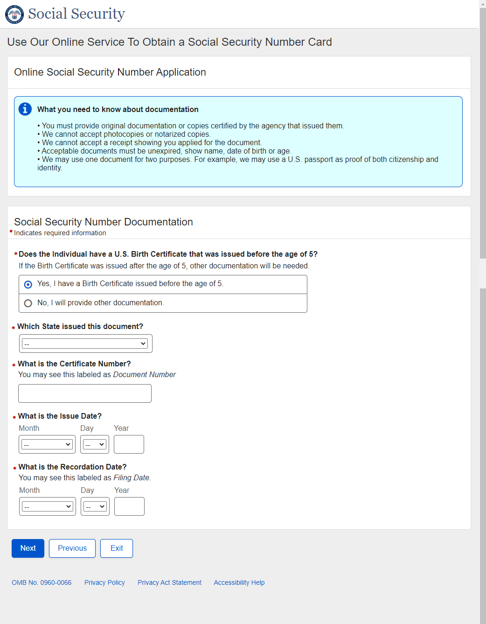
** Proof of Age Field Level Data and other options are identical to U.S. Original Self and will not be repeated here.

- U.S. Original Someone Else – Adult – Proof of Citizenship for Individual
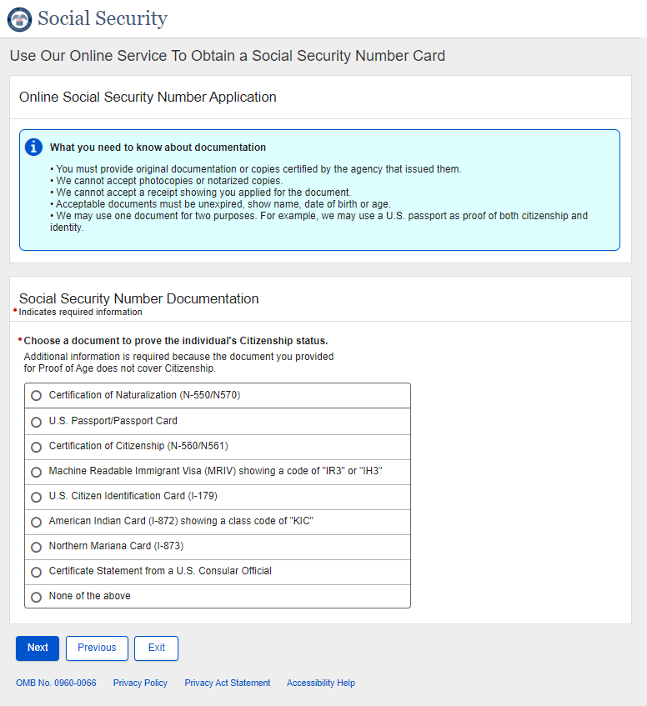
** Proof of Citizenship Field Level Data and other options are identical to U.S. Original Self and will not be repeated here.
- U.S. Original Someone Else – Adult – Proof of Identity for Individual
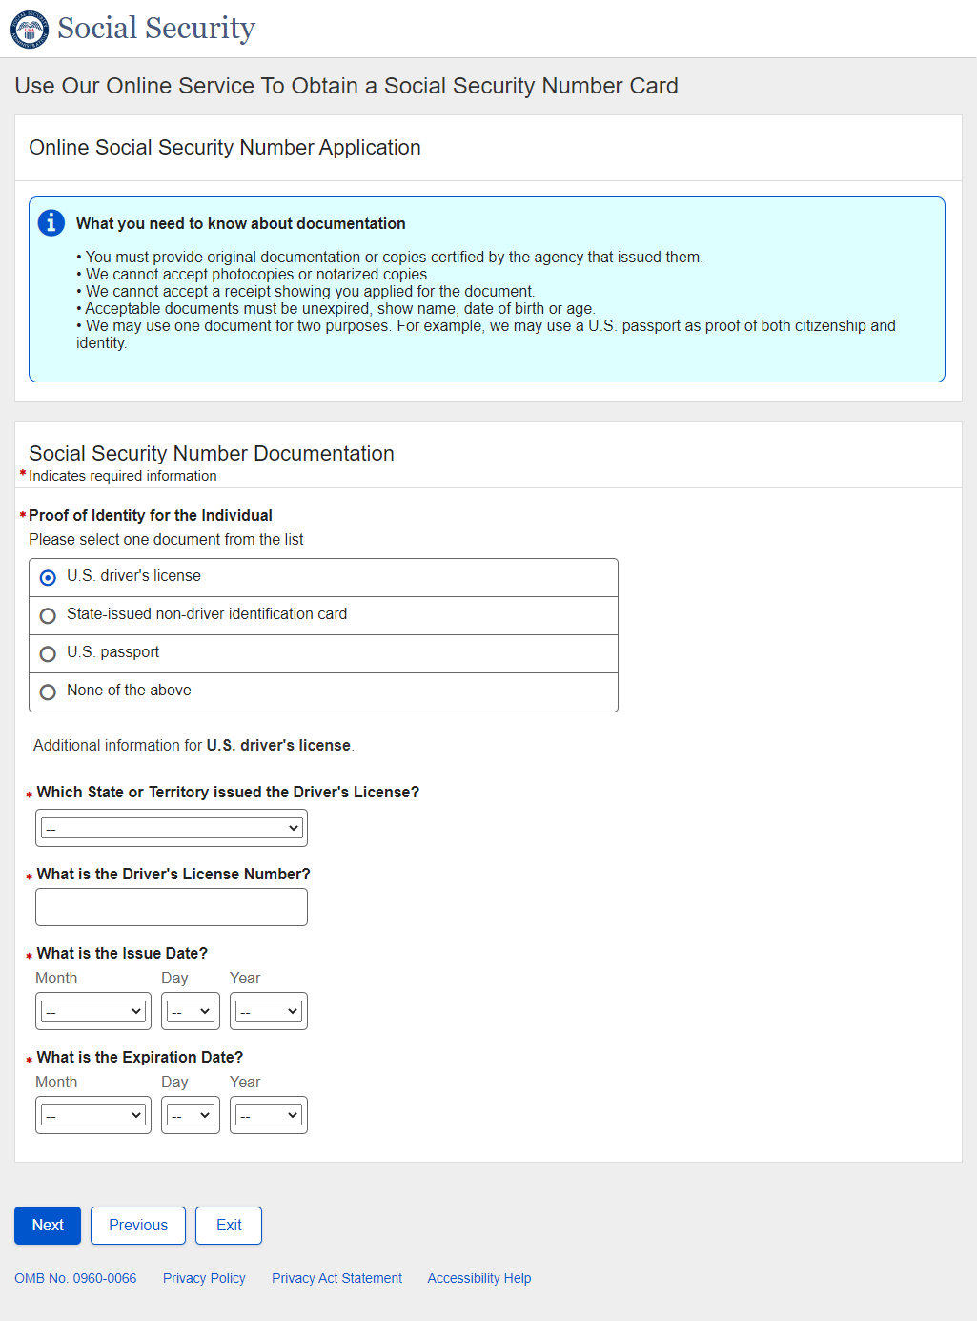
* Other Proof of Identity Options are identical to U.S. Original Self and will not be repeated here.
- U.S. Original Someone Else Adult - Review and Edit
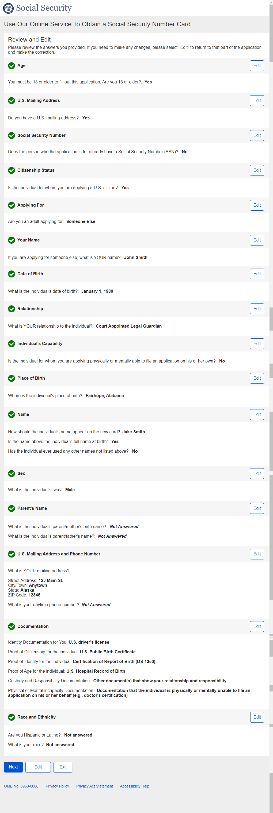

U.S. Original Someone Else Adult - Review and Edit – Continued

U.S. Original Someone Else Adult - Review and Edit - Continued
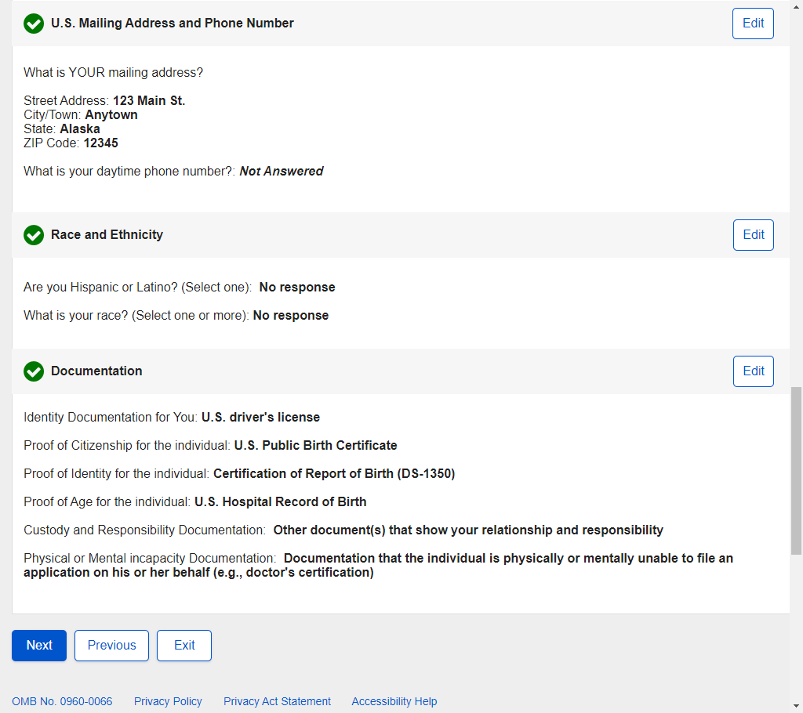

- U.S. Original Someone Else Adult - Attestation
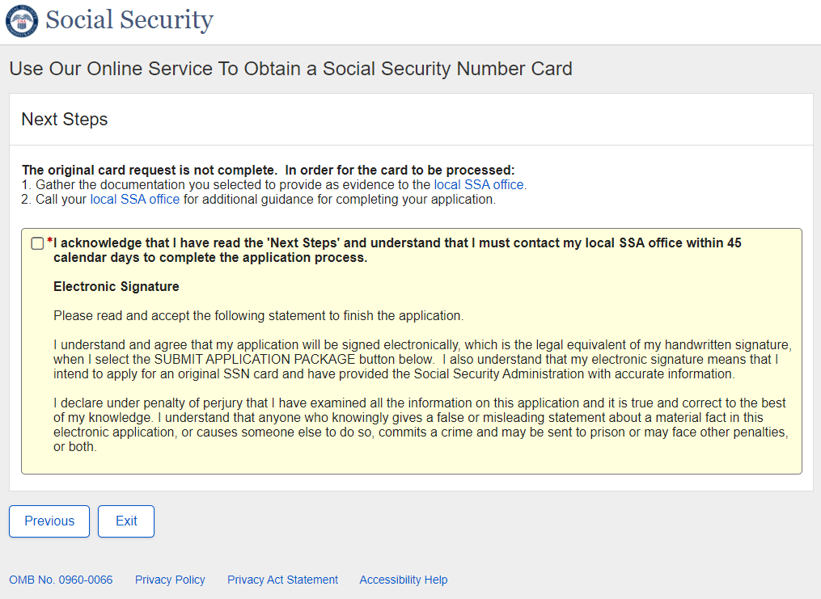

- U.S. Original Someone Else Adult - Success
Success – Non-ESS:
- U.S. Original Someone Else Child - Landing
- U.S. Original Someone Else Child - Age 18 or Older
- U.S. Original Someone Else Child - U.S. Mailing Address Available
- U.S. Original Someone Else Child - Have an SSN
- U.S. Original Someone Else Child - Citizenship
- U.S. Original Someone Else Child - Applying For
- U.S. Original Someone Else Child - Applying For Someone Else Name
- U.S. Original Someone Else Child – Individual’s Date of Birth
- U.S. Original Someone Else Child - Relationship Child
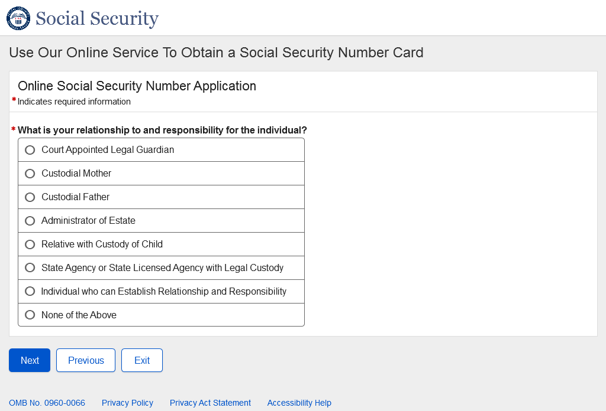
- U.S. Original Someone Else Child - Individual's Place of Birth
- U.S. Original Someone Else Child - Individual's Name
- U.S. Original Someone Else Child - Individual's Sex
- U.S. Original Someone Else Child - Individual's Parents Names
- U.S. Original Someone Else Child - U.S. Mailing Address
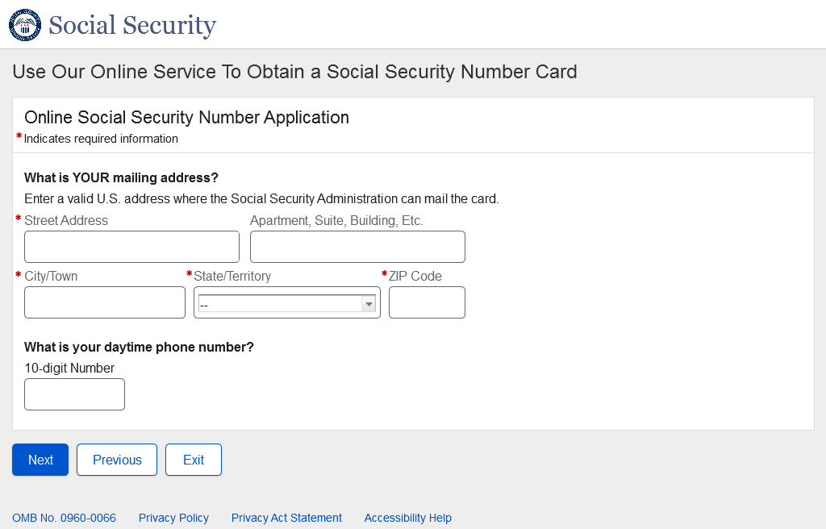
- U.S. Original Someone Else Child – Race and Ethnicity
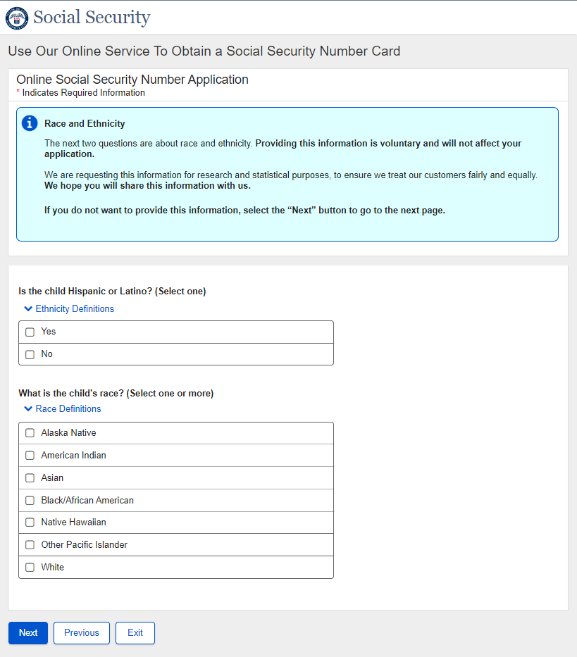
- U.S. Original Someone Else Child - Individual's Identity
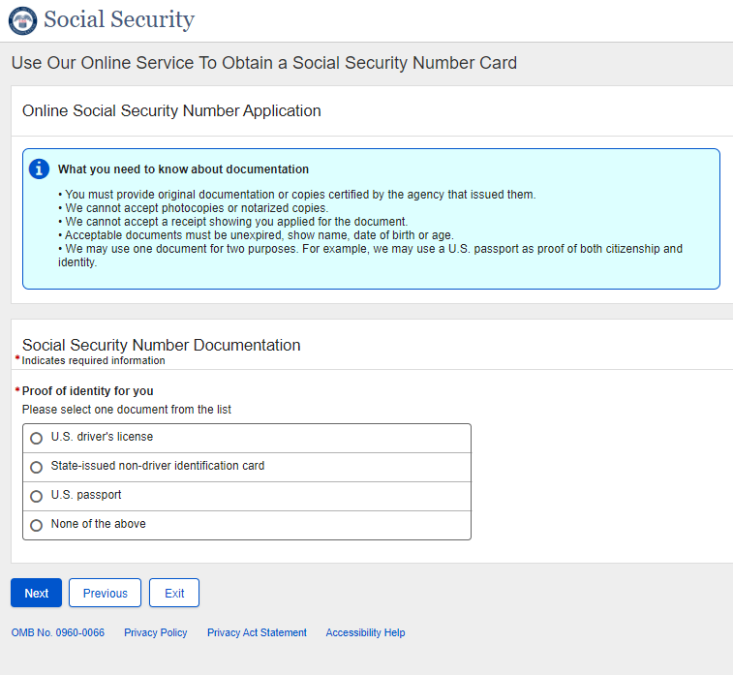
** Field Level data and other options are identical to U.S. Original Self and will not be repeated here.

- U.S. Original Someone Else Child – Proof of Age for Child
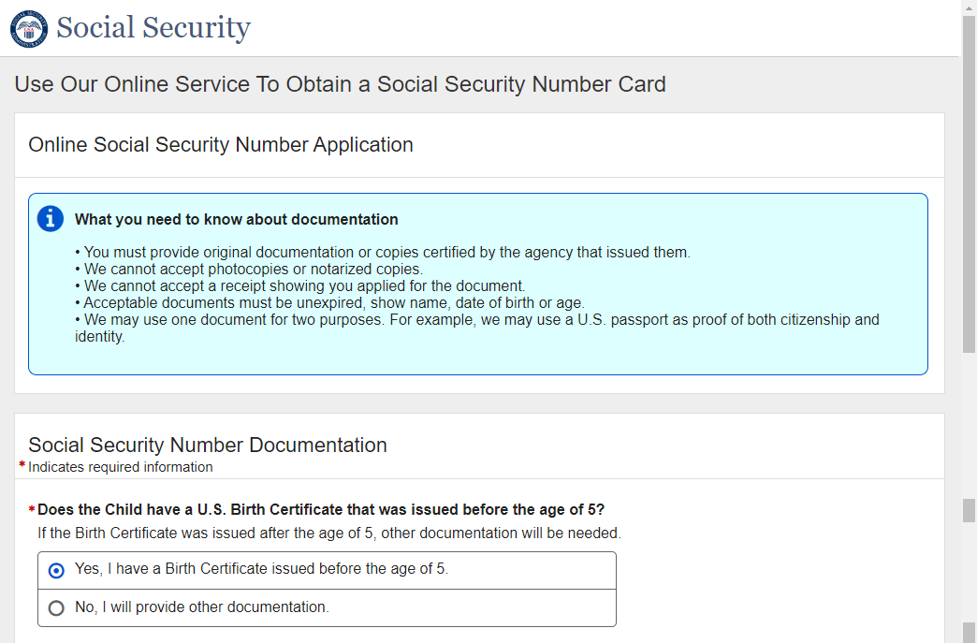
**Field level data and other options are identical to U.S. Original Self and will not be repeated here.
- U.S. Original Someone Else Child – Proof of Citizenship for Child
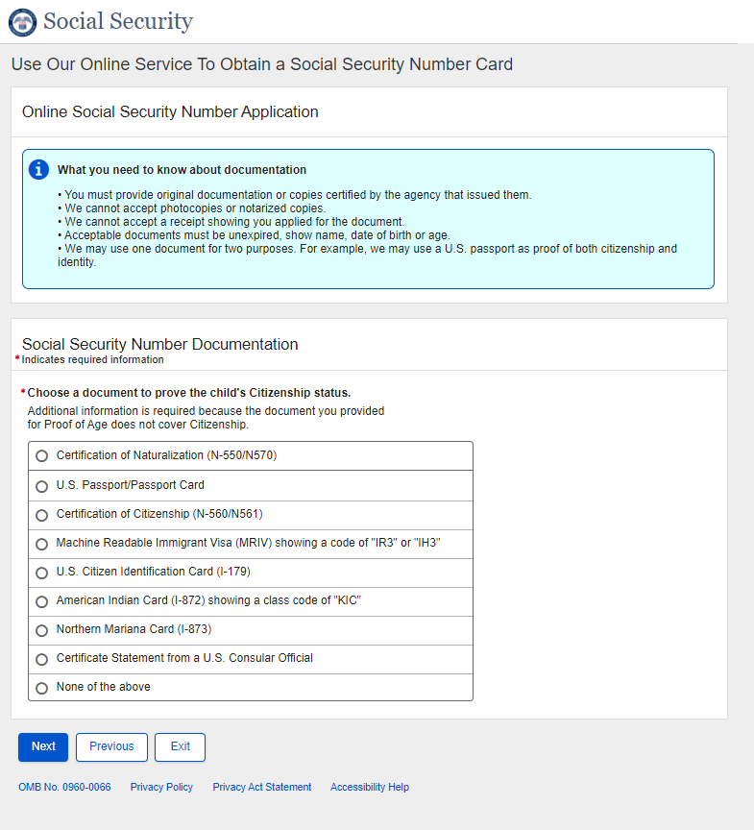
**Field level data and other options are identical to U.S. Original Self and will not be repeated here.
- U.S. Original Someone Else Child – Proof of Identity for Child
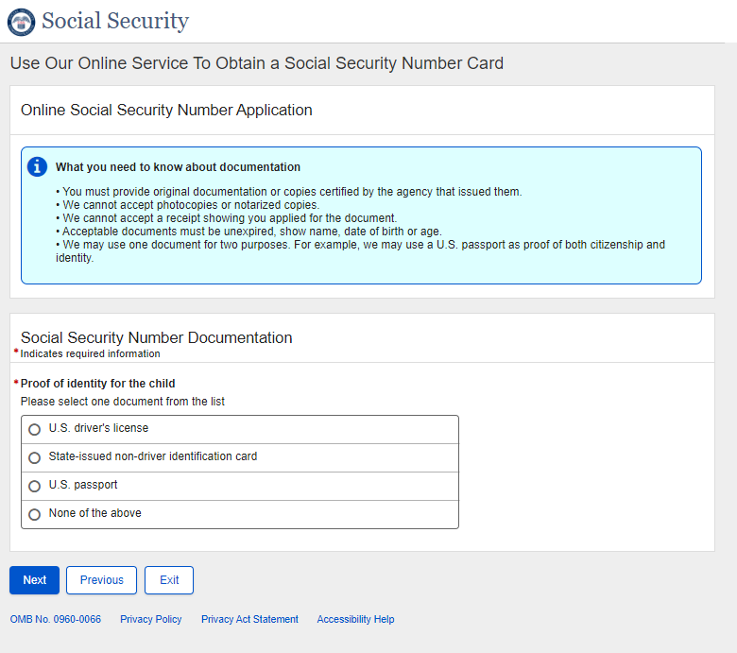
**Field level data and other options are identical to U.S. Original Self and will not be repeated here.

- U.S. Original Someone Else Child - Review and Edit
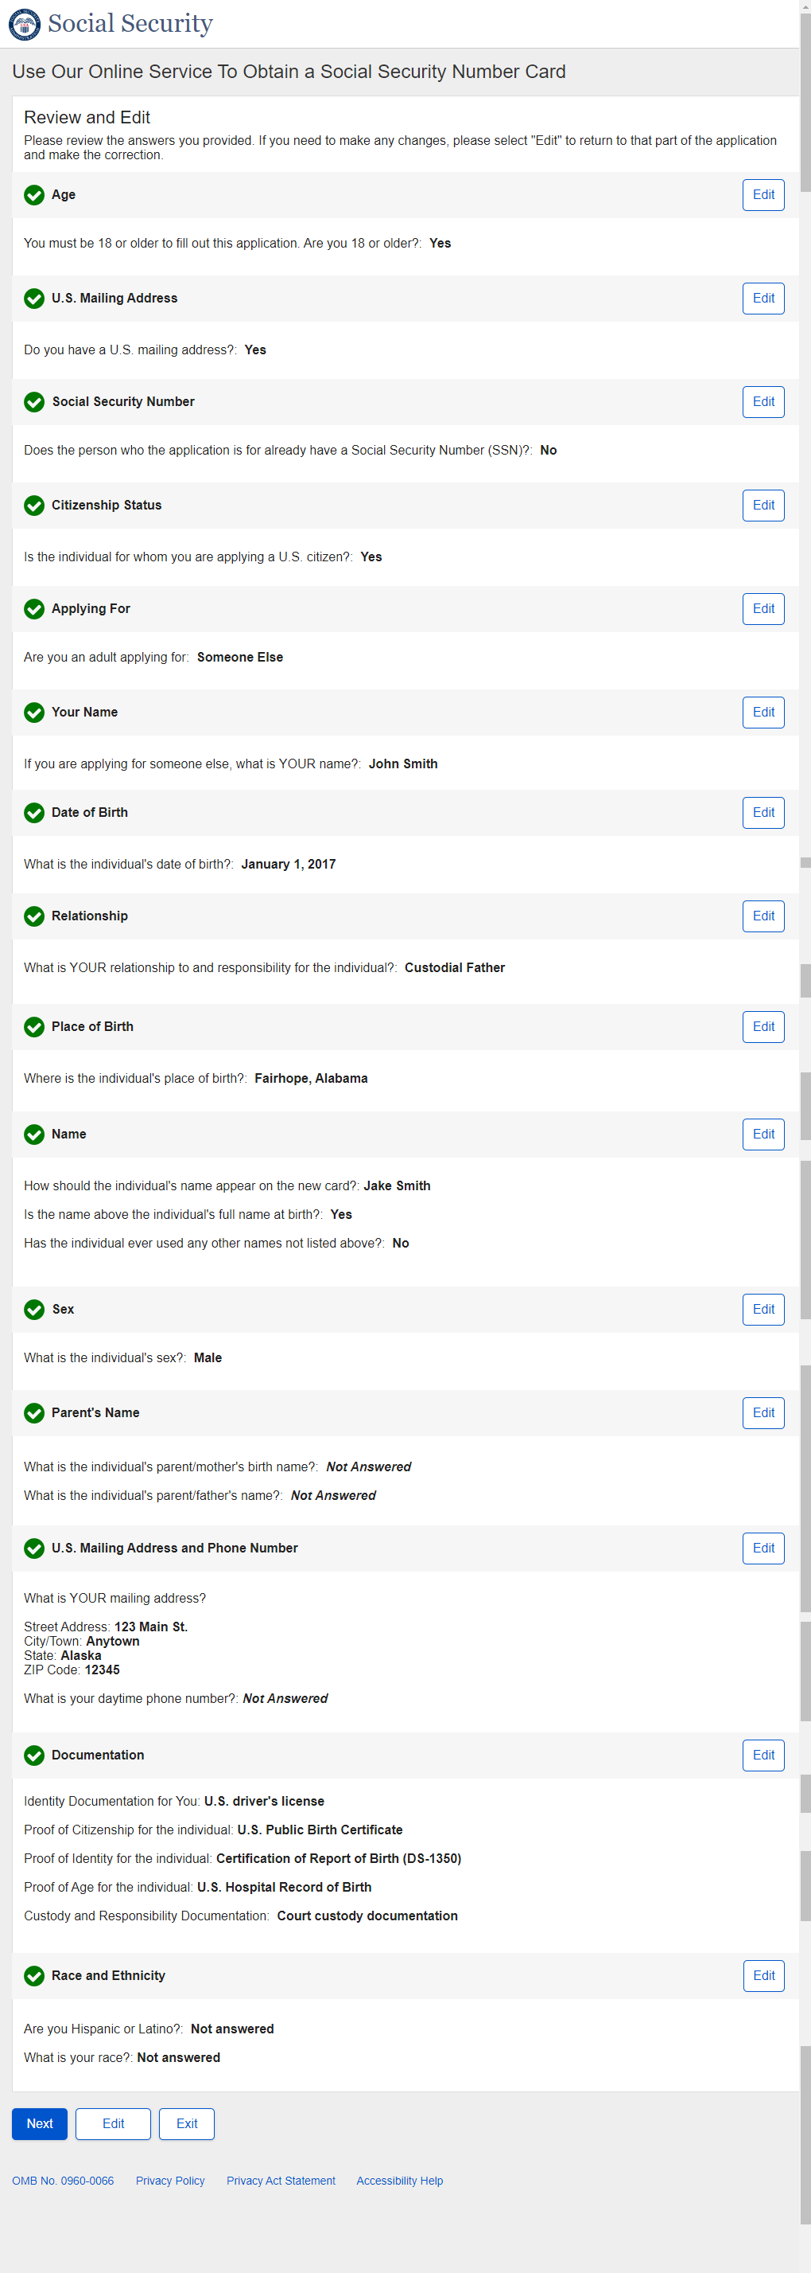

U.S. Original Someone Else Child - Review and Edit - Continued

U.S. Original Someone Else Child - Review and Edit - Continued
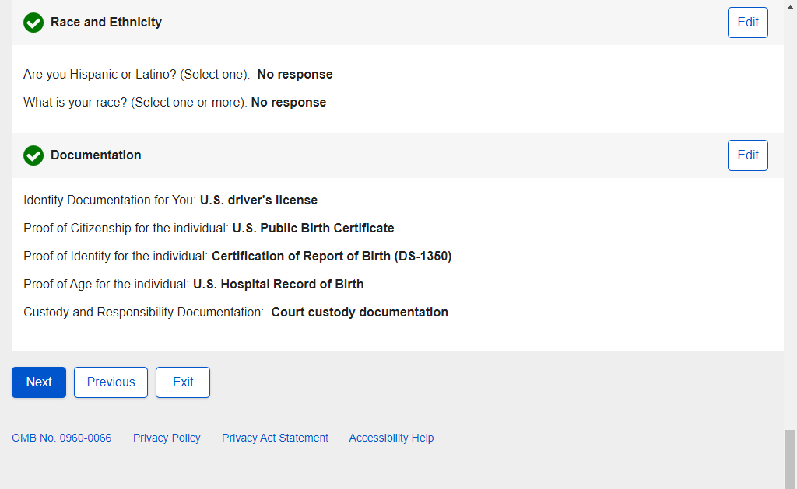

- U.S. Original Someone Else Child - Attestation

- U.S. Original Someone Else Child - Success
Success – Non-ESS:

- U.S. Replacement Self - Landing
- U.S. Replacement Self - Age 18 or Older
- U.S. Replacement Self - U.S. Mailing Address Available
- U.S. Replacement Self - Have an SSN
- U.S. Replacement Self - Citizenship
- U.S. Replacement Self - Applying For
- U.S. Replacement Self - Date of Birth
- U.S. Replacement Self - Name Change
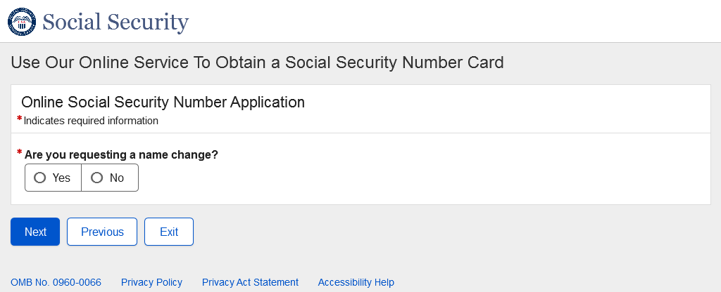
- U.S. Replacement Self - Place of Birth
- U.S. Replacement Self - SSN
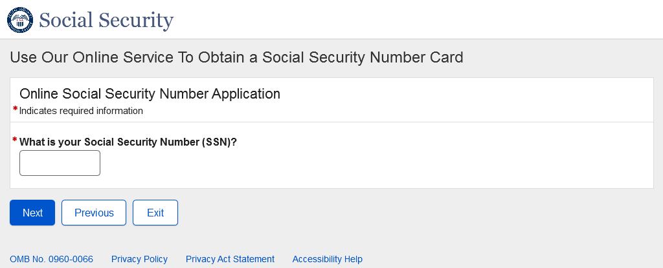
- U.S. Replacement Self - Name
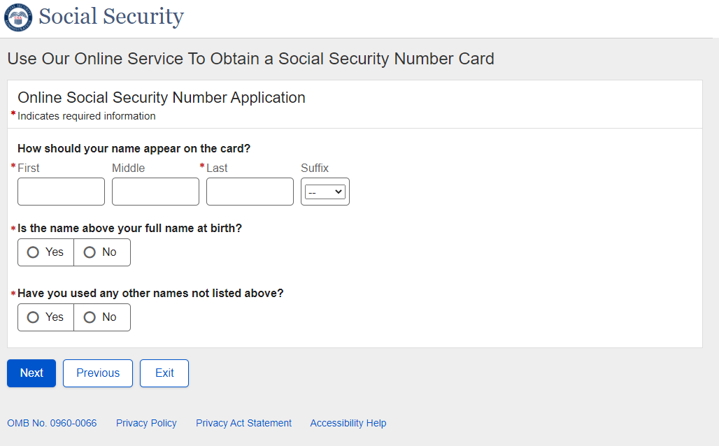

- U.S. Replacement Self - Parents Names
- U.S. Replacement Self - U.S. Mailing Address
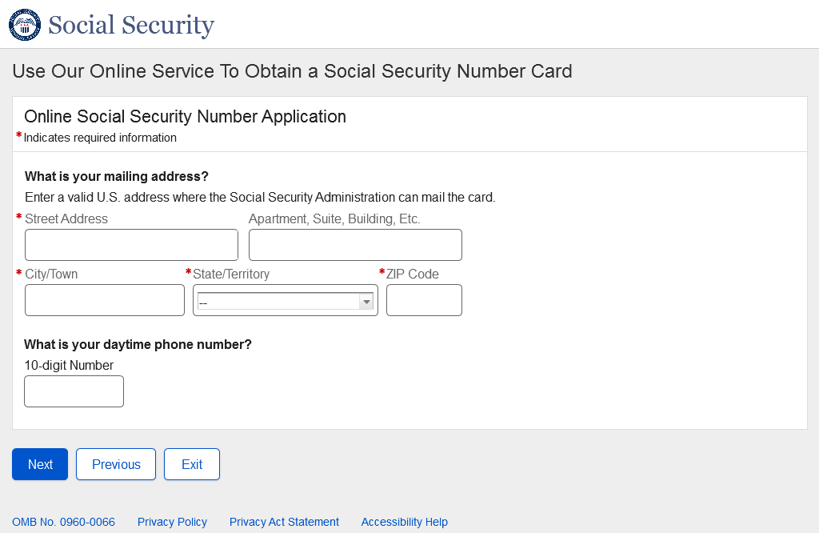
- U.S. Replacement Self - U.S. Documentation
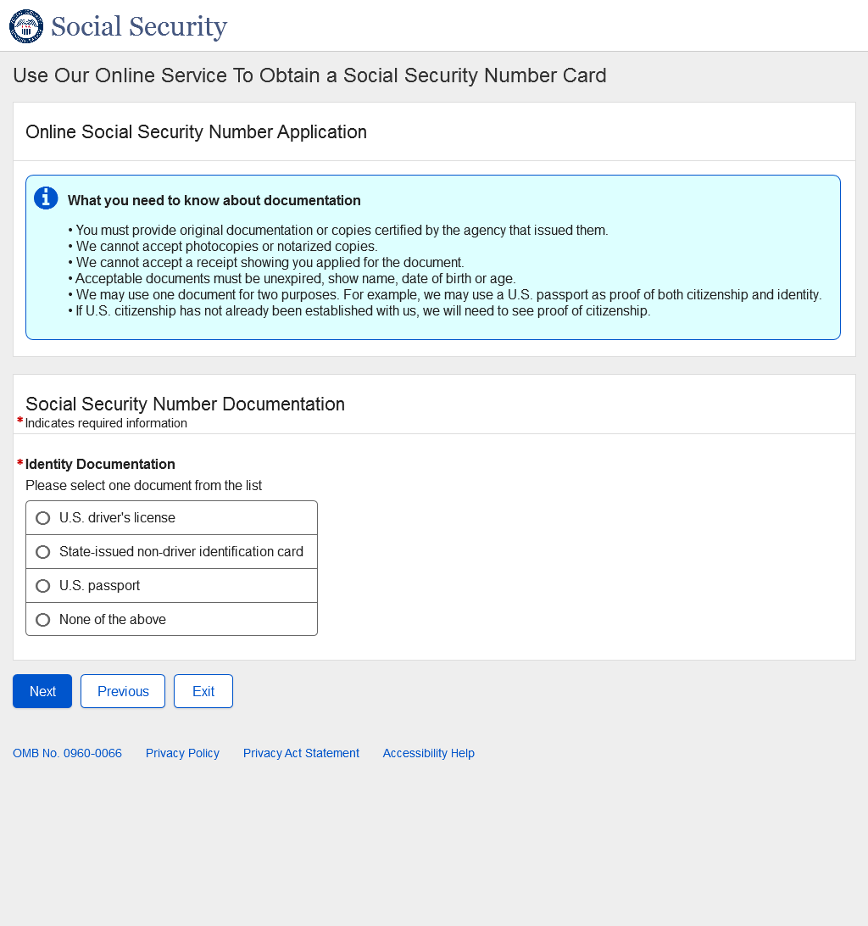

- U.S. Replacement Self - U.S. Documentation - Name Change
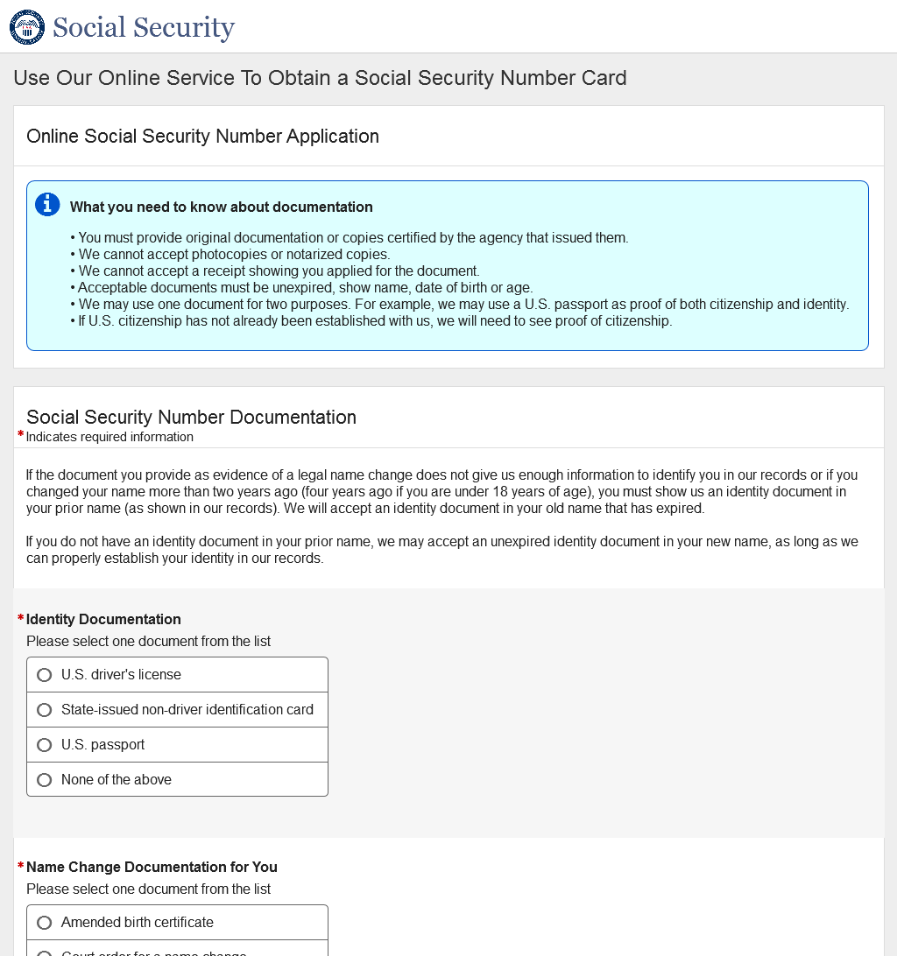
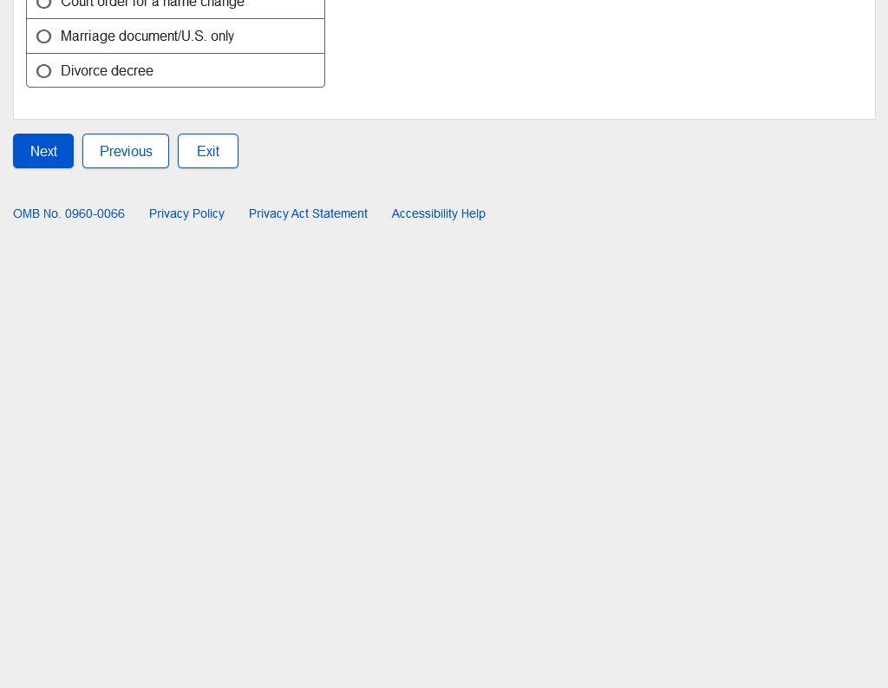

  - U.S. Replacement Self - U.S. Documentation - Name Change – Amended Birth Certificate
* In the Name Change Documentation for You field in the screenshot below, Amended Birth Certificate dynamic fields are the same in all paths and will not be shown in future paths.
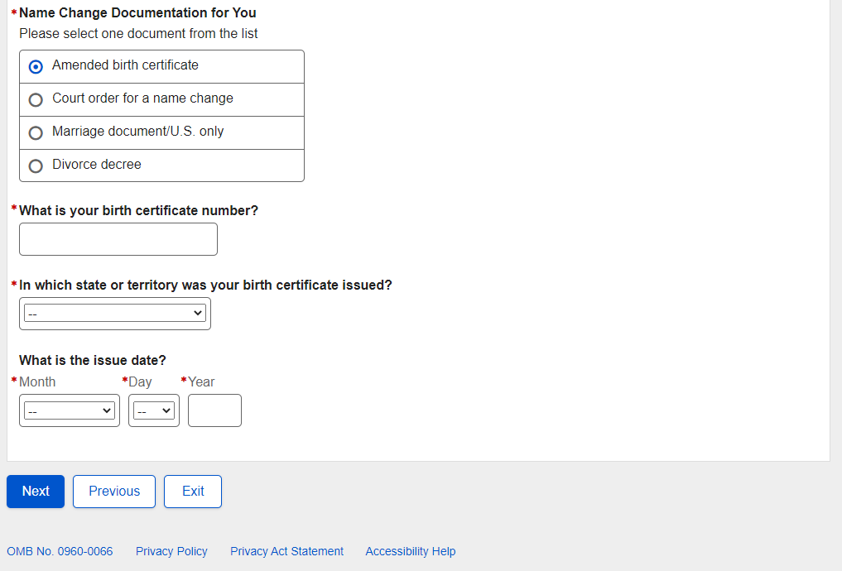
  - U.S. Replacement Self - U.S. Documentation - Name Change – Court Order for a Name Change
* In the Name Change Documentation for You field in the screenshot below, Court order for a name change dynamic fields are the same in all paths and will not be shown in future paths.
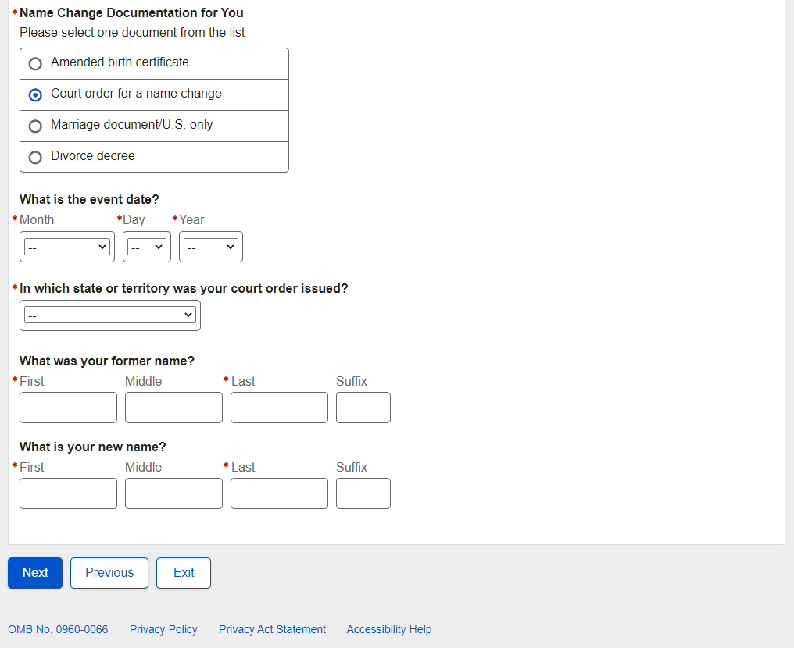
  - U.S. Replacement Self - U.S. Documentation - Name Change – Marriage Document/U.S. only
* In the Name Change Documentation for You field in the screenshot below, Marriage document/U.S. only dynamic fields are the same in all paths and will not be shown in future paths.
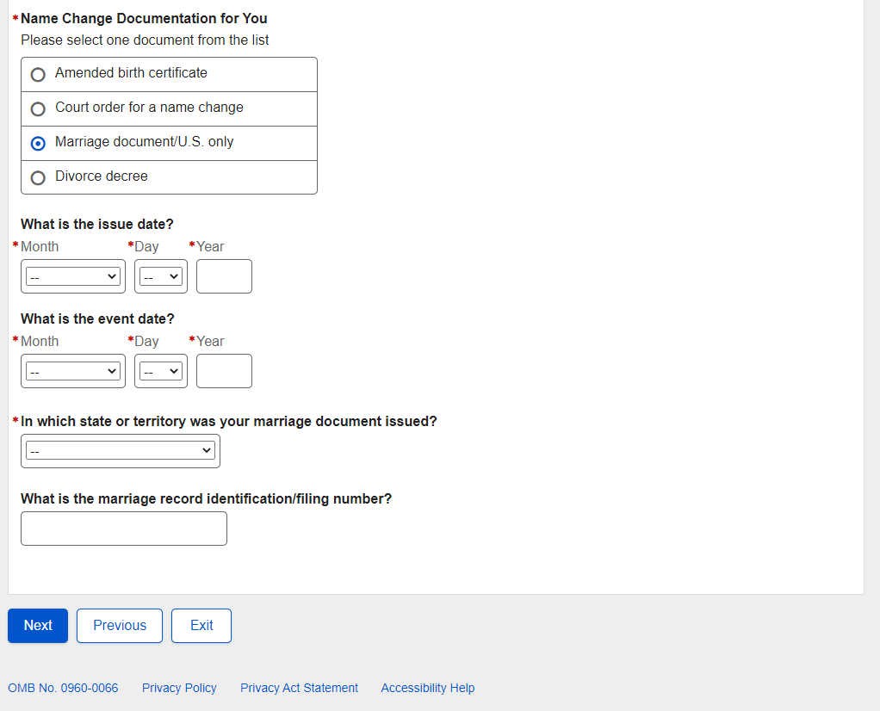
  - U.S. Replacement Self - U.S. Documentation - Name Change – Divorce decree
* In the Name Change Documentation for You field in the screenshot below, Divorce decree dynamic fields are the same in all paths and will not be shown in future paths.
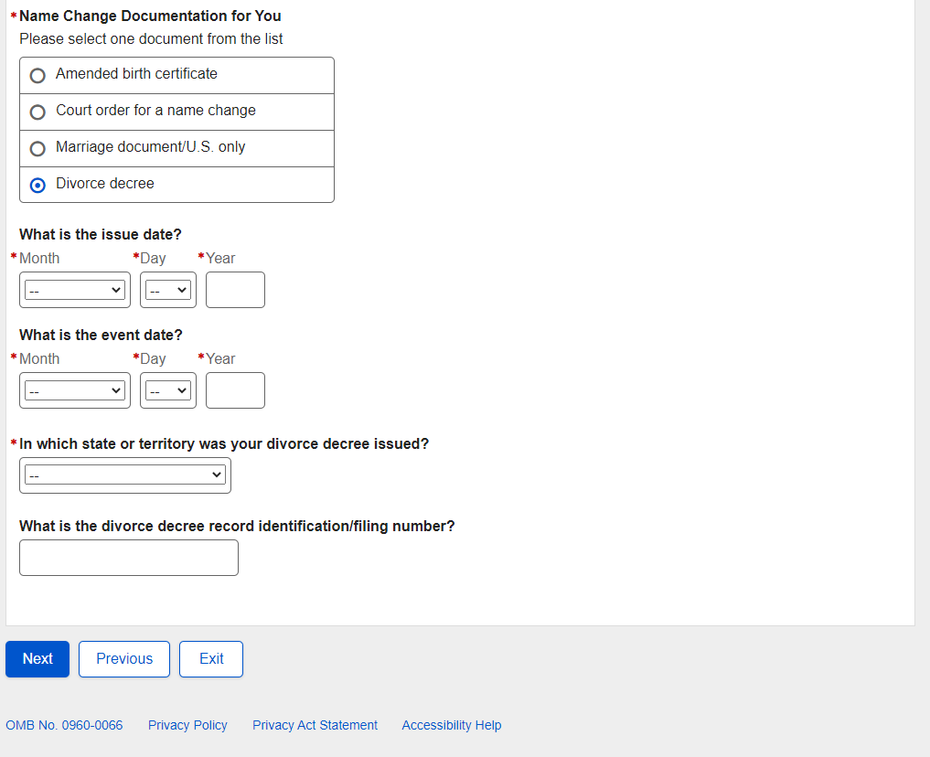

- U.S. Replacement Self - Review and Edit
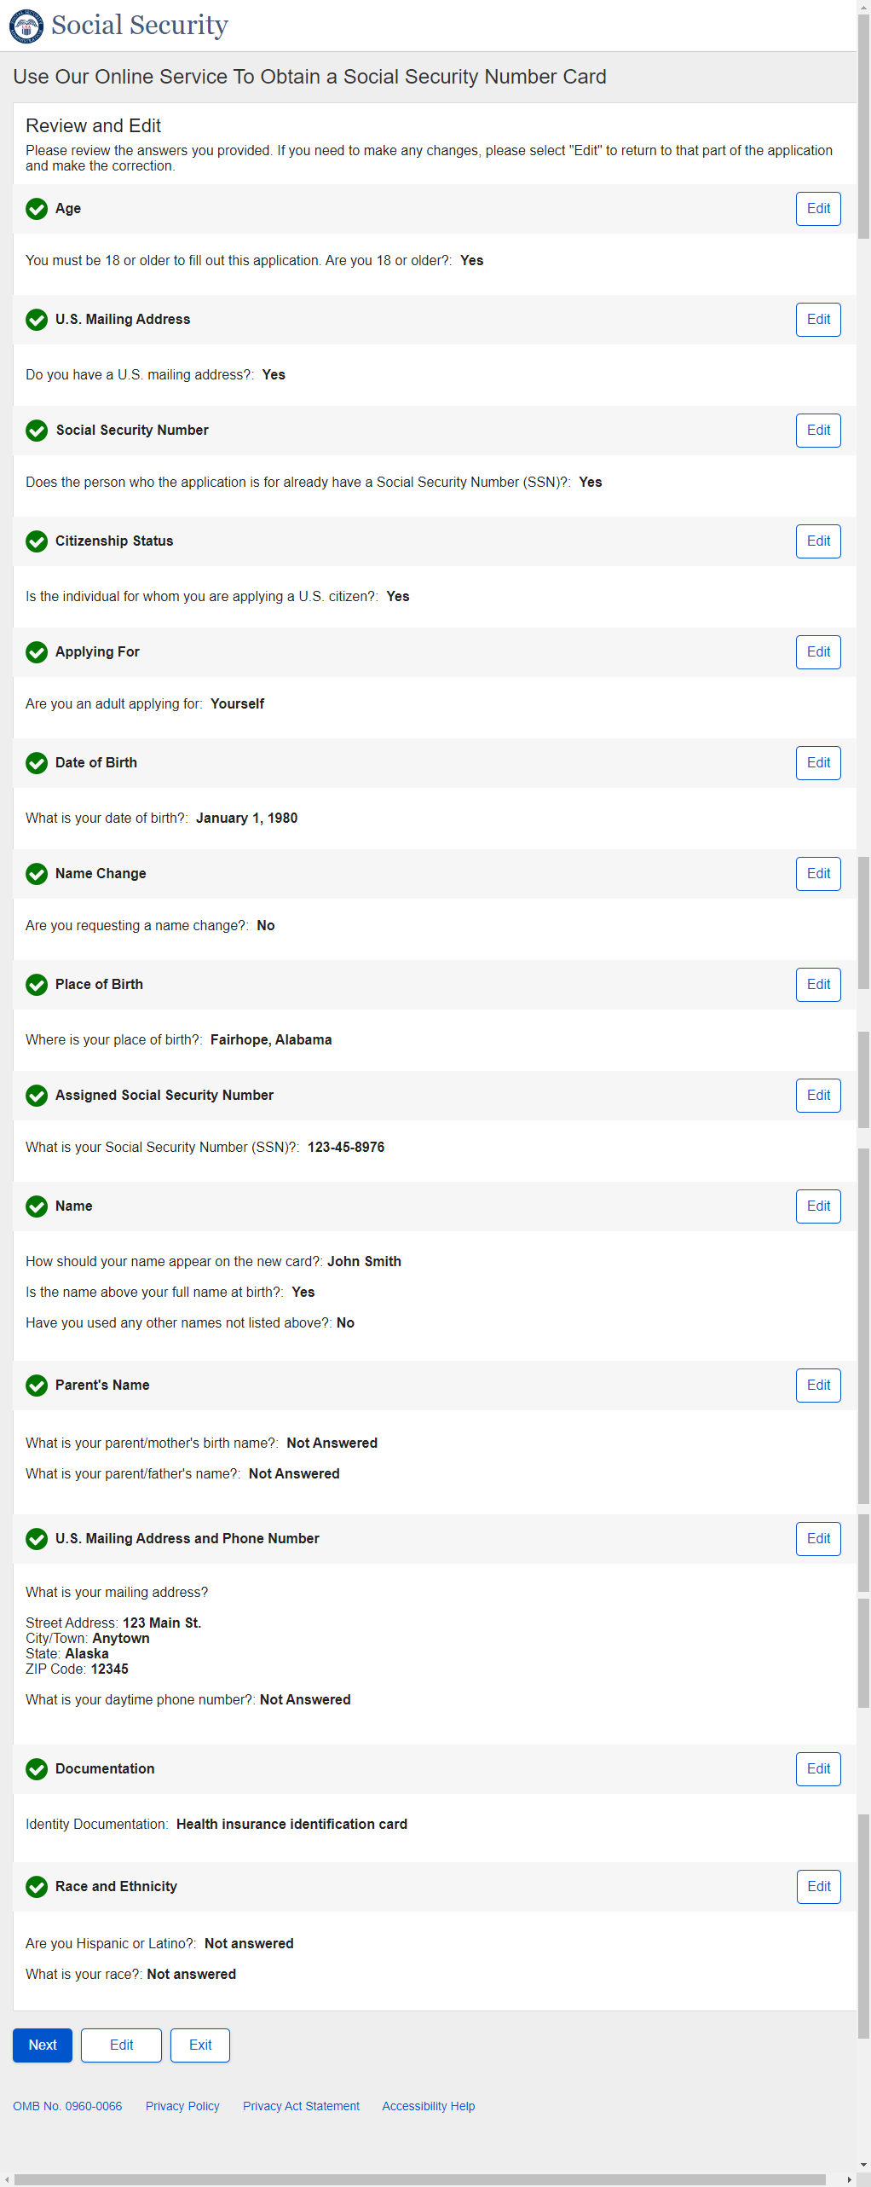

U.S. Replacement Self - Review and Edit - Continued

U.S. Replacement Self - Review and Edit - Continued
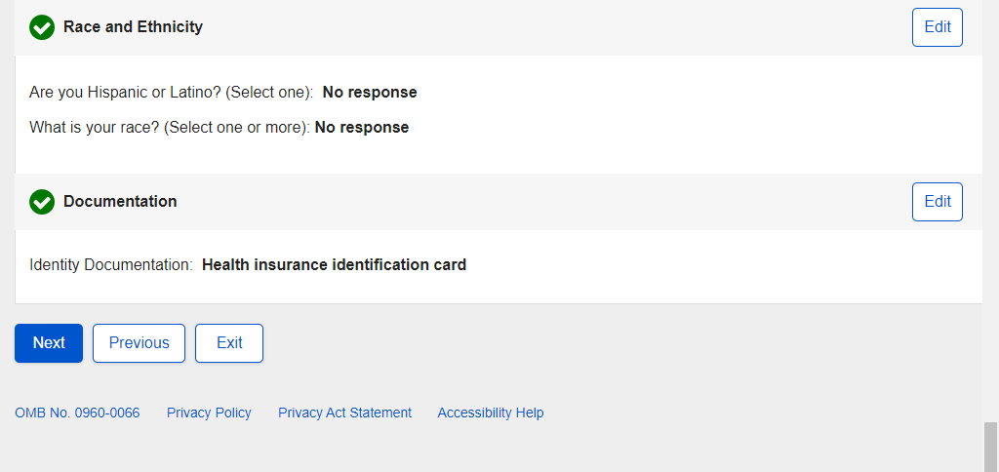
- U.S. Replacement Self - Attestation
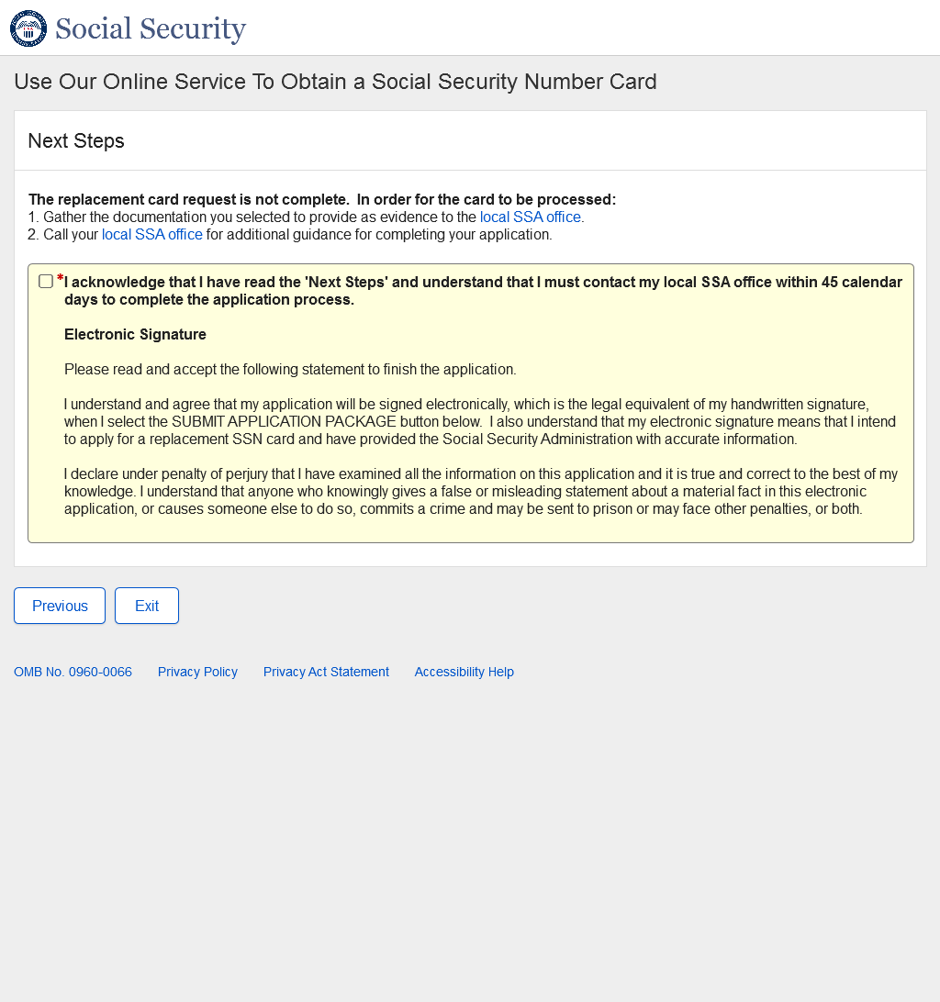

- U.S. Replacement Self - Success
Success – Non-ESS:

Success - Banned:

Success - ESS

- U.S. Replacement Someone Else Adult - Landing
- U.S. Replacement Someone Else Adult - Age 18 or Older
- U.S. Replacement Someone Else Adult - U.S. Mailing Address Available
- U.S. Replacement Someone Else Adult - Have an SSN
- U.S. Replacement Someone Else Adult - Citizenship
- U.S. Replacement Someone Else Adult - Applying For
- U.S. Replacement Someone Else Adult - Applying For Someone Else Name
- U.S. Replacement Someone Else Adult – Individual’s Date of Birth
- U.S. Replacement Someone Else Adult - Relationship Adult
- U.S. Replacement Someone Else Adult - Individual Capabilities
- U.S. Replacement Someone Else Adult - Name Change
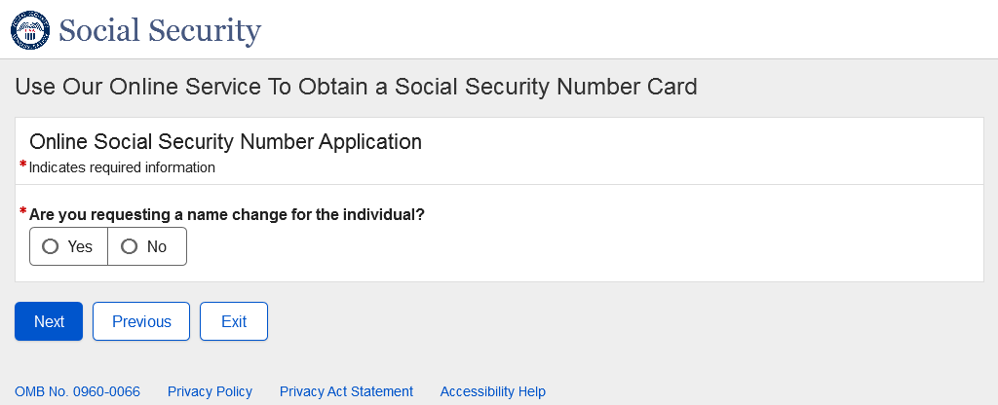
- U.S. Replacement Someone Else Adult - Individual's Place of Birth
- U.S. Replacement Someone Else Adult - Individual's SSN
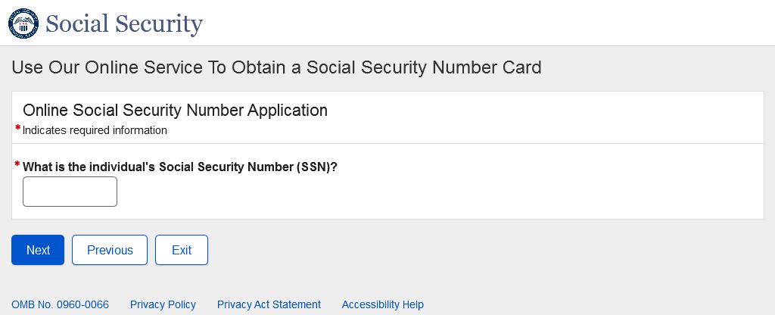
- U.S. Replacement Someone Else Adult - Individual's Name
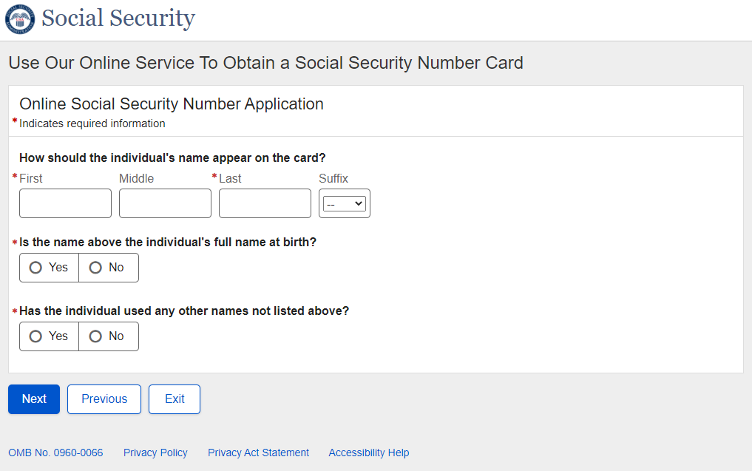

- U.S. Replacement Someone Else Adult - Individual's Parents Names
- U.S. Replacement Someone Else Adult - U.S. Mailing Address
- U.S. Replacement Someone Else Adult - Individual's U.S. Documentation
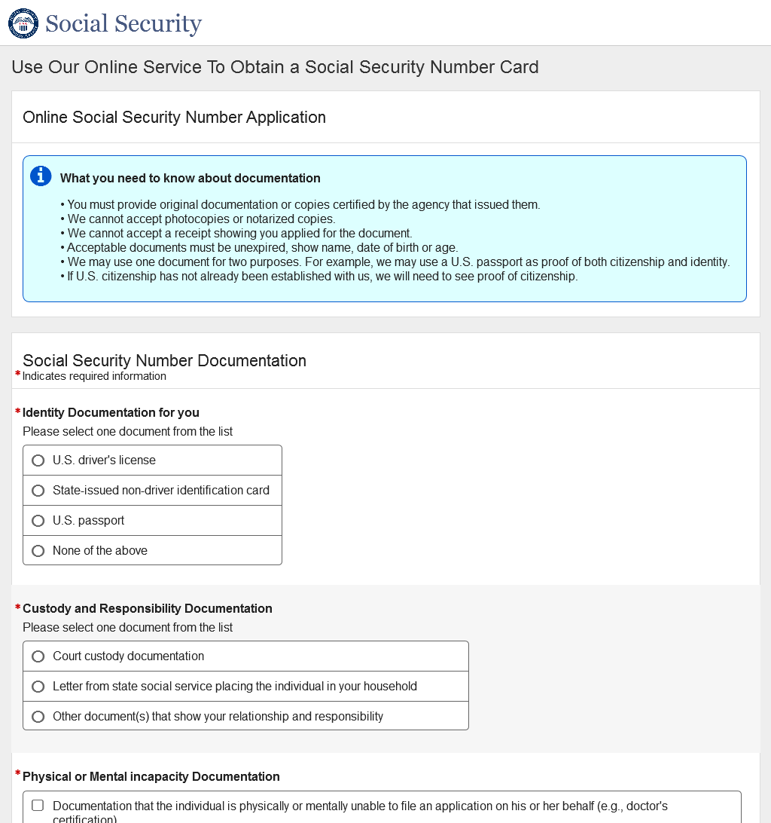
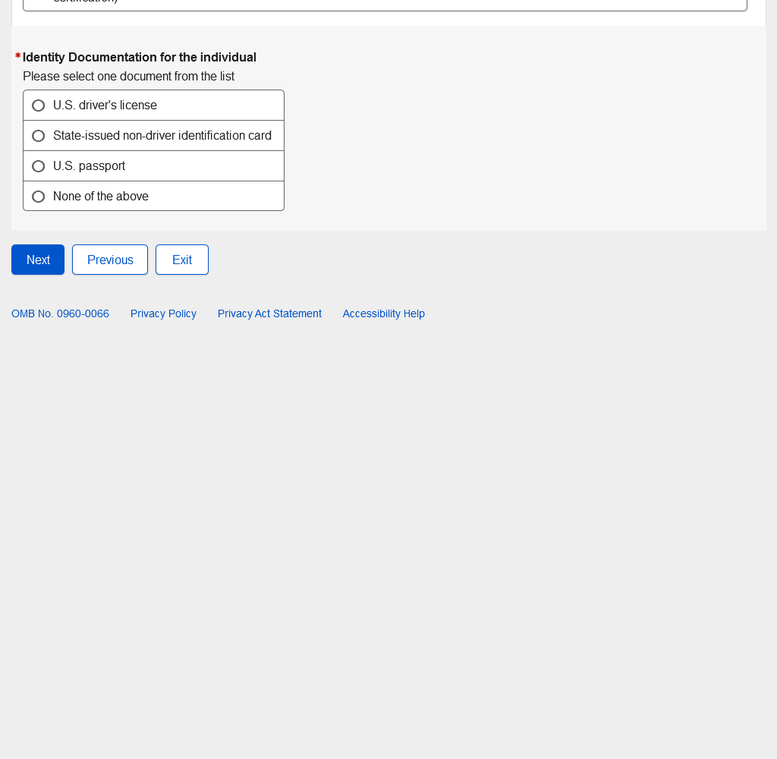
- U.S. Replacement Someone Else Adult - Individual's U.S. Documentation - Name Change
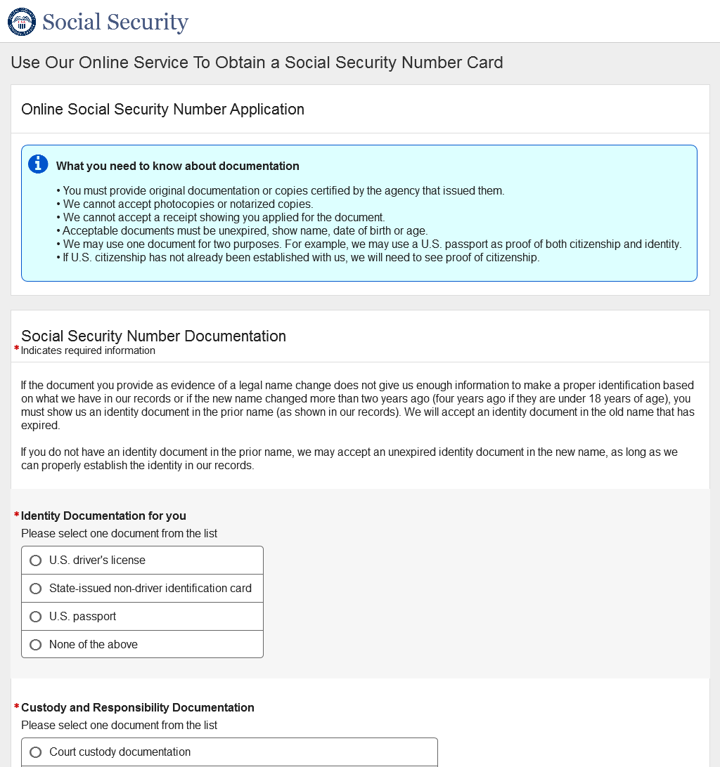
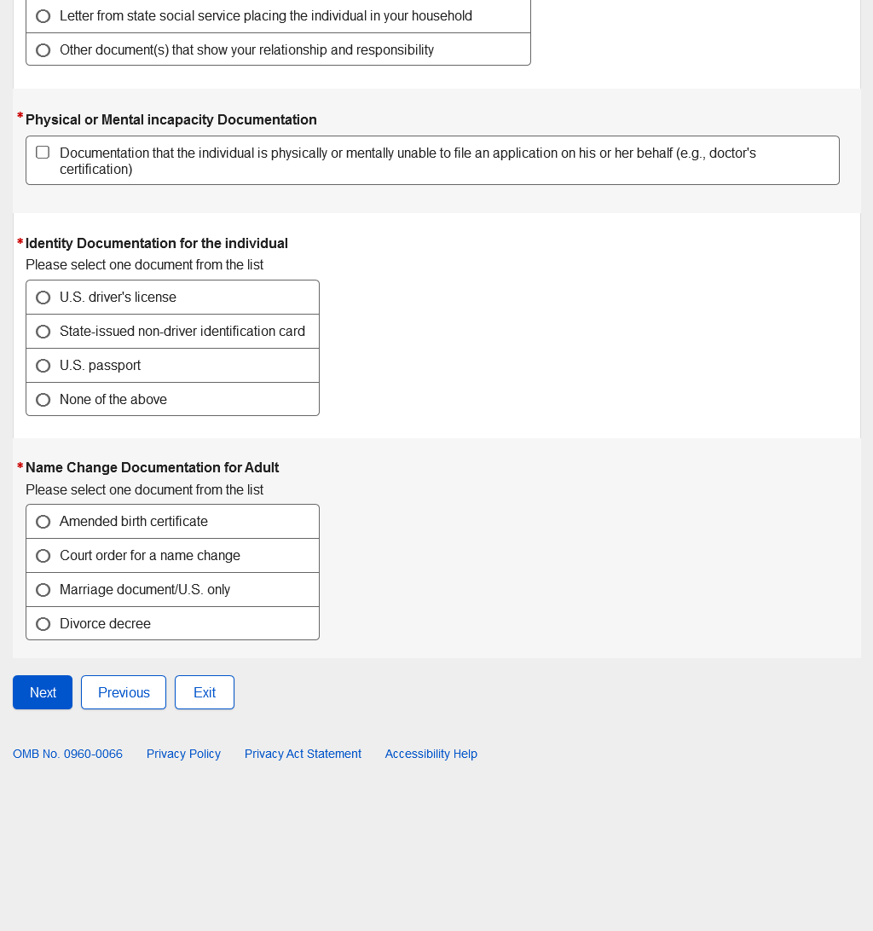

- U.S. Replacement Someone Else Adult - Review and Edit
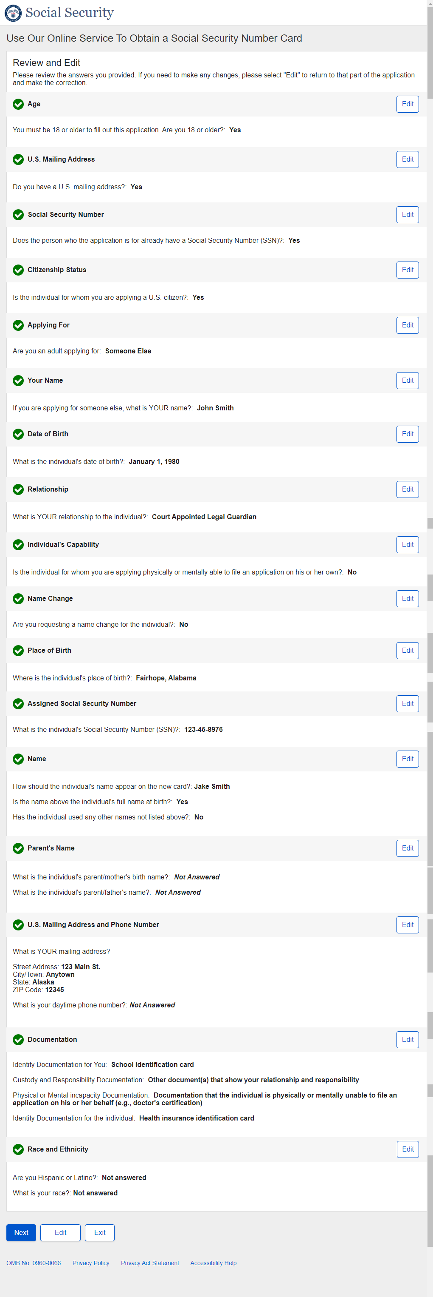

U.S. Replacement Someone Else Adult - Review and Edit - Continued

U.S. Replacement Someone Else Adult - Review and Edit - Continued
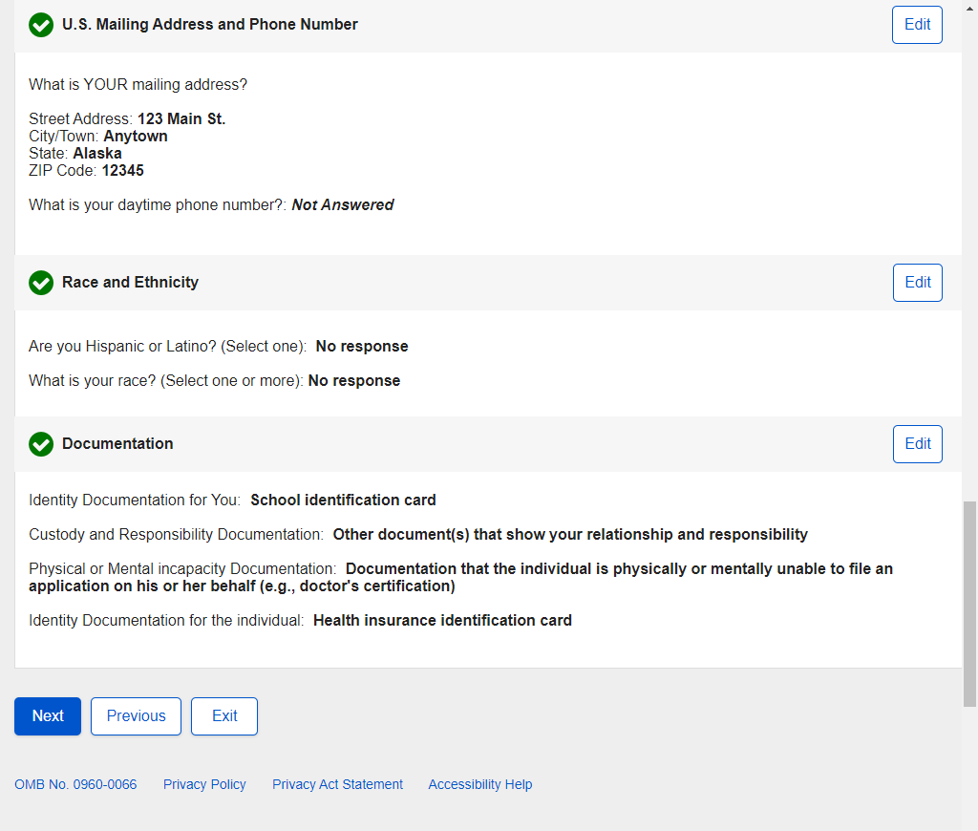

- U.S. Replacement Someone Else Adult - Attestation
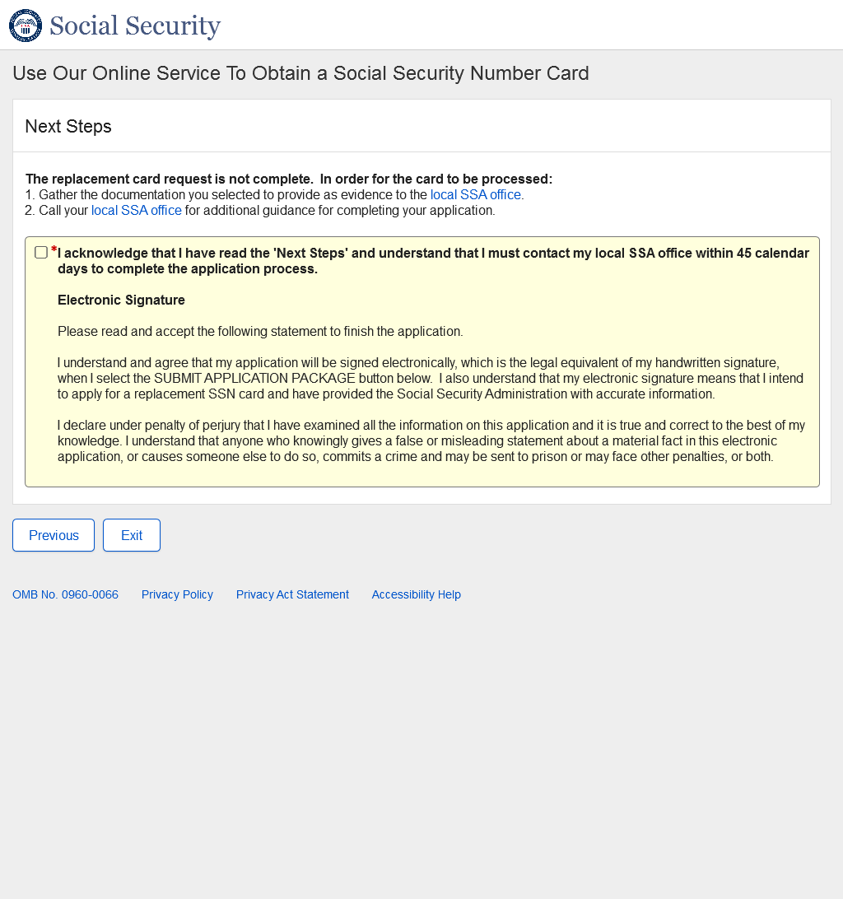

- U.S. Replacement Someone Else Adult - Success
Success - ESS

- U.S. Replacement Someone Else Child - Landing
- U.S. Replacement Someone Else Child - Age 18 or Older
- U.S. Replacement Someone Else Child - U.S. Mailing Address Available
- U.S. Replacement Someone Else Child - Have an SSN
- U.S. Replacement Someone Else Child - Citizenship
- U.S. Replacement Someone Else Child - Applying For
- U.S. Replacement Someone Else Child - Applying For Someone Else Name
- U.S. Replacement Someone Else Child – Individual’s Date of Birth
- U.S. Replacement Someone Else Child - Relationship Child
- U.S. Replacement Someone Else Child - Name Change
- U.S. Replacement Someone Else Child - Individual's Place of Birth
- U.S. Replacement Someone Else Child - Individual's SSN
- U.S. Replacement Someone Else Child - Individual's Name
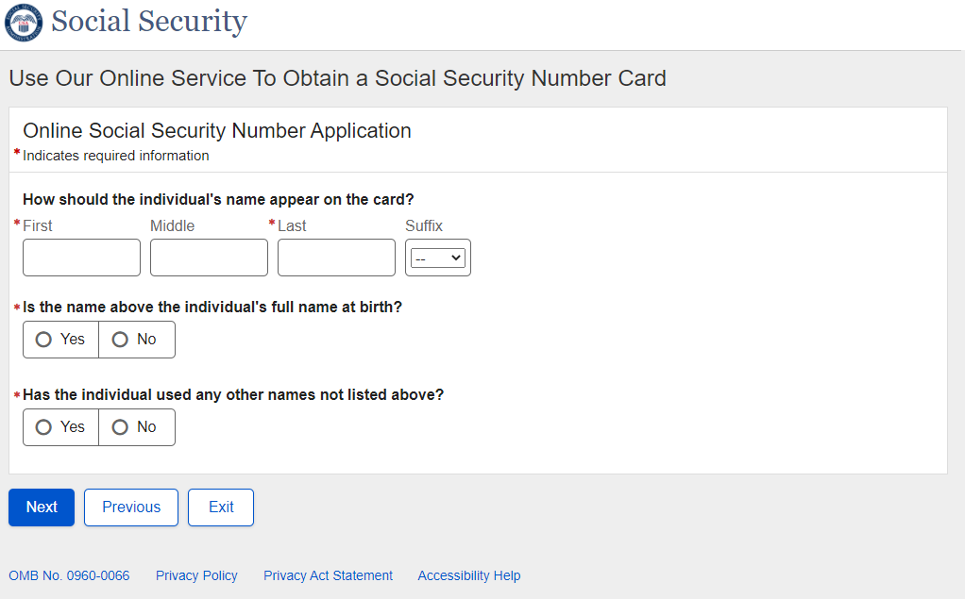

- U.S. Replacement Someone Else Child - Individual's Parents Names
- U.S. Replacement Someone Else Child - U.S. Mailing Address
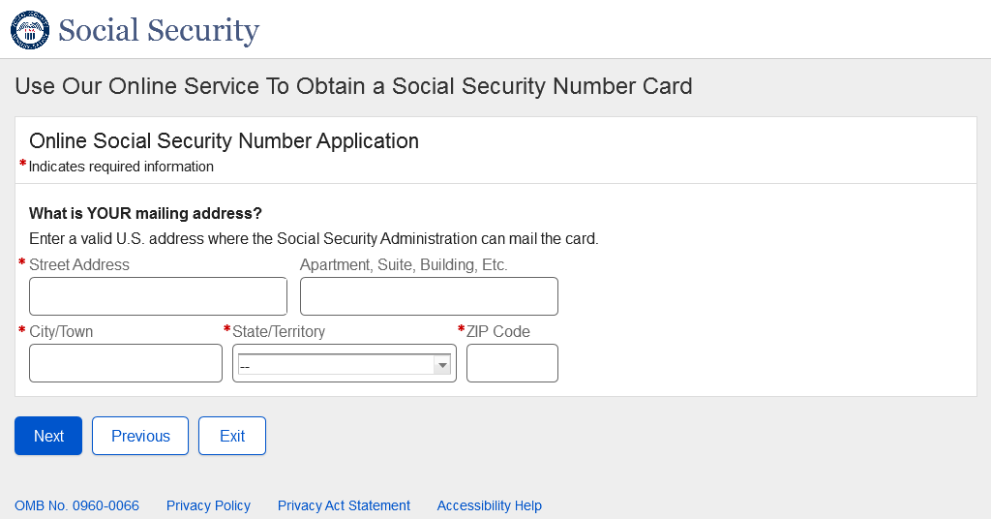
- U.S. Replacement Someone Else Child - Individual's U.S. Documentation
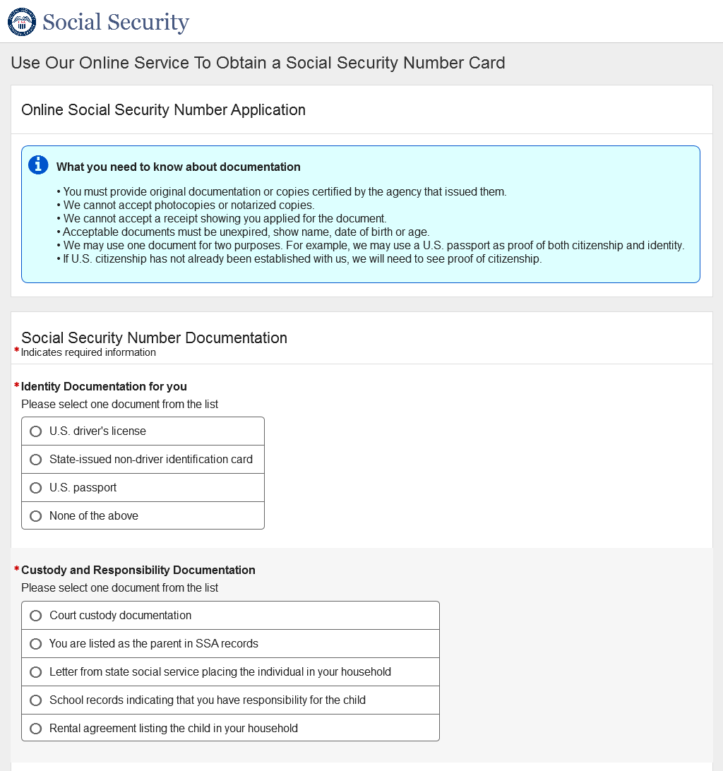
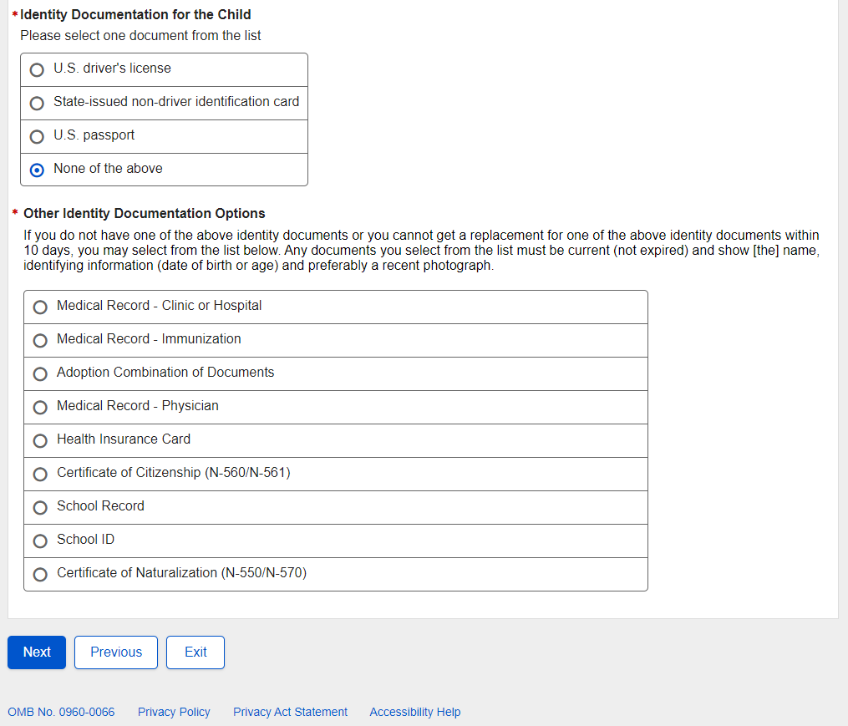

- U.S. Replacement Someone Else Child - Individual's U.S. Documentation - Name Change
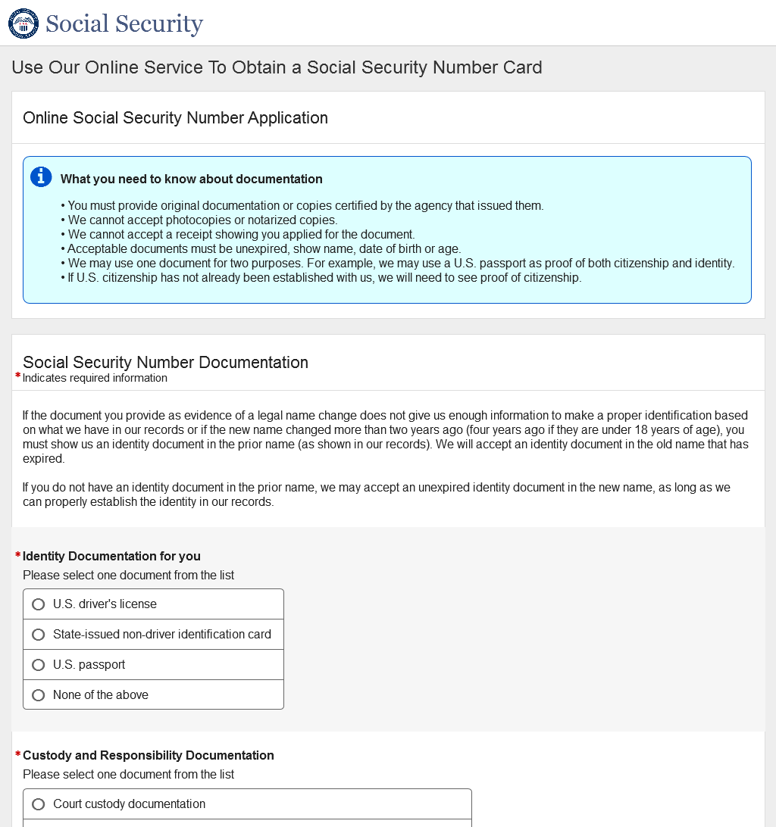
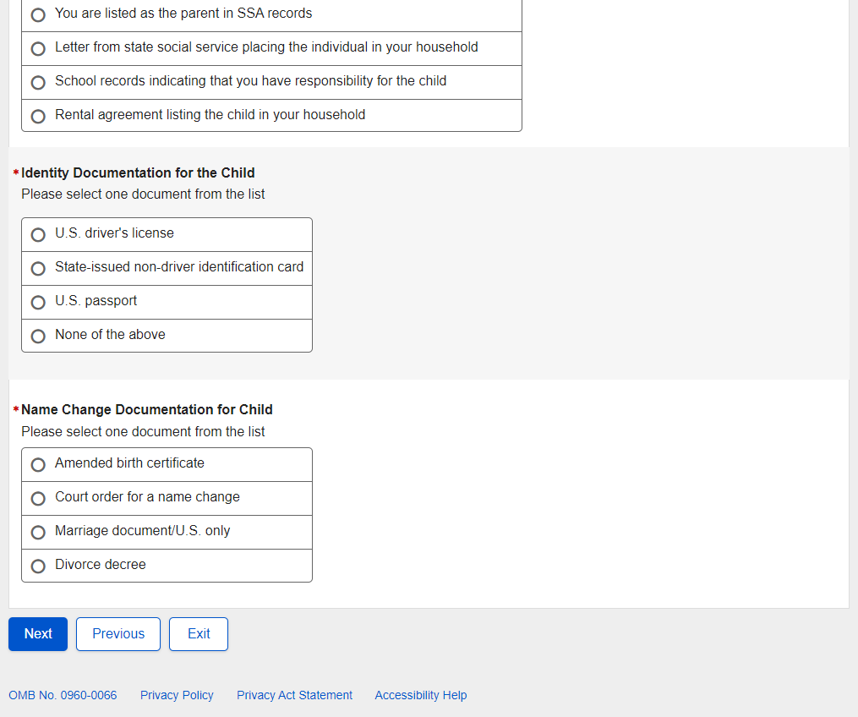

- U.S. Replacement Someone Else Child - Review and Edit
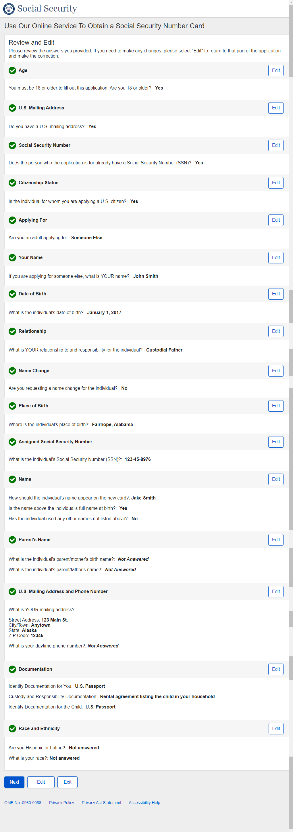
U.S. Replacement Someone Else Child - Review and Edit – Continued

U.S. Replacement Someone Else Child - Review and Edit – Continued
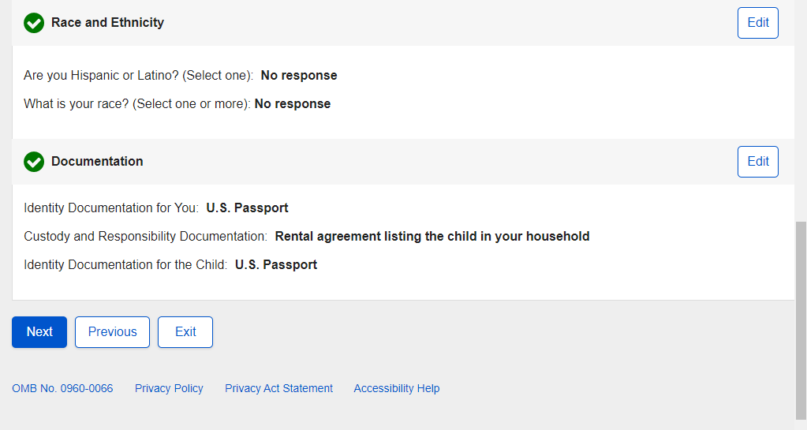

- U.S. Replacement Someone Else Child - Attestation
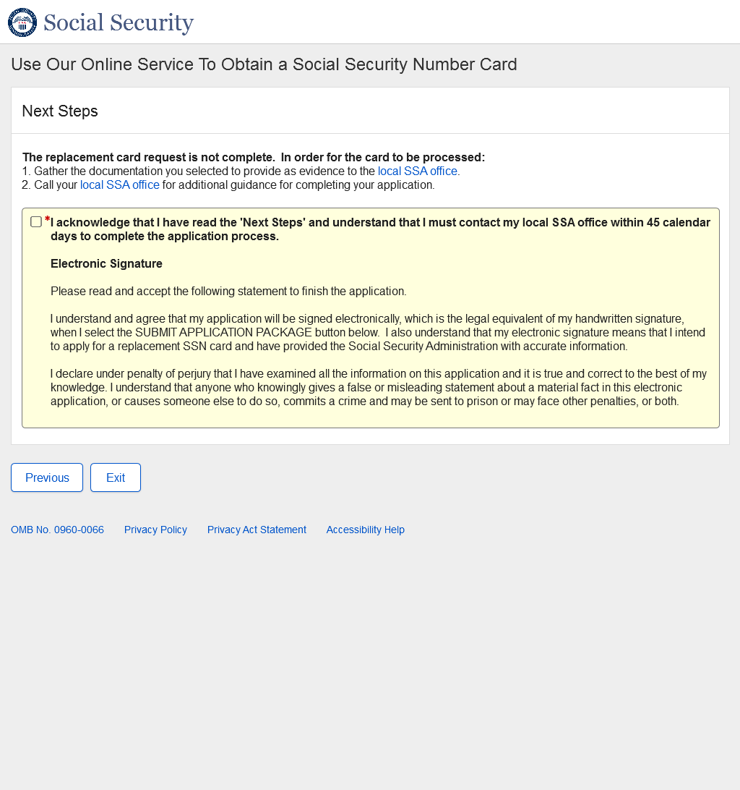

- U.S. Replacement Someone Else Child - Success
Success - ESS

- Non-U.S. Original Self - Landing
- Non-U.S. Original Self - Age 18 or Older
- Non-U.S. Original Self - U.S. Mailing Address Available
- Non-U.S. Original Self - Have an SSN
- Non-U.S. Original Self - Citizenship
- Non-U.S. Original Self - Applying For
- Non-U.S. Original Self - Date of Birth
- Non-U.S. Original Self - Place of Birth
- Non-U.S. Original Self - Name
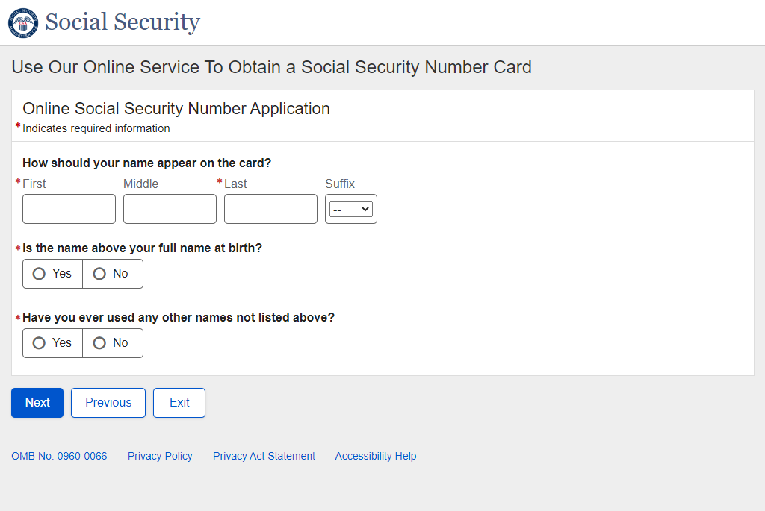
- Non-U.S. Original Self - Sex
- Non-U.S. Original Self - Parents Names
- Non-U.S. Original Self - U.S. Mailing Address
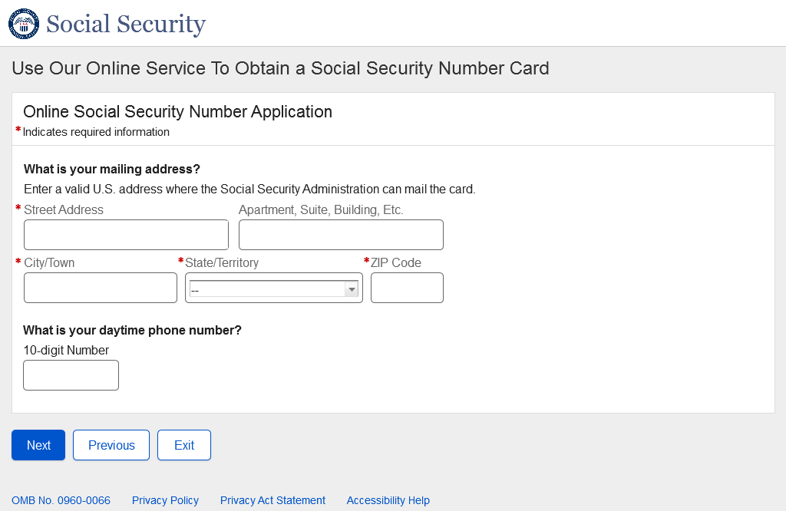
- Non-U.S. Original Self - Documentation
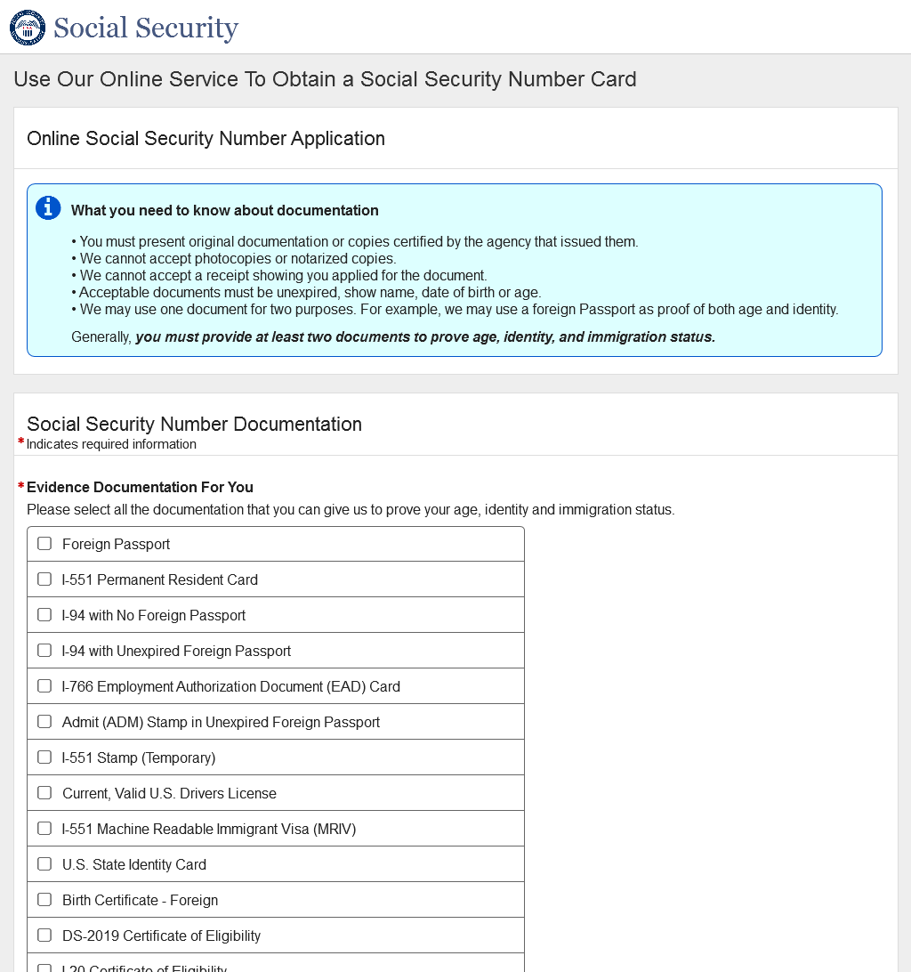
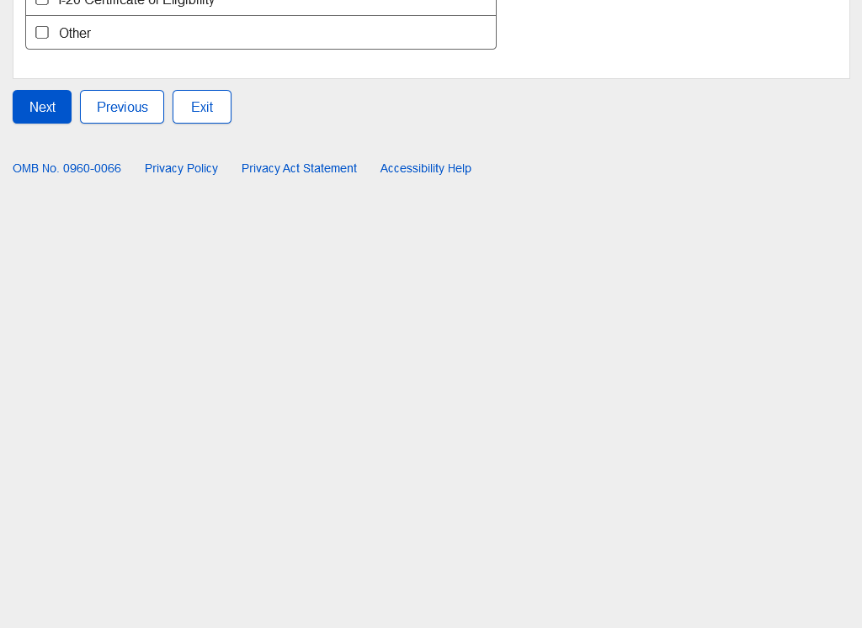
- Non-U.S. Original Self - Review and Edit
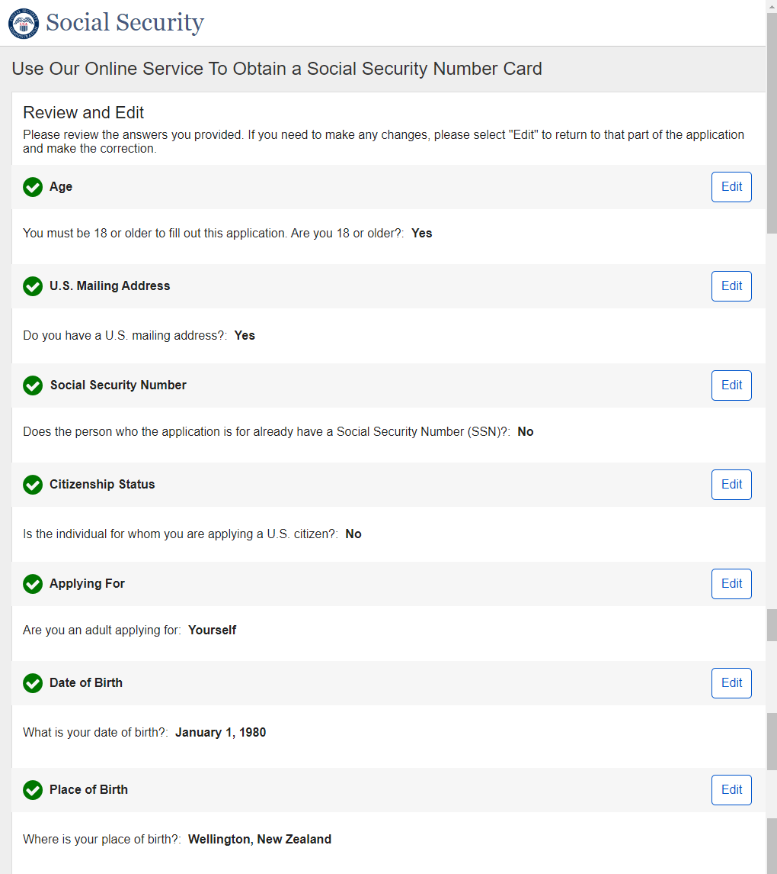

Non-U.S. Original Self - Review and Edit - Continued
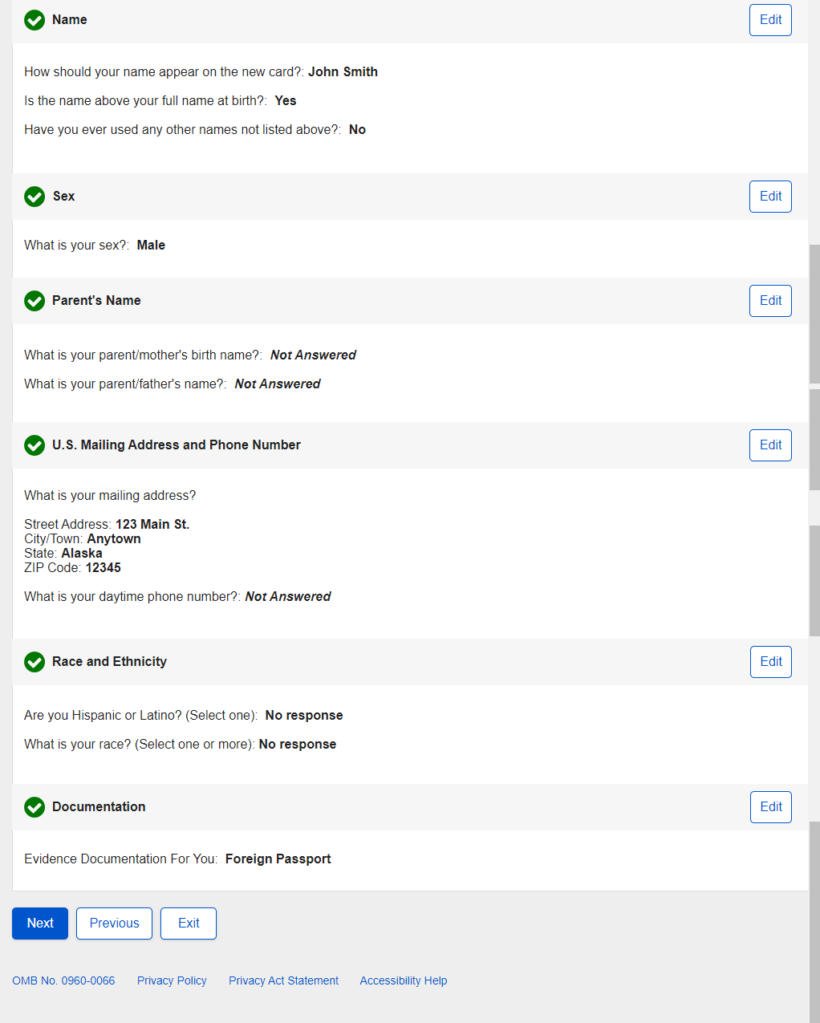
- Non-U.S. Original Self - Attestation
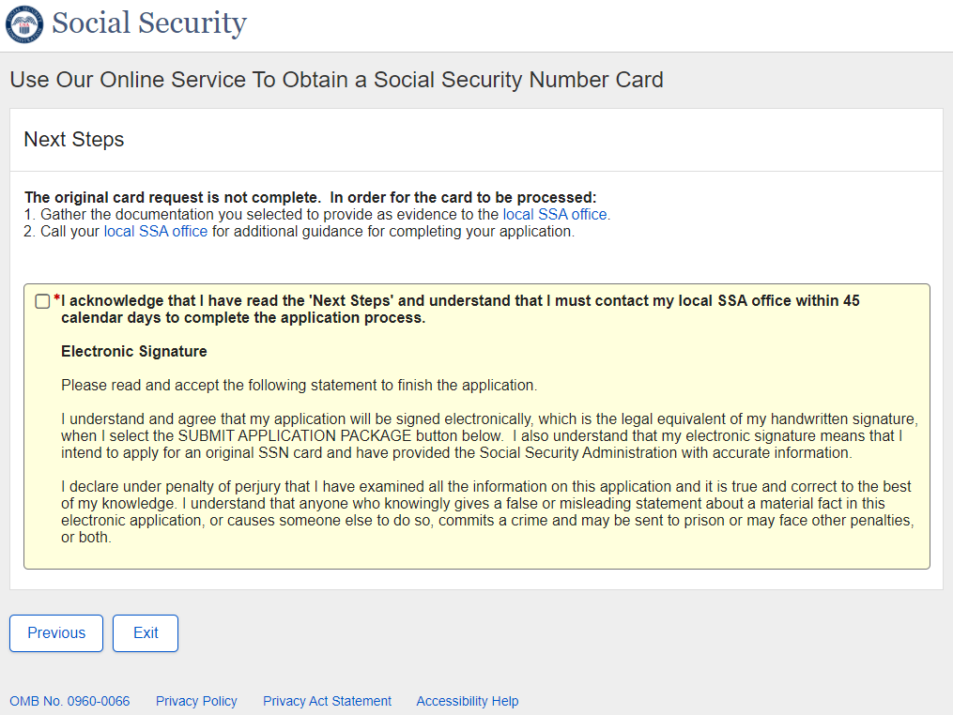

- Non-U.S. Original Self - Success
Success - ESS
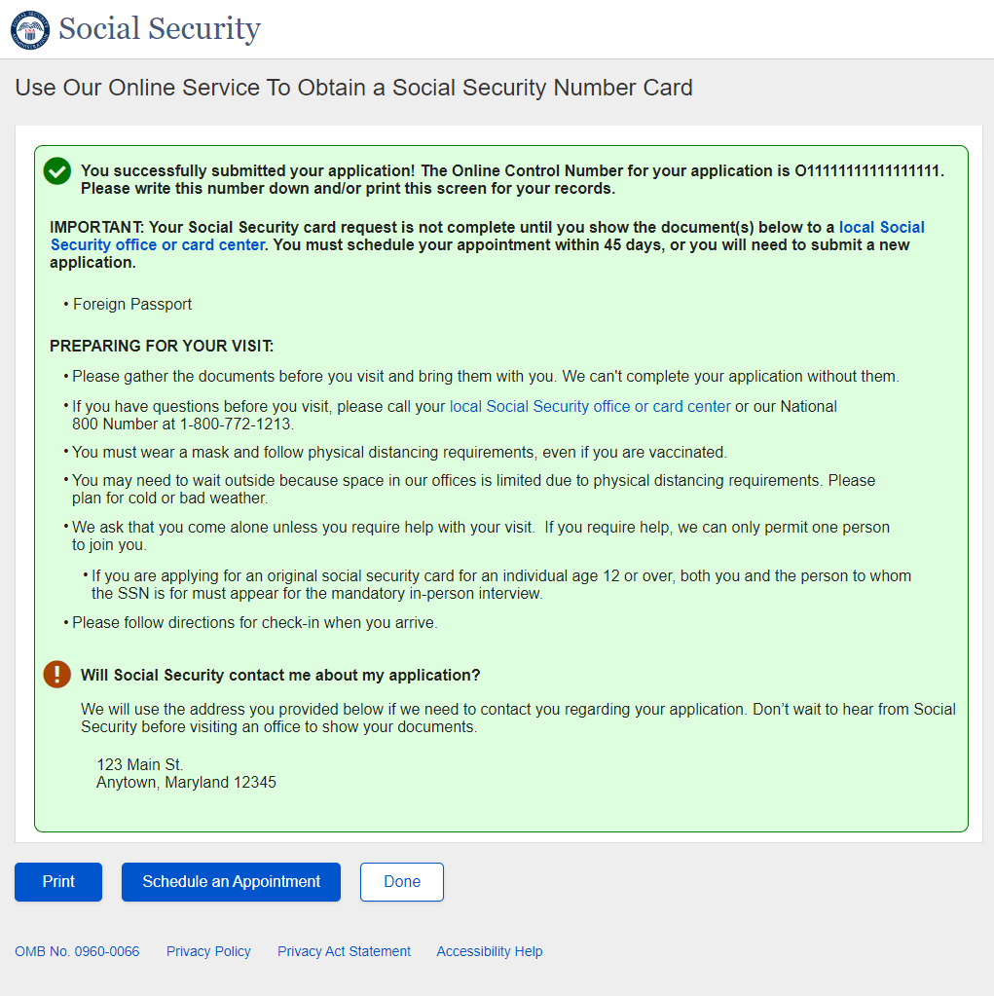

- Non-U.S. Original Someone Else Adult - Landing
- Non-U.S. Original Someone Else Adult - Age 18 or Older
- Non-U.S. Original Someone Else Adult - U.S. Mailing Address Available
- Non-U.S. Original Someone Else Adult - Have an SSN
- Non-U.S. Original Someone Else Adult - Citizenship
- Non-U.S. Original Someone Else Adult - Applying For
- Non-U.S. Original Someone Else Adult - Applying For Someone Else Name
- Non-U.S. Original Someone Else Adult – Individual’s Date of Birth
- Non-U.S. Original Someone Else Adult - Relationship Adult
- Non-U.S. Original Someone Else Adult - Individual Capabilities
- Non-U.S. Original Someone Else Adult - Individual's Place of Birth
- Non-U.S. Original Someone Else Adult - Individual's Name
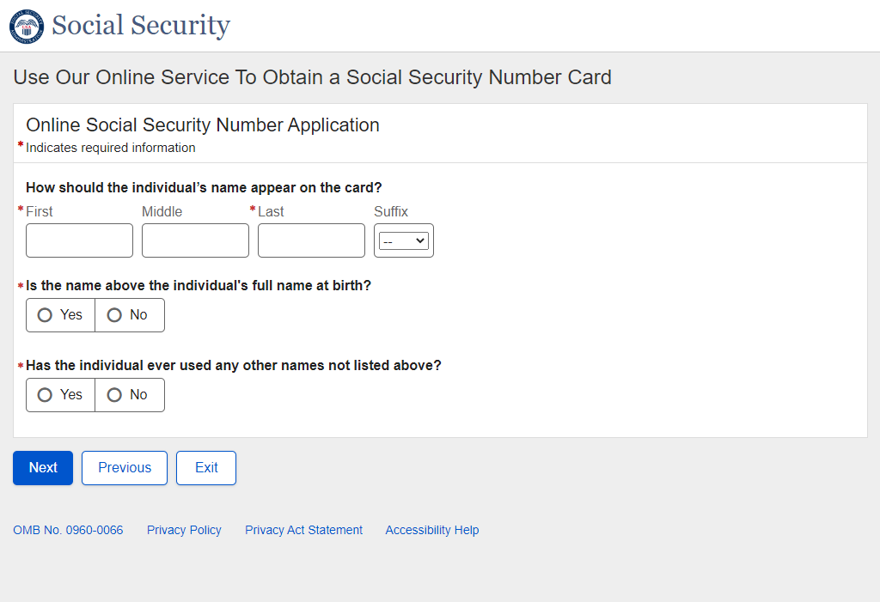
- Non-U.S. Original Someone Else Adult - Individual's Sex
- Non-U.S. Original Someone Else Adult - Individual's Parents Names
- Non-U.S. Original Someone Else Adult - U.S. Mailing Address
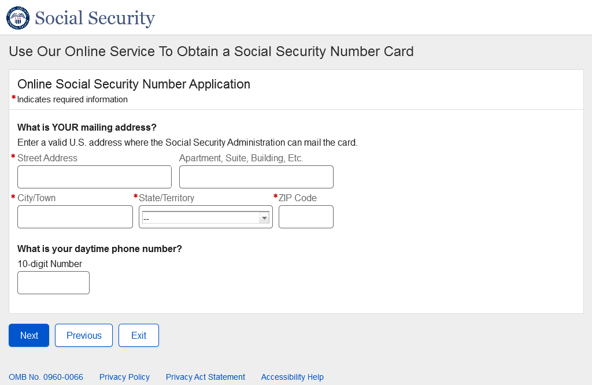
- Non-U.S. Original Someone Else Adult - Individual's Documentation
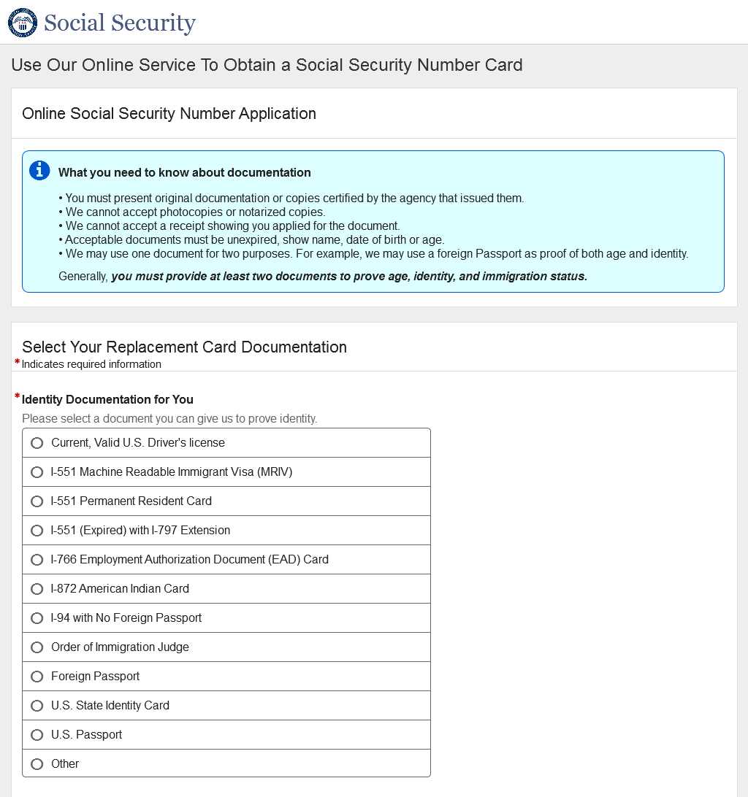
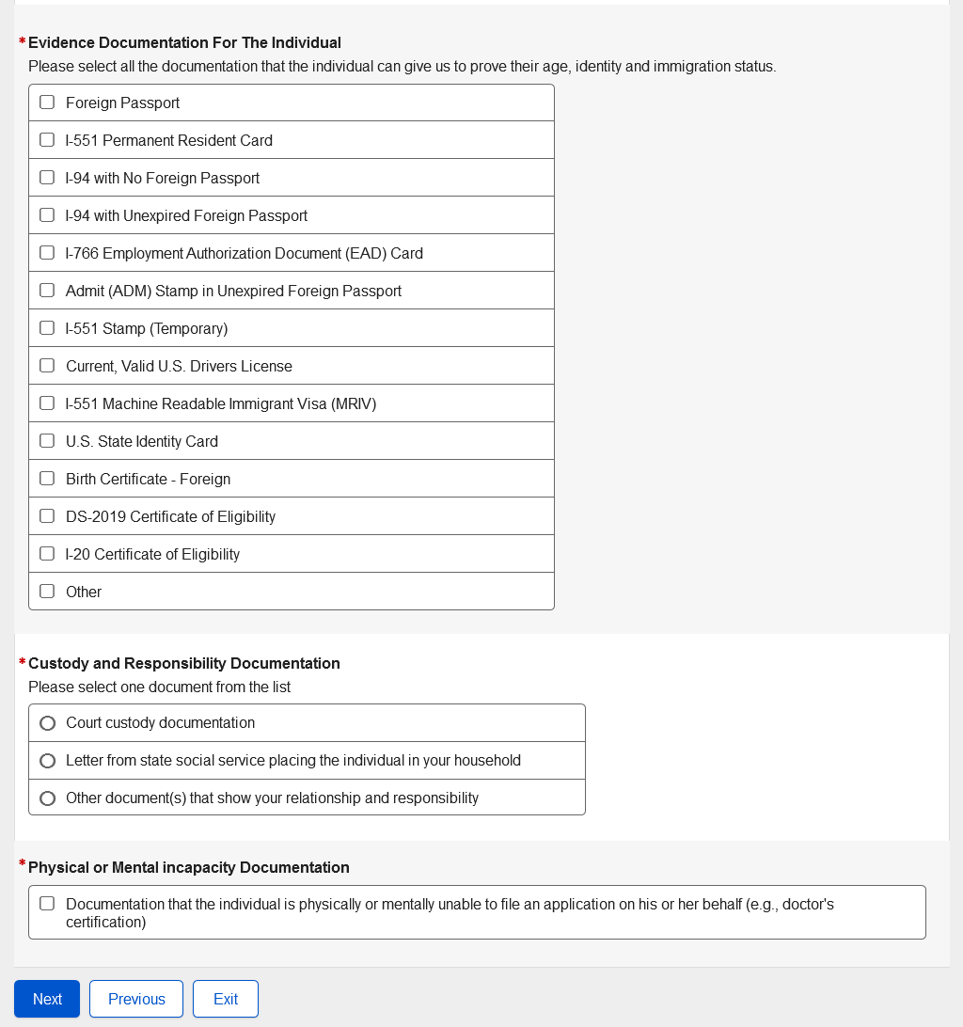
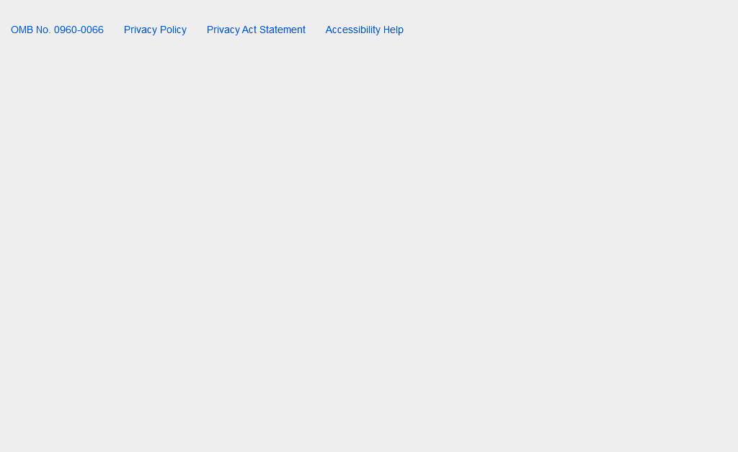
- Non-U.S. Original Someone Else Adult - Review and Edit
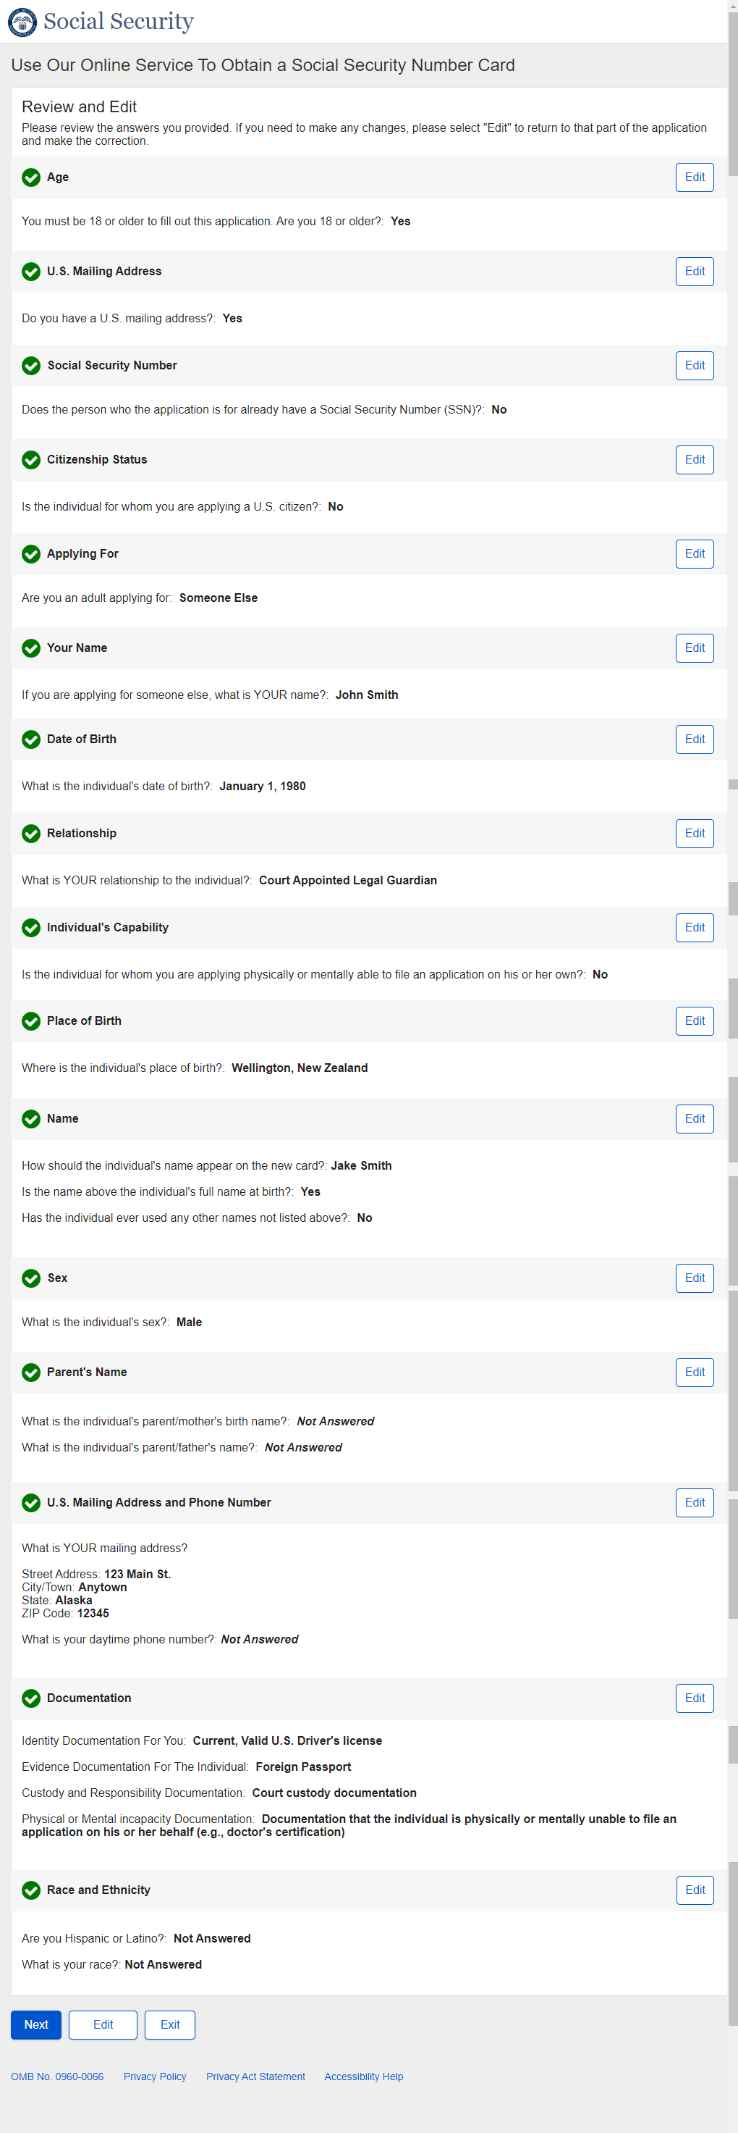

Non-U.S. Original Someone Else Adult - Review and Edit – Continued

Non-U.S. Original Someone Else Adult - Review and Edit – Continued
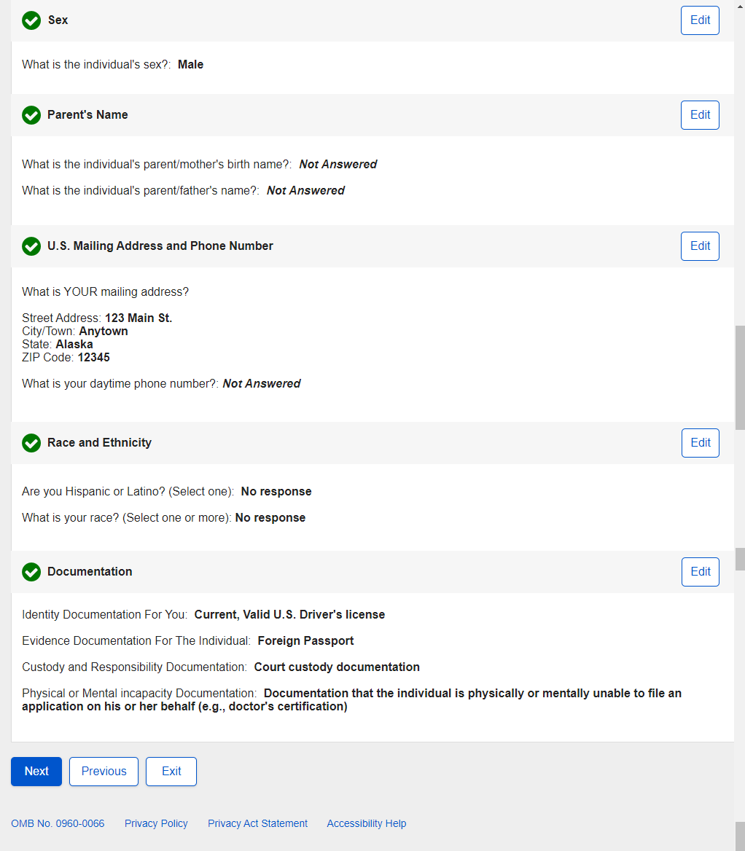

- Non-U.S. Original Someone Else Adult - Attestation
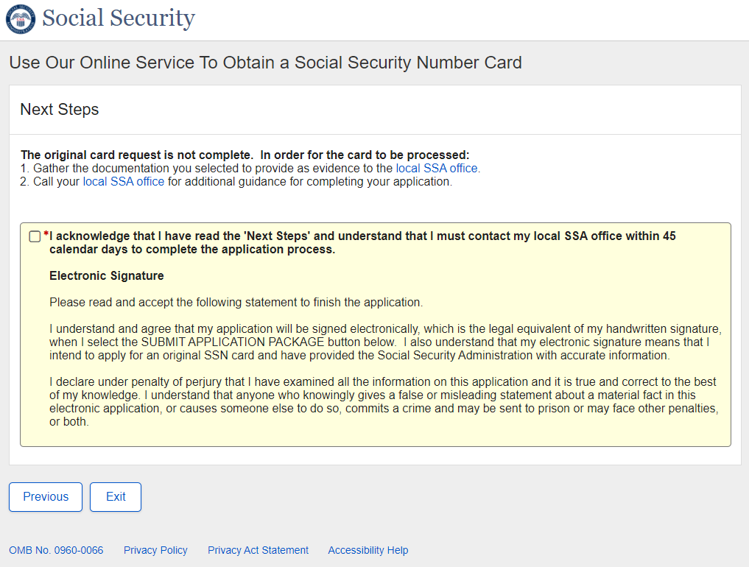

- Non-U.S. Original Someone Else Adult - Success
Success – ESS

- Non-U.S. Original Someone Else Child - Landing
- Non-U.S. Original Someone Else Child - Age 18 or Older
- Non-U.S. Original Someone Else Child - U.S. Mailing Address Available
- Non-U.S. Original Someone Else Child - Have an SSN
- Non-U.S. Original Someone Else Child - Citizenship
- Non-U.S. Original Someone Else Child - Applying For
- Non-U.S. Original Someone Else Child - Applying For Someone Else Name
- Non-U.S. Original Someone Else Child – Individual’s Date of Birth
- Non-U.S. Original Someone Else Child - Relationship Child
- Non-U.S. Original Someone Else Child - Individual's Place of Birth
- Non-U.S. Original Someone Else Child - Individual's Name
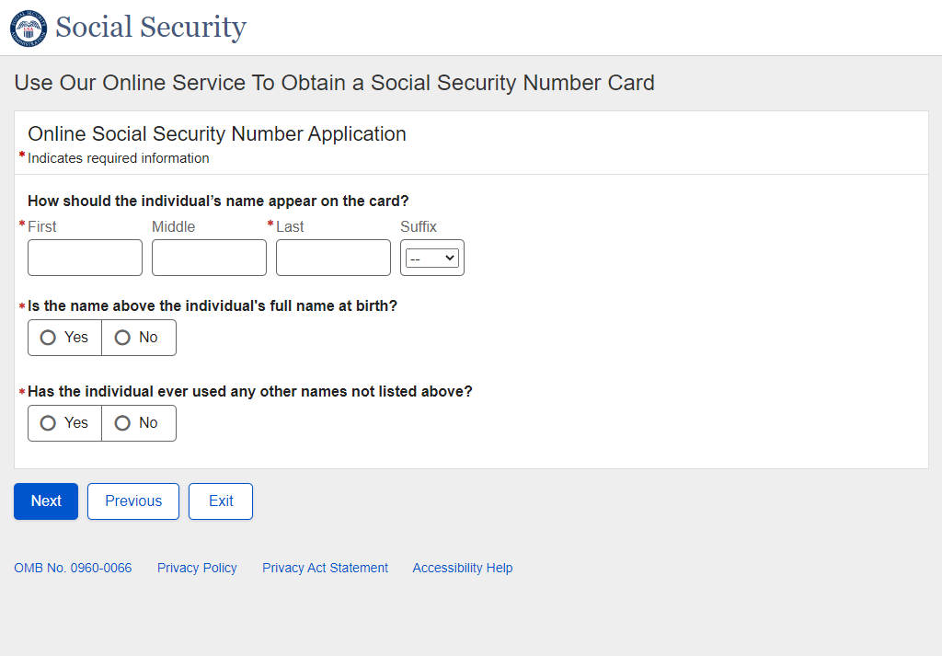
- Non-U.S. Original Someone Else Child - Individual's Sex
- Non-U.S. Original Someone Else Child - Individual's Parents Names
- Non-U.S. Original Someone Else Child - U.S. Mailing Address
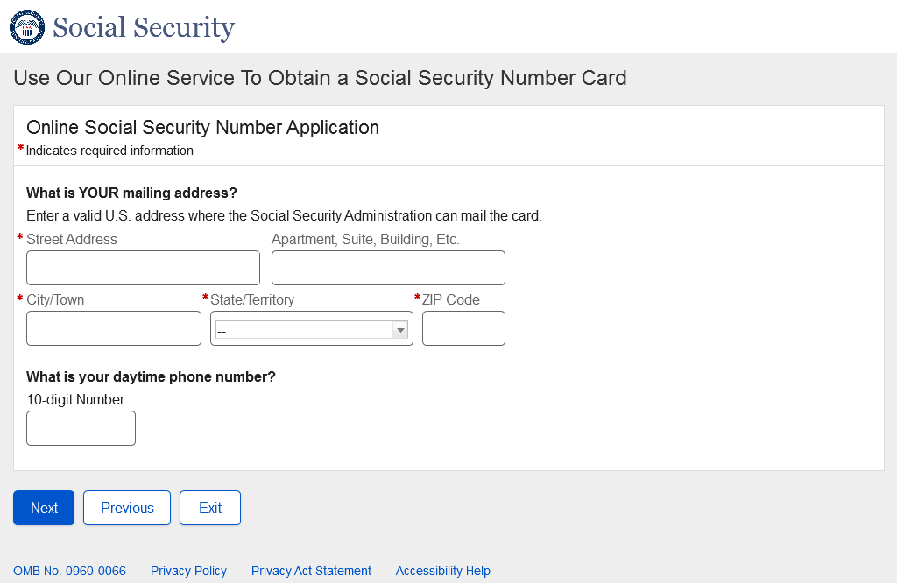
- Non-U.S. Original Someone Else Child - Individual's Documentation
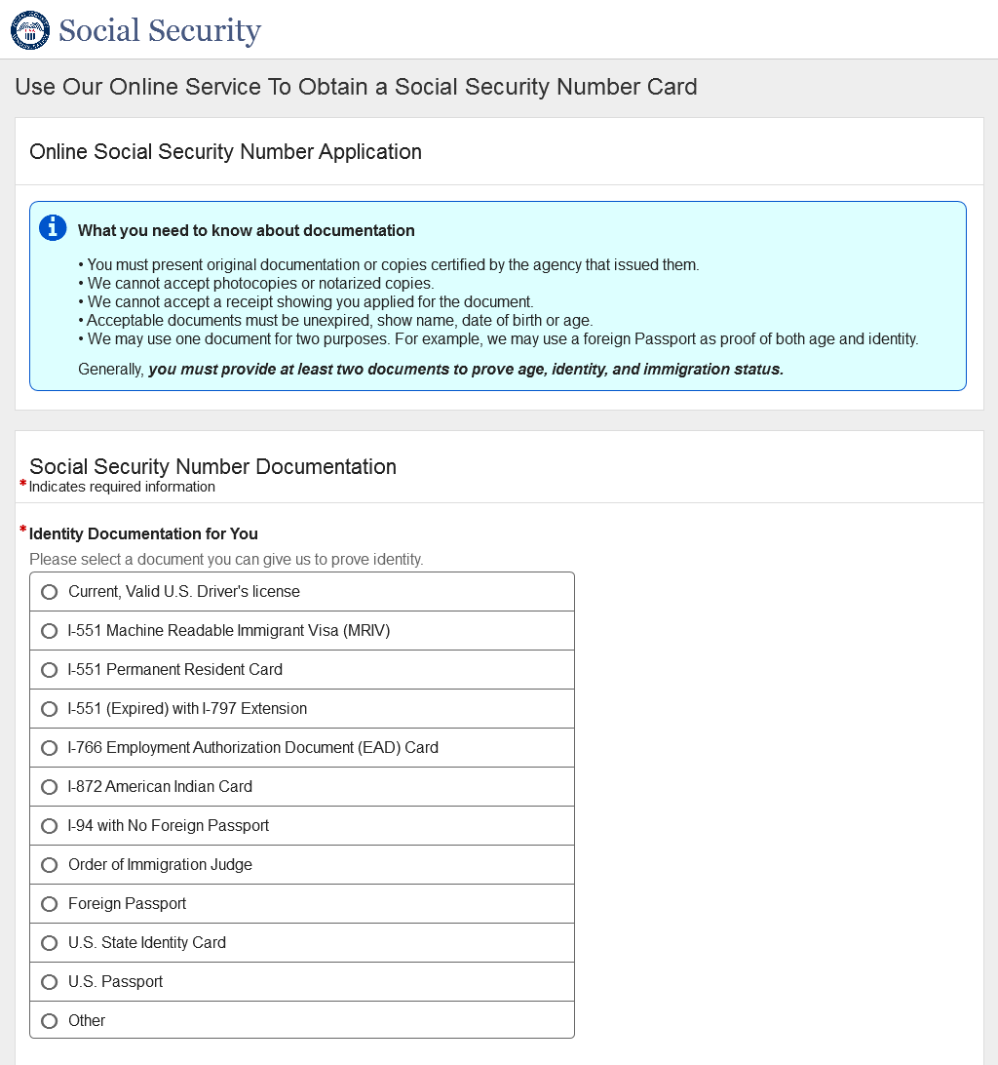
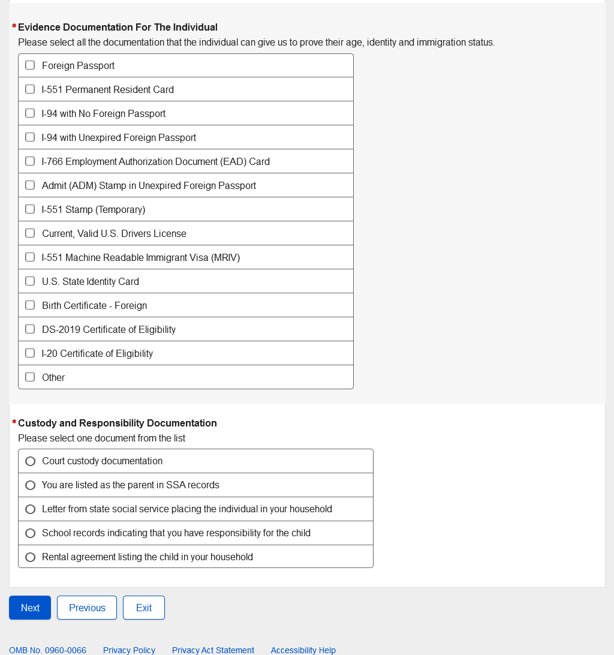

- Non-U.S. Original Someone Else Child - Review and Edit
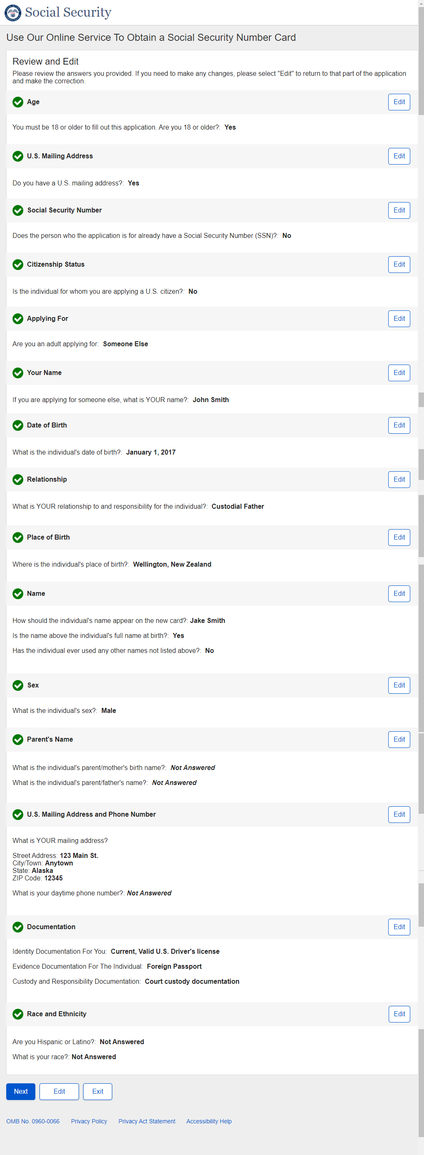
Non-U.S. Original Someone Else Child - Review and Edit - Continued

Non-U.S. Original Someone Else Child - Review and Edit - Continued
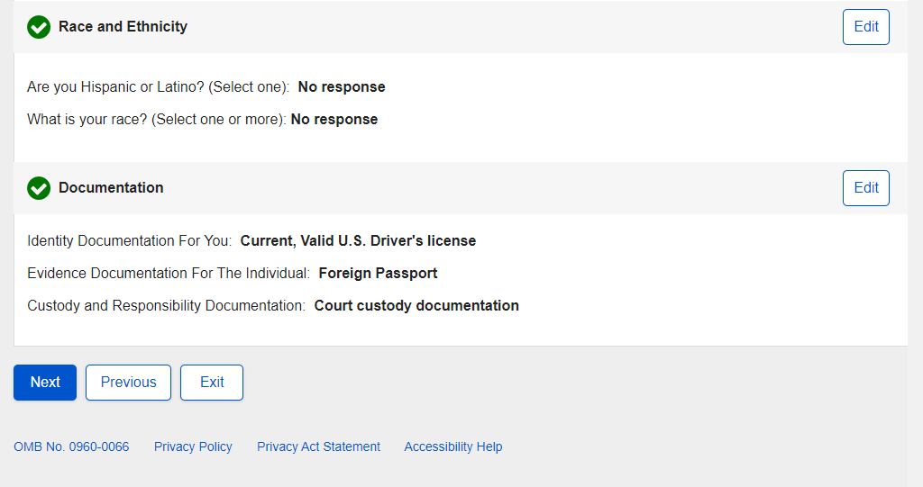

- Non-U.S. Original Someone Else Child - Attestation
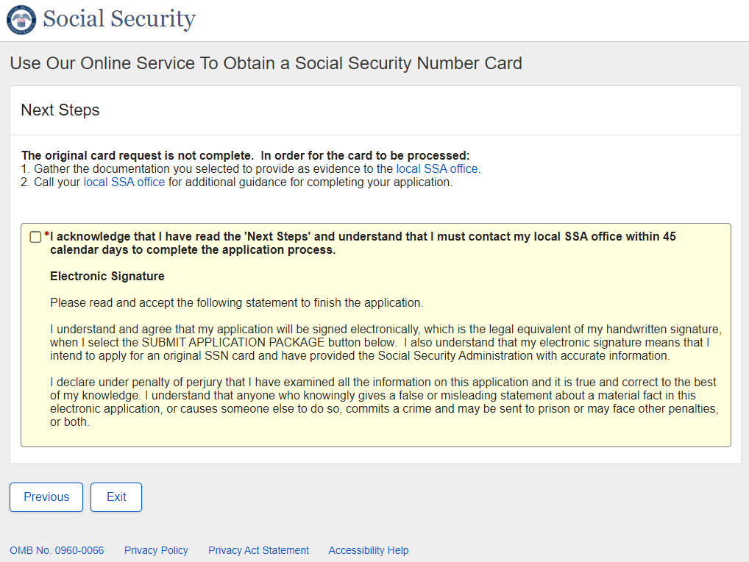

- Non-U.S. Original Someone Else Child - Success
Success – ESS
- Non-U.S. Replacement Self - Landing
- Non-U.S. Replacement Self - Age 18 or Older
- Non-U.S. Replacement Self - U.S. Mailing Address Available
- Non-U.S. Replacement Self - Have an SSN
- Non-U.S. Replacement Self - Citizenship
- Non-U.S. Replacement Self - Applying For
- Non-U.S. Replacement Self - Date of Birth
- Non-U.S. Replacement Self - Name Change
- Non-U.S. Replacement Self - Place of Birth
- Non-U.S. Replacement Self - SSN
- Non-U.S. Replacement Self - Name
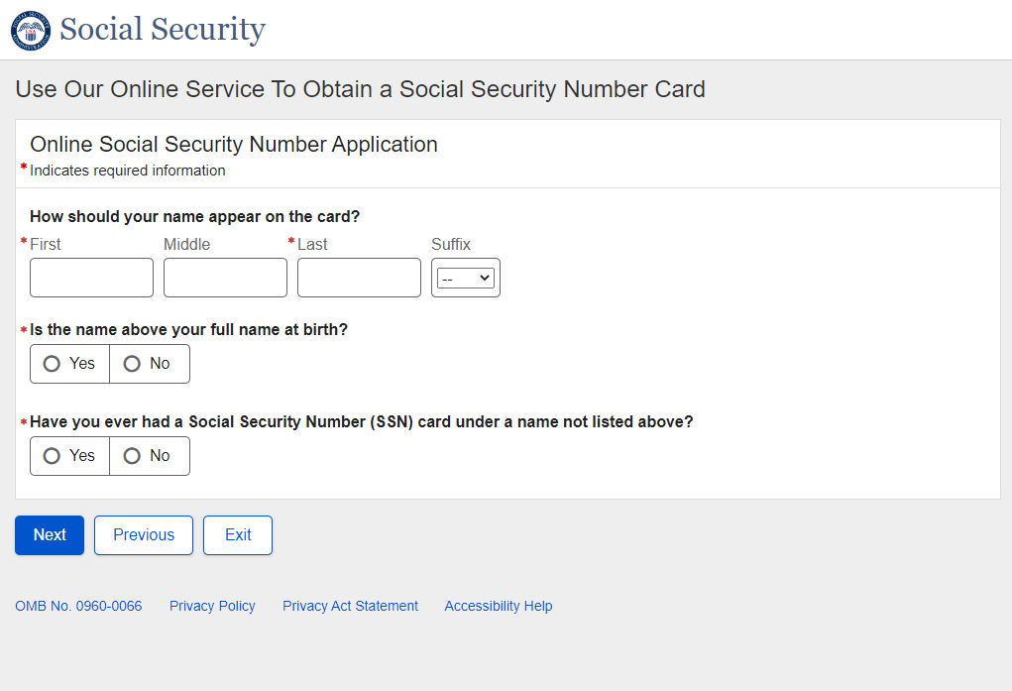

- Non-U.S. Replacement Self - Parents Names
- Non-U.S. Replacement Self - U.S. Mailing Address
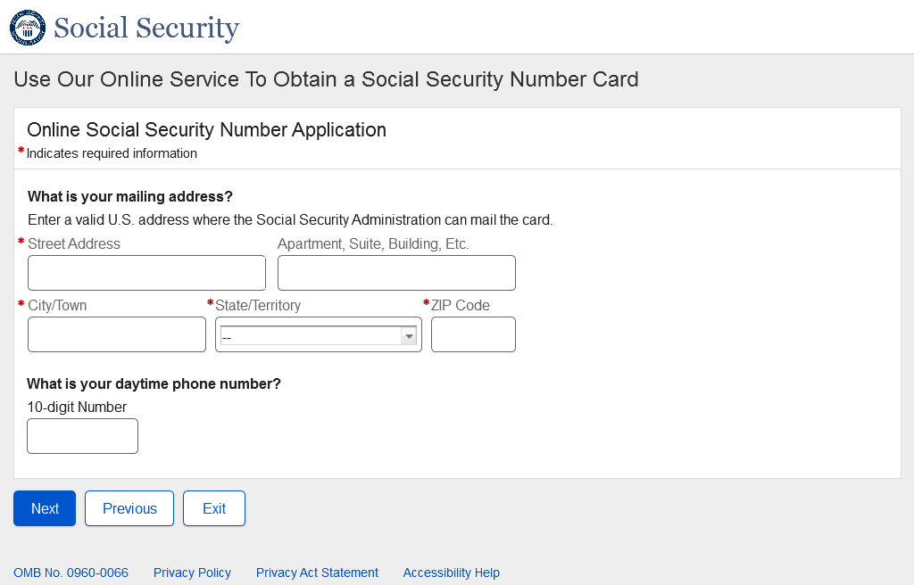
- Non-U.S. Replacement Self - Documentation
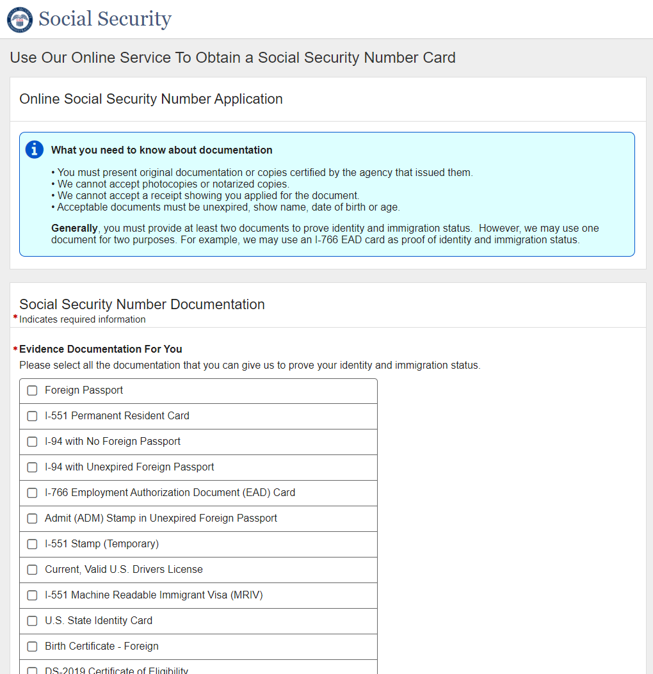
- Non-U.S. Replacement Self - Documentation - Name Change
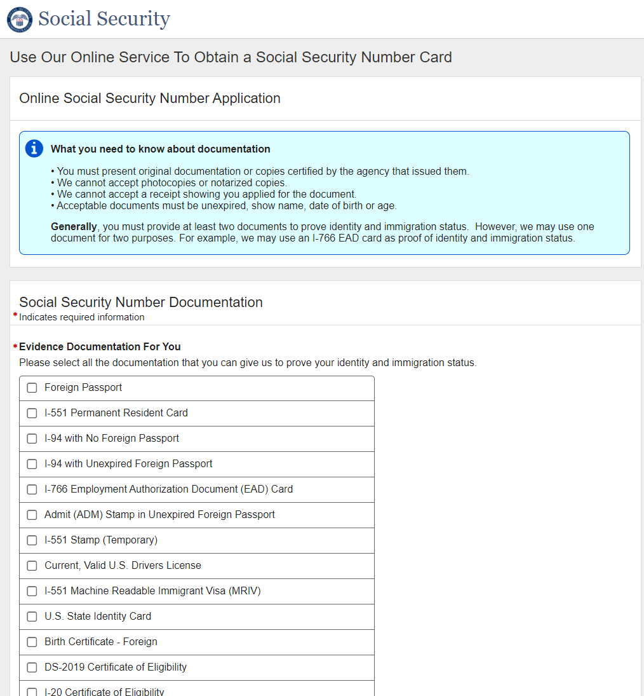
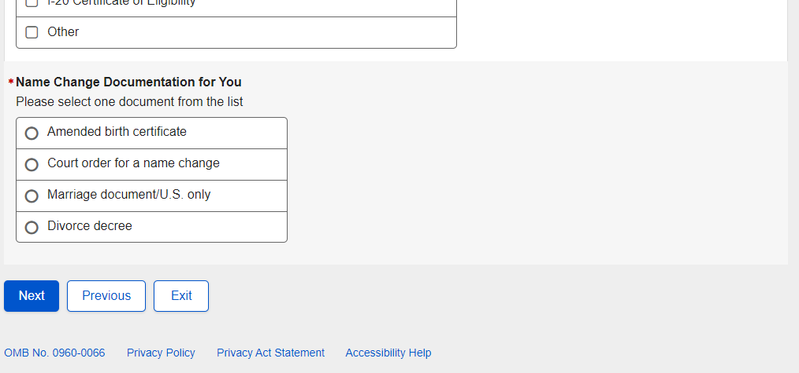
- Non-U.S. Replacement Self - Review and Edit
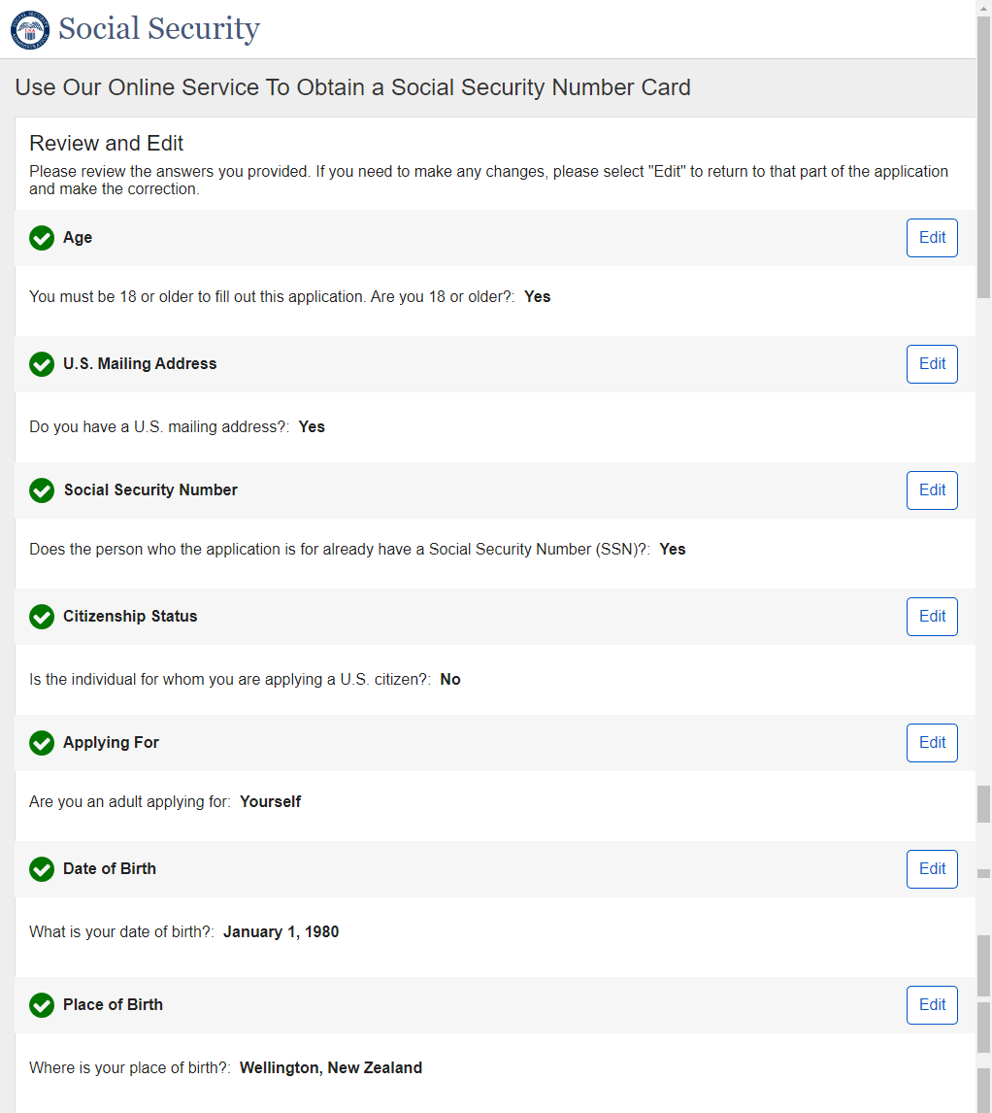

Non-U.S. Replacement Self - Review and Edit - Continued
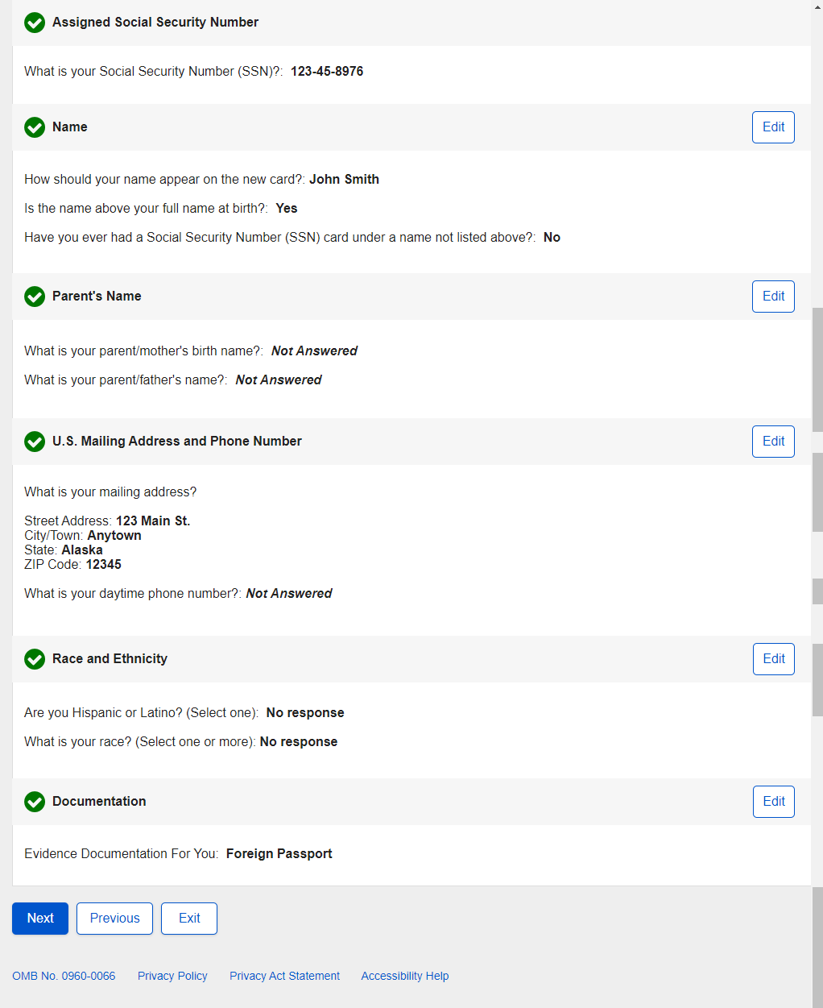
- Non-U.S. Replacement Self - Attestation
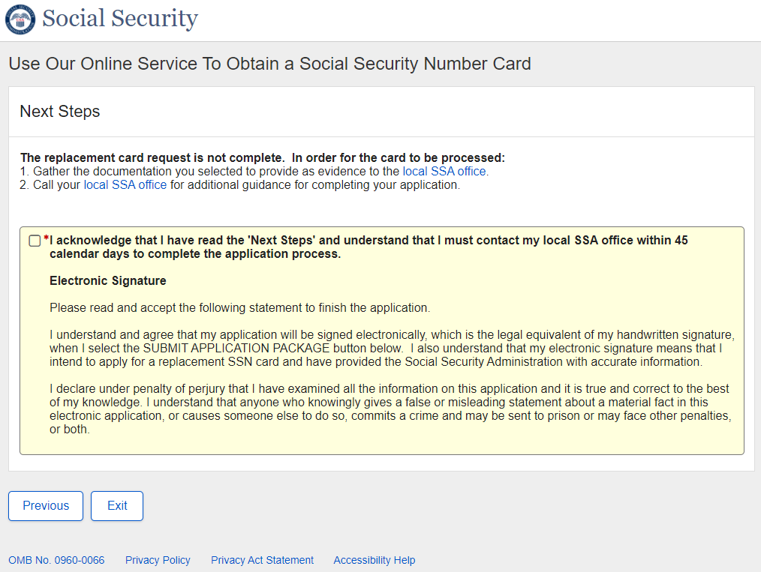

- Non-U.S. Replacement Self - Success
Success - ESS
- Non-U.S. Replacement Someone Else Adult - Landing
- Non-U.S. Replacement Someone Else Adult - Age 18 or Older
- Non-U.S. Replacement Someone Else Adult - U.S. Mailing Address Available
- Non-U.S. Replacement Someone Else Adult - Have an SSN
- Non-U.S. Replacement Someone Else Adult - Citizenship
- Non-U.S. Replacement Someone Else Adult - Applying For
- Non-U.S. Replacement Someone Else Adult - Applying For Someone Else Name
- Non-U.S. Replacement Someone Else Adult – Individual’s Date of Birth
- Non-U.S. Replacement Someone Else Adult - Relationship Adult
- Non-U.S. Replacement Someone Else Adult - Individual Capabilities
- Non-U.S. Replacement Someone Else Adult - Name Change
- Non-U.S. Replacement Someone Else Adult - Individual's Place of Birth
- Non-U.S. Replacement Someone Else Adult - Individual's SSN
- Non-U.S. Replacement Someone Else Adult - Individual's Name
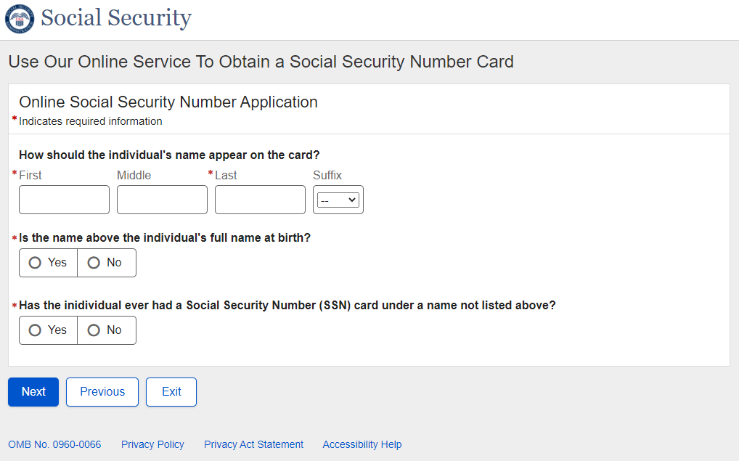

- Non-U.S. Replacement Someone Else Adult - Individual's Parents Names
- Non-U.S. Replacement Someone Else Adult - U.S. Mailing Address
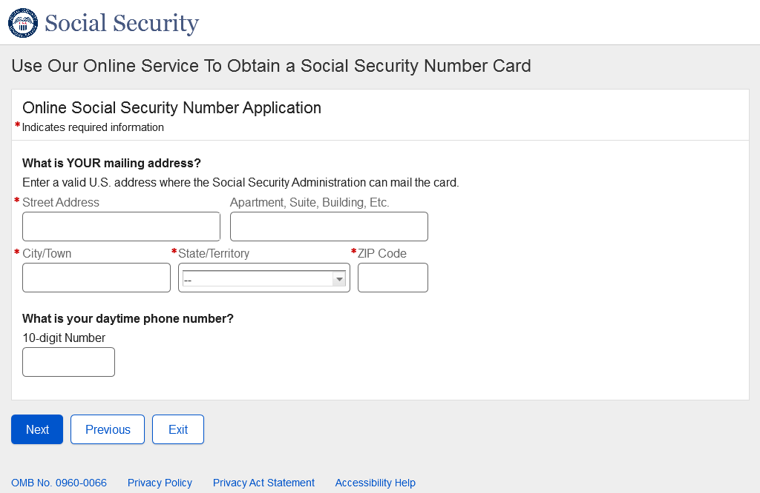
- Non-U.S. Replacement Someone Else Adult - Individual's Documentation
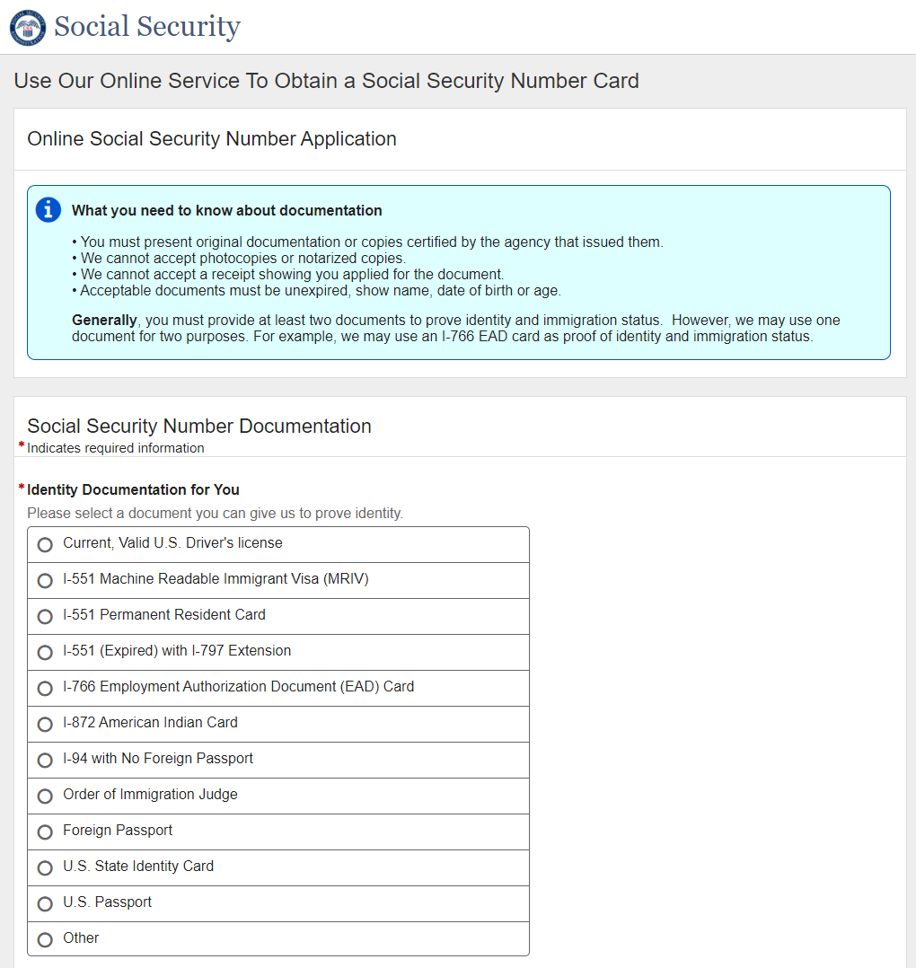
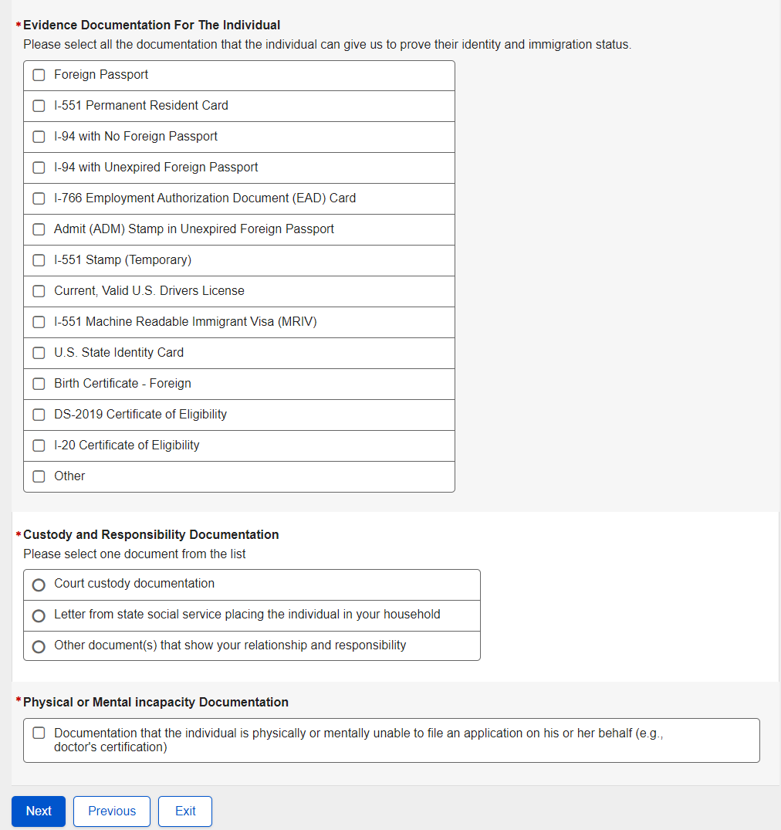
- Non-U.S. Replacement Someone Else Adult - Individual's Documentation - Name Change
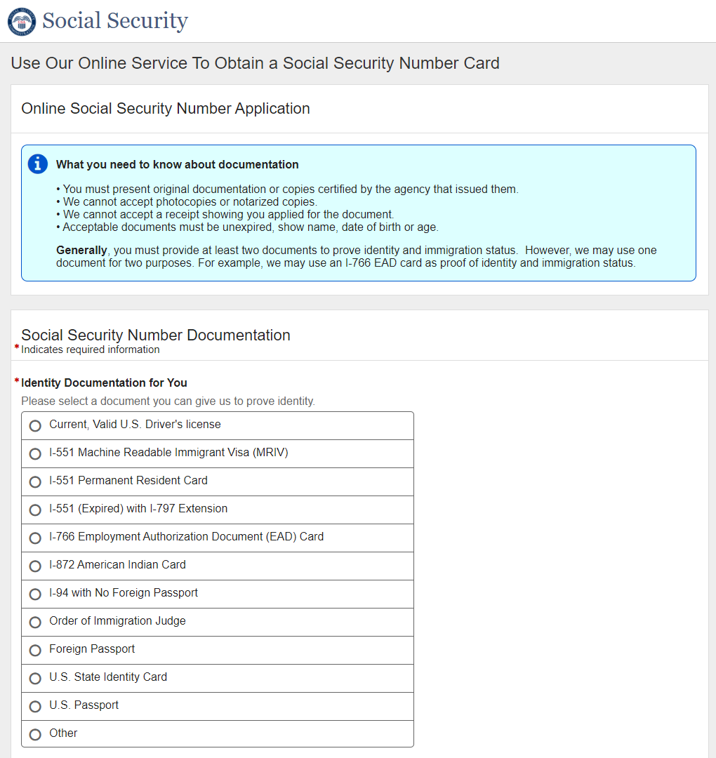
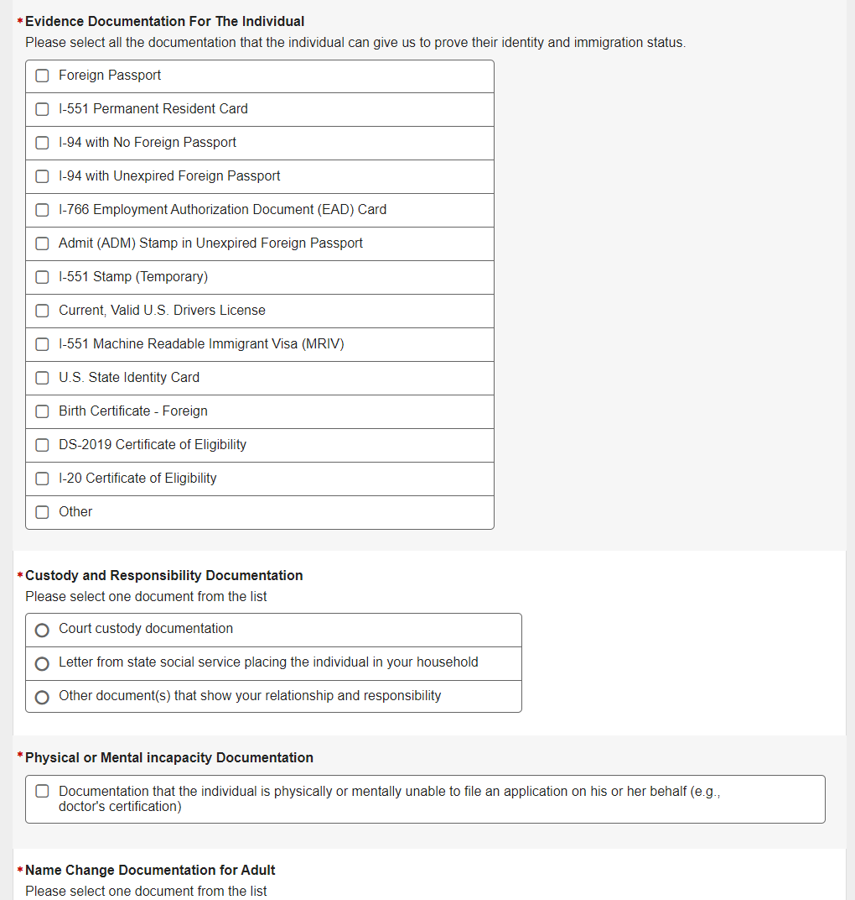
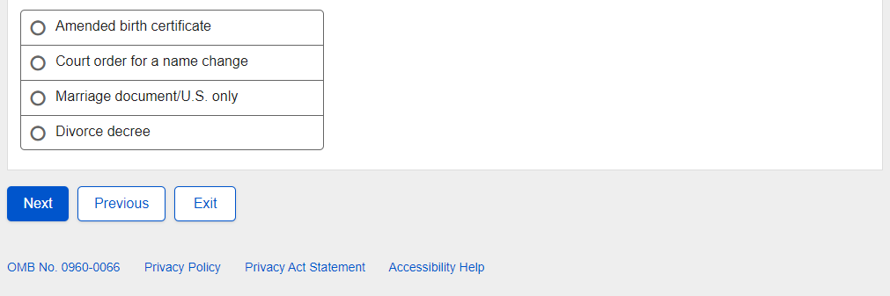
- Non-U.S. Replacement Someone Else Adult - Review and Edit
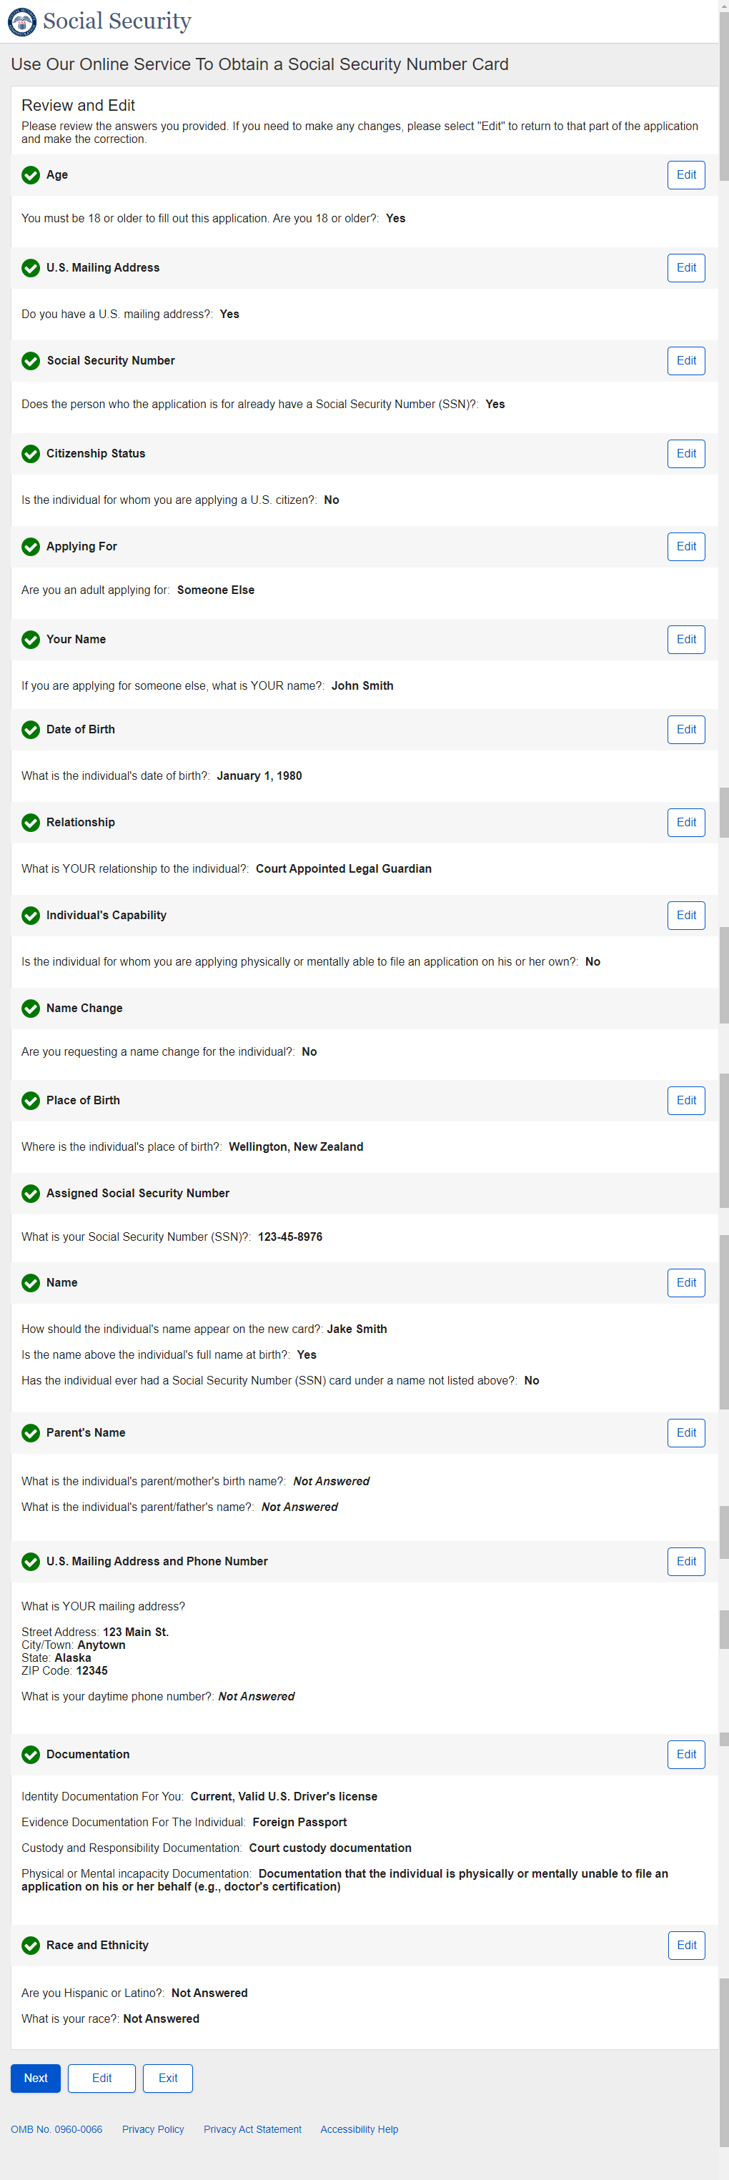
Non-U.S. Replacement Someone Else Adult - Review and Edit - Continued

Non-U.S. Replacement Someone Else Adult - Review and Edit - Continued
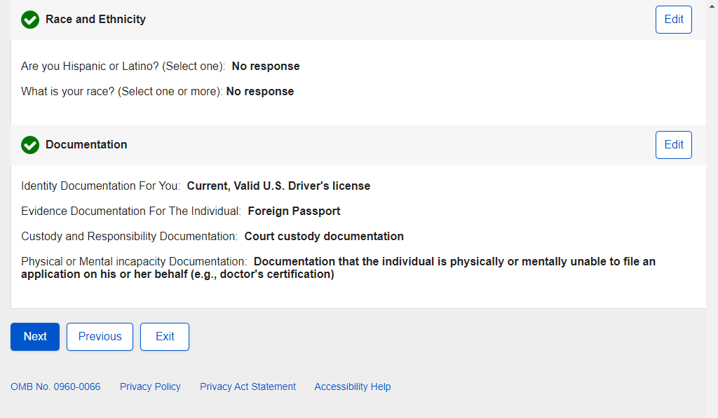

- Non-U.S. Replacement Someone Else Adult - Attestation
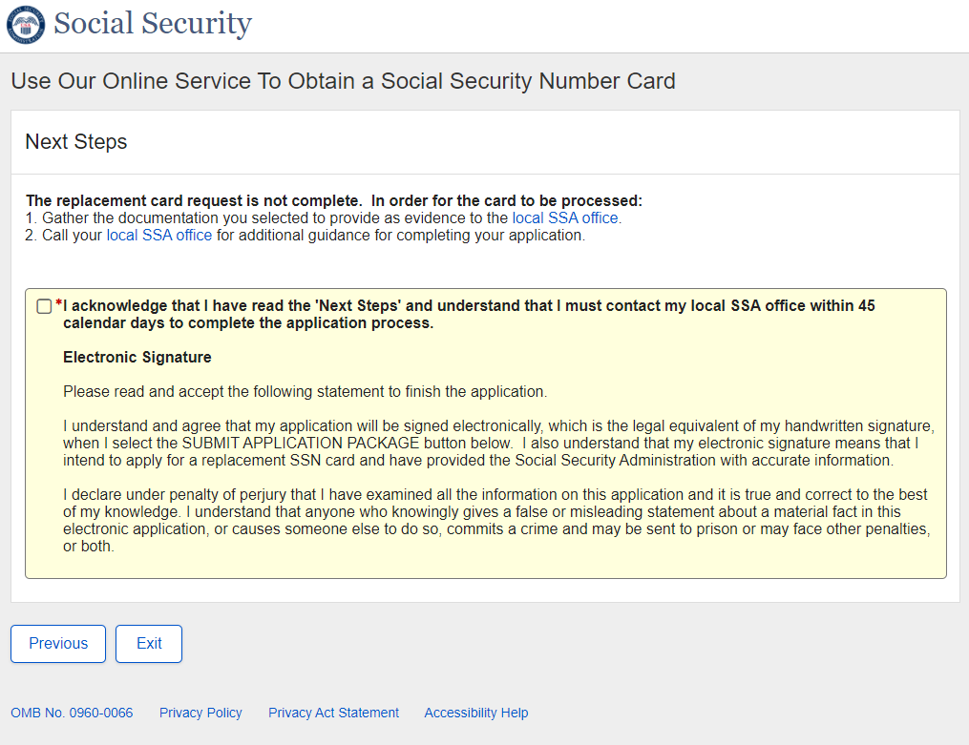

- Non-U.S. Replacement Someone Else Adult - Success
Success - ESS
- Non-U.S. Replacement Someone Else Child - Landing
- Non-U.S. Replacement Someone Else Child - Age 18 or Older
- Non-U.S. Replacement Someone Else Child - U.S. Mailing Address Available
- Non-U.S. Replacement Someone Else Child - Have an SSN
- Non-U.S. Replacement Someone Else Child - Citizenship
- Non-U.S. Replacement Someone Else Child - Applying For
- Non-U.S. Replacement Someone Else Child - Applying For Someone Else Name
- Non-U.S. Replacement Someone Else Child – Individual’s Date of Birth
- Non-U.S. Replacement Someone Else Child - Relationship Child
- Non-U.S. Replacement Someone Else Child - Name Change
- Non-U.S. Replacement Someone Else Child - Individual's Place of Birth
- Non-U.S. Replacement Someone Else Child - Individual's SSN
- Non-U.S. Replacement Someone Else Child - Individual's Name
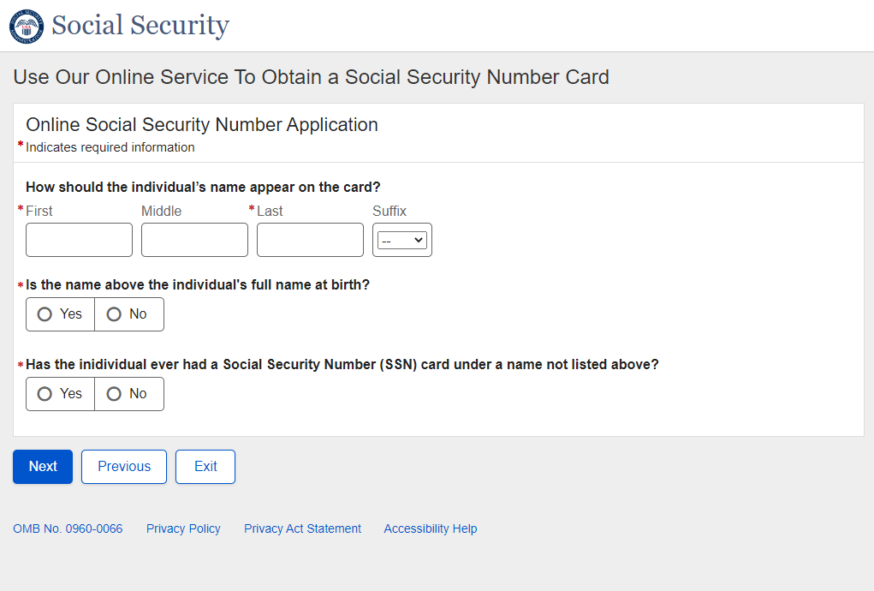

- Non-U.S. Replacement Someone Else Child - Individual's Parents Names
- Non-U.S. Replacement Someone Else Child - U.S. Mailing Address
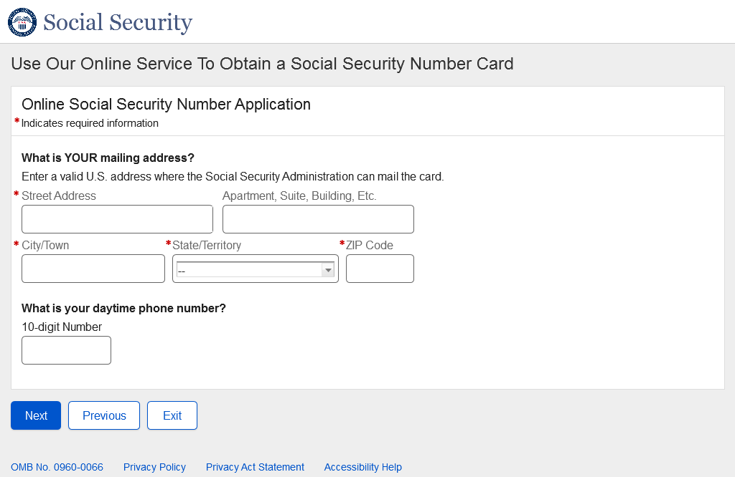
- Non-U.S. Replacement Someone Else Child - Individual's Documentation
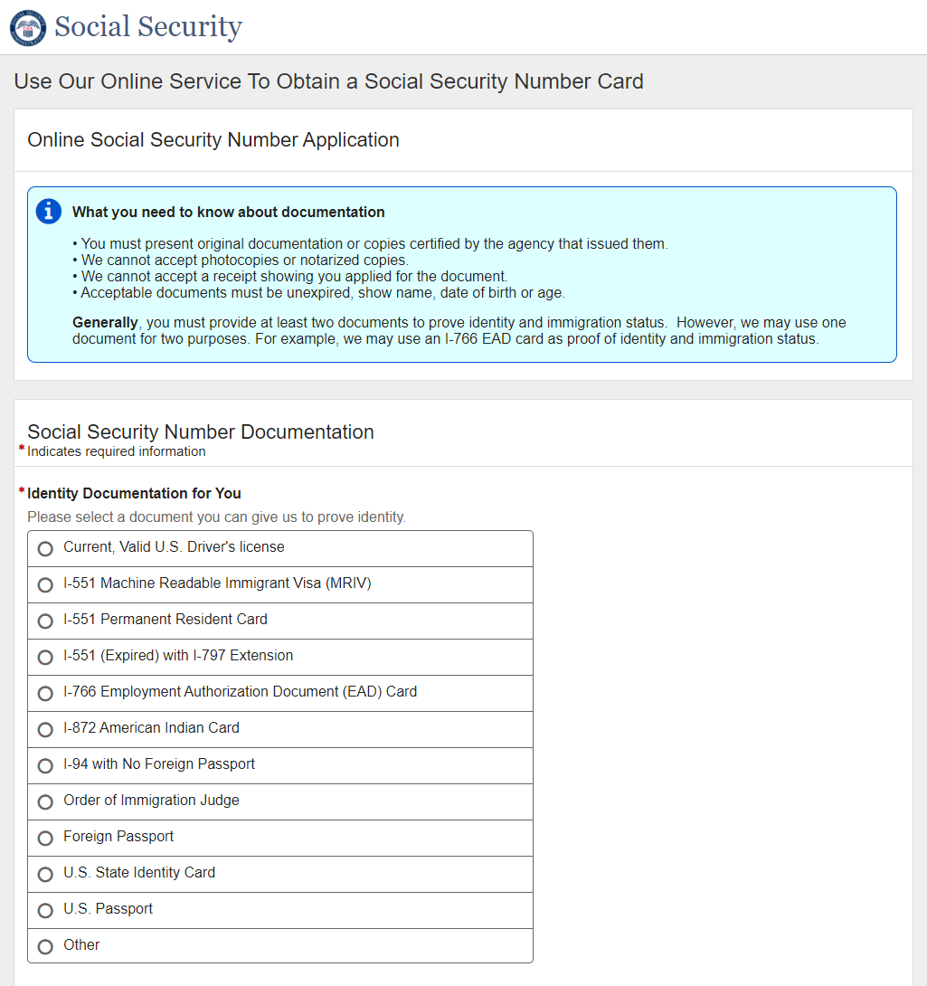
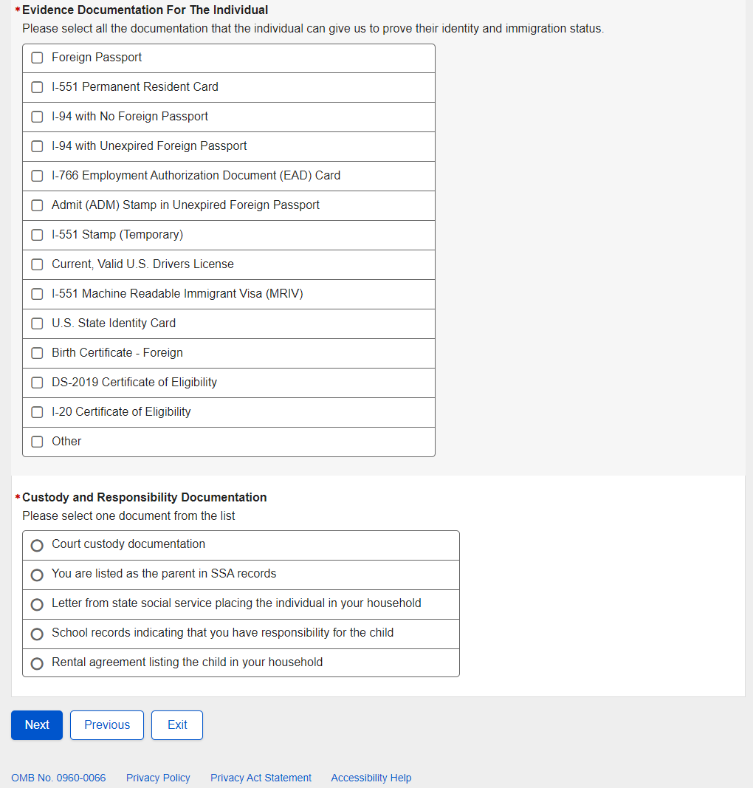

- Non-U.S. Replacement Someone Else Child - Individual's Documentation - Name Change
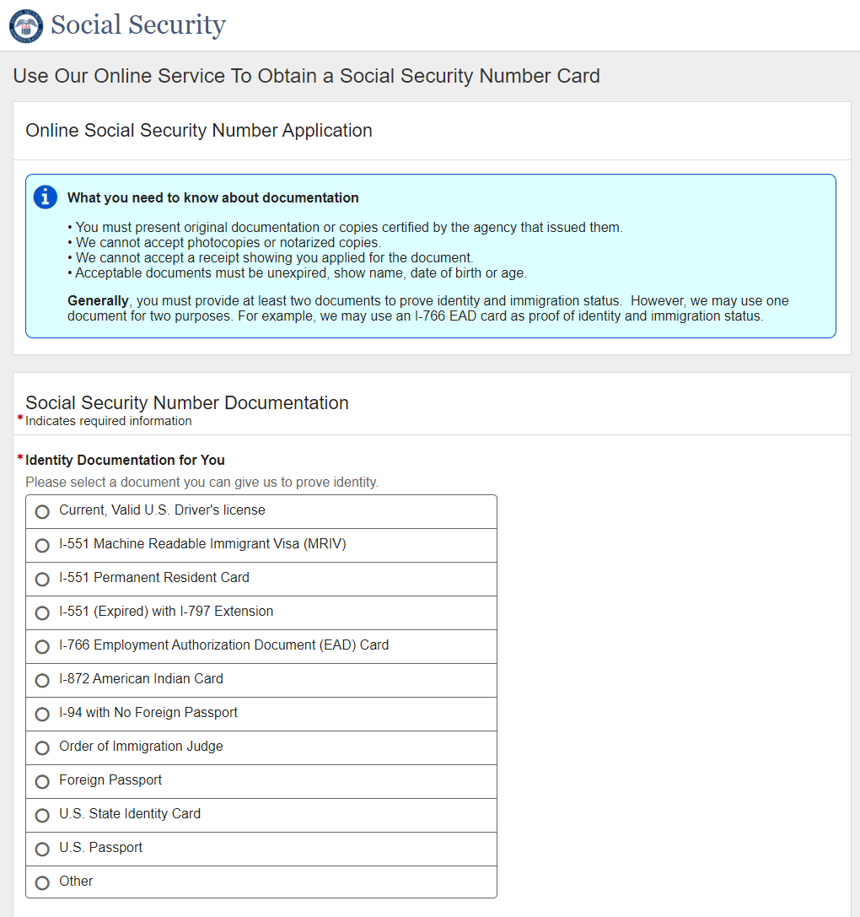

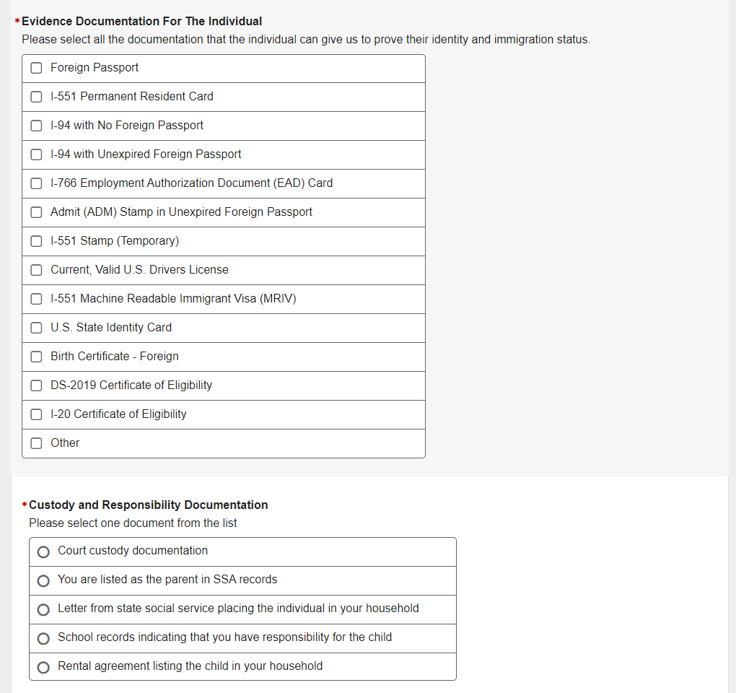

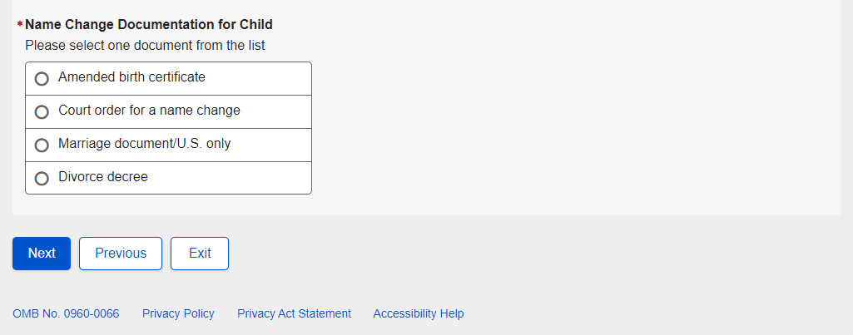

- Non-U.S. Replacement Someone Else Child - Review and Edit
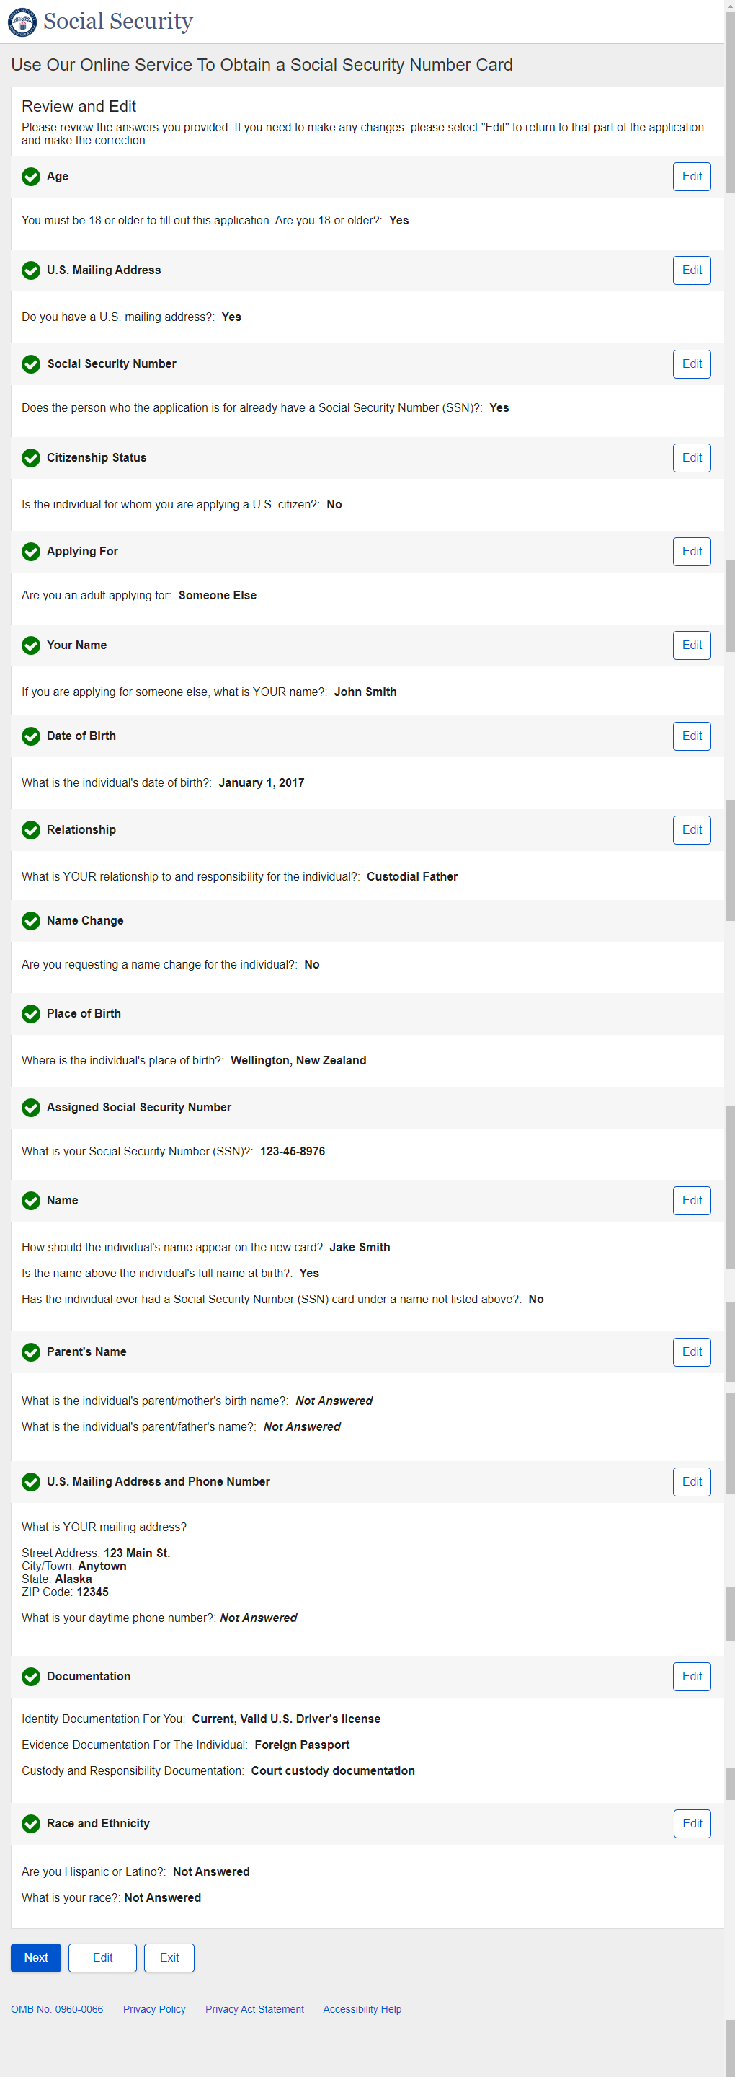
Non-U.S. Replacement Someone Else Child - Review and Edit - Continued

Non-U.S. Replacement Someone Else Child - Review and Edit - Continued
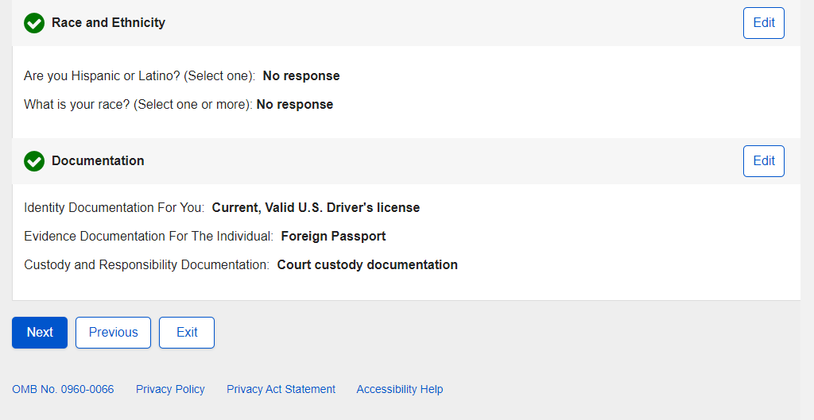

- Non-U.S. Replacement Someone Else Child - Attestation
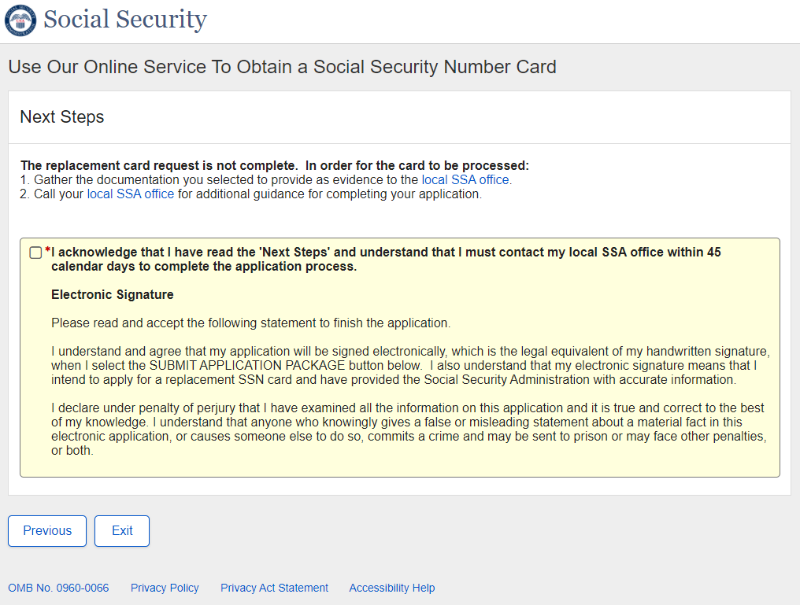

- Non-U.S. Replacement Someone Else Child - Success
Success - ESS

