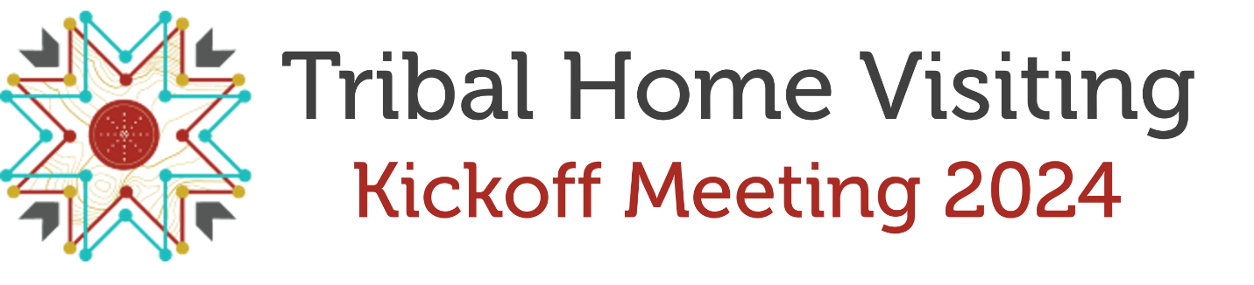
Registration
Salutation
First Name
Last Name
Suffix
Tribal Affiliation (if applicable)

Tribe or Organization
- Future Generations Collaborative
- Jicarilla Apache Nation
- Mashantucket Pequot Tribal Nation
- Oglala Sioux Tribe
- Seneca Nation of Indians
- South East Alaska Regional Health
- ACF
- PATH
- TEI
- OTHER
Title
Phone
Email
Role most closely aligned with your Tribal Home Visiting responsibilities:
- Administrator/Director/Lead
- Data Manager
- Direct Service Provider
- Evaluator
- Federal Staff
- Home Visitor
- National TA Provider
- Speaker
- Other
Emergency Contact
Emergency Contact Name (someone not traveling with you)
Emergency Contact Phone Number

Special Requests
ADA Requests
- Wheelchair Accessibility
- Visual Impairment
- Hearing Impairment
- Accompanied Eye Dog
- Other
Data Privacy Notice
- Please enter your initials below stating that you have read and understand the above data privacy policies as for the 2024 Tribal Home Visiting Kickoff Meeting provided by ZERO TO THREE and its partners.

- I opt out of including my name and contact information on the 2024 Tribal Home Visiting Kickoff Meeting attendee list.
Optional Networking Opportunity
- Are you interested in participating in the networking opportunity?
- Are you likely to participate in the ride-share to the Native Art Market on Wednesday evening at 5:00 pm?

PAPERWORK REDUCTION ACT OF 1995 (Pub. L. 104-13) STATEMENT OF PUBLIC BURDEN: Through this information collection, ACF is gathering information to assess the quality and outcomes of Training and Technical Assistance events. Public reporting burden for this collection of information is estimated to average of 5 minutes per respondent, including the time for reviewing instructions, gathering and maintaining the data needed, and reviewing the collection of information. This is a voluntary collection of information. agency may not conduct or sponsor, and a person is not required to respond to, a collection of information subject to the requirements of the Paperwork Reduction Act of 1995, unless it displays a currently valid OMB control number. The OMB # is 0970-0617, and the expiration date is 09/30/2026. If you have any comments on this collection of information, please contact Anne Bergan, Office of Early Childhood Development, Administration for Children and Families, HHS, Mary E. Switzer Building 330 C Street SW, Suite 3014F, Washington, DC 20024.

