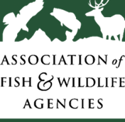

Dear [FIRST NAME] [LAST NAME],

The Association of Fish and Wildlife Agencies (AFWA) is partnering with [insert partner name] to conduct the 2022 Survey of Fishing, Hunting, and Wildlife-Associated Recreation (FHWAR). **We are currently looking for people aged 18 and over to participate in testing the FHWAR survey.**

Testing will entail taking the survey online while you speak (on the phone or via an online meeting) with an [insert partner name] interviewer, who will ask you questions about whether the questions are easy to understand and answer, your suggesting for improving the survey, and other topics. The process will last no more than 60 minutes and you will be paid $50 in appreciation of your time.

We are contacting you because your state recognizes you as an active participant in fishing, hunting, and/or wildlife watching, and feels your feedback would make a valuable contribution to this study.

If you are interested in participating or would like additional information about the testing process, please contact us at:

[insert partner name] email

[insert partner name] phone

Or, check out our FAQ’s! [LINK]

Sincerely,

Name, Title

National Survey of Fishing, Hunting, & Wildlife-Associated Recreation