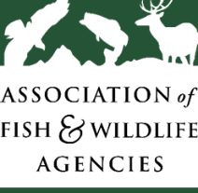**Participants Wanted for Research Study**



The *Association of Fish and Wildlife Agencies* is looking for people aged 18 and over to respond to a variety of questions about hunting, fishing, and wildlife-watching that may be asked on a national survey. The survey research interview will take approximately 60 minutes and participants will receive $50.

**FOR MORE INFORMATION**

Contact [insert partner name] at:

**xxx-xxx-xxxx or email: xxx**