OMB Control Number 1024-XXXX
Expiration Date: XX-XX-XX


National Park Service
Creel Survey
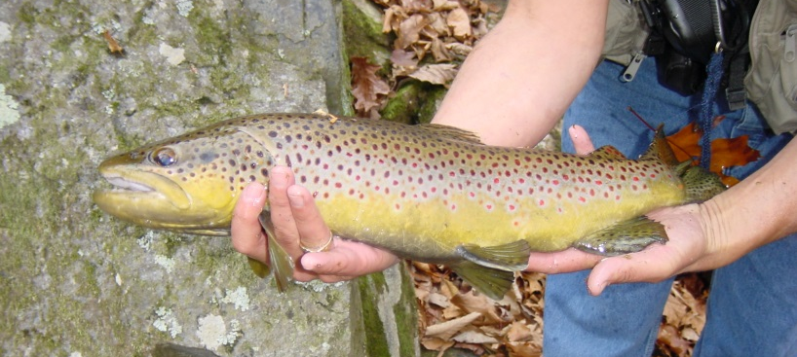

Paperwork Reduction and Privacy Act Statements: The National Park Service is authorized by 16 U.S.C. 1a-7 to collect this information. We will use this information to learn more about angler fishing experiences at [insert National Park name]. Your response is voluntary and anonymous. Your name will never be associated with your responses. You may quit at any time by simply closing the web browser A Federal agency may not conduct or sponsor, and you are not required to respond to, a collection of information unless it displays a currently valid OMB Control Number.

BURDEN ESTIMATE Statement: The public reporting burden for this collection will be no more than 10 minutes per response. This includes the time that it takes for you to navigate to the survey and the time to complete the entire questionnaire. Please direct your comments regarding any other aspect of this collection to [NPS Fisheries Manager contact information].

Anger Creel Survey Overview:
An angler creel survey is a record of a single days fishing effort, providing details on what an angler caught, released and how much time was spent fishing. The purpose of this survey is to provide information on the numbers and sizes of fish caught and harvested in Great Smoky Mountain National Park (GRSM) streams.

Instructions on How to Fill Out an Angler Creel Survey:
- Anglers should fill out a survey once they return from their trip.

- One survey should be completed per person for each day fished. For example, if you fished for three hours after work, you would fill out one survey for that day. If you fished in the morning and then again in the evening of the same day, you would fill out one survey totaling the hours you fished that day. If you go on a backcountry trip and fish for 4 days, then you would fill out four separate surveys for each day you fished.

Note to reviewer: This is the base set of questions for all surveys. Parks will be allowed to add no more than five (5) additional questions from the “Supplement Questions for NPS Creel Survey).

For electronic versions of the survey, there will be a holdover box with the extra information. For in-person interviews the interviewer will be available to provide additional information to help the respondent understand the question.

To complete the survey, please answer the following questions:

- Date: When did you fish at GRSM? Fill in the date you fished (please complete one survey for each day you fished at GRSM).

- Location fished: Where did you fish? Please list the name of the stream you fished that day. If multiple streams were fished on the same day, please fill out one survey for each stream fished. If you do not know the name of the stream, name the watershed or closest landmark you are aware of.)

- Where are you from? What is your current state/country of residence?

- How many people were in your group?

- Time started fishing: What time did you start fishing (ex. 9:00 am)?

- Time ended fishing: What time did you finish fishing (ex. 3:00 pm)?

- Hours fished: How many hours did you fish that stream that day? (Do not include hours hiking or driving to the stream, eating lunch, etc.)

- Did you fish catch and release? Did you practice ‘catch and release’ when fishing or did you harvest fish?

- Number of fish released: How many fish did you catch, unhook, and throwback while fishing?

- Number of fish kept: How many fish did you keep?

- What was the Species of fish kept? What was the species (ex. brook, brown or rainbow trout and/or rock or smallmouth bass (If unsure, please see pictures below for species identification)?

12. What was the length of fish kept? [Total length is measured from the tip of the nose to the longest length on the tip of the tail when pinched together. Total length can be in inches (to ¼ of inch) or centimeters (to 1/10 of cm).]
NOTE TO REVIEWERS: The photos below are examples that will be exchanged with park-specific fish that will aid in species identification.

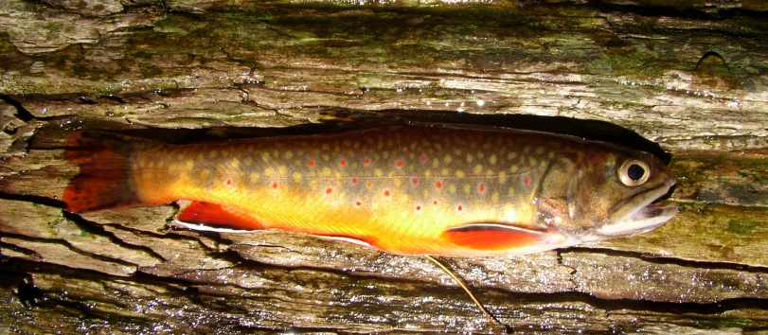
Brook Trout: Light spots on a dark body with worm-like vermiculation across its back. Will have tri-colored fins colored in orange, black, and white edges, and may also have red coloring in its dorsal fin.

Brown Trout: Dark or red spots on a light body surrounded by white halos and may have white-edged fins.

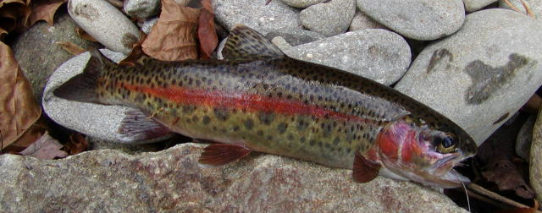
Rainbow Trout: Dark spots on a light body with a large pink stripe down the side. Some fish may also have a pink or red cheek patch and may also have white tips to some fins.

Supplemental Questions (available as needed to create Park-specific surveys)
1. Are you aware of the online creel survey?
- Were you fishing in the park today?
- What is your age bracket? <18, 18-30, 31-50, >50,
- Were you fishing with a guide?
- Are you familiar with the park’s fishing regulations?
- Where did you find the park’s fishing regulations?
- Were the park fishing regulations easy to understand?
- Did you buy a fishing license? From which state?
- What habitat were you fishing today (flats, reef, channels, deepwater (trolling)?
- Did you utilize a mooring buoy for your fishing activity today, and if so, which one?
- What fishing method did you use today? (e.g. boat, shoreline, dock, wading, etc.)
- What gear type were you using? (Bait, Fly, Lure, Plug, Combination)
- Are you aware of and using best practices for bait use and disposal?
- Were you satisfied, overall, with fishing on this water? Y/N
- Were you satisfied with the numbers of fish? Y/N
- Were you satisfied with the sizes of fish? Y/N
- Why did you choose to fish here today (e.g. relaxation, to be with family and friends, closeness to nature, sport, food, trophy fish)?
- Would you rate yourself (generally) as an inexperienced angler, experienced angler, or expert angler?
- Are you aware of best practices for cleaning boats, fishing gear, and clothing to minimize the spread of aquatic invasive species?
- Would you support an incentivized harvest system (bounty) on certain species of non-native fish?
- Would you support a chemical treatment to remove non-native/invasive fish or other aquatic species and replace them with native species? (yes or no)
- Would you support a chemical treatment to remove non-native/invasive fish or other aquatic species to return this water to its natural fishless status? (yes or no)
- Did you see anything concerning that should be addressed by park managers? (examples: dead fish on the shore; new invasive fish; zebra mussels or other harmful aquatic invasive species)
- Would you like to include any additional information?

